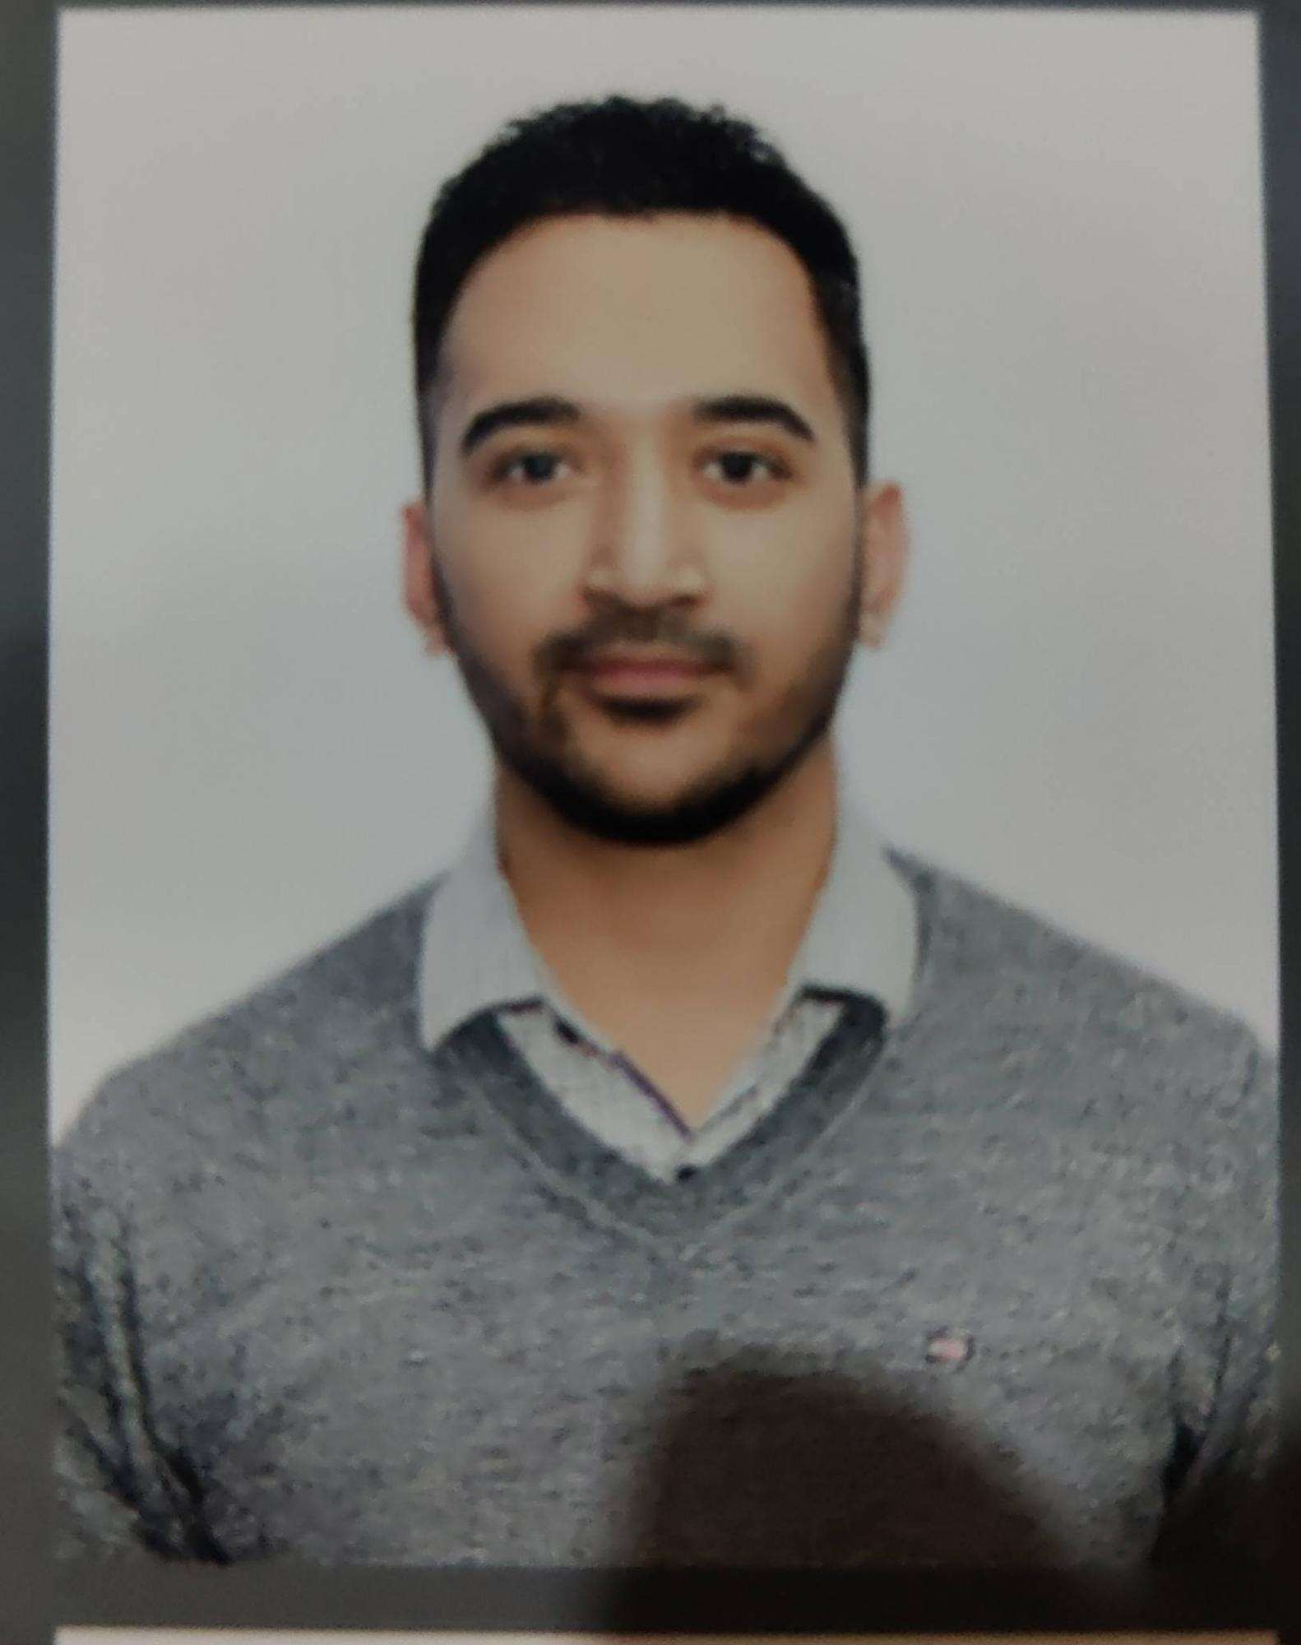

### **Highlights**

* Eloquent, Excellent Communicator
* Analytical & complex problem solver
* Project Management
* Strong decision maker
* Business development
* Effective marketing
* Operability and commitment
* Ability to motivate staff and maintain good relations
* Resistance to stress
* Adaptable and flexible
* Results-oriented

### Experience

Worked as a **Business Sales Manager** in Himalaya Scientific House, Chandigarh for **7 years**.

### Hobbies

* Sports, Travelling to adventurous places.
* Music & Reading- great way to unwind, distress, and keep the mind sharp.

### Education

* **QUATERNARY**

MBA in Retail Management

University Institute of Applied Management Sciences,

Panjab University,

Chandigarh.

Secured - 60%

* **TERTIARY**

BCA (Discrete maths, Java, C, C++, Project management, Internet programming)

DAV college,

Sector-10, Chandigarh

Secured - 64%

* **SECONDARY**

NON-MEDICAL,

DAV Model School,

Sector 15-A, Chandigarh

Secured - 65%

* **PRIMARY**

DAV Model School,

Sector 15-A, Chandigarh

Secured - 65%

Activities:

* I have been the General Secretary of Rotaract Club, Chandigarh during college (2011-2012) and have worked on projects such as awareness on Eve teasing, collecting donations for a girl child’s heart surgery, etc.
* Participated in IIPS Inter college Quiz competition in 2011.
* Participated in Inter-department Cricket Tournament in PU in 2013.

I intend to join a prestigious organization which will provide me with knowledge, recognition and achievement. I would like to enhance my academic learning through practical implementation. At the same time, I also want to utilize my fullest potential that will give opportunities to enhance my personality and career growth.

**ROHIT GULERIA**

**CONTACT NO. 9876726836**

**E-MAIL: Silentsoul05@gmail.com**

**ADDRESS: HOUSE NO. 3356, SECTOR 15-D, CHANDIGARH**

Holmes

+1 (970) 333-3833

elizabeth.holmes@coolfreecv.com