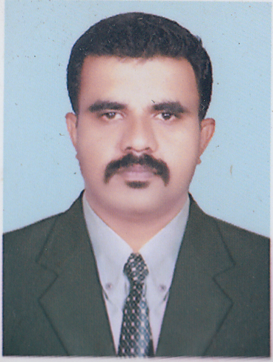

CURRICULUM VITAE

**Punathil (H)**

**Kakkodi (P O)**

**Near G L P School**

**Kozhikode-673611**

**Kerala**

[**Email-prajithperumbilly2011@gmail.com**](mailto:Email-prajithperumbilly2011@gmail.com)

**Mobile-9745060457, 7094498993**

**PRAJITH PG**

# CAREER OBJECTIVE

 To pursue a challenging and rewarding career where I can leverage my knowledge in management, and where I will get enough opportunities to utilize my knowledge and experience.

**STRENGTHS**

* Good interpersonal and communication skills
* Sincere, hardworking and commitment to excel in the testing field.
* Willingness to utilize the abilities developed through experience and education with the intent to grow professionally.
* Ability to convince and handle people
* Good analytical skill with problem solving capabilities, sense of responsibility, creative and soft-spoken.
* Good leader ship skills and ability to motivate self and the whole team
* Willingness to travel.
* Positive thinking and ability to implement innovative ideas
* Willingness to learn and acquire new strategies
* Motivate self and others

**ACADEMIC CAREER**

|  |  |  |
| --- | --- | --- |
| **Discipline** | **Centre / University** | **Score** |
|  |  |
| B.Com | M G University | 3rd Class |
| Plus-Two | Board of Higher secondary Kerala | 3rd Class |
| S.S.L.C | Board of secondary school Kerala | 3rd Class |

**PROFESSIONAL CAREER**

|  |  |  |
| --- | --- | --- |
| **Designation** | **Organization** | **Duration** |
| Marketing Manager | Global Ispaat PVT LTD | 2020-2022 |
| Marketing Manager | Agni Steel PVT LTD | 2015-2020 |
| Area Sales Manager | Thai Impex PVT LTD | 2011-2015 |
| Sales executive | Future India trading Co. | 2004-2011 |

**PROFESSIONAL EXPERIENCE**

Employer : GLOBAL ISPAAT PVT LTD MAGNA TMT

Designation : Marketing Manager (Kerala, Tamilnadu)

Key responsibility

* Marketing Development
* New counter appointing
* Material display and promotion

-------------------------------------------------------------------------------------------------------------------

Employer : AGNI STEEL PVT LTD

Designation : Marketing Manager

Key Responsibilities

* Area Mapping.
* Develop the particular area, which was assigned.
* Preparation of Targets
* Stock allocation to Branches
* Market Analysis
* Preparation of a Marketing Plan & Strategies on a monthly and quarterly basis
* Preparation of Monthly and Quarterly basis reports
* Achieve the Branch wise targets.
* Motivating all collogues of three Districts

-------------------------------------------------------------------------------------------------------------------

Employer : THAI IMPEX PVT LTD

Designation : Area sales Manager

Key Responsibilities

* Area Mapping.
* Develop the particular area, which was assigned.
* Creating Good Delar for life.
* Creating Good Relationship with Delars,Costemers
* Preparation of a Marketing Plan & Strategies on a monthly basis.
* Achieve the team sales targets.
* Manage 4 executives
* Customer service
* Recruiting Sales officers for the company
* Selection, Training and development of executives.
* Identifying and categorizing Delars
* Motivating all collogues.

-------------------------------------------------------------------------------------------------------------------

Employer : FUTURE INDIA TRADING Co.

Designation : Sales Executive

Key Responsibilities

* Area Mapping.
* Develop the particular area, which was assigned.
* Creating Good Delar for life.
* Creating Good Relationship with Delar
* Preparation of a Marketing Plan & Strategies on a monthly basis.
* Achieve the sales targets.

**INTERESTED AREAS**

Marketing and Sales, Business Development, Relationship Management

# Computer Skills

* MS Office , Internet & Email

**PERSONAL DATA**

Name of Father : P P Gopalakrishnan

Date of Birth : 18/02/1983

Age : 37

Marital Status : Married

Gender : Male

Nationality : Indian

Religion & Cast : Hindu, Nair

Languages Known : Malayalam, English & Tamil

**HOBBIES**

Travelling, listening music.

**DECLARATION**

I hereby declare that all the information furnished in the above statements is true according to best of my knowledge and belief.

Place : CALICUT

Date : **PRAJITH P G**