RESUME

# A.SARAVANAN

**NO 20, TRUST PURAM 9TH CROSS STREET KODAMBAKKAM -6000024**

# Mobile No: 9884811715

**E-Mail ID:** [**sharuhasan1985@gmail.com**](mailto:sharuhasan1985@gmail.com)

CARRIER OBJECTIVE: Seeking a position to utilize my skills and abilities in a reputed organization that offers professional growth while being resourceful and innovative.

Work Experience:

Company : Black Gold Investments (Maldives) Work Experience : From Sep 2015– Aug 2017 Designation : Operation Manager

Responsibilities:

1. **Hire peoples in India and Bangladesh**
2. **Coordinate with embassy to arrange visa process**
3. **Coordinate with Hospital to arrange Medical Test**
4. **Maintain Daily Attendance**
5. **Maintain Store Stock & Reorder Level**
6. **Preparing Salary sheet**
7. **Coordinate with local Vendor to sale our product**
8. **Preparing Income and expanse sheet**
9. **Coordinate with Sea Flight to arrange Entry and exit time**
10. **Coordinate marketing to arrange guest arrival and arrangements**
11. **Discuss with Showroom Team (Suzuki Marine ) To monthly sales**
12. **Conducted Customer Meeting**
13. **Conduct Marine pilot Meeting**
14. **Coordinate with international vendors to get materials for hotel constructions**

Work Experience:

Company : Bentonville Hardware (Italy) Work Experience : From Sep 2017– Dec 2018

Designation : Regional Sales Manager (South India)

Responsibilities:

1. **To maintain competitive edge formed by strategic association with key business partners**
2. **Coordinate with Purchase to arrange Stock process**
3. **Coordinate with Edp to and maintain stock .**
4. **Coordinate with PA to make Stock Indent .**
5. **Coordinate with CRE to make Month store Target as Last year target Increase 30% .**
6. **Responsible for achieving Sales target and analyze yearly comparison for Company Growth .**
7. **Arrange Monthly Meeting Store manager level .And Sales Staff, Company Boss**
8. **Conducted monthly meeting Manager level for advertisement and budget planning .**
9. **Preparing Yearly sales Plan and Monthly plan based on last Year Growth Report**
10. **Discussed with Boss Preparing production target based on volume .**
11. **Maintain Market share and as per company norms .**
12. **Preparing 30days Plan Report**
13. **Preparing Preparing MBPR.**
14. **Preparing QC1,QC2,QC3QC4 Planning Report**

# DEALING BRANDS (ITALY,GERMAN,FRANCE ,EGYPT)

1. **OLIVARI**
2. **SIRO**
3. **FURNIPART**
4. **LINA CALI**
5. **ENRICO CASINA**
6. **PULLCAST**
7. **SAILCE PAULO**
8. **FERRETTO**
9. **BOSSATI MARILO**
10. **OMPORRO**
11. **KOBA**

Work Experience:

Company : Abhi Vairavan Pluming And co

Work Experience : From Jan 2019 – Dec 2021

Designation : Retail sales Head (South)

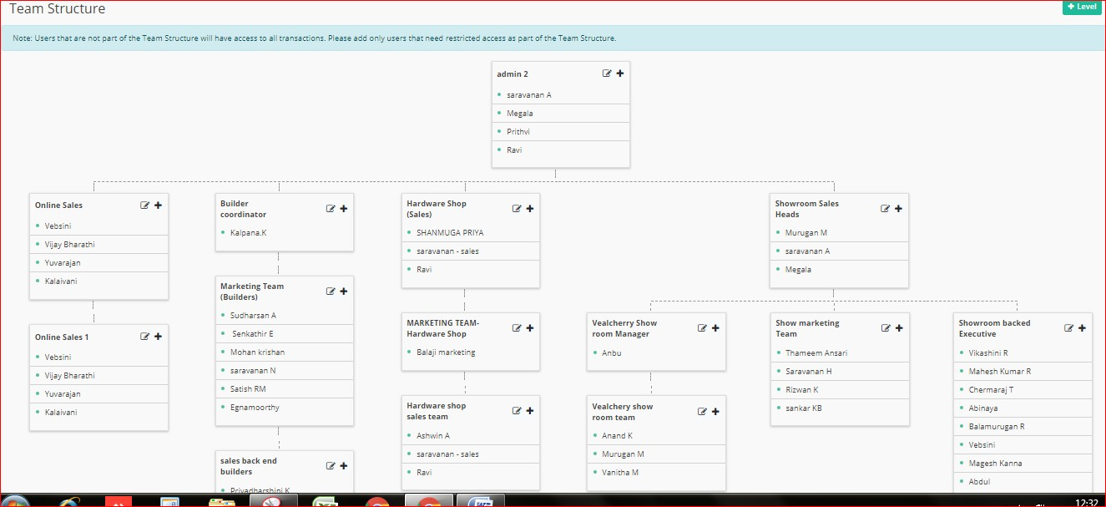TEAM STRUCTURE

# DEALING BRANDS

1. **HINDWARE**
2. **NEOM TILES**
3. **MALWA TILES**
4. **QUEO**
5. **ALCYMI**
6. **KOHLER**
7. **GROHE**
8. **JAQUAR**
9. **AMORE**
10. **AQUANT**
11. **VIKING**
12. **WATER MAN**
13. **ZERO-B**
14. **PRINCE**
15. **ASTRAL**
16. **CRI PUMP**
17. **KAMAL**
18. **GEBRIT**
19. **CARRYSIL SINK**
20. **HINDWARE SINK**
21. **PRIINCE SINK**
22. **FUTURA SINK**

JOB DESCRIPTION:

1. **Handled Sales Team & Customers operation**
2. **Interact with Vendors to growth and business dealing**
3. **Interact with vendors conducted training weekly base as on subject**
4. **Preparing repots and share Chairman**
5. **Coordinate with builder team to assigned orders**
6. **Coordinate with marketing team to check daliybase vist architect**
7. **Coordinate with purchase team to put orders as per balance**
8. **Coordinate with purchase team to check re order level**
9. **Identify slow moving items to sales and give more incentive**
10. **Preparing monthly incentive sheet**
11. **Coordinate with store to plan delivery and check stock**

Responsibilities:.

1. **To maintain competitive edge formed by strategic association with key business partners**
2. **Coordinate with Purchase to arrange Stock process**
3. **Coordinate with Edp to and maintain stock .**
4. **Coordinate with PA to make Stock Indent .**
5. **Coordinate with CRE to make Month store Target as Last year target Increase 30% .**
6. **Responsible for achieving Sales target and analyze yearly comparison for Company Growth .**
7. **Arrange Monthly Meeting Store manager level .And Sales Staff, Company Boss**
8. **Conducted monthly meeting Manager level for advertisement and budget planning .**
9. **Preparing Yearly sales Plan and Monthly plan based on last Year Growth Report**
10. **Discussed with Boss Preparing production target based on volume .**
11. **Maintain Market share and as per company norms .**
12. **Preparing 30days Plan Report**
13. **Preparing Preparing MBPR.**
14. **Preparing QC1,QC2,QC3QC4 Planning Report**

Work Experience:

Company : Tvh Consumer Pvt Ltd ( Personal Space & Akshara)

Work Experience : From Jan 2022 – Still

Designation : Retail Sales Head

# DEALING BRANDS

1. **TOTO**
2. **GROHE**
3. **HANS GROHE**
4. **DURAVIT**
5. **FIMA**
6. **DONEBRACKET**
7. **FANTANI**
8. **SCHELL**
9. **VIEGA**

JOB DESCRIPTION:

1. **Handled Sales Team & Customers operation**
2. **Interact with Vendors to growth and business dealing**
3. **Interact with vendors conducted training weekly base as on subject**
4. **Preparing repots and share Chairman**
5. **Coordinate with builder team to assigned orders**
6. **Coordinate with marketing team to check daliybase vist architect**
7. **Coordinate with purchase team to put orders as per balance**
8. **Coordinate with purchase team to check re order level**
9. **Identify slow moving items to sales and give more incentive**
10. **Preparing monthly incentive sheet**
11. **Coordinate with store to plan delivery and check stock**

Responsibilities:.

1. **To maintain competitive edge formed by strategic association with key business partners**
2. **Coordinate with Purchase to arrange Stock process**
3. **Coordinate with Edp to and maintain stock .**
4. **Coordinate with PA to make Stock Indent .**
5. **Coordinate with CRE to make Month store Target as Last year target Increase 30% .**
6. **Responsible for achieving Sales target and analyze yearly comparison for Company Growth .**
7. **Arrange Monthly Meeting Store manager level .And Sales Staff, Company Boss**
8. **Conducted monthly meeting Manager level for advertisement and budget planning .**
9. **Preparing Yearly sales Plan and Monthly plan based on last Year Growth Report**
10. **Discussed with Boss Preparing production target based on volume .**
11. **Maintain Market share and as per company norms .**
12. **Preparing 30days Plan Report**
13. **Preparing Preparing MBPR.**
14. **Preparing QC1,QC2,QC3QC4 Planning Report**

PERSONAL INFORMATION:

Date of Birth : 27-05-1985

Sex : Male

Marital Status : Married

Nationality : Indian

Languages Known : English, Tamil, Hindi, and Malayalam Strengths : Committed, Team Player, Dedicated.

Hobbies : Social working, Surfing net & networking people

ACADEMIC PROFILE:

* **2009 MBA From University Of Madras**
* **2007 BA From Voorish College Vellore (Thiruvalluvar University)**
* **2004 XII From Govt Boys Higher Secondary School, Katpadi**

I hereby declare the information given above is true to my best of knowledge

AUTHENTICALLY,

(A.SARAVANAN)