G.BALAJI 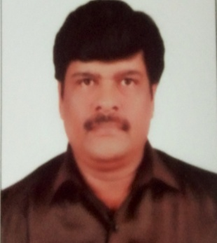

Phone: 8939669568

[E.Mail:argbalaji@gmail.com](mailto:argbalaji@gmail.com)

# Objectives:

To be productive for the organization, by extending personal goals to align myself with the organizational goals and work for the betterment.

# Work summary:

Over 23 years of professional experience extensively in marketing and Admin activities.

# Educational Qualification:

B.A .co-operation

# Professional Experience:

# JUPITER AQUA LINES LTD (Manufacturing of JAL faucets & Fittings)

# Period: from FEB 2022’

# Position: AREA SALES MANAGER

# Responsibility: Appointing Distributors, Dealers, Projects

# M V GROUP OF COMPANIES (Distributors for ASTRAL CPVC UPVC PVC Pipes)

# Period: from Aug ‘2020 to JAN ‘2022

# Position: MARKETING MANAGER

# Responsibility: MEETING Dealers, Sub-dealers, Plumbing Contractors.

1. **KOHLER (WHITEROSE CONCEPTS)** (Exclusive for KOHLER Taps, sanitary wares & Kajaria)

**Period:** from 2018 to July 2020

# Position: MARKETING MANAGER

**Responsibility**: Meeting Architects, Builders, Plumbing contractors.

1. **AQUA EXCEL** (Manufacturing of CPVC UPVC PVC Pipes)

**Period:** Feb ‘2017 to 2018

# Position: BDM

**Responsibility**: (Appointing dealers sub-dealers and meeting contractors)

1. **NEYCER INDIA LTD: (**Manufacturing of Sanitrarywares)

**Period:** Dec ‘2013 to Jan’ 2017

# Position: BDM

**Responsibility:** Meeting distributors, Dealers, Sub-dealers, Builders

Plumbing Contractors.

1. **DANUSH ENTERPRISES PVT LTD**. (Distributors for Branded Vitrified tiles)

**Period:** Jan**’**2000 to NOV ‘2012

# Position: Manager show room – SALES.

**Responsibility:** Managing showroom sales, Contact Dealers

**Sub-**dealers, Architects.

1. **VAIGAI SANITATION PVT LTD.** (Distributors for Branded Vitrified tiles)

**Period:** 1998 to 1999

# Position: Sales officer.

**Responsibility:** Attending the customers, architects, builders in the showroom & close the sales.

# PERSONAL DETAILS

**Father Name:** A.R. Govindasamy

**Date of Birth:** 24-04-1975

**Languages Known:** Tamil, English, and Telugu.

**Address:** 5, Leela Nagar, East-

Tambaram, Chennai-600059

# Declaration:

I do hereby declare that the information given in this form is true to the best of my knowledge and belief.

**NOTE:**

1. Projects done in **KOHLER** (White Rose) = Supplied **Kohler taps & Sanitarywares,kajaria**

Vitrified Tiles for **Actor Surya Office**, Year

2020, value 8.4 lacs

1. Projects done in **NEYCER INDIA** LTD = Supplied 0rrisa Pan ICF Railways.( Integral

Coach Factory) Year 2014 = 920 nos. value

7, lacs

1. Projects done in **Danush Enterprises Pvt Ltd** = Supplied **Ozar bathroom taps & Fittings**

For **JC Residency 5star Hotel in kodaikanal**

Value 4.7 lacs. Year 2006.

&

Supplied Vitrified tiles, Wall tiles, Parking Tiles

For SRI RENGA NURSING HOME Chengalpattu

Tamil Nadu Value 5.3 Lacs year 2006