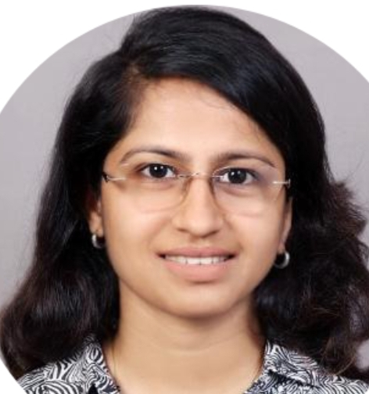 **POOJA K. NABAR**

**E-mail:** poojanabar125@gmail.com

**Phone:** +91-9920752141

**LinkedIn:** https://www.linkedin.com/in/pooja-rao-6a0262a2/

Result-driven professional with a verifiable track record targeting assignments in **Sales & Marketing**

**Location Preference:** Goa

|  |  |  |
| --- | --- | --- |
| **CORE COMPETENCIES**  **Creativity**  **Business Development**  **Client Relationship Management**  **Product Promotions**  **Lead Generation/Management**  **Market Research (Trade & Consumer)**  **Industry Interface and Relationships**  **Knowledge Management** |  | **PROFILE SUMMARY**   * Achievement-driven professional with experience of **over 5 years** * **Maharashtra state board scholarship holder** of 4th & 7th std scholarships. * Received a **gold-medal** for the final year project Innovative Packaging for Jaggery in Printing & Packaging PG course * Created interest in products and services, generated new business leads and arranged meetings through effective cold calling * Displayed efficiency in gathering market and customer information to enable negotiations regarding variations in prices, delivery and customer specifications to the management * Proficient at maintaining cordial relationship with customers, ensuring quality and service norms to achieve customer satisfaction and business retention * Conducted market research through industry contacts, trade events and tracked business news to identify ideas for growth * An effective communicator with strong analytical, problem-solving & organizational capabilities |

**ORGANIZATIONAL EXPERIENCE**

**Since Mar ’16 – Jan ’20 with Marshal’s Wallcoverings, as Assistant Manager.**

**May ’15 – Mar ’16 with Muraspec Wallcovering Pvt. Ltd., as Sales Executive**

**Key Result Areas:**

* Identifying new markets and business opportunities, tracking sales and sending out reports
* Monitoring sales, supporting the management in all decisions, and ensuring a high level of competitiveness for the brand in the market
* Mapping business needs and tailoring solutions using all relevant products and solutions, drawing on expert internal resources as required for promoting the Brand
* Developing effective working relationships with Architects, Interior Designers, PMC’s, Corporate, Developers and Interior Contracting Firms through regular meetings; identifying and obtaining further sales and business development opportunities & increasing customer base

**INTERNSHIPS**

**Title:** Feasibility Studies & Franchise Strategy of **Amul Ice Cream Parlours**

**Organization:** Gujarat Cooperative Milk Marketing Federation Ltd. (GCMMF), AMUL

**Duration:** 2 Months

**Role:** Market Research Executive

**Description:**

* Primary market research on the new launches of Amul Ice Cream: Flaavyo Yoghurt & Sugar Free Ice Cream
* Comparative studies of AMUL scooping parlour with the competitor brands in market

**Title:** Packaging Course Internship

**Organization:** Hexagon Nutrition

**Duration:** 6 Months

**Role:** Purchase Executive

**Description:** Played a key role while working as an assistant to the Purchase Manager

**ACADEMIC PROJECTS**

**Title:** shoppazy.com (e-Marketing Website)

**Duration:** 6 Months

**Description:** Targeted achievement of enrolments of fashion Jewellery/Clothing shops on a shopping portal

**Title:** CSR Project in **RPG Ltd.**

**Description:** Education sector project to study & make report on better ways to manage the technical schools sponsored by RPG Enterprise

**ACADEMIC DETAILS**

* MBA (Marketing) from Indian Education Society’s Management College and Research Centre, in 2014
* PG in Printing & Packaging from SIES, in 2011
* B.Sc.(Chem.) from JSM College, in 2009

ADDIONAL CERTIFICATES

**British Counsel Spoken English course** intermediate Module1 & 2

**ACADEMIC POSITIONS OF RESPONSIBILITY**

* Member of MBA college marketing club ‘Market Makerz’

**SOCIAL ENGAGEMENTS**

* Active for Environment related causes like **Save Aarey movement**
* Write-ups about social causes like gender equality published in regional news paper ‘Maharashtra times’

**EXTRACURRICULAR ACTIVITIES**

* Participated in various theme rangoli making events

**PERSONAL DETAILS**

**Date of Birth:** 12th May 1988

**Languages Known:** English, Hindi & Marathi

**Address:** ‘Vrundavan’, bunglow, Nabar wadi, Shiroda, Vengurla, Sindhudurg 416518