**SAKTHI MURUGAN S**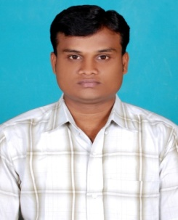

33/17,South Street,

Pennadam Road,

Vriddhachalam Taluk,

Cuddalore (Dist)

Tamil Nadu. Pin-606001

[sakthibtechit@yahoo.com](mailto:sakthibtechit@yahoo.com)

+91 99527 77705

**___________________________________________________________________________**

**OBJECTIVE :**

To pursue an intellectual career and looking for a dynamic position, where my skills and application knowledge can be innovated and utilized for the success of an organization.

**ACADEMIC PROFILE:**

* **Bsc Computer Science** with batch of 2015 - CDE,Bharathidasan University,Trichy.
* **HSC** with 64% in the batch of 2007 - Sri Saraswathi Vidhyalaya Matriculation Higher Secondary School. Vriddhachalam.
* **SSLC** with 63% in the batch of 2005 - Sri Saraswathi Vidhyalaya Matriculation Higher Secondary School. Vriddhachalam.
* **VALUE ADDED COURSE: GOLD APPRAISER,** Thiagarajar Polytechnic College,Salem.

**TECHNICAL:**

* **Operating System** : Windows XP, Windows 7, Windows 8
* **Languages** : C, C++, HTML. **Application** : .net framework

**PROJECT:** **Hairais:** A Method For Automatic Image Registration Through Histogram-based Image Segmentation**.**

**PERSONAL DETAILS:**

**Date of Birth :** 20.12.1989 **Father’s Name :** Mr. A. Shanmugam

**Languages Known :** English, Tamil **Sex :** Male

**REFERENCE:**

* **Mr.Joe Arunraja** HOD of I.T Department,

A.C.T College of Engineering and Technology,

Anna university, Maduranthagam Taluk, Kanchepuram Dist.

**DECLARATION:** I hereby assure that the details given above are true to the best of my knowledge. I assure that I will discharge the given duties to the atmost satisfaction of my superiors.

**DATE : (S.SAKTHI MURUGAN)**