**RESUME**

**PERSONAL DETAILS** 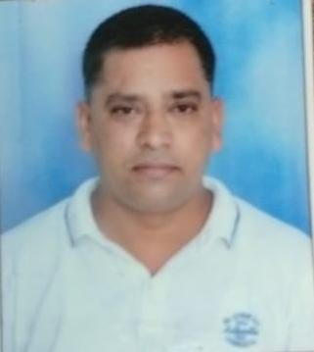

**NAME: VIVEK ANAND PANDEY**

**ADD: L.G 101-4/8 INDRA NAGAR**

**SUNDER BAUG**

**LBS LANE. KAMANI KURLA (W)**

**MUMBAI. PINCODE: 400070**

**SEX: MALE**

**MATIAL STATUS: MARRIED**

**DATE OF BIRTH: 31ST JANUARY 1984**

**CONTACT: 9022313774**

**Email: vivekpandey668441@gmail.com**

**OBJECTIVE**

I am looking forward to a challenging work environment where my accountability & management abilities can be used to the maximum potential and where there is scope for enhancement of my Professional skills.

**WORK EXPERIENCE**

**Company**: Bhavesh Glass House

**Place**: Rajkot Gujarat.

**Position**: Sales & Marketing Manager, Quality Control, Product.

**Working** **State**- Karnataka, A.P Tamil Nadu, Kerala, Telangana, Kolkata, Bhubaneswar, Guwahati.

**Year**: - 1st November 2018 to 30th June 2022.

**Note** – Worked almost city in above states.

**Company:** Brijbasi Art press ltd.

**Place:** Delhi

**Position:** Sales & Marketing Manager

**Year**: - Between 20th March 2014 to 31st October 2018.

**Working** **State**- Karnataka, A.P Tamil Nadu, Kerala, Telangana, U.P Panjab,

**Company:** Lion India picture & Frames

**Place**: Mumbai Goregaon

**Position**: Sales & Marketing (Coordinator Manager)

**Working** **State**: Mumbai, Maharashtra, Gujrat.

**Year:** 26th July 2010 to 31st March 2013

**Note: I Received Best Sales executive Award in 2011**

**Company:** Oxford Moulding

**Place:** Mumbai Andheri

**Position:** Marketingexecutive

**Working** **State:** M.P U. PKarnataka, A.P

**EDUCATION**

**MARCH 2005: Bachelor Degree of Arts from Dr. R.M.L AVADH University**

**2003: Finished senior Highschool**

**2000: 10th pass**

**Strengths:** **Time work**

Effective teamwork comes in many shapes and sizes and has Significant impact

on the success of the organization.

**Willingness to learn:** New technology and knowledge come out all the time, an organization and systems

change. Whoever does not learn risk staying behind, no Matter their

accumulated knowledge or position.

**Communication:** Being skill in communication does not mean you have to be grate with words or

even really sophisticated and eloquent. You need to be able to clearly get your

message across, in verbal or written speech.

**Self-motivation**: It’s the way you feel and think about yourself, including your expectation and believe

about what is possible for you one experience holder person has confidence in

himself gains the confidence of others

**Hobbies:** Reading business magazine, watching action movies & sports.

Vivek Pandey Date:-

Place: - Delhi