**CURRICULAM VITAE**

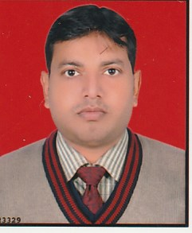

**HIMANSHU SRIVASTAVA**

**486/70 Station Road, Daliganj**

**Lucknow.**

**PIN NO.226020**

**Contact No**. 9956888012, 9559709076

Email-him_srivastava888@rediffmail.com

**CAREER OBJECTIVE:-**

To obtain a career position where. I am fully utilizing my education, experience & personal abilities while contributing to the benefit of my employer.

**PERSONAL INFORMATION:-**

Father’s Name : Shri. A.K. Srivastava

Date of Birth : 15/10/1984

Language Known : Hindi & English

Nationality : Indian

Gender : Male

Marital : Married

**ACADEMIC QUALIFICATION:-**

* High School from U.P Board in the Year of 2001
* Intermediate from U.P Board in the Year of 2003
* B.SC (Z.B.C) from Lucknow university in the year of 2007

**PROFESSIONAL QUALIFICATION:-**

* M.B.A from H.B.T.I, Kanpur in the year of 2010 with specialization marketing & finance.
* Basic knowledge of computer (MS-office).

**STRENGTH :**

* Ability to absorb knowledge and express thoughts with clarity and confidence.
* Strong Technical skills and ability to understand new requirements.
* Zeal to accept work related challenges, dedication towards work.
* Pragmatic, self- motivated and a good team player.
* Good interpersonal skill and analytical skills.

**WORK EXPERIENCE:-**

* 1 year experience in A.R. Realty Associate as Sale Executive in the year of Aug 2010 to Sep.2011
* 2 year experience in V.R.S. Food Limited as Sale Executive in the year of Oct. 2011 to Aug 2013.
* 3 years experience in Elan Pharma(India) Pvt. Limited as Medical Representative in the year of Oct.2013 to Aug 2016.
* 3 years experience in Innovcare Life Science (I) PVT. Limited as Medical Associate in year of Sep 2016 to Sep 2019.
* Currently, I am working in Portea Health care (p) Ltd (Ostomy and Respiratory- surgical & equipment div). As Business development officer.

**DECLARATION:-**

All the above mentioned details are true to the best of my knowledge and understanding.

Date:-..................

Place: - LUCKNOW Signature

(**HIMANSHU SRIVASTAVA**)