**OUTPUTS :**

**WHEN WE RUN THE PYTHON PROGRAM FILE :-**

Name : PARTH SINGH

##----PYTHON & MySQL DATABASE MANAGEMENT----##

Project Name : "COLLEGE ADMISSION SYSTEM"

#-----MENU-----#

1-CREATE DATABASE

2-SHOW DATABASE

3-CREATE TABLE

4-SHOW TABLES

5-DESC TABLE

6-INSERT DYNAMICALLY

7-SELECT QUERY

8-WHERE CLAUSE

9-SEARCH AND DISPLAY

10-UPDATE FEES

11-DELETE

12-EXIT

Enter your choice :

**WHEN USER CHOOSE 1 FROM THE MENU :-**

Enter your choice : 1

Database created : 'college'

**THEN AFTER EVERY TASK CHOOSED BY THE USER FROM THE MENU PROGRAM RE-PRINT THE MENU :-**

#-----MENU-----#

1-CREATE DATABASE

2-SHOW DATABASE

3-CREATE TABLE

4-SHOW TABLES

5-DESC TABLE

6-INSERT DYNAMICALLY

7-SELECT QUERY

8-WHERE CLAUSE

9-SEARCH AND DISPLAY

10-UPDATE FEES

11-DELETE

12-EXIT

**WHEN USER CHOOSE 2 FROM THE MENU :-**

Enter your choice : 2

('college',)

('information_schema',)

('mysql',)

('performance_schema',)

('python',)

('sys',)

**WHEN USER CHOOSE 3 FROM THE MENU :-**

Enter your choice : 3

Table created : 'student'

**WHEN USER CHOOSE 4 FROM THE MENU :-**

Enter your choice : 4

('student',)

**WHEN USER CHOOSE 5 FROM THE MENU :-**

Enter your choice : 5

('ADMNO', 'int', 'YES', '', None, '')

('NAME', 'varchar(20)', 'YES', '', None, '')

('COURSE', 'varchar(5)', 'YES', '', None, '')

('FEES', 'int', 'YES', '', None, '')

**WHEN USER CHOOSE 6 FROM THE MENU :-**

Enter your choice : 6

Enter how many record you want to insert : 4

Enter student's admission number : 100

Enter student's name : parth

Enter Your Course (BCA,BBA,BCOM,BTECH) : bca

Enter course's fees : 5000

Enter student's admission number : 101

Enter student's name : tejas

Enter Your Course (BCA,BBA,BCOM,BTECH) : bba

Enter course's fees : 6000

Enter student's admission number : 102

Enter student's name : madhu

Enter Your Course (BCA,BBA,BCOM,BTECH) : bcom

Enter course's fees : 7000

Enter student's admission number : 104

Enter student's name : nitul

Enter Your Course (BCA,BBA,BCOM,BTECH) : btech

Enter course's fees : 8000

RECORD IS INSERTED

**WHEN USER CHOOSE 7 FROM THE MENU :-**

Enter your choice : 7

(100, 'parth', 'bca', 5000)

(101, 'tejas', 'bba', 6000)

(102, 'madhu', 'bcom', 7000)

(104, 'nitul', 'btech', 8000)

**WHEN USER CHOOSE 8 FROM THE MENU :-**

Enter your choice : 8

1-BCA

2-BBA

3-BCOM

4-BTECH

Enter your choice (1,2,3,4) : 1

total no of rows : 1

(100, 'parth', 'bca', 5000)

**WHEN USER CHOOSE 9 FROM THE MENU :-**

Enter your choice : 9

Enter name to search : madhu

(102, 'madhu', 'bcom', 7000)

**WHEN USER CHOOSE 10 FROM THE MENU :-**

Enter your choice : 10

1-BCA

2-BBA

3-BCOM

4-BTECH

Enter your choice (1,2,3,4) : 2

(101, 'tejas', 'bba', 2000)

1 FEES IS UPDATED

**WHEN USER CHOOSE 11 FROM THE MENU :-**

Enter your choice : 11

1-BCA

2-BBA

3-BCOM

4-BTECH

Enter your choice (1,2,3,4) : 3

1 Record is deleted where course is BCOM

**WHEN USER CHOOSE 12 FROM THE MENU :-**

Enter your choice : 12

PROGRAM EXITED

**OUTPUTS :**

**OUTPUTS IN MYSQL PROGRAM :-**

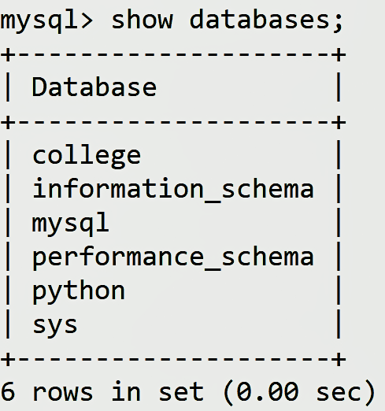 1.

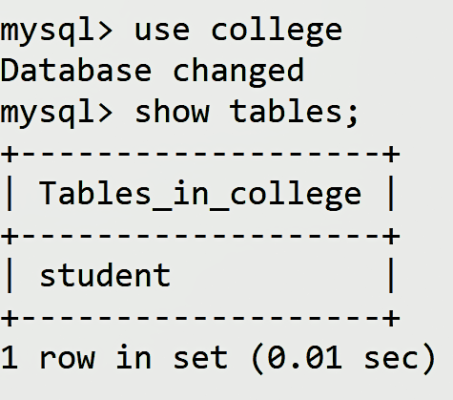 2.

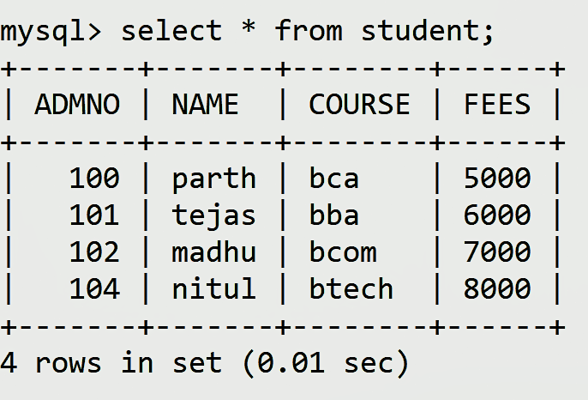 3.

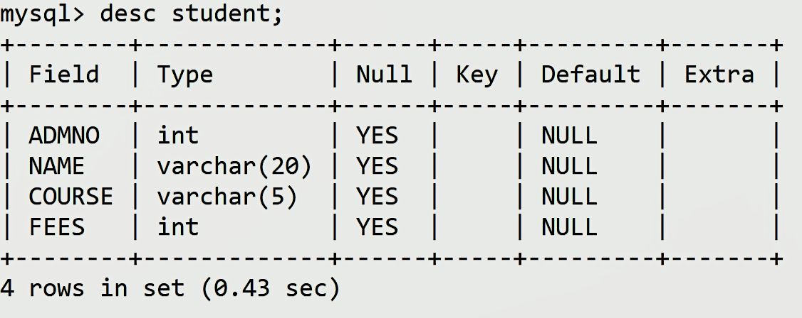 4.