Selection Guide
Part No. | Emitting Color
WLBGR3528C/R | Red、Blue、Green

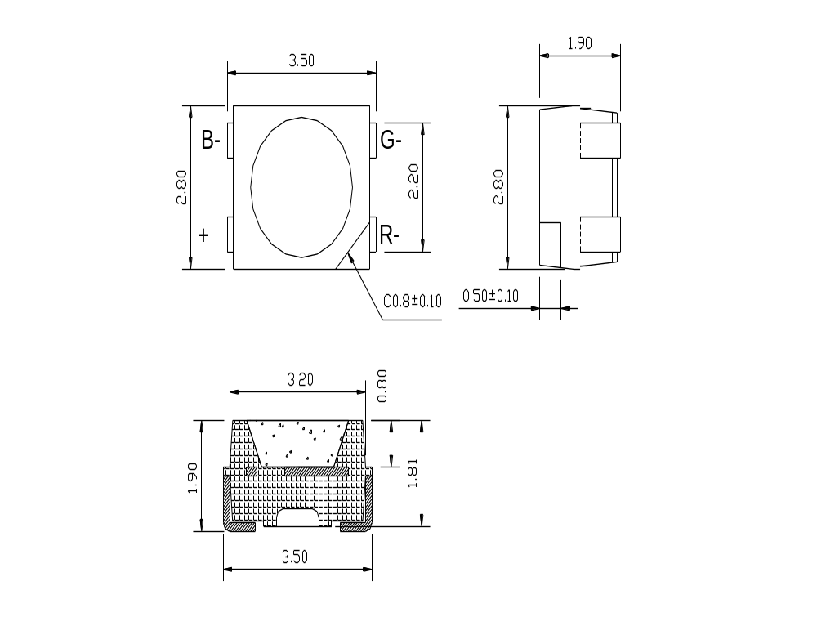Package Dimensions

Notes:
1. All dimensions are in mm.
2. Tolerance is ±0.25mm unless otherwise noted..

Features
- PLCC LED dimensions:3.5(L)×2.8(V)×1.9(H)
- High intensity
- Extremely wide view angle
- Anti-electrostatic tape package
- Reliable and stable

Absolute Maximum Rating at Ta=25℃

parameter | Max. | unit
Peak Forward Current(1/10 Duty Cycle,0.1ms Pulse Width) | 50 | Ma
Continuous Forward Current | 20 | Ma
Reverse voltage | 5 | v
Operating temperature range | -25℃to+85℃
Storage temperature range | -40℃to+100℃
Lead soldering temperature | 260℃ for 3 seconds
Note:It can not be exceeded 5 seconds while applying in peak forward current circumstance unless it has special heat dispersion design.

Electrical Optical Characteris tics at Ta=25℃
Parameter | Symbol |  | Min. | Typ. | Max. | Unit | Test condition
Luminous Intensity | Iv | B | 200 | --- | 300 | mcd | IF= 20mA
Luminous Intensity | Iv | G | 800 |  | 1000 | mcd | IF= 20mA
Luminous Intensity | Iv | R | 100 | --- | 200 | mcd | IF= 20mA
Wavelength | λ | B | --- | 470 | --- | nm | IF= 20mA
Wavelength | λ | G | --- | 525 | --- | nm | IF= 20mA
Wavelength | λ | R | --- | 625 | --- | nm | IF= 20mA
Viewing Angle | 2θ1/2 |  | --- | 120 | --- | Deg | IF= 20mA
Forward Voltage | VF | B | 3.0 | --- | 3.5 | V | IF= 20mA
Forward Voltage | VF | G | 3.0 | --- | 3.5 | V | IF= 20mA
Forward Voltage | VF | R | 1.8 | --- | 2.4 | V | IF= 20mA
Reverse Current | IR |  | --- | --- | 10 | μA | VR=5V

Notes:
- all dimensions are in millimeter.tolerance is±0.25mm(.01″)unless others otherwise noted.
- EB maintains a tolerance of±10% on flux and power measurements.
- CCT ±5% te ster tolerance and λd±1nm
- A tolerance of ±0.1V on forward voltage measurements
- View Angle maintains a tolerance of±20°
- Specifications are subject to change without notice.
- These products are sensitive to static electricity;high standard of care must be fully taken when handling them.Particularly if an over-voltage that exceeds the Absolute maximum Rating of these products.Buyer shall take absolute secure countermeasures against static electricity and surge when handling these products
- Luminous intensity is measured with a light sensor and filter combination that approximates the CIE eye-response curve.θ1/2 is the off-axis angle at which the luminous intensity is half the axial luminous intensity.
- It use many parameters that correspond to the CIE1931 2°
X,Y,and Z are CIE 1931 2°values of Red,green and Blue content of the measurement.
10.Brightness rank is 1:1.2 for sorting.

Typical electrical/optical characteristic curves

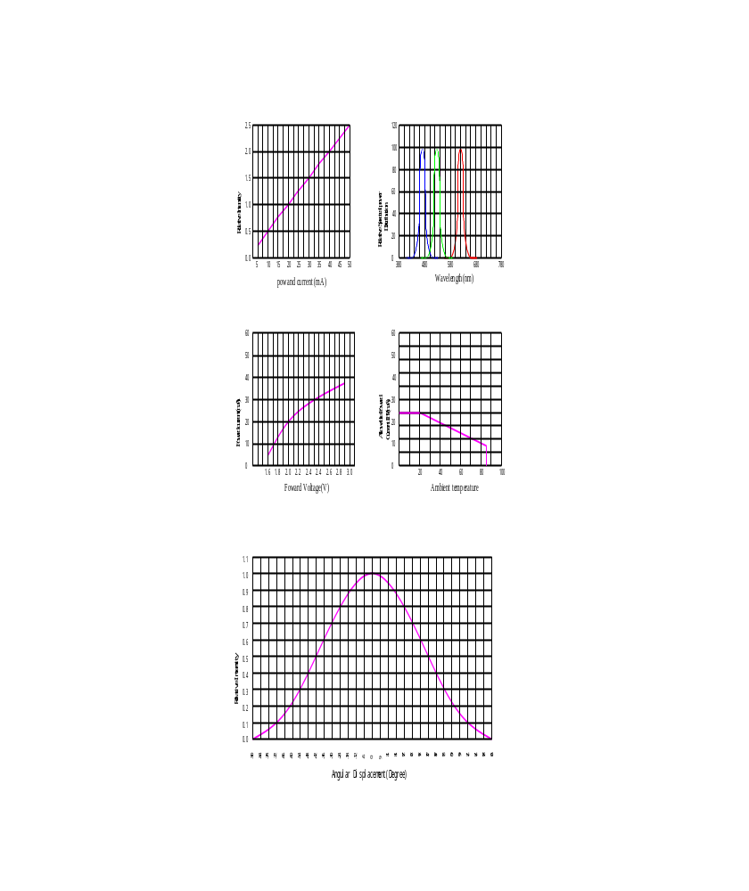

Soldering condition
Reflow Soldering |  |  | Hand Soldering
 | Lead Solder | Lead – free Solder
Pre-heat | 120~150℃ | 180~200℃ | Temperature | 350℃ Max.
Pre-heat time | 120sec. Max. | 120sec. Max. | Soldering time | 3sec. Max.  (one time only)
Peak temperature | 240℃ Max. | 260℃ Max. | Soldering time | 3sec. Max.  (one time only)
Soldering time | 10sec. Max. | 10sec. Max. | Soldering time | 3sec. Max.  (one time only)
Condition | refer to  Temperature-  Profile 1 | refer to  Temperature-  Profile 2 | Soldering time | 3sec. Max.  (one time only)
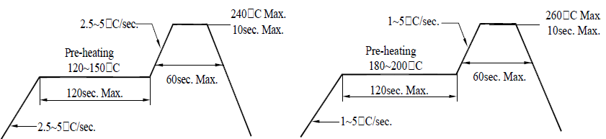
Temperature profile in re-flow machine for lead type and lead free type

1. Reliability test
1.1. N.A.
2. Storage condition:
In order to avoid the absorption of moisture, it is recommended to store in the dry box (or desiccators) with a desiccant. Otherwise, to store them in the following environment is recommended. Temperature: 5℃~30℃ Humidity: 60%HR max.

Dimension of carrier tape
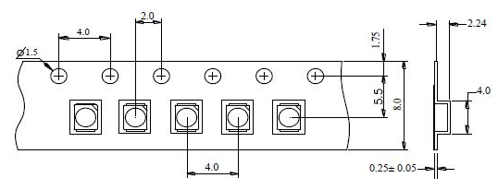

Dimension of reel
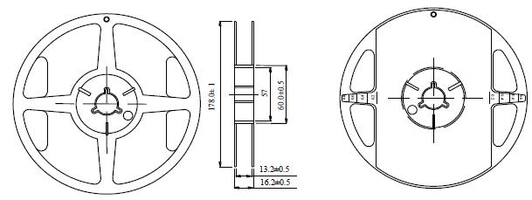

Notes:
1. All dimensions are in mm, tolerance is±2.0mm unless otherwise noted.
2. Specifications are subject to change without notice.

Packing
1. Number of SMD 5050 product in reel and bag(anti-static bag)
1.1. 2000 piece of SMD 3528 Products on one reel. The reel will be put in the anti-static bag, then sealed.
1.2. 2000 piece of SMD 3528 products on one bag.

