Approval Sheet

Customer：

Item： TOP VIEW LEDS

Part No.: WLUB0603A-341

Customer P/N:

PREPARED BY | CHECKED BY | APPROVED BY |  | SIGNATURE | CHECKED BY | APPROVED BY

供方签章： 客户签章：
SUOOLIER： CUSTOMER：

日期： 日期：
DATE： DATE：

备注：承认签章后请回复一份（或复印件）给我公司，其余由贵司留作存盘。如果在签章的承认书（或复印件）回复我司之前，下了有关此零件的订单且又无特殊说明，那么我司就确定贵司已完全承认。
Please return one specification or one copy of it with your chop and signature of approval and retain the others for your record.In the event of an order being placed for this part number before the chop and signed with specification (or copy) is returnde and without special explanation,it will be assumed that full approval have been given.

TYPE NO: WLUB0603A-341

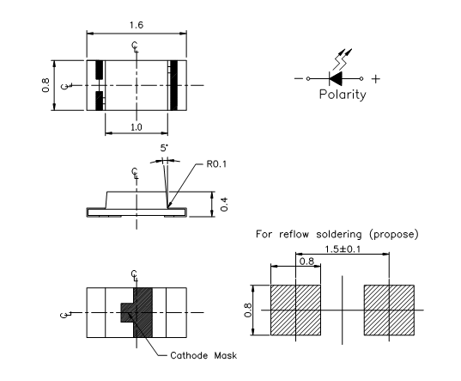 PACKAGE DIMENSIONS

Note:
1. All Dimensions are in millimeters
2. Tolerance is ±0.1mm Unless otherwise specified.

Device Selection Guide
Emitting Color | Lens Type
Blue | Water clear
Absolute Maximum Ratings at Ta=25℃
Parameter | Symbol | Max | Unit
Power Dissipation | P_{d} | 100 | mW
Peak Forward Current  1/10 Duty Cycle,0.1ms Pulse Width | I_{FP} | 100 | mA
Forward Current | I_{F} | 30 | mA
Reverse Voltage | V_{R} | 5 | V
Operating Temperature Range | Topr | -40℃ to+100℃
Storage Temperature Range | Tstg | -40℃ to+110℃
Lead Soldering Temperature  【3mm From Body】 | Tsol | 260℃ For 5 Seconds
Electrical Optical Characteristics at Ta=25℃
Parameter | Symbol | Min | Typ | Max | Unit | Condition
Forward Voltage | VF | 2.9 | --- | 3.5 | V | IF=20mA
Luminous Intensity | IV | 30 | 80 | ---- | mcd | IF=20mA
Dominant Wavelength | λd | 465 | --- | 475 | nm | IF=20mA
Reverse Current | IR | / | / | 10 | μA | VR=5V
Viewing Angle | 2θ1/2 | / | 120 | / | deg | IF=20mA

Note.
1.Tolerance of Luminous Intensity:11%
2.Tolerance of Dominant Wavelength:+1nm
3.Toleance of Forward Voltage:+0.1V

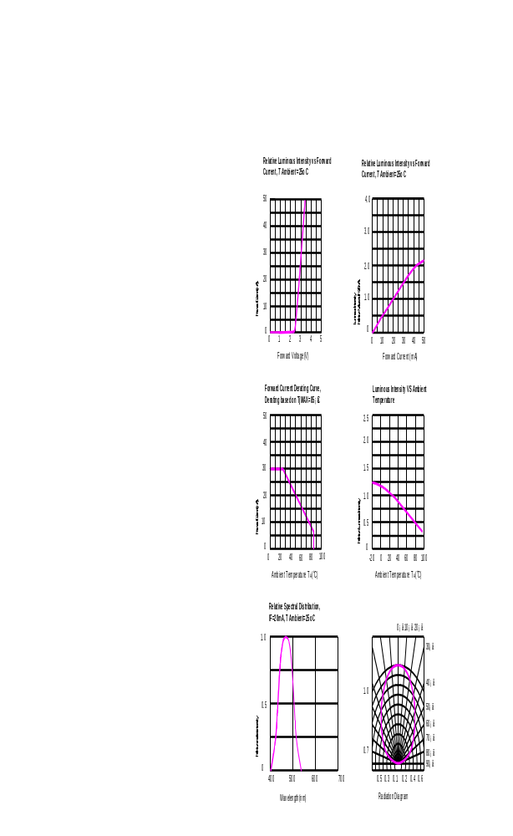Typical Electro-Optical Characteristics Curves

Soldering condition
Reflow Soldering |  |  | Hand Soldering
 | Lead Solder | Lead – free Solder
Pre-heat | 120~150℃ | 180~200℃ | Temperature | 350℃ Max.
Pre-heat time | 120sec. Max. | 120sec. Max. | Soldering time | 3sec. Max.  (one time only)
Peak temperature | 240℃ Max. | 260℃ Max. | Soldering time | 3sec. Max.  (one time only)
Soldering time | 10sec. Max. | 10sec. Max. | Soldering time | 3sec. Max.  (one time only)
Condition | refer to  Temperature-  Profile 1 | refer to  Temperature-  Profile 2 | Soldering time | 3sec. Max.  (one time only)

Temperature profile in re-flow machine for lead type and lead free type

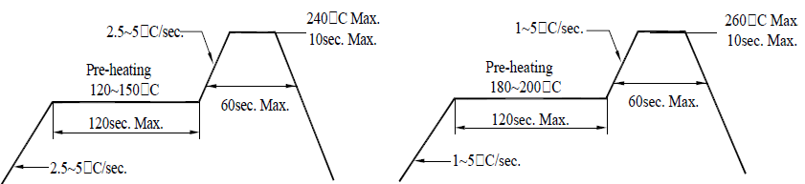

Dimension of carrier tape

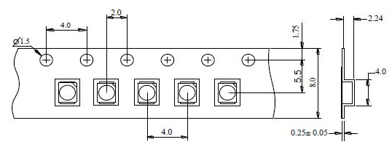

Dimension of reel
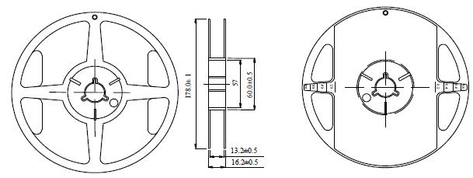

Notes:
- All dimensions are in mm, tolerance is±2.0mm unless otherwise noted.
- Specifications are subject to change without notice.

Packing
1. 2000 piece of SMD 3528 Products on one reel. The reel will be put in the anti-static bag, then sealed.
2. 2000 piece of SMD 3528 products on one bag.

