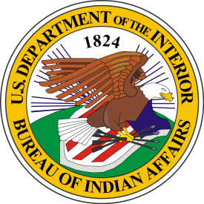
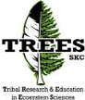
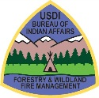

Pathways Program Eligibility and Requirements
- Enrolled in a Federally Recognized Tribe
(Submit a form BIA - 4432),
- Be at least 18 years of age,
- Enrolled or accepted full-time in an accredited college or university and seeking a degree in related academic program
- Completed at least 1 academic year of academic study
- A cumulative GPA of 2.0 or higher
- Ability to obtain and maintain a security clearance
- Service Agreements (Tuition)
- Maintain a valid Pathways Program Participant Agreement
Some positions may also require a Medical exam, Drug Testing, and a Driver License

Conversion Opportunities
To be eligible for non-competitive conversion into a full-time position within the BIA, Interns must:
- Complete at least 640 hours of work experience acquired through the Internship Program,
  - In rare cases, we waive up to 320 for Interns who demonstrate high potential as evidenced by outstanding academic achievement and exceptional job performance.
- Complete their degree or certificate requirements,
- Meet the OPM qualification standards for the position to which the Intern will be converted,
- Meet agency-specific requirements as specified in the Participant's Agreement, and
- Performed their job successfully.

TREES Program
BIA partners with the Salish Kootenai Tribal College’s Tribal Research and Education in Ecosystem Sciences (TREES) program to provide tuition subsistence, mentorship, recruitment and other logistical support.

For additional information:
Rachel Smith, Program Manager and Advisor
rachel_smith@skc.edu
406.275.4748 (office)
406.396.6735 (cell)

Office of Trust Services
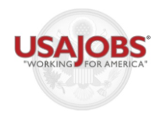


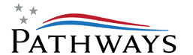
https://www.facebook.com/#!/BIAFWFM
https://www.facebook.com/SKCTREES

OTS Website
To find information on our Youth and Internship Program, please visit http://www.bia.gov/WhoWeAre/BIA/OTS/index.htm

Branch of Wildland Fire
http://www.bia.gov/nifc/index.htm

Where to look for OTS Pathways Internships
We are continuously recruiting to fill internships. We post ALL job opportunities for Pathways Internships on USAJOBS. https://www.usajobs.gov/studentsandgrads/

Careers for Native American and Alaska Native Students in

Natural Resource Management

in and for the

Make a

POSITIVE

DIFFERENCE
BIA

TRIBAL COMMUNITIES

WE SERVE

INTERNSHIP PROGRAM

Our Organization
The Bureau of Indian Affairs (BIA), Office of Trust Services’ (OTS), is committed to serving Tribal communities and their members by ensuring the activities associated with management and protection of trust and restricted lands; natural resources; forestry and wildland fire management; irrigation, power and safety of dams; and real estate services are improving tribal government infrastructures and communities, along with other components of long term sustainable development investments to improve the quality of life for their tribal members
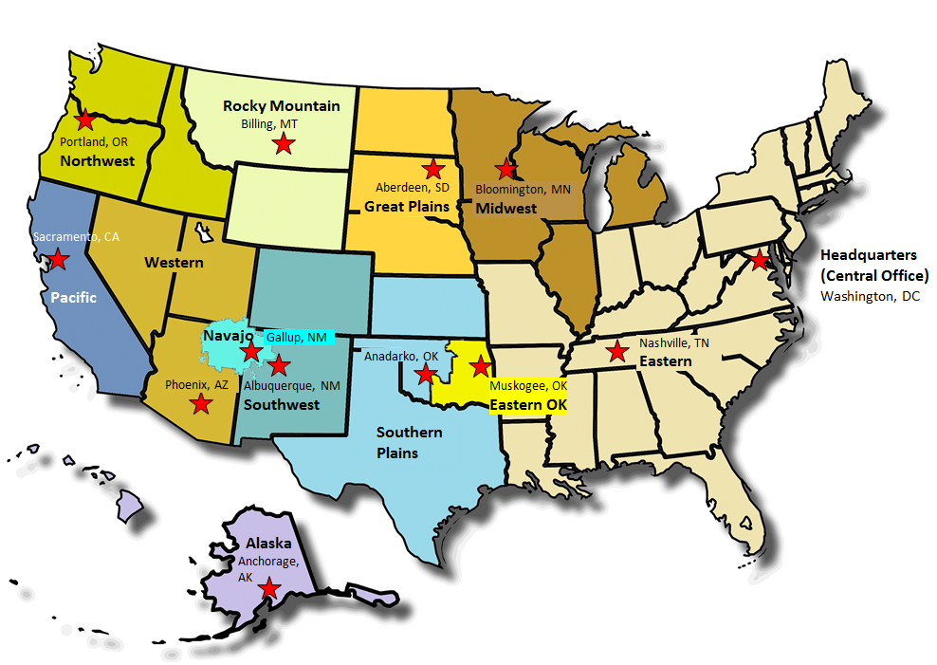

Pathways Internships
Our program offers internships for emerging leaders who are seeking degrees in natural resources management, forestry and other related environmental and biological science fields. This Program not only offers students paid employment, while they continue their education, but also gives them valuable and unique work experiences. We offer rotational summer assignments within different programs and work environments, where they can train and job shadow with industry professionals.

Under the Pathways program, there are two types of Internships.
- Annual Year Round (Career-Seasonal / Excepted Indefinite). Appointment duration is upon graduation.
- Traditional Summer Employment. Appointment normally is NTE 1 year or Term NTE 4 years.
Program Benefits (Career Conditional and temporary appointments that are more than one year)
- Up to $5,000 Tuition/education subsistence *,
- Paid Summer Employment – related to academic field of study, beginning $12-13.68 per hour,
- Full or part-time schedules,
- Travel and Rotational summer assignments Students are recruited nationally across Indian Country,
- Do not have to have prior work experience,
- Mentoring, training and career development opportunities,
- Vacation, Sick and Holiday Pay,
- Life Insurance, Flexible Spending Accounts, Health Benefits, and Retirement, and
- Potential for non-competitive placement after graduation into a permanent professional entry-level BIA or tribal position.
*Not all internships offer tuition support, some internships are for summer employment only

Top 3 Occupations
Technical: Forestry Technician, Miscellaneous Clerk and Assistant, and Engineering Technical
Professional: Natural Resources Management, Forestry, and Engineering
Administrative : Realty, Criminal Investigating, Miscellaneous Management and Program Analyst
Other White Collar: Police, Correctional Officer, and Various Student Trainee Occupations

Scientific, Technical, Engineering, and Mathematics (STEM)
The BIA has an unprecedented outreach initiative to target, attract and recruit American Indian and Alaskan Natives into professional, critical, and hard-to-fill occupations in scientific, engineering, mathematics, and natural resources disciplines.

BIA’s Occupational Demographics

Top 3 Categories
Technical: Forestry Technician, Miscellaneous Clerk and Assistant, and Engineering Technical
Professional: Natural Resources Management, Forestry, and Engineering
Administrative : Realty, Criminal Investigating, Miscellaneous Management and Program Analyst
Other White Collar: Police, Correctional Officer, and Various Student Trainee Occupations

Fast Fact: By the year 2025, 75% of the workforce will be millennials.

There are 56 million acres of trust lands and 45 million acres of land held by Native Alaskan state-chartered corporations.

The OTS has the following 7 Divisions:
- Natural Resources (Agriculture and Rangeland Management)
- Forestry and Wildland Fire Management
- Environmental and Cultural Resources
- Probate and Special Projects
- Land Titles and Records
- Water and Power
- Real Estate Services
- Head Quarters
- 12 Regional Offices
- 107 – Agencies/Field Offices
- 223 - Duty Locations
As 2013. Does it include Office of Justice Services

