Background on Strategy Map
June 10, 2011

The goal of the Baldrige Performance Excellence Program’s strategy map is to detail where we are going (vision) and how we are going to get there. Specifically, our destination is driven by our ability to achieve client, funder, and stakeholder outcomes. These outcomes are considered “lagging indicators” and result from “leading indicators”: the processes, people, and learning. The objectives that will populate this map create an upward chain of cause and effect, ultimately arriving at our vision as an organization.
At the top of the map is the Baldrige Program’s mission “to improve the performance and competitiveness of U.S. organizations in ways that enhance economic security and improve our quality of life.” Our goal will eventually be to determine a metric—perhaps an indexed, aggregated metric—that shows our achievement towards this mission.
At the bottom of the map are three strategic thrusts that comprise the mission: promote performance excellence, define performance excellence, and recognize performance excellence. All that we do should fall into one of these thrusts.

FUNDER/STAKEHOLDER PERSPECTIVE
DISCUSSION
Who Are Our Key Funders/Stakeholders
Unlike many organizations, the end users of our products and services are not the ones who provide program funding. We defined two tiers of funders/stakeholders:
- Tier 1 stakeholders are those who have direct influence over our funding and viability. Tier 1: White House, Congress, Office of Management and Budget (OMB), Department of Commerce (DOC), National Institute of Standards and Technology (NIST), and Foundation for the Malcolm Baldrige National Quality Award
- Tier 2 stakeholders and funders contribute “social capital” to the program and our efforts. Tier 2: Board of Overseers, Alliance for Performance Excellence
In January 2011, the program invited a representative sample of our funder/stakeholder community to a discussion at NIST. Members included NIST leaders, Award winners/examiners, state program/Alliance for Performance Excellence leaders, the American Society for Quality (ASQ), judges, overseers, and Foundation leaders. The purpose of the meeting was to solicit input on their requirements, which would inform our next steps in the strategy mapping process: specifically, what measurable impacts must we achieve to delight our funders/stakeholders (given our three strategic thrusts), as well as what they thought we must do for our customers (given our strategic goals and mission)?
During the meeting, we conducted an environmental scan of what they perceive to be the pressures, trends, challenges, and opportunities in their respective industries; explored the Baldrige value proposition; elicited their requirements of what we must do to be sustainable; and received some initial feedback on what we could stop doing in order to refocus energy and efforts in other more strategic areas (i.e., marketing, partnerships, and relationships). Group members did note, however, that they did not know all of our key processes and the amount of time, energy, and resources those consume in order to make the best decision about which ones to stop doing and which ones to expand. The information obtained from this meeting was then used as we went forward in building out the top two boxes of the strategy map.

IMPACTS WE MUST ACHIEVE:
“What measurable impacts must we achieve to satisfy our funders/stakeholders?”

The number-one impact we need to show to satisfy our funders/stakeholders is value to the country, with an aggregate value to customers. Value to the country might be expressed as a return on federal dollars or “social return to the country.” Other impacts we must achieve follow:

Broad Meaningful Use: We must be able to prove that the Baldrige Criteria and associated Baldrige Program tools are being used in a broad, meaningful way, which we defined as use across all sectors of the U.S. economy and with penetration into all markets of the economy. Broad, meaningful use also means sustained use and of value to stakeholders, with the Criteria embedded into organizations, and it includes use of the Criteria by Baldrige-based programs, such as the VA Carey Award.
We discussed how to define “use of Baldrige” and how we can know every instance of Baldrige use; we concluded that the behaviors that indicate use are that the organization has done something with the Criteria or associated tools and implemented Criteria thinking to some degree, even through a self-assessment. We understand that broad meaningful use might be the best impact to make our “government case” for Baldrige and may result in “volume-of-use” measures.

We began with the following potential measures but narrowed the list to proposed scorecard measures as follows:

Potential Measures

- Percentage of ISO 9000-certifed organizations using Baldrige
- Accredited organizations using Baldrige: This includes Joint Commission-accredited organizations, as well as organizations with education-based accreditations
- Dropout rate: This represents organizations at both the state and national level that either used the Criteria or applied for an award but then dropped out of the process
- Number of organizations that apply to the national program
- Number of organizations that apply to state/local Baldrige-based programs
- Number of Criteria downloads (see Reuse/Customer Loyalty/Long-term Engagement Measure below for discussion on this measure).
- Number of strategic partnerships/distributors
- Consultant data (possibly a count of the number of clients, not including names)
- NAICS codes, so that we can determine sector coverage

Proposed Scorecard Measures for Overseers’ Feedback

- Total relative use: This will be an aggregate measure that combines the number of applicants applying for the national, state and local, and other Baldrige-based awards. It was noted that this was a lagging indicator; leading indicators, such as interactions with state and local programs, would be cascaded to teams/individuals to track.
- Interest in Baldrige but not yet applicants: This will be a measure to track those who come to the Baldrige Web site and answer optional questions from a pop-up survey. Questions might be (1) are you a first-time visitor, returning visitor,etc.; (2) what is your industry?; and (3) would you be willing to provide your e-mail address (optional) and allow us to follow up with you regarding your use of Baldrige tools, including the Criteria? We also might measure the number of times someone views a Web page on the Baldrige site; for example, through our advertising, we drive people to Web pages for the Criteria, becoming an examiner, and Quest, and we could use the number of views to measure the effectiveness of our advertising.

Highly Visible Value Creation: We need to document how we create value for our customers (i.e., value from the customer perspective); for example, how many jobs were created, how many lives were saved, how many more students graduated due to use of the Criteria. We understand that we can’t always prove cause and effect, but we need to do a better job working with our Award winners to show Baldrige’s impact.

We began with the following potential measures but narrowed the list to proposed scorecard measures as follows:

Potential Measures

- Return on investment for the country: Return on federal dollars, or social return for the country: An October 2001 economic evaluation of the Baldrige Program characterized the benefit-to-cost ratio of the program conservatively as 207-to-1. Similarly, in 2000, the “Baldrige Index” study outperformed the Standard & Poor's 500 by 4.8 to 1; in 2002, the index outperformed the S&P 4.5 to 1, a 512 percent return on investment. The Manufacturing Extension Partnership (MEP), another NIST operating unit, calculates this measure as 3 to 1.
- Return on investment for an individual organization
- “Bounce rate”: Tracking of time a user spends on the Criteria Web page might help us narrow down the number of customers who were engaged in learning about or using the Criteria (i.e., broad, meaningful use) versus customers who quickly leave the Criteria Web pages.
- Jobs created by applicants at the national and state/local levels
- Number of delivered messages on Baldrige by elected officials
- Profitability, or some other sector-specific measure
- Productivity growth (e.g., revenue growth/employee or net revenue growth/employee)
- Index may be helpful, with drill-down ability
- Name recognition of program
- President and governors attend ceremonies; DOC gets the message out
- Organizations using Baldrige outperform their sectors (e.g., Press Ganey segments Baldrige winners from others and has data on Baldrige health care organizations outperforming others)
- Award winners better leveraged through testimonials, quotes, identification of industry measures

Proposed Scorecard Measures for Overseers’ Feedback

- Outperform index: Baldrige users outperforming non-users in their sectors. We are conducting conference calls now with sector experts to learn more about the most common measured tracked in each sector.
- Social rate of return/ROI for the Baldrige Program, the country, and customers (users/people who engage with us): This is intended as a value creation measure for both users of Baldrige tools, including the Criteria, and for the program (e.g., social return = ROI for appropriated funds). We had a lot of discussion of whether an ROI measure should rise to the top of the strategy map as a measure of effectiveness in meeting our mission, and how we would calculate the ROI for the program (i.e., if the budget is the denominator, then what is the numerator?). An ROI measure for customers/users of Baldrige tools might rise to the top if it shows how organizations have improved their competitiveness through use of Baldrige. Such an ROI measure could most likely only be tracked periodically.

Baldrige = Excellence: We want to be the thought leader for organizational performance and the name Baldrige to become synonymous with excellence (much like Kleenex is to tissues and Xerox is to copies), eventually leading to “Baldrige” becoming a household name. Further, we want the Criteria to be at the heart of excellence, and we need to address the misperception of Baldrige as a “flavor of the month” or only for the “elite.” Part of our message is that excellence is not created overnight, but Baldrige has the tools to help you on your journey towards excellence.

We began with the following potential measures but narrowed the list to proposed scorecard measures as follows:

Potential Measures

- Brand awareness (use a branding survey to determine the percentage of leaders who recognize “Baldrige”)
- Percentage of master’s programs that teach Baldrige, or number of business schools, colleges, etc., teaching Baldrige as part of their curricula
- Number of countries adopting Baldrige-based Criteria
- Number of Baldrige citations in media and publications
- Percentage of consultants who use Baldrige as a tool (e.g., consultants who push Baldrige as the next step in the continuum from tools such as LEAN and Six Sigma)

Proposed Scorecard Measure for Overseers’ Feedback

- Brand Awareness Survey: Discussion centered on the fact that this was a perception metric, and we needed to overcome that misperceptions that CEOs have about Baldrige. A single survey would be crafted to measure awareness and perception of Baldrige.

Effective Baldrige Enterprise Leadership: The Baldrige enterprise is defined as those entities that are currently spreading the Baldrige message through Baldrige-based programs and outreach; however, we do not currently have a lot of control/leadership over the messages and outreach. We agreed we need to find a way to better lead the enterprise, which we defined as follows:

- Alliance for Performance Excellence (Baldrige-based state and local programs)
- Consultants
- Baldrige Award winners
- The Foundation
- Overseers
- Examiners as ambassadors
- Fellows
- ASQ

Proposed Scorecard Measure for Overseers’ Feedback

- Key Partner Quality Index: We need a quality metric to determine how well we are leading and guiding the enterprise (in other words, measure the outcome of our leading and guiding); however, we do not have the resources to immediately measure this for every key partner. Since state and local programs have been vocal when they are dissatisfied, we decided to begin with them and develop a quality metric to measure their performance. A Key Partner Index might have 4–5 quality indicators, and we would measure the number of state and local programs that meet each indicator as a measure of their performance and our leadership.

CUSTOMER PERSPECTIVE
DISCUSSION
Who Are Our Key Customer Groups
We identify our key customer groups as
- Applicants: eligible and potential
- Organizations that use or may use Baldrige to self-assess
- State and local programs

We then identified a second tier of customers who are defined as “enablers”: consultants, examiners, and Award winners. This second tier comprises direct customers of our products and services who also perform outreach to other key customers. Examiners are both second-tier customers and part of the Baldrige Program’s workforce.
In order to answer the question of what differentiates Baldrige (i.e., why does a customer choose Baldrige over a similar quality/performance excellence methodology), we explored customer data and what we know and don’t know about our customers and potential customers.

Customer Data
To gather customer data, in May 2011, we sent a short survey to Quest for Excellence Conference attendees and to 2009 and 2010 examiners on barriers to organizations not using the Criteria; to the examiners, we specifically asked whether their organizations were using Baldrige and if not, why not. Examiners answered the question of what best characterizes their current or most recent organization’s engagement with Baldrige as 50.5% currently using Baldrige, 21.3% as organization has considered Baldrige but decided not to use it, 18.5% as organization has no awareness of Baldrige, and 9.7% as my organization has used Baldrige in the past but has decided not to use it now.

Respondents said that in order to overcome barriers, the Baldrige Program needs to

- Build a return-on-investment case
- Simplify the Criteria for Performance Excellence
- Help organizations get started/roll-out Baldrige
- Give examples of what to do to each respective organization
- Make the Criteria relevant to each organization

As part of a separate Quest survey in April 2011, we asked attendees what potential educational and training products would help their organizations improve performance. We extracted the following themes:
- Simpler way to use the Criteria
- More webinars (suggested topics were educating senior leaders and understanding the Criteria)
- Additional assessment tools/templates that are clear and simple for beginners
- Help with ways to describe Baldrige to boards/senior leaders, and help with ways to get buy-in from boards/senior leaders
- More easily accessed information on how organizations use Baldrige and their best practices
- One-on-one consulting with organizations interested in Baldrige
- Step-by-step process beginning with organizations deciding to adopt the Criteria, to their first assessment, to using results
- Toolkits for educating middle management and front-line staff
- Workshops for specific Criteria categories

In a 2008 survey conducted by Joshua Woods, state and local programs provided the following ways that Baldrige can help support them:

- Build solid business case
- Improve marketing and outreach (including tools)
- Develop a more systematic feeder system, including providing national guidance to start at the state/local level
- Conduct more research to show the value of Baldrige

Based on these data, we summarize that users and potential users of the Criteria

- Want better business results (from sustainability, to competitive advantage, to market leadership)
- Want the program to make Baldrige easy to use, considering cost, time, and resources
- Want the program to show that use of the Baldrige Criteria leads to business results
- Want the program to make products relevant and current

In addition, we discussed other sources of customer information that would be helpful to this discussion: American College of Healthcare Executives [ACHE], branding research, nonreturning examiners, and users of other improvement methods (e.g., Six Sigma, LEAN).

Finally, we discussed what we know and don’t know about our three key customer groups:

Applicants
What we know
- Years of Judges’ survey data on how applicants feel about the Criteria, application process, feedback reports, staff, etc.
- Levels of application for the national Baldrige Award by sector
- Levels of participation in state programs

What we don’t know
- What does “usage” mean to those who download the Criteria? What do they do with it?
- Beyond applicants, what are the barriers to meaningful use?
- What other means are there to access/use Baldrige?
- What do organizations need from Baldrige (or someone like us)?
- What are the barriers to our own national examiners’ organizations not using the Criteria?

Nonusers
What we know
- Results from interviews conducted in 2006 by the Collaborative in which CEOs were polled on their impressions of “Baldrige,” with the goal of exploring the decrease in manufacturing applicants for the award and what it might take to reverse the trend. Most still had the perception that “Baldrige” was a quality program of the late ’80s, and they did not value applying for the award as a high priority.

What we don’t know
- What are nonusers’ specific thoughts on the Criteria (e.g., regarding their complexity, etc.)?
- What do we need to do to attract nonusers?
- What are their awareness levels of Baldrige and what it is?

State/Local Programs
What we know
- Data on number of applicants and examiners
- Requests for training materials

What we don’t know
- What is the market of each program?
- What business models are being used? What are the effectiveness of and process used in those models (e.g., tiered levels)?
- What products do state/local programs desire from Baldrige?

IMPACTS WE MUST ACHIEVE:
“In order to achieve our funder/stakeholder objectives,
what must we do for our customers?”

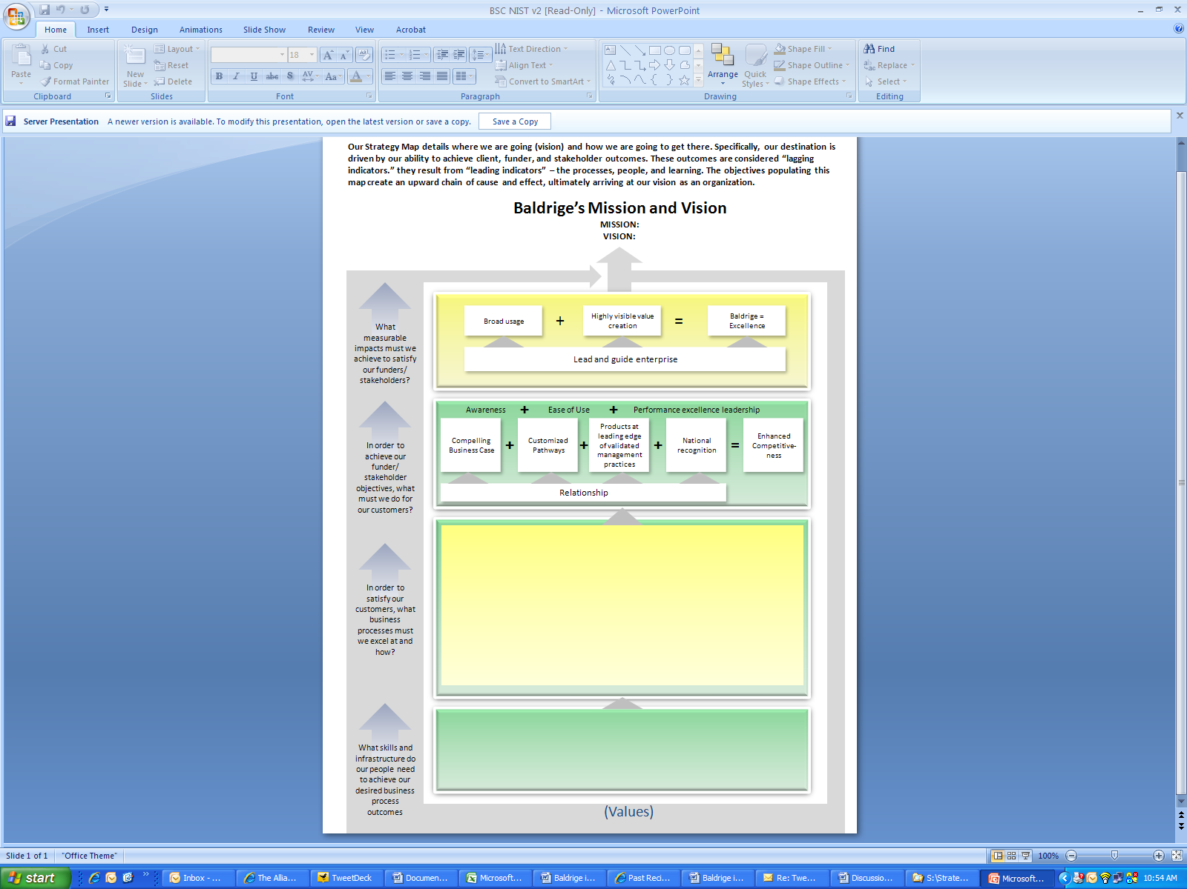

The number-one impact we need to achieve is value to the customer, viewed through the customers’ perspectives.

“Customized pathways” should provide several entry points for an organization to continue with Baldrige, whether that organization is a novice or an Award winner. Moving from one pathway to another is analogous to movement from “mass production” to “mass customization.”

Providing products and services at the leading edge of validated management practices is aligned with Baldrige providing performance excellence leadership.

Providing relevant and sustained relationships should be the foundation for all we do for customers. Relationship considerations include maintaining a balance between distributors and end-users and ensuring that end-users have access to supportive relationships at all times.

National recognition includes recognition by associated, Baldrige-based programs (e.g., VA Carey Award and organizations like Cargill that have their own internal Baldrige-based awards).

Enhanced competitiveness should answer the customer question, “What’s in it for me?”

We began with the following potential measures but narrowed the list to proposed scorecard measures as follows:

Potential Measures
- Net Promoter Score (NPS): NPSs capture broad concept/relationships and are used to gather the perceptions of those already engaged in Baldrige (“captured customers”) and partners (e.g., ACHE); NPSs can be gathered through annual surveys to customers. A follow-up question to an NPS might be “What one thing could we do to improve the score?” A similar question might be asked of examiners: “What one thing could we do to help those that are referred to you/that you interact with (potential users)?” A single question such as this could also be asked of state/local programs, Baldrige-based programs such as the VA Carey Award and Cargill’s internal program, and potential applicants. Potential mechanism for gathering NPSs include a CEO survey of large manufacturers and service organizations (or we could purchase a few questions on a larger, well-known survey to increase the responses) or a survey given by one of our partners (e.g., health care and education associations).

- Reuse/Customer Loyalty/Long-term Engagement Measure: To understand the engagement of repeat customers, especially in an effort to understand why organizations on a Baldrige journey stay or don’t stay with the Criteria, we need a loyalty measure to track meaningful use of the Criteria by Award winners, applicants (national, state, and sector [e.g, Baldrige-based programs such as the Carey Award, American Health Care Association, and companies with their own Baldrige-based awards]), and Criteria users. We also understand from Award winners that meaningful use means more than just applying for the Award (e.g., we know that SSM, though it has not reapplied for the Award, still uses the Health Care Criteria, and Stoner said at Quest that it still uses the Criteria without applying to help it evaluate other organizations for potential acquisitions).
We are able to acquire data on Award winners and applicants, but knowing the loyalty of Criteria users and potential Criteria users is more difficult. We discussed starting with those who access the Criteria and its associated tools through the Web site by using a no-more-than-three question pop-up survey that asks for an e-mail address (OMB prohibits requiring e-mail addresses as a type of registration to download material in the public domain [i.e., the Criteria], but we can voluntarily seek e-mail addresses). The brief survey might ask whether the person is a first-time user of the Criteria and associated tools, repeat user, or regular user. We also could track “unsubscribe” data from users who opt out of Baldrige Criteria mailings and conduct analysis of mailing list data to determine how many people request to be mailed paper copies of the Criteria and have continued that request over the years.

Proposed Scorecard Measures for Overseers’ Feedback

- NPS for all groups included in “broad meaningful use,” captured through survey question
- NPS for partners’ perceptions of us
- Retention: Measure of partner referrals to us showing that the referrals eventually became engaged in the program
- Number of applicants (including Award recipients) that stay engaged

NEXT STEPS
- Based on overseers’ and judges’ feedback, adjust strategy map.
- By end of June, complete strategy map’s Operations Perspective (internal processes and staff skills and infrastructure) by identifying objectives and potential measures. Also, share work with rest of Baldrige staff to solicit their input.
- By end of July, schedule customer focus group (applicants and known users) to comment on objectives and measures in Operations Perspective.
- By end of July, “close the loop” with “funders/stakeholders” group that provided input in January by sharing strategy map to date.
- Enlist a change management consultant to help the program turn the strategy map into a balanced scorecard and engage the current staff in implementing needed changes.
- Evaluate various funding scenarios for accomplishing the strategy, in collaboration with the Baldrige Foundation.

