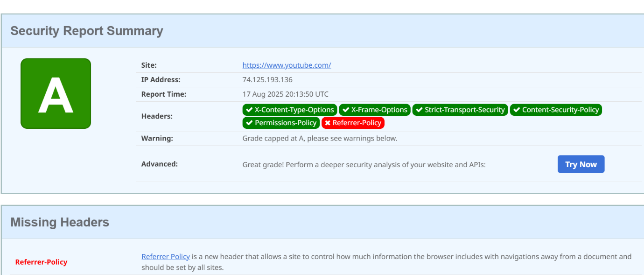

The above image is for youtube website. It got A grade report only missing header is Referrer-policy.

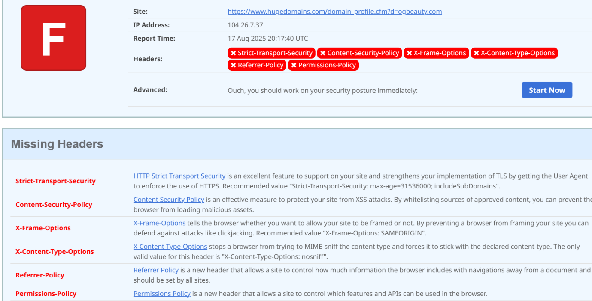

The above image is for hugedomains website. It got grade of F which is least secure by improving and including all header it can be better and protected form cyber attacks.