WorkX Agentic Orchestration
High-Level Design
DRAFT — first-shot structure for review

Table of Contents

1. Document Overview

1.1 Purpose
Enable business teams to orchestrate AI Agents within WorkX BPMN processes.

1.2 Principle
AI does not replace the business process. AI becomes another execution participant alongside humans and enterprise systems. WorkX remains the system of record for process execution while orchestrating AI for tasks requiring reasoning, research, interpretation, planning, recommendation, or content generation.

1.3 Objectives
Orchestration of AI Agents in WorkX requires availability of AI Agents. We propose two strategies for enabling the same:
- Allow creation of WorkX-native Agents
- Allow business-owned agents to be used in WorkX

2. Architecture at a Glance
The two strategies differ in one key respect: who owns the agent's reasoning loop and tool execution.
Strategy | Owns the agent loop | Owns tool execution | WorkX state control
WorkX-native Agents | WorkX | WorkX | Full — incidents, retries, compensation, escalation
Business-owned Agents | External runtime | External runtime | None — agent may choose to report state via AEP

3. Strategy 1: WorkX-native Agents

3.1 Concept
Business Process + WorkX Agent + Agentic Orchestration
- WorkX models the Agent as an Agent task and tools as Agent sub-processes.
- WorkX owns the Agent loop.
- LLM chooses the next tool; WorkX runtime executes the tool as a BPMN activity, maintaining state and control.
- WorkX controls the incidents, failures, compensation, escalation, and any other aspect of state management for these agents.

3.2 Capabilities
A WorkX-native Agent is modeled using the AI Agent Connector. The AI Agent connector enables integration with an LLM to provide interaction/reasoning capabilities.
Feature | Description
LLM Support | Supports LLM capabilities via Tachyon.
Memory | Provides short term/conversational memory to handle feedback loops.
Tool Calling | Support for an AI agent to interact with tasks within an ad-hoc sub-process, allowing use of all Camunda 7 features such as connectors and user tasks (human-in-the-loop). Automatic tool resolution allows an AI agent to identify the tools available in an ad-hoc sub-process.
Table 1: AI Agent Connector capabilities

3.3 Implementation Patterns
The AI Agent Connector is available in two variants.

Variant 1: AI Agent Task
The AI Agent Task implementation is the original variant that relies on a standard BPMN service task, optionally combined with a multi-instance ad-hoc sub-process.
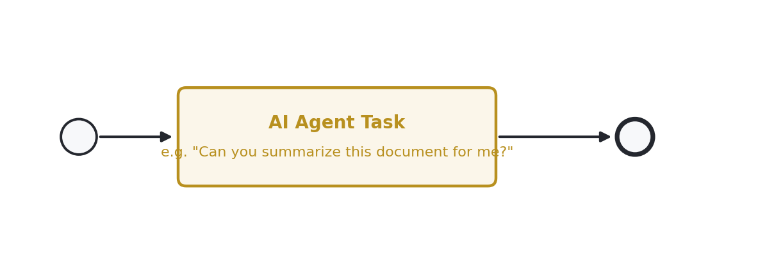
Figure 1: AI Agent Task, alone — a one-shot task capable of making a direct LLM call without tool calling.
- With the above orchestration, it can be used as a one-shot task capable of making a direct LLM call without tool calling.
- The connector can be made agentic by adding a multi-instance ad-hoc sub-process to create a tool-calling feedback loop.
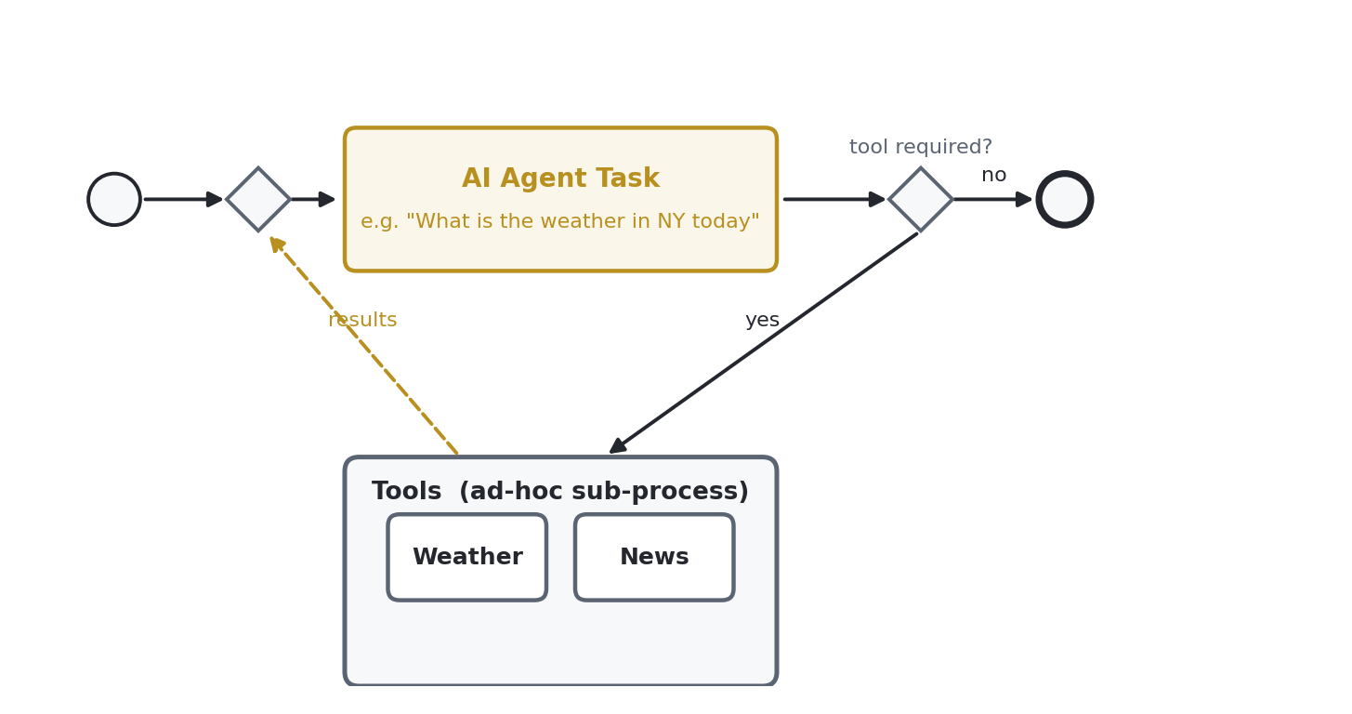
Figure 2: AI Agent Task with an explicit, modeler-built tool-calling loop.

Variant 2: AI Agent Sub-Process
This connector implementation uses the ad-hoc sub-process implementation to provide an integrated solution to handle tool resolution and a feedback loop. This offers:
- Simplified orchestration and configuration, as the tool feedback loop is handled internally.
- Support for handling of event sub-processes within the ad-hoc sub-process.
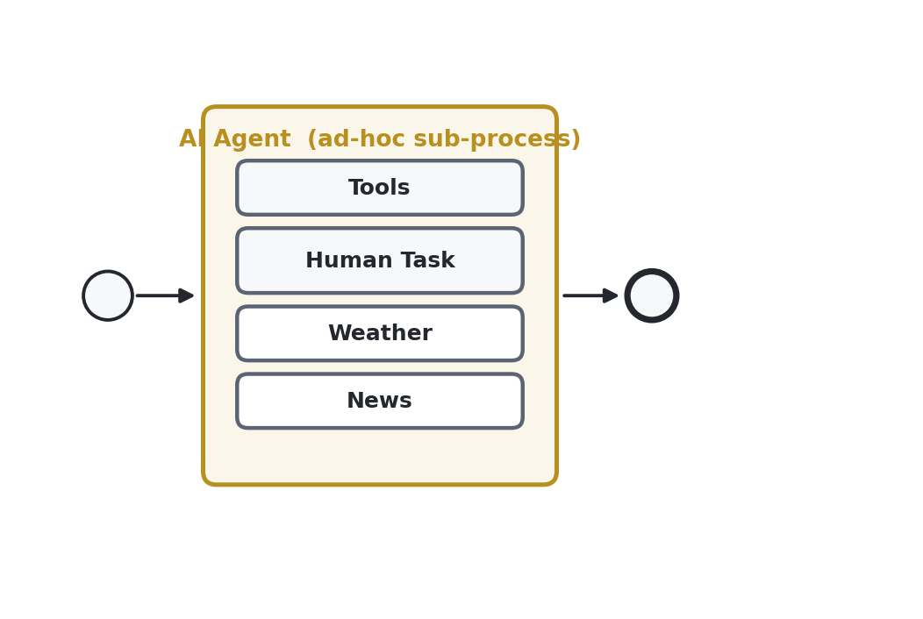
Figure 3: AI Agent Sub-process — tool resolution and the feedback loop are handled internally, including support for a Human Task as one of the tools.

3.4 Sequence Diagrams
The following sequence diagrams should be inserted here from the existing working files:
- WorkX Native Agent Sequence — AI Agent Task connector variant (explicit, modeler-built loop).
- WorkX Native Agent Sequence — AI Agent Sub-process connector variant (internal loop).
Open item: insert the existing sequence-diagram images here at full resolution — the versions currently in the working draft are screen captures and should be replaced with the source files.

4. Strategy 2: Business-owned Agents

4.1 Concept
Business Process + WorkX Agent Connector + Business Agent
- WorkX provides a connector for business-owned Agents.
- WorkX owns the orchestration of Agents; the external runtime owns the Agent loop.
- The external runtime owns the execution of tools. WorkX does not maintain the state of the Agent, but the Agent can choose to report state back to WorkX at various milestones via a proposed protocol — the Agent Event Protocol (AEP).
- WorkX does not control incidents, failures, or escalations of business-owned agents.
- The detailed strategy for how human-in-the-loop will be handled for business-owned agents is covered separately — see Section 6, Open Questions.

4.2 Capabilities
A business-owned Agent is modeled using the AI Agent Connector. The AI Agent connector enables integration with an LLM to provide interaction/reasoning capabilities which already exist and have been created by the business teams. This allows teams to integrate those capabilities into the business process without any reinvention.
Open item: the capabilities table for business-owned Agents was not fully captured in the source draft — needs to be completed (likely mirrors Table 1, scoped to what the connector exposes for an externally-owned LLM/agent).

4.3 Agent Event Protocol (AEP)
We propose certain integration principles for external agents — the Agent Event Protocol (AEP). An external agent that chooses to participate reports its state to WorkX at the following milestones:
- AGENT_STARTED
- PLAN_CREATED
- TOOL_DISCOVERED
- TOOL_SELECTED
- TOOL_STARTED
- TOOL_COMPLETED
- TOOL_FAILED
- HUMAN_INTERVENTION_REQUIRED
- HUMAN_RESPONSE_RECEIVED
- AGENT_WAITING
- AGENT_RESUMED
- AGENT_COMPLETED
- AGENT_FAILED
Open item: per-event payload schema is not yet defined — needed before this can be implemented against.

4.4 Integration Architecture
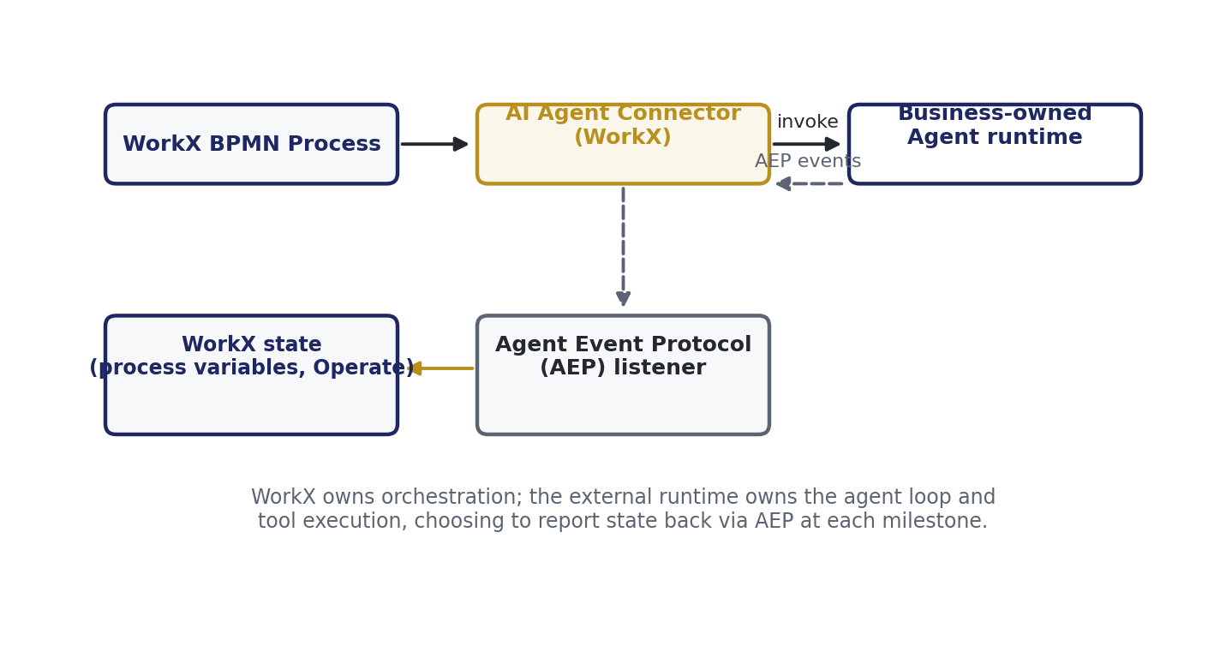
Figure 4: Business-owned Agent integration — WorkX owns orchestration; the external runtime owns the agent loop and reports state via AEP.

5. Cross-Cutting Concerns

5.1 Governance
All LLM calls, whether from WorkX-native or business-owned Agents, are routed through Tachyon.

5.2 Error Handling
WorkX-native Agents: incidents, failures, compensation, and escalation are fully controlled by WorkX (see 3.1). Business-owned Agents: WorkX does not control incidents, failures, or escalations — these remain owned by the external runtime (see 4.1).

5.3 Observability
Open item: this section needs input — how AEP events surface in Operate/Cockpit, and whether business-owned agent activity is visible in the same audit trail as WorkX-native agent activity.

6. Open Questions
- Business-owned Agent capabilities table (Section 4.2) is incomplete in the source draft.
- AEP per-event payload schema (Section 4.3) is not yet defined.
- Human-in-the-loop strategy for business-owned agents is referenced but not yet written (see 4.1).
- Observability strategy for business-owned agents (Section 5.3) needs input.

7. Appendix: Glossary
Term | Definition
Tachyon | The enterprise SDK/service through which all LLM calls are routed for governance.
AEP | Agent Event Protocol — the proposed set of milestone events a business-owned agent may report back to WorkX.
Ad-hoc sub-process | A BPMN construct whose child activities can execute in any order, repeated, or skipped — used as the agent's “toolbox.”
AI Agent Connector | The WorkX/Camunda connector that integrates a BPMN task with an LLM.

