**Malaviya National Institute of Technology, Jaipur**

**Department of Computer Science and Engineering**

**&**

**Department of Physics**



**REPORT**

**On**

**Cosmology Calculator**

**Submitted By-**  **Submitted To-**

Vipul Gharde (2015UCP1024) Dr. K Venkataratnam Kamma

Ritu Karela (2015UCP1072) Assistant Professor, Parul Agrawal (2015UCP1073) Department of Physics

Komal Mittal (2015UCP1469)

Table of Contents

[**Abstract**](#_8a0i0lqq4pl2) **2**

[**Useful Definitions**](#_je5qz7a1lk2t) **2**

[Hubble Constant](#_8v0lexj5uac2) 2

[Red Shift](#_o09o7vz054k9) 3

[Density Parameter Omega](#_vt7ah4peahts) 3

[Age of Universe](#_unipvtwddhcf) 4

[Comoving radial distance](#_7is5atpvke2d) 4

[Comoving Volume](#_ad7i8p4omqmy) 5

[Angular size distance](#_539rz6ha4t8a) 5

[Distance Modulus](#_3q261lyvupi9) 5

[Luminosity distance](#_q2o3wm4ev45r) 5

[Plate Scale](#_h1f5234px2y3) 6

[**Python Code**](#_owzqzbxa74t8) **7**

[**Result**](#_eyach21o0w33) **11**

[**References**](#_u11ap7j9htkj) **12**

# Abstract

A cosmology calculator that computes times and distances as a function of redshift for user-defined cosmological parameters has been made available online. This paper gives the formulae used by the cosmology calculator and discusses some of its implementation. A version of the calculator that allows one to specify the equation-of-state parameter w and w', and one for converting the light-travel times usually given in the popular press into redshifts, is also located at the same site.

This calculator allows one to input user-selected values of the Hubble constant, Omega(matter), Omega(vacuum) and the redshift z, and returns the current age of the Universe, the age, the comoving radial distance (and volume) and the angular-size distance at the specified redshift, as well as the scale (kpc/arcsec) and the luminosity distance.

# 

# 

# Useful Definitions

## Hubble Constant

The Hubble Constant is the unit of measurement used to describe the expansion of the universe. The cosmos has been getting bigger since the Big Bang kick-started the growth about 13.82 billion years ago. The universe, in fact, is getting faster in its acceleration as it gets bigger.

What's interesting about the expansion is not only the rate, but also the implications, according to NASA. If the expansion begins to slow down, that implies that there is something in the universe that is making the growth slow down — perhaps dark matter, which can't be sensed with conventional instruments. If the growth gets faster, though, it's possible that dark energy is pushing the expansion faster.

As of January 2018, measurements from multiple telescopes showed that the rate of expansion of the universe is different depending on where you look. The nearby universe (measured by the Hubble Space Telescope and Gaia space telescope) has a rate of expansion of 45.6 miles per second (73.5 kilometers per second) per megaparsec, while the more distant background universe (measured by the Planck telescope) is a bit slower, expanding at 41.6 miles per second (67 km per second) per megaparsec. A megaparsec is a million parsecs, or about 3.3 million light-years, so this is almost unimaginably fast.

## Red Shift

In physics, redshift happens when light or other electromagnetic radiation from an object undergoes an increase in wavelength.

"Redshifting" does not mean that the light is actually red, or actually becomes red. The term "red" refers to the fact that in human terms, longer wavelengths are found at the red end of the visible spectrum. Whether or not the light is visible, a "redshift" means an increase in wavelength, equivalent to lower frequency and lower photon energy, in accordance with, respectively, the wave and quantum theories of light. A gamma ray perceived as an X-ray, or initially visible light perceived as radio waves would be typical examples of redshifting in astronomy. The opposite of a redshift is a "blueshift", where light experiences a shortening of wavelength, or increase in energy. Blueshifts are generally seen when a light-emitting object moves toward an observer or when electromagnetic radiation moves into a gravitational field. However, redshift is a more common term and sometimes blueshift is referred to as negative redshift.

## Density Parameter Omega

The galaxies we see in all directions are moving away from the Earth, as evidenced by their red shifts. Hubble's law describes this expansion. Remarkably, study of the expansion rate has shown that the universe is very close to the critical density that would cause it to expand forever. It is customary to express the density as a fraction of the density required for the critical condition with the parameter Ω = ρ/ρcritical so that Ω = 1 represents the condition of critical density.

The expansion of the universe has been studied in a number of different ways, but the WMAP mission completed in 2003 represents a major step in precision and the results quoted here will be mainly those from WMAP.

## 

## Age of Universe

In physical cosmology, the age of the universe is the time elapsed since the Big Bang. The current measurement of the age of the universe is 13.799±0.021 billion (109) years within the Lambda-CDM concordance model.[]](https://en.wikipedia.org/wiki/Age_of_the_universe#cite_note-NASA_on_Planck_2015-2) The uncertainty has been narrowed down to 21 million years, based on a number of projects that all give extremely close figures for the age. These include studies of the microwave background radiation, and measurements by the Planck satellite, the Wilkinson Microwave Anisotropy Probe and other probes. Measurements of the cosmic background radiation give the cooling time of the universe since the Big Bang,and measurements of the expansion rate of the universe can be used to calculate its approximate age by extrapolating backwards in time.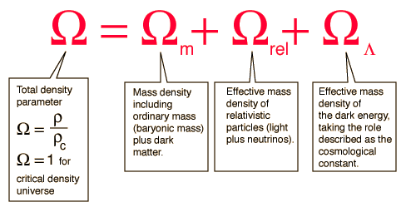

## Comoving radial distance

In standard cosmology, comoving distance and proper distance are two closely related distance measures used by cosmologists to define distances between objects. Proper distance roughly corresponds to where a distant object would be at a specific moment of cosmological time, which can change over time due to the expansion of the universe. Comoving distance factors out the expansion of the universe, giving a distance that does not change in time due to the expansion of space (though this may change due to other, local factors, such as the motion of a galaxy within a cluster). Comoving distance and proper distance are defined to be equal at the present time; therefore, the ratio of proper distance to comoving distance now is 1. At other times, the scale factor differs from 1. The Universe's expansion results in the proper distance changing, while the comoving distance is unchanged by this expansion because it is the proper distance divided by that scale factor.

## Comoving Volume

The comoving volume VC is the volume in which the number densities of non-evolving objects locked into the Hubble flow are constant with redshift. It is the proper volume times three factors of the relative scale factor from the present epoch to the time at redshift z, or (1 + z)3. It can be thought of as the cosmological volume with the expansion of the Universe factored out, i.e. the comoving volume defined by a fixed set of objects remains constant, and is useful in cosmological calculations.

## Angular size distance

The **angular diameter distance** is a distance measure used in astronomy. It is defined in terms of an object's physical size, x,and theta the angular size of the object as viewed from earth.

d = x / theta

## Distance Modulus

The ‘distance modulus’ is the difference between the apparent magnitude and absolute magnitude of a celestial object (m – M), and provides a measure of the distance to the object, r.

|  |  |  |  |
| --- | --- | --- | --- |
| $ \underbrace{m - M}_{\text{Distance Modulus}} = 5\log_{10} (\frac{r}{10}) $ | where | m = | apparent magnitude of the star |
|  | M = | absolute magnitude of the star, and |
|  | r = | distance to the star in parsecs |

## Luminosity distance

**Luminosity distance** *DL* is defined in terms of the relationship between the absolute magnitude *M* and apparent magnitude *m* of an astronomical object.

## Plate Scale

The plate scale of a telescope can be described as the number of degrees, or arcminutes or arcseconds, corresponding to a number of inches, or centimeters, or millimeters (etc.) at the focal plane (where an image of an object is "seen") of a telescope. Each telescope has its own plate scale, depending on the characteristics of the all the optical elements (mirrors or lenses) that are in the telescope. Very simply, the plate scale for a telescope can be calculated if you know the diameter, D, of the primary mirror and the telescope effective focal length, F, or if you have its *f-number* (f/#):



In this common expression of plate scale, D is in millimeters (mm). The *f-number* is unitless, as it is a ratio of the focal length to the diameter:

.

In principle, the f/# can be determined from the design specifications of a given telescope, but, in practice, it is checked by measuring the effective focal length directly once the telescope is assembled.

# 

# Python Code

#!/usr/bin/env python  
   
import sys  
from math import \*  
  
try:  
 length=len(sys.argv)   
  
# if no values, assume Benchmark Model, input is z  
 if length == 2:  
 if float(sys.argv[1]) > 100:  
 z=float(sys.argv[1])/299790. # velocity to redshift  
 else:  
 z=float(sys.argv[1]) # redshift  
 H0 = 75 # Hubble constant  
 WM = 0.3 # Omega(matter)  
 WV = 1.0 - WM - 0.4165/(H0\*H0) # Omega(vacuum) or lambda  
  
# if one value, assume Benchmark Model with given Ho  
 elif length == 3:  
 z=float(sys.argv[1]) # redshift  
 H0 = float(sys.argv[2]) # Hubble constant  
 WM = 0.3 # Omega(matter)  
 WV = 1.0 - WM - 0.4165/(H0\*H0) # Omega(vacuum) or lambda  
  
# if Univ is Open, use Ho, Wm and set Wv to 0.  
 elif length == 4:  
 z=float(sys.argv[1]) # redshift  
 H0 = float(sys.argv[2]) # Hubble constant  
 WM = float(sys.argv[3]) # Omega(matter)  
 WV = 0.0 # Omega(vacuum) or lambda  
  
# if Univ is General, use Ho, Wm and given Wv  
 elif length == 5:  
 z=float(sys.argv[1]) # redshift  
 H0 = float(sys.argv[2]) # Hubble constant  
 WM = float(sys.argv[3]) # Omega(matter)  
 WV = float(sys.argv[4]) # Omega(vacuum) or lambda  
  
# or else fail  
 else:  
 print '\n\t\tKindly Provide the Following Input: \n',  
 print '\t\t1. Redshift\n\t\t2. Hubble Constant(Ho)\n\t\t3. Matter Density(Omega\_m)\n\t\t4. Vaccum Density(Omega\_vac)\n'  
 sys.exit()  
  
# initialize constants  
 WR = 0. # Omega(radiation)  
 WK = 0. # Omega curvaturve = 1-Omega(total)  
 c = 299792.458 # velocity of light in km/sec  
 Tyr = 977.8 # coefficent for converting 1/H into Gyr  
 DTT = 0.5 # time from z to now in units of 1/H0  
 DTT\_Gyr = 0.0 # value of DTT in Gyr  
 age = 0.5 # age of Universe in units of 1/H0  
 age\_Gyr = 0.0 # value of age in Gyr  
 zage = 0.1 # age of Universe at redshift z in units of 1/H0  
 zage\_Gyr = 0.0 # value of zage in Gyr  
 DCMR = 0.0 # comoving radial distance in units of c/H0  
 DCMR\_Mpc = 0.0   
 DCMR\_Gyr = 0.0  
 DA = 0.0 # angular size distance  
 DA\_Mpc = 0.0  
 DA\_Gyr = 0.0  
 kpc\_DA = 0.0  
 DL = 0.0 # luminosity distance  
 DL\_Mpc = 0.0  
 DL\_Gyr = 0.0 # DL in units of billions of light years  
 V\_Gpc = 0.0  
 a = 1.0 # 1/(1+z), the scale factor of the Universe  
 az = 0.5 # 1/(1+z(object))

h = H0/100.  
 WR = 4.165E-5/(h\*h) # includes 3 massless neutrino species, T0 = 2.72528  
 WK = 1-WM-WR-WV  
 az = 1.0/(1+1.0\*z)  
 age = 0.  
 n=1000 # number of points in integrals  
 for i in range(n):  
 a = az\*(i+0.5)/n  
 adot = sqrt(WK+(WM/a)+(WR/(a\*a))+(WV\*a\*a))  
 age = age + 1./adot  
  
 zage = az\*age/n  
 zage\_Gyr = (Tyr/H0)\*zage  
 DTT = 0.0  
 DCMR = 0.0  
  
# do integral over a=1/(1+z) from az to 1 in n steps, midpoint rule  
 for i in range(n):  
 a = az+(1-az)\*(i+0.5)/n  
 adot = sqrt(WK+(WM/a)+(WR/(a\*a))+(WV\*a\*a))  
 DTT = DTT + 1./adot  
 DCMR = DCMR + 1./(a\*adot)  
  
 DTT = (1.-az)\*DTT/n  
 DCMR = (1.-az)\*DCMR/n  
 age = DTT+zage  
 age\_Gyr = age\*(Tyr/H0)  
 DTT\_Gyr = (Tyr/H0)\*DTT  
 DCMR\_Gyr = (Tyr/H0)\*DCMR  
 DCMR\_Mpc = (c/H0)\*DCMR  
  
# tangential comoving distance  
 ratio = 1.00  
 x = sqrt(abs(WK))\*DCMR  
 if x > 0.1:  
 if WK > 0:  
 ratio = 0.5\*(exp(x)-exp(-x))/x   
 else:  
 ratio = sin(x)/x  
 else:  
 y = x\*x  
 if WK < 0: y = -y  
 ratio = 1. + y/6. + y\*y/120.  
 DCMT = ratio\*DCMR  
 DA = az\*DCMT  
 DA\_Mpc = (c/H0)\*DA  
 kpc\_DA = DA\_Mpc/206.264806  
 DA\_Gyr = (Tyr/H0)\*DA  
 DL = DA/(az\*az)  
 DL\_Mpc = (c/H0)\*DL  
 DL\_Gyr = (Tyr/H0)\*DL  
  
# comoving volume computation  
  
 ratio = 1.00  
 x = sqrt(abs(WK))\*DCMR  
 if x > 0.1:  
 if WK > 0:  
 ratio = (0.125\*(exp(2.\*x)-exp(-2.\*x))-x/2.)/(x\*x\*x/3.)  
 else:  
 ratio = (x/2. - sin(2.\*x)/4.)/(x\*x\*x/3.)  
 else:  
 y = x\*x  
 if WK < 0: y = -y  
 ratio = 1. + y/5. + (2./105.)\*y\*y  
 VCM = ratio\*DCMR\*DCMR\*DCMR/3.  
 V\_Gpc = 4.\*pi\*((0.001\*c/H0)\*\*3)\*VCM  
   
   
 print '\n\n~~~~~~~~~~~~~~~~~~~~~~~~~~~~~Cosmology Calculator~~~~~~~~~~~~~~~~~~~~~~~~~~~~~~\n\n'  
 print 'For H\_o = ' + '%1.1f' % H0 + ', Omega\_M = ' + '%1.2f' % WM + ', Omega\_vac = ',  
 print '%1.2f' % WV + ', z = ' + '%1.3f' % z,  
 print '\n\n'  
 print 'Cosmology Parameters\t\t\tValues'  
 print '-------------------------------------------------------------------------------\n'  
 print 'Age of the Universe\t\t\t'+ '%1.1f' % age\_Gyr + ' Gyr\n'  
 print 'Age at Redshift (z = ' + '%1.3f' % z + ')\t\t' + '%1.1f' % zage\_Gyr + ' Gyr\n'  
 print 'Light Travel Time\t\t\t' + '%1.1f' % DTT\_Gyr + ' Gyr\n'  
 print 'Comoving Radial Distance\t\t'+'%1.1f' % DCMR\_Mpc + ' Mpc or ' + '%1.1f' % DCMR\_Gyr + ' Gyr\n'  
 print 'Angular Size Distance\t\t\t' + '%1.1f' % DA\_Mpc + ' Mpc or ' + '%1.1f' % DA\_Gyr + ' Gyr\n'  
 print 'Luminosity Distance\t\t\t' + '%1.1f' % DL\_Mpc + ' Mpc or ' + '%1.1f' % DL\_Gyr + ' Gyr\n'  
 print 'Distance Modulus\t\t\t' + '%1.2f' % (5\*log10(DL\_Mpc\*1e6)-5) + '\n'  
 print 'Comoving Volume\t\t\t\t' + '%1.1f' % V\_Gpc + ' Gpc^3\n'

print 'Plate Scale\t\t\t\t' + '%.2f' % kpc\_DA + ' kpc/arcsec\n'  
  
except IndexError:  
 print '\n\t\tKindly Provide the Following Input: \n',  
 print '\t\t1. Redshift\n\t\t2. Hubble Constant(Ho)\n\t\t3. Matter Density(Omega\_m)\n\t\t4. Vaccum Density(Omega\_vac)\n'  
  
except ValueError:  
 print '\n\t\tWrong Values!\n'

Open with

# Result

Above python code gives values of all cosmology parameters for some input parameters.

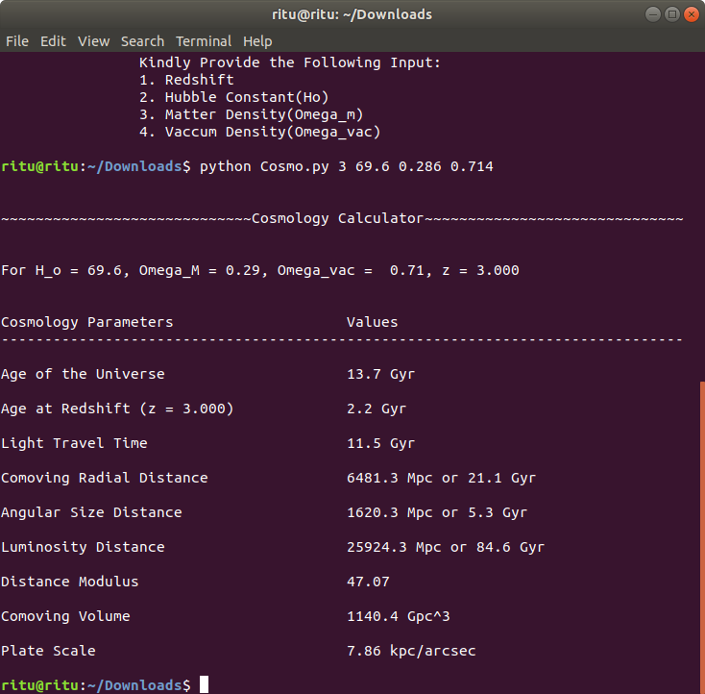

# 

# References

<http://www.astro.ucla.edu/~wright/CosmoCalc.html>

<https://www.wikimedia.org/>

<https://www.google.com/>

<http://www-supernova.lbl.gov/>

<https://www.space.com>