**ASSIGNMENT 1**

**on**

**REINFORCEMET LEARNING**

FLAMES – A Chasing Game inspired by snake game

**Submitted By**

**Parul Wadhwa Snehal Kathiriya**

**Amandeep Kaur**

**Kiranpal Sidhu**

**Vatsal Shah**

**Arvind Pal Singh**

**OBJECTIVE**:

The objective of this project is to develop an AI-driven game called "Flames" stands for FRIENDS, LOVE, AFFAIRE, MARRIAGE, ENEMIES, SIBLINGS, inspired by the classic Snake game. The aim is to create an interactive and engaging environment where an AI agent can learn and adapt its strategy to play the game efficiently. Using advanced techniques in reinforcement learning and deep Q-learning, the project will focus on enabling the AI to navigate, make decisions, and grow in the game environment, similar to how a player manoeuvres the Flames in the traditional Snake game. This project aims to demonstrate the capabilities of AI in game strategy and decision-making, while also providing an entertaining and educational platform for understanding AI and machine learning concepts.

**REINFORCEMENT LEARNING**

Reinforcement Learning (RL) is a branch of machine learning where an agent learns to make decisions by interacting with its environment. The agent performs actions and receives feedback in the form of rewards or penalties. This feedback helps the agent to learn which actions lead to the best outcomes. The core concepts of RL include:

1. Agent: The learner or decision maker.

2. Environment: The world in which the agent operates.

3. Action: What the agent can do.

4. State: The current situation returned by the environment.

5. Reward: Feedback from the environment based on the agent's action.

6. Policy: The strategy that the agent employs to determine its actions.

7. Value Function: It predicts the expected reward of an action taken in a state.

8. Model of the Environment (optional): This represents how actions affect the environment.

The goal in RL is to learn a policy that maximizes the cumulative reward for the agent over time, allowing it to make optimal decisions based on its interactions and experiences.

**HISTORY & BACKGROUND**

Reinforcement Learning (RL) has evolved since the 1950s, combining insights from psychology and optimal control theory. In the 1980s, it was formalized through algorithms like Temporal Difference learning. The 1990s and 2000s saw RL expand into various applications, including robotics and games. A significant breakthrough came in the 2010s with the integration of deep learning, leading to Deep Reinforcement Learning (DRL). This was highlighted by DeepMind's AlphaGo's success in 2016. RL continues to grow, influenced by fields like neuroscience and computer science, and is applied to increasingly complex challenges. The introduction of Q-learning and the development of deep learning methods, like Deep Q Networks (DQN), have significantly advanced RL.

**APPLICATIONS OF REINFORCEMENT LEARNING**

Reinforcement Learning (RL) has diverse applications across multiple fields, showcasing its ability to solve complex, dynamic problems. Here's a more detailed look at some of these applications:

1. Healthcare: RL is used to personalize treatment plans, manage patient care, and optimize resource allocation in hospitals.
2. Supply Chain and Logistics: RL algorithms help optimize inventory management, routing, and logistics planning.
3. Energy Management: In smart grids, RL aids in optimizing energy production, distribution, and consumption, contributing to more efficient and sustainable energy use.
4. Manufacturing: RL improves operational efficiency by optimizing production lines and maintenance schedules.
5. Retail: Used in recommendation systems, RL helps in personalizing shopping experiences and managing stock levels.
6. Finance: Beyond trading, RL is used for credit scoring, fraud detection, and managing financial risks.
7. Agriculture: RL assists in precision farming, crop management, and resource allocation, enhancing agricultural productivity.
8. Autonomous Drones: For navigation, surveillance, and delivery services.
9. Education and Training: In adaptive learning systems, RL customizes learning experiences to individual students' needs.

**REAL LIFE USE CASE:**

Companies like [Gatik](https://gatik.ai/) are pioneering the use of autonomous vehicles (AVs) in the logistics sector, focusing on middle and last-mile deliveries. Their innovations are transforming the supply chain, enhancing efficiency, and redefining customer service in the retail and logistics industries.

**Gatik: Revolutionizing Middle Mile Deliveries**

Gatik's primary focus is on middle mile deliveries, a crucial segment in the supply chain that involves transporting goods from distribution centers to retail stores. This segment has traditionally been labor-intensive and costly, but Gatik's autonomous trucks are changing the landscape. By deploying AVs on these repetitive and predictable routes, Gatik is addressing several challenges:

1. Efficiency: Gatik's AVs can operate continuously, reducing delivery times and increasing the frequency of shipments. This continuous operation is particularly beneficial for perishable goods, ensuring fresher products reach store shelves faster.

2. Cost Reduction: Automation significantly reduces labor costs, which are a major component of transportation expenses. Moreover, AVs can optimize fuel consumption and reduce wear-and-tear costs, contributing to overall cost efficiency.

3. Safety and Reliability: With advanced sensors and AI algorithms, Gatik's trucks are designed to navigate urban and suburban roads with high accuracy and safety, reducing the risk of accidents associated with human error.

**PRACTICAL DEMONSTRATION**

Q-learning is a model-free reinforcement learning algorithm used for finding optimal action-selection policies in a given environment. It works by learning the value of an action in a particular state, aiming to maximize the total reward over time. In Q-learning an agent learns to maximize rewards in an environment by updating a Q-table using the Bellman equation, balancing exploration, and exploitation.

Practical Demonstration with Flames Game: Our implementation of a Flames game using reinforcement learning techniques, particularly with PyTorch, offers a compelling illustration of RL principles in action.

**Game Setup:**

1. Environment: The grid in which the Flames game is played, including obstacles and Flames items.
2. Agent: The RL algorithm, controlling the Flames movements.
3. States: The various positions of the Flames, and obstacles on the grid.
4. Actions: Moving the Flames in different directions (up, down, left, right).
5. Rewards: Positive for consuming Friend, Love, Affair, Marriage and Siblings (increasing the length of the Flames), negative for consuming Enemy, hitting walls or itself.

**Learning Mechanism:**

1. Initial Learning: The agent starts by making random moves. With each move, it learns from the consequences.
2. Reinforcement Learning Algorithm: The chosen RL algorithm (like Deep Q-Learning) updates its strategy based on the outcomes of each move. It learns to predict the expected rewards for each action in each state, progressively enhancing its decision-making.
3. Trial and Error: The agent learns optimal strategies through continuous interaction with the game environment and adjusting its actions based on the feedback (rewards) received.

**Key Insights:**

* The RL agent in the Flames game starts without prior knowledge and improves through continuous gameplay.
* The learning process exemplifies the essence of reinforcement learning, where the agent adapts its strategy based on the feedback from its actions.
* This Flames game implementation provides a tangible example of how reinforcement learning can be applied to develop intelligent agents capable of learning and adapting in dynamic environments.

**Output:**

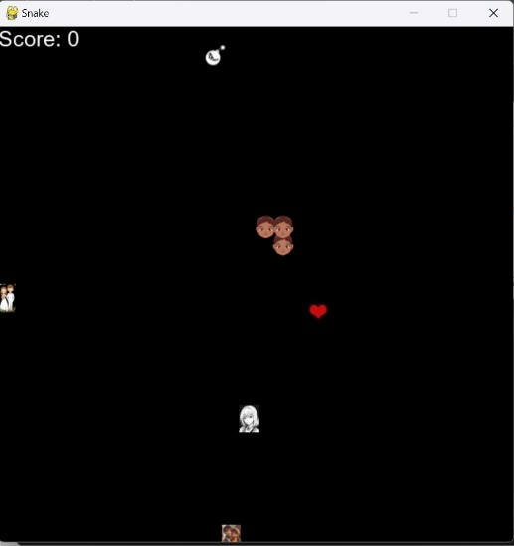

**REFERENCES**

1. DriveU.auto. (n.d.). Autonomous vehicles: Path to ROI & profitable use cases. Retrieved from https://driveu.auto/blog/autonomous-vehicles-path-to-roi-profitable-use-cases/
2. Santa Clara University. (n.d.). 9 real-life examples of reinforcement learning. Retrieved from https://onlinedegrees.scu.edu/media/blog/9-examples-of-reinforcement-learning
3. Analytics Steps. (n.d.). Real world applications of reinforcement learning. Retrieved from https://www.analyticssteps.com/blogs/real-world-applications-reinforcement-learning
4. Loeber, P. (n.d.). Snake AI PyTorch. GitHub. Retrieved from https://github.com/patrickloeber/snake-ai-pytorch
5. Loeber, P. [Patrick Loeber]. (n.d.). Teach AI to play Snake! Reinforcement Learning with PyTorch and Pygame [Video file]. Retrieved from <https://www.youtube.com/watch?v=L8ypSXwyBds>
6. Gatik. (n.d.). Gatik’s Autonomous Transportation as a Service (ATaaS) [Company webpage]. Gatik. https://gatik.ai/deliver-with-us