**Setup: Create 2 users devops and demo**

Create 3 files in devops $HOME_DIR [user: devops]

- devops_file1.txt

- devops_file2.txt

- devops_file3.txt

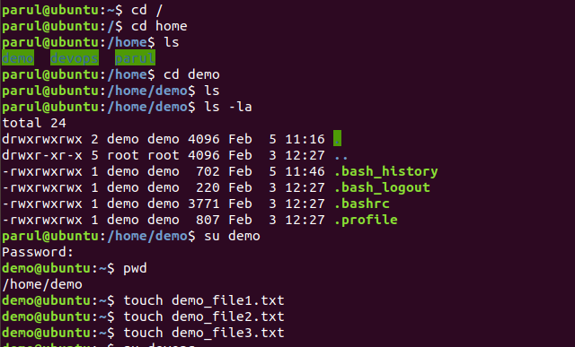

Create 3 files in demo $HOME_DIR [use: demo]

- demo_file1.txt

- demo_file2.txt

- demo_file3.txt

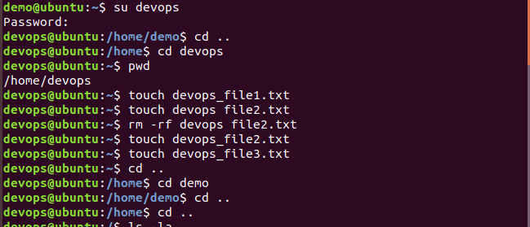

**Case 1:**

Try modifying devops_file2.txt in devops $HOME$DIR by [user: demo] login

Note down if it is success or failure

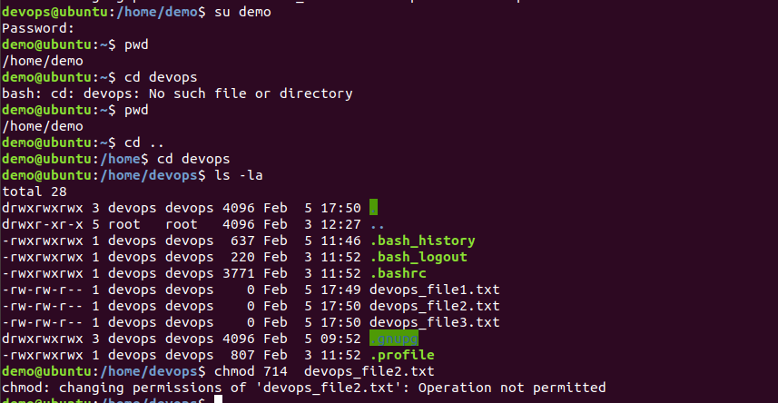

If failure

Change group of [user: demo] from demo to su

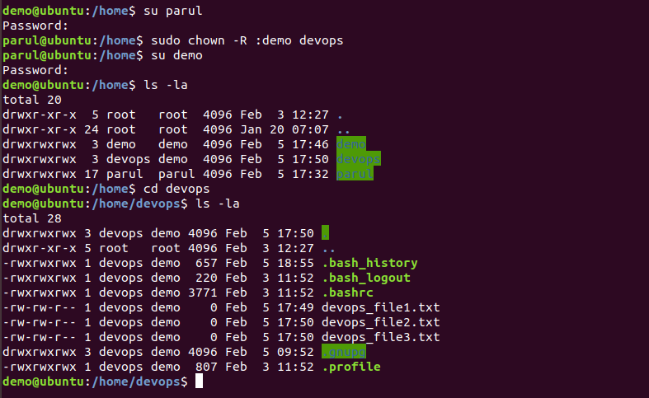

Then try modifying file2.txt in devops $HOME$DIR from [user: demo] login



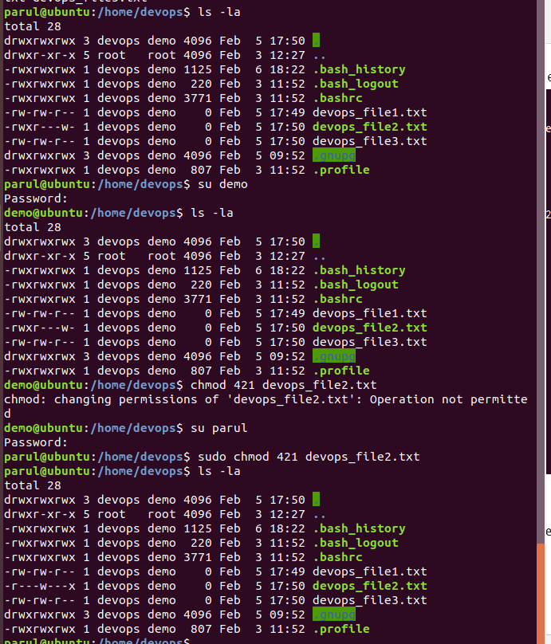

**Case 2:**

Give write permission to file demo_file3.txt for others by using symbolic mode.

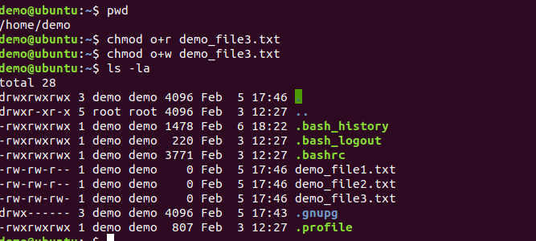

Change terminal login to [user: devops].

Check if [user: devops] can now write to demo_file3.txt.

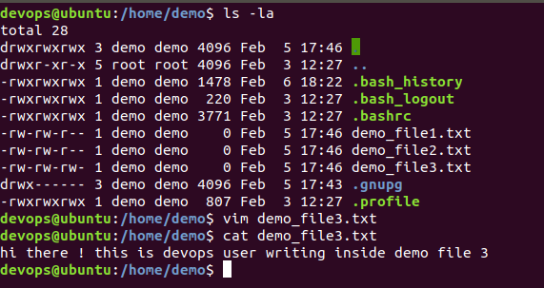

**Case 3:** Check if [user: devops] can write to demo_file2.txt

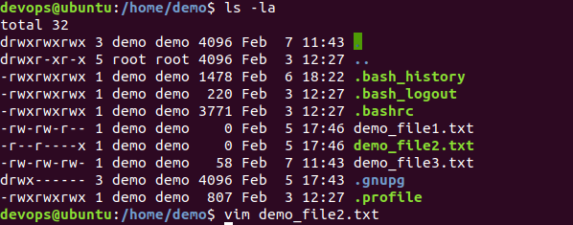



If failure Change of owner of demo_file2.txt to devops



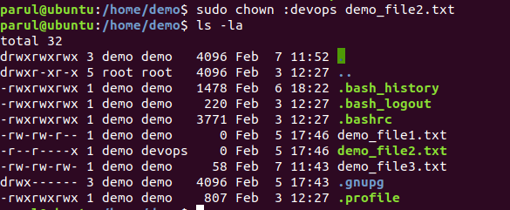

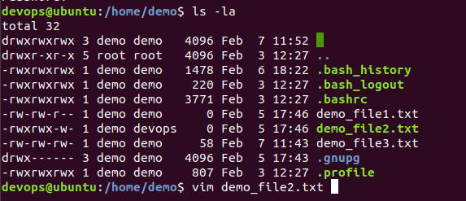

Check now [user:devops] can write to demo_file2.txt



