**FOR LOOP:**

1. User case to print all the files and directory that exists under the /etc directory

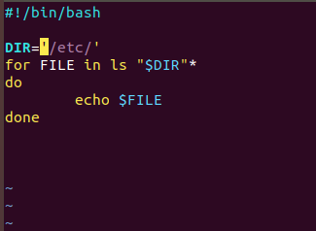

1. User case where an array that stores the first ten prime numbers. Iterate over the array and print out each element inside it

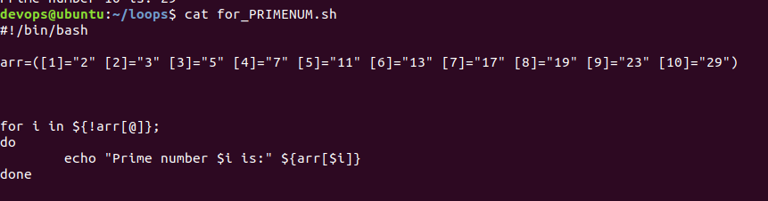

1. User case to print all 7 days of a week by passing values as arguments and iterating for loop over these values

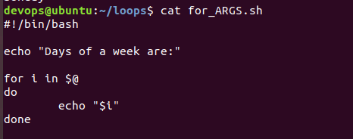

NOTE: We can pass parameters just after the name of the script while running the bash interpreter command.

bash <scriptname>.sh –This will run the script w/o any arguments

bash <scriptname>.sh parameter1 parameter2 parameter3 nth-parameter- This will run the script with the arguments

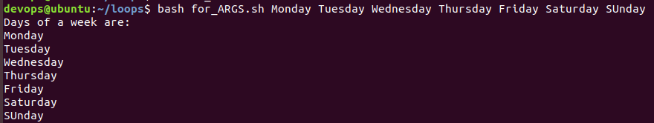

1. Creating a numbered menu to allow a user to select a number. Once a number is selected by the user display whether the number is even or odd.