Assignment-5

**Step 1: Pull the nginx image from Docker hub**

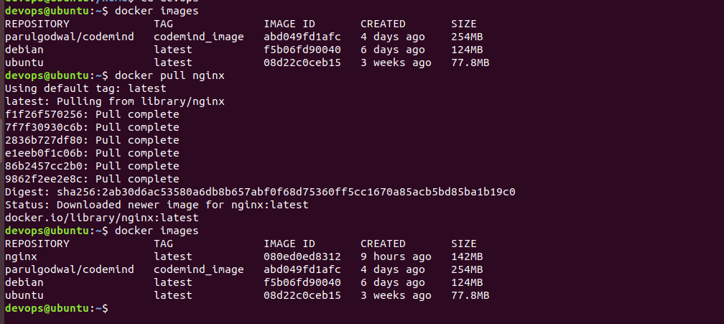

**Step 2: Create container from the nginx image and give port 8000:80**

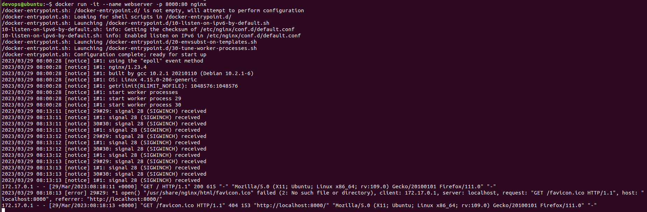

**Step 3: On web browser localhost:8000 we will get welcome page.**

