**Assignment 2**

Create a docker image from a Dockerfile

Create a docker image from a Dockerfile against which when container comes up it should:

Use Case 1: Display the date in form of mm-dd-yy [ENTRYPOINT use case]

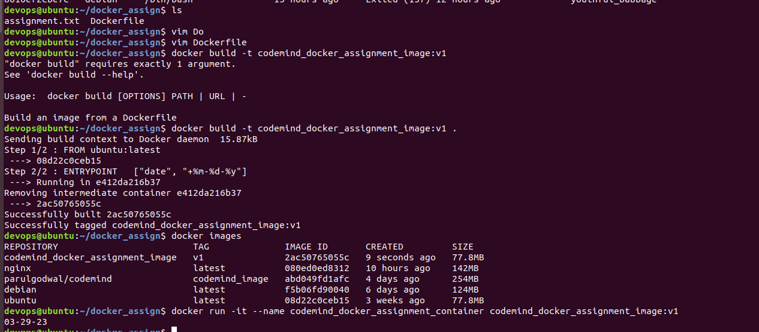

Use case 2: Display the pwd to be `/var/log` [WORKDIR use case]

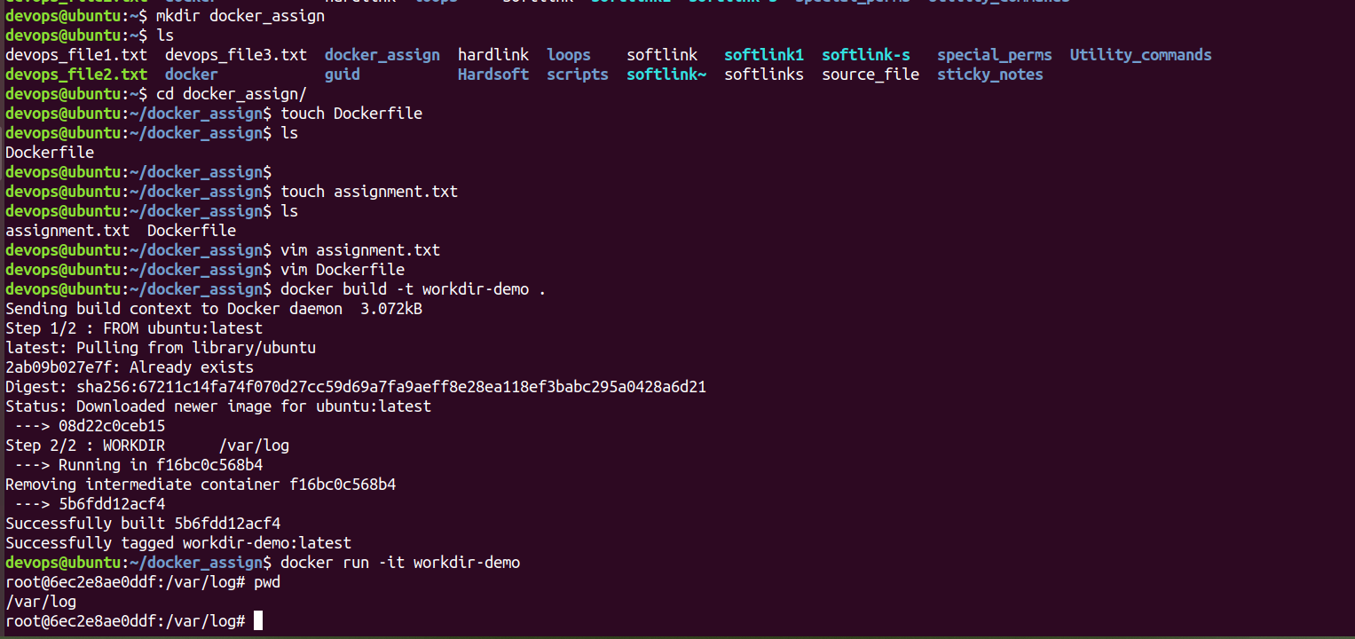

Use Case 3: Display the pwd to be `/var/log` [CMD and WORKDIR use case]

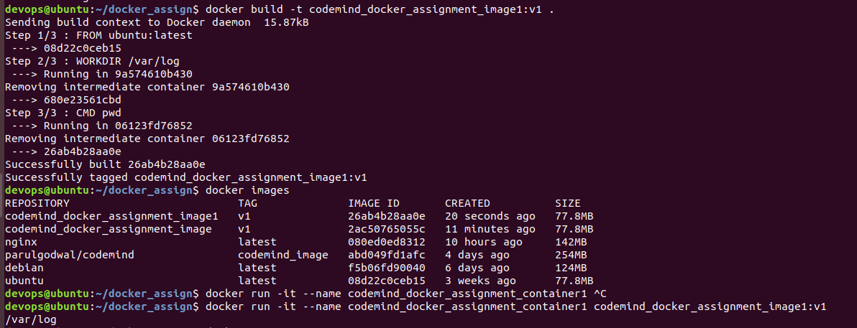

Another way to check the pwd (present working directory) is

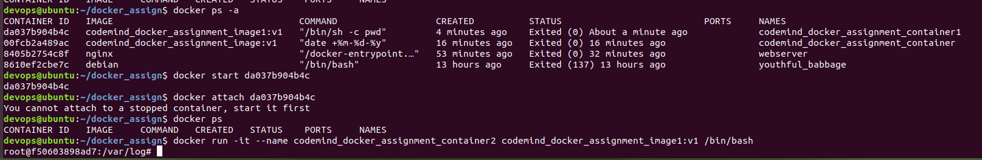

Use Case 4: Map a source_code.txt inside the container in a way it should sync the content inside the container at container run time. [VOLUME use case]

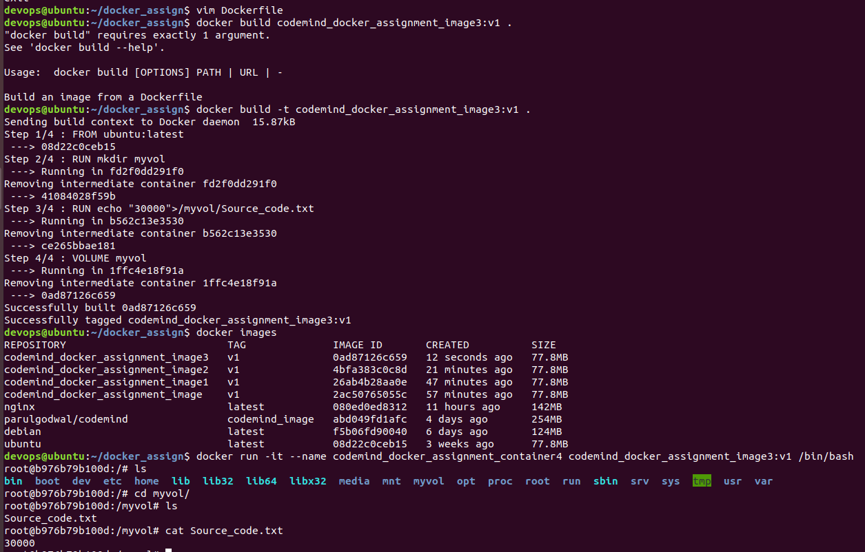

Use Case 5: Display output of echo $NAME to be CODEMIND [ENV use case]

