PROJECT DOCUMENTATION
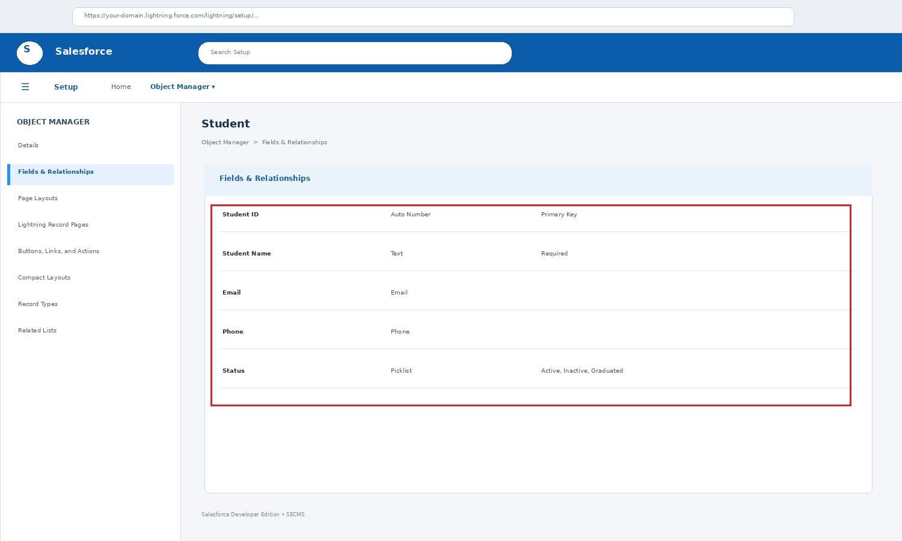
Figure: Salesforce Student object configuration
STUDENT ENROLLMENT & COURSE
MANAGEMENT SYSTEM (SECMS)
Salesforce-Based Academic Project
Department of Computer Science
Immaculate College for Women, Viriyur
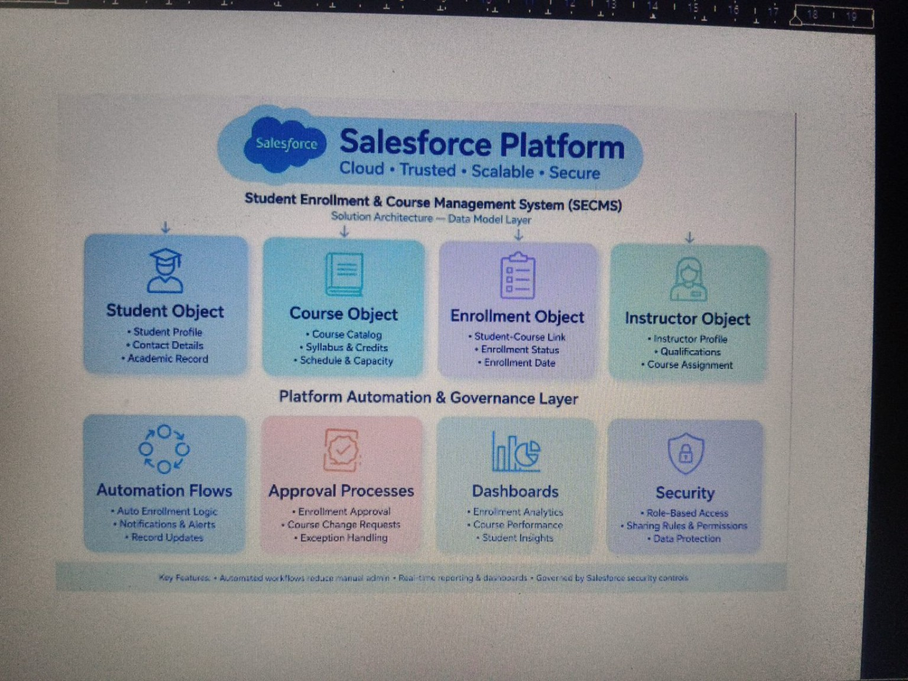
Figure 1. SECMS solution architecture implemented on the Salesforce platform.

CERTIFICATE
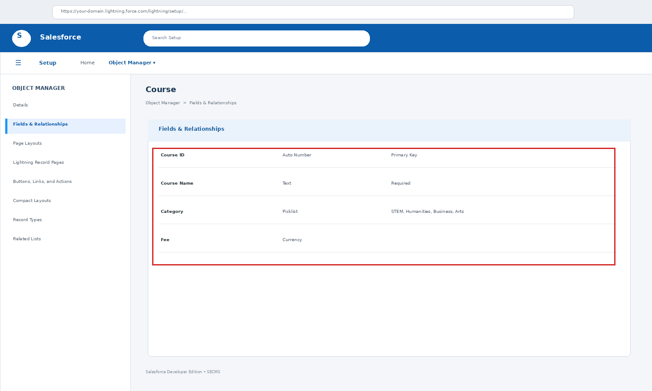
Figure: Salesforce Course object configuration
This is to certify that the project entitled “Student Enrollment & Course Management System (SECMS)” is a documentation of an academic system developed to organize student, course, and enrollment information using Salesforce platform concepts.
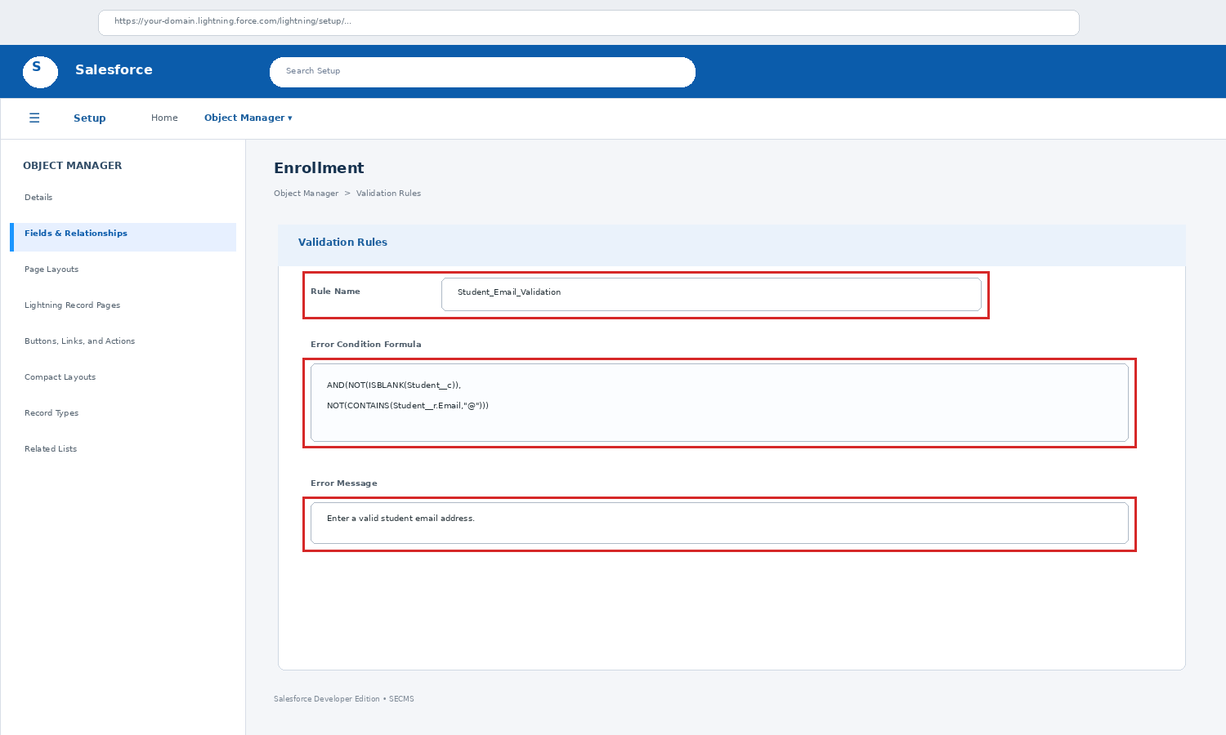
Figure: Salesforce validation rule configuration
The documentation covers the requirement study, system design, Salesforce object configuration, relationships, validation, user interface, testing, and possible future enhancements.

Particular | Details
Student Name(s) | ____________________________________________
Register Number(s) | ____________________________________________
Project Guide | ____________________________________________
Department | B.Sc. Computer Science
College | Immaculate College for Women, Viriyur
Date | ____________________________________________

DECLARATION
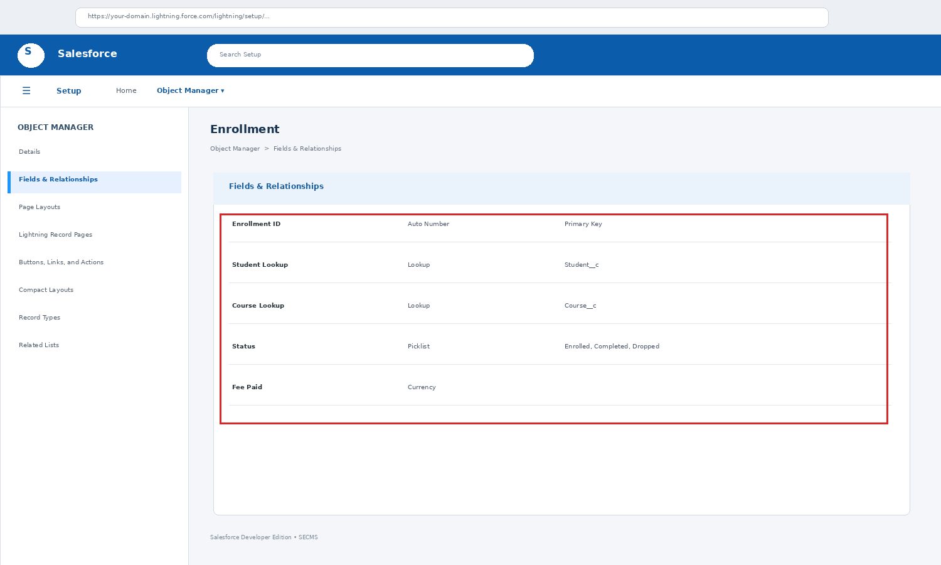
Figure: Salesforce Enrollment object configuration
We hereby declare that the project documentation entitled “Student Enrollment & Course Management System (SECMS)” has been prepared for academic and internship project purposes. The system model, object structure, relationships, screenshots, testing cases, and descriptions presented in this document are intended to explain the implemented or demonstrated Salesforce-based solution.
The documentation has been prepared from the project workflow and configuration activities carried out during the development process.

Student Name(s): ______________________________________________
Register Number(s): ___________________________________________
Signature: ____________________________________________________

ACKNOWLEDGEMENT
The successful preparation of this project documentation would not have been possible without the guidance and support received during the development and learning process.
We sincerely thank the management and faculty members of the Department of Computer Science for providing the opportunity to work on this project. We express our gratitude to the project guide for valuable suggestions, technical guidance, and continuous encouragement.
We also thank our friends and family for their support throughout the learning, configuration, testing, and documentation stages of the Student Enrollment & Course Management System.
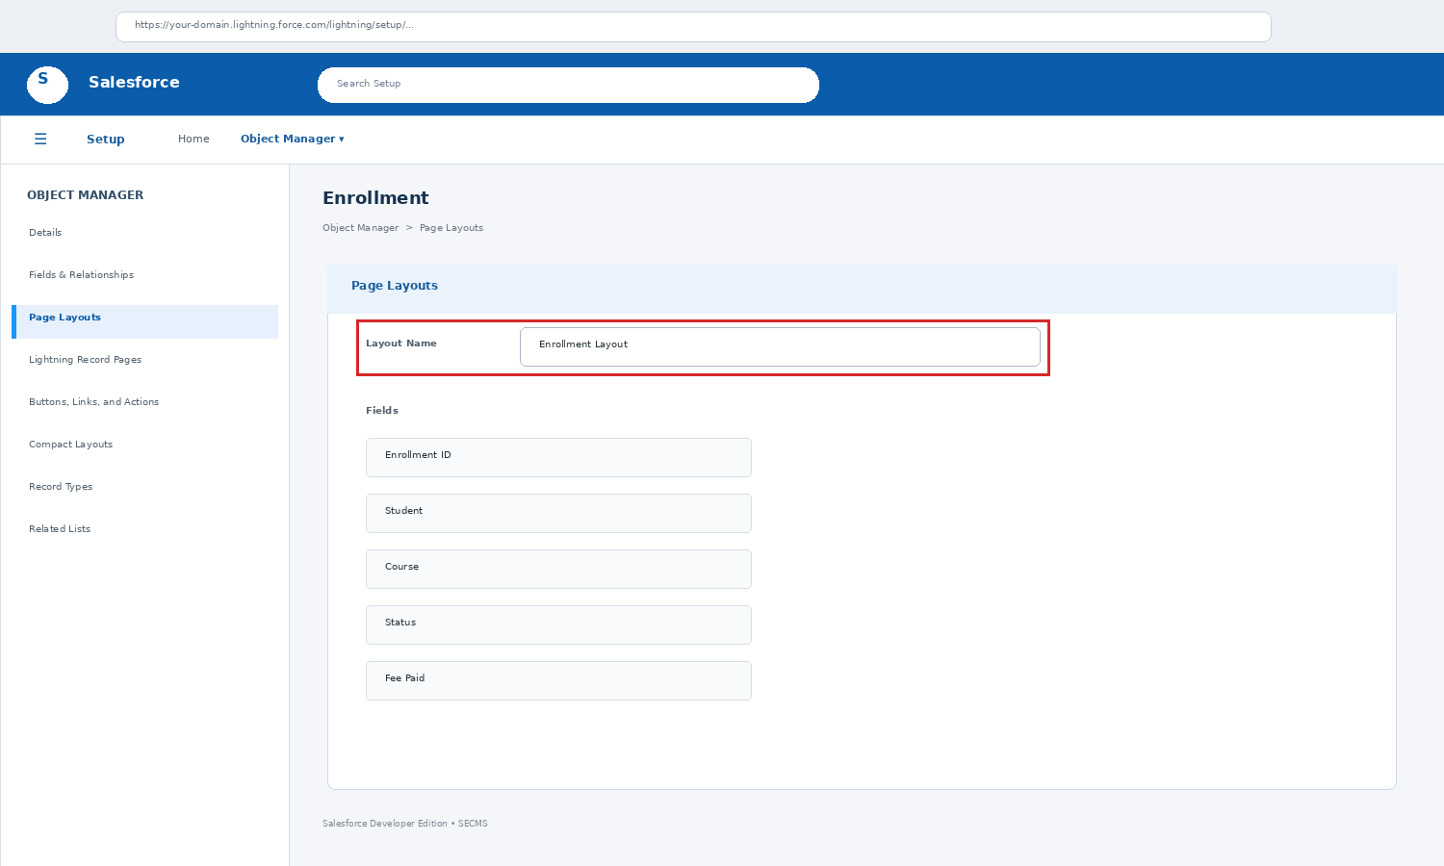
Figure: Salesforce Enrollment page layout configuration
Finally, we acknowledge the learning resources and Salesforce platform documentation that helped in understanding objects, fields, relationships, page layouts, validation rules, and record management.

ABSTRACT
Student Enrollment & Course Management System (SECMS) is a structured academic record management solution designed to maintain student details, course information, and enrollment records in a connected environment.
The system uses Salesforce objects and relationships to organize academic data. Student and Course records are maintained independently, while Enrollment acts as the connecting record. Lookup relationships allow users to associate an enrollment with the appropriate student and course.
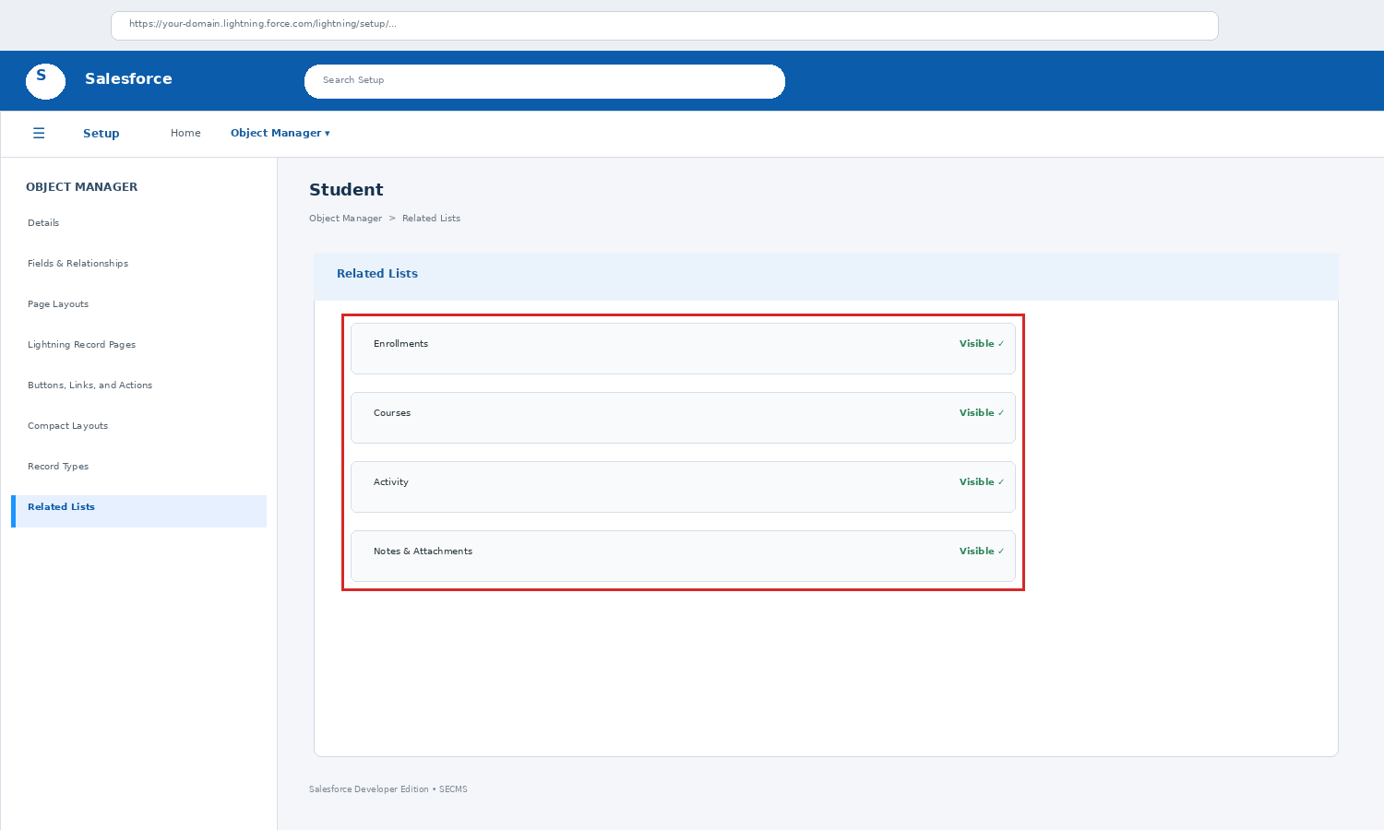
Figure: Salesforce related list configuration
The project also demonstrates required-field validation, related lists, record search, status management, page layouts, and testing of common operations. The design can later be extended with reports, dashboards, approval processes, automation, notifications, and role-based access.
Keywords: Salesforce, Student Management, Course Management, Enrollment, Lookup Relationship, Validation, Related List, Academic Records

TABLE OF CONTENTS
Section | Topic
1 | Introduction
2 | Existing System
3 | Proposed System
4 | Objectives and Scope
5 | System Requirements
6 | System Modules
7 | Functional Requirements
8 | Non-Functional Requirements
9 | System Architecture
10 | ER / Data Model
11 | Database and Object Design
12 | Student Object
13 | Course Object
14 | Enrollment Object
15 | Relationships and Related Lists
16 | User Interface
17 | Validation and Data Quality
18 | Process Flow
19 | Testing
20 | Advantages and Limitations
21 | Future Enhancements
22 | Conclusion
23 | References and Appendix

1. INTRODUCTION
SECMS is an academic information management project that focuses on three core data areas: Student, Course, and Enrollment. The system provides a connected structure so that information can be entered once and then viewed through related records.
The Salesforce platform is suitable for this project because it provides configurable objects, fields, page layouts, relationships, validation rules, list views, and reporting features without requiring a large custom application for the basic record-management layer.
- Centralized student and course information.
- Enrollment records connecting students with courses.
- Validation of mandatory and important fields.
- Related lists for easier navigation between records.
- A foundation for reports, dashboards, and automation.
Figure 7.1 — Project focus: Student + Course + Enrollment.

2. EXISTING SYSTEM
In a traditional academic workflow, student and course information may be maintained in paper files, spreadsheets, or separate documents. When records increase, searching and updating become more difficult.
- Student information may be entered repeatedly in different files.
- Course details and student enrollment data may not be directly connected.
- Finding a particular student or course can require manual searching.
- Duplicate or inconsistent information may occur during repeated updates.
- Generating organized summaries may require additional manual work.
- Relationship information such as enrolled courses may not be immediately visible.
The main issue is not only data storage but also the absence of a connected record structure. SECMS addresses this by defining separate objects and linking them through enrollment records.

3. PROPOSED SYSTEM
The proposed SECMS organizes academic information into connected Salesforce objects. Each object has a clear purpose and contains only the fields required for that record type.
Object | Purpose | Typical Information
Student | Maintain student profile | Name, ID, email, phone, status
Course | Maintain course catalogue | Course name, code, category, fee
Enrollment | Connect student and course | Student lookup, Course lookup, status, date, fee paid
Instructor | Optional academic reference | Name, email, phone, department

This separation improves clarity and allows each record to be maintained independently while still supporting connected views through relationships.

4. OBJECTIVES AND SCOPE

4.1 Objectives
- Maintain student records in a structured format.
- Maintain course information and basic academic attributes.
- Create enrollment records using valid Student and Course references.
- Reduce duplicate and inconsistent data entry.
- Provide easy navigation between related records.
- Validate required information before records are saved.
- Provide a base for reports, dashboards, and automation.

4.2 Scope
- Student registration and record maintenance.
- Course creation and maintenance.
- Student-course enrollment tracking.
- Status and date management.
- Related-list based navigation.
- Basic validation and testing.

5. SYSTEM REQUIREMENTS

5.1 Hardware Requirements
Requirement | Recommended
Processor | Dual-core or better
RAM | 4 GB minimum; 8 GB preferred
Storage | At least 5 GB free space for project materials
Display | 1366 × 768 or higher
Network | Stable internet connection

5.2 Software Requirements
- Salesforce Developer Edition / suitable Salesforce environment.
- Modern web browser such as Chrome, Edge, or Firefox.
- Microsoft Word or compatible document editor for documentation.
- Image editor or screenshot tool for evidence capture.
- Optional spreadsheet software for sample data preparation.

6. SYSTEM MODULES
Module | Main Function
Student Management | Create, view, edit, search, and maintain student records.
Course Management | Maintain course name, code, category, fee, and status.
Enrollment Management | Connect a student with a selected course and store enrollment details.
Relationship Management | Display related enrollments from Student and Course records.
Validation | Prevent incomplete or incorrect mandatory entries.
Search & Lists | Locate records using list views and search options.
Testing | Verify record creation, editing, validation, and relationships.

The three core modules are Student, Course, and Enrollment. Other modules support data quality, navigation, and verification of the core workflow.

7. FUNCTIONAL REQUIREMENTS
- The system shall allow a user to create a Student record.
- The system shall allow existing Student records to be viewed and edited.
- The system shall allow creation and maintenance of Course records.
- The system shall allow an Enrollment record to reference a Student.
- The system shall allow an Enrollment record to reference a Course.
- The system shall store enrollment status and date.
- The system shall display related enrollments where configured.
- The system shall validate mandatory fields before saving.
- The system shall allow users to search for existing records.
- The system should support future reports and dashboards.

8. NON-FUNCTIONAL REQUIREMENTS
Quality | Requirement
Usability | Forms, fields, and navigation should be easy to understand.
Performance | Normal record operations should respond within an acceptable time.
Security | Access to academic data should follow configured user permissions.
Reliability | Saved records should remain consistent and traceable.
Maintainability | Objects and fields should be easy to modify or extend.
Scalability | The structure should support increasing numbers of records.
Data Quality | Validation should reduce incomplete and invalid entries.

These requirements help ensure that the project is not limited to data storage alone. The system should also remain usable, controlled, and maintainable as the academic data grows.

9. SYSTEM ARCHITECTURE
The architecture follows a simple flow from user interaction to validation, data storage, and output. Salesforce provides the user interface, configurable data model, and platform services required for the core record-management workflow.
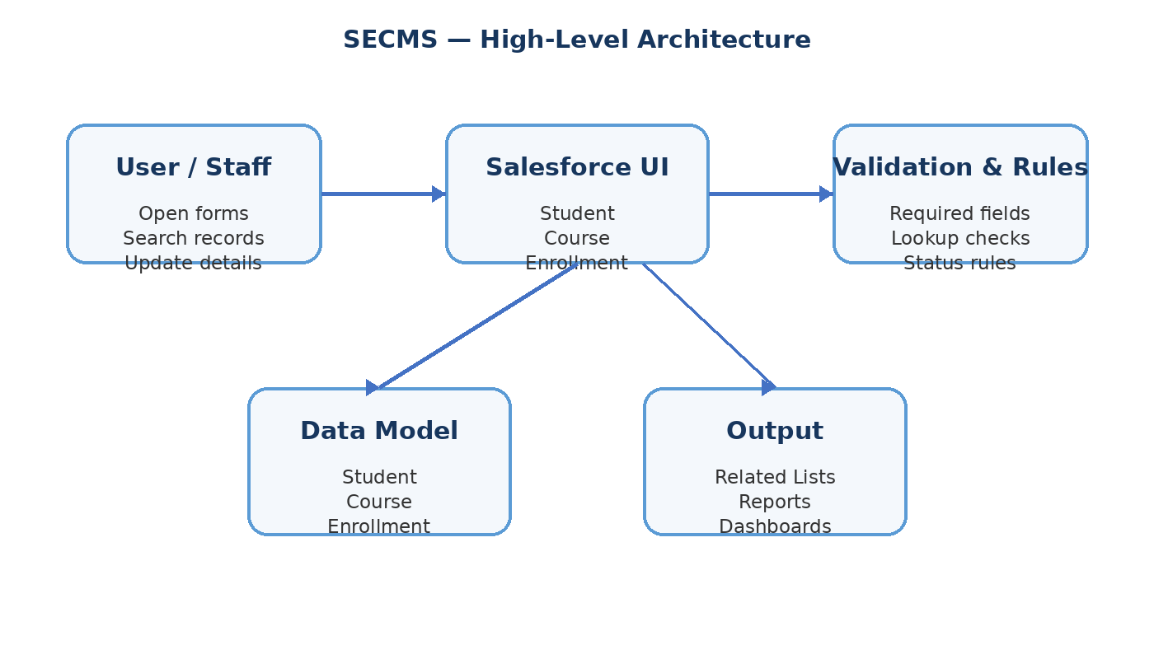
Figure 15.1 — High-level architecture of the SECMS solution.

10. ER / DATA MODEL
The main relationship is based on Student, Course, and Enrollment. A Student can have multiple Enrollment records, and a Course can also be connected to multiple Enrollment records. Enrollment therefore works as the connecting record.
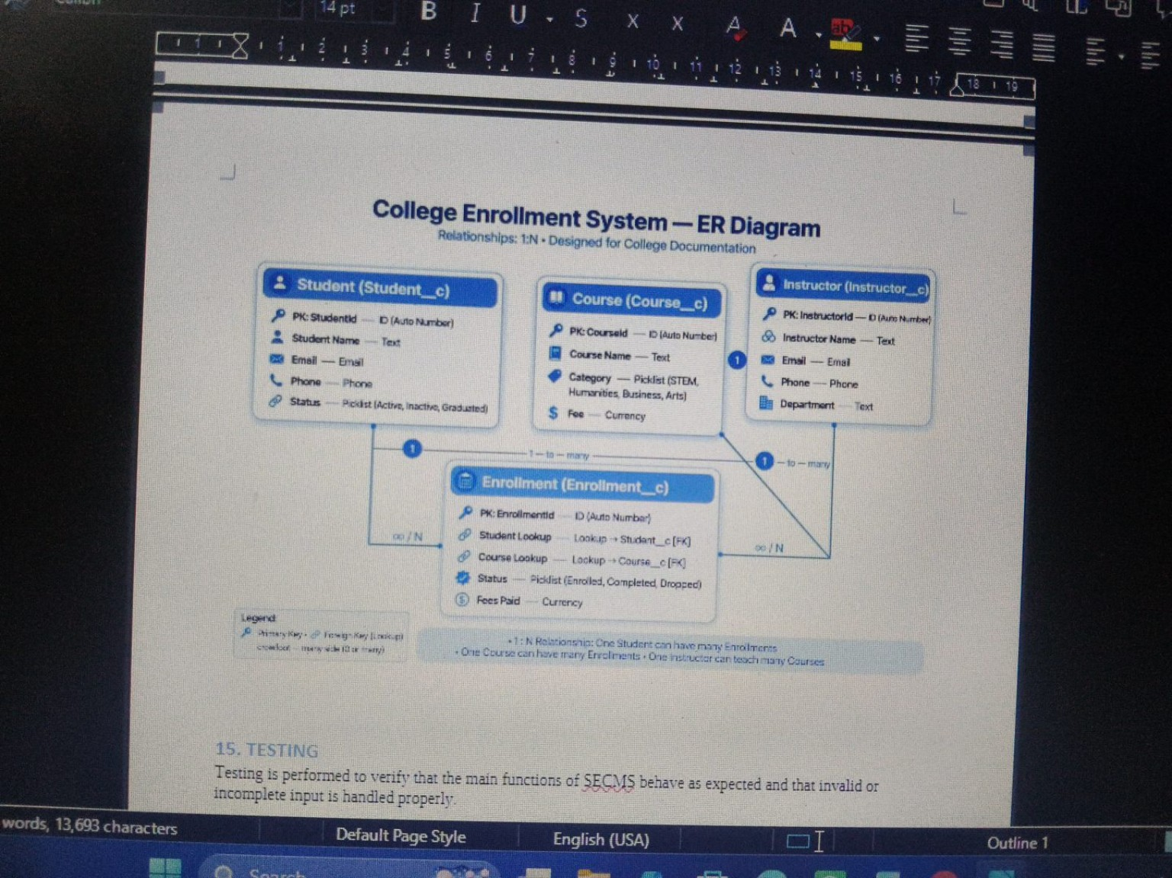
Figure 16.1 — ER-style model showing Student, Course, Instructor, and Enrollment relationships.

11. DATABASE AND OBJECT DESIGN
Object | Key Fields | Relationship / Role
Student__c | StudentId, StudentName, Email, Phone, Status | Parent of Enrollment records
Course__c | CourseId, CourseName, Category, Fee | Parent of Enrollment records
Enrollment__c | EnrollmentId, StudentLookup, CourseLookup, Status, FeePaid | Connects Student and Course
Instructor__c | InstructorId, Name, Email, Phone, Department | Optional teaching reference

Salesforce objects act as structured data containers. Auto Number fields can be used for identifiers, Text or Email fields store descriptive data, Picklists standardize status/category values, Currency fields store fees, and Lookup fields create relationships.

12. STUDENT OBJECT
The Student object stores the basic identity and contact information needed to identify a student within the system. A status field can be used to distinguish active, inactive, or graduated records.
Field | Type | Purpose
StudentId | Auto Number | Unique student reference
Student Name | Text | Student full name
Email | Email | Contact email
Phone | Phone | Contact number
Status | Picklist | Active / Inactive / Graduated

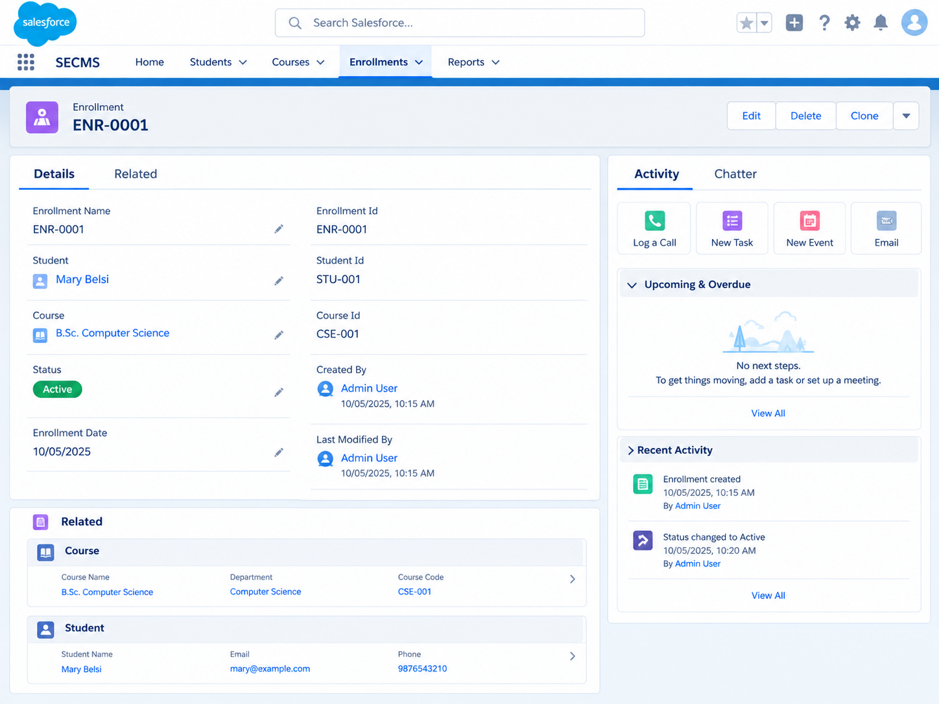
Figure 18.1 — Salesforce-style record view showing an SECMS enrollment with linked student information.

13. COURSE OBJECT
The Course object maintains the course catalogue used by the enrollment module. Keeping course information in a separate object avoids repeating the same course details for every student.
Field | Type | Example / Purpose
CourseId | Auto Number | Unique course reference
Course Name | Text | Name of the course
Category | Picklist | STEM / Humanities / Arts
Fee | Currency | Course or enrollment fee
Department | Text | Academic department
Status | Picklist | Active / Inactive

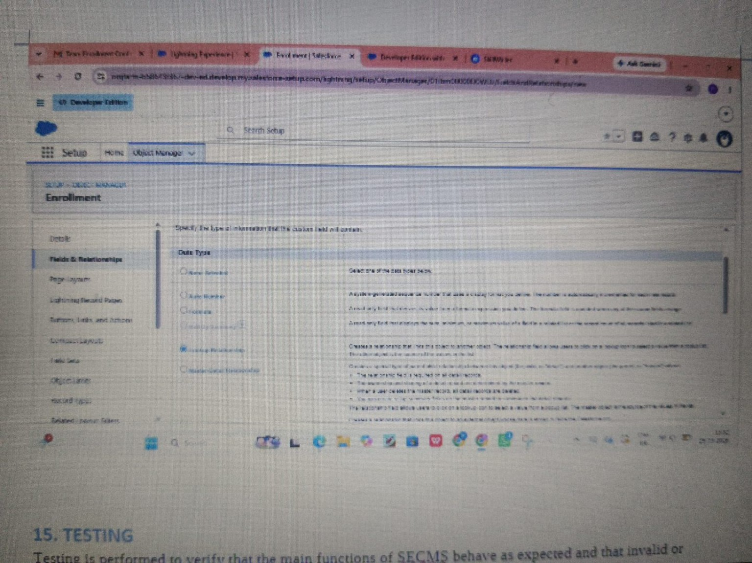
Figure 19.1 — Salesforce configuration view related to field and relationship setup.

14. ENROLLMENT OBJECT
Enrollment is the central transaction object. It records the association between a selected Student and a selected Course. The lookup fields prevent users from entering unrelated free-text values when a record relationship is required.
Field | Type | Purpose
EnrollmentId | Auto Number | Unique enrollment reference
Student Lookup | Lookup → Student | Select the student
Course Lookup | Lookup → Course | Select the course
Status | Picklist | Enrolled / Completed / Dropped
Fee Paid | Currency | Record payment amount
Enrollment Date | Date | Date of enrollment

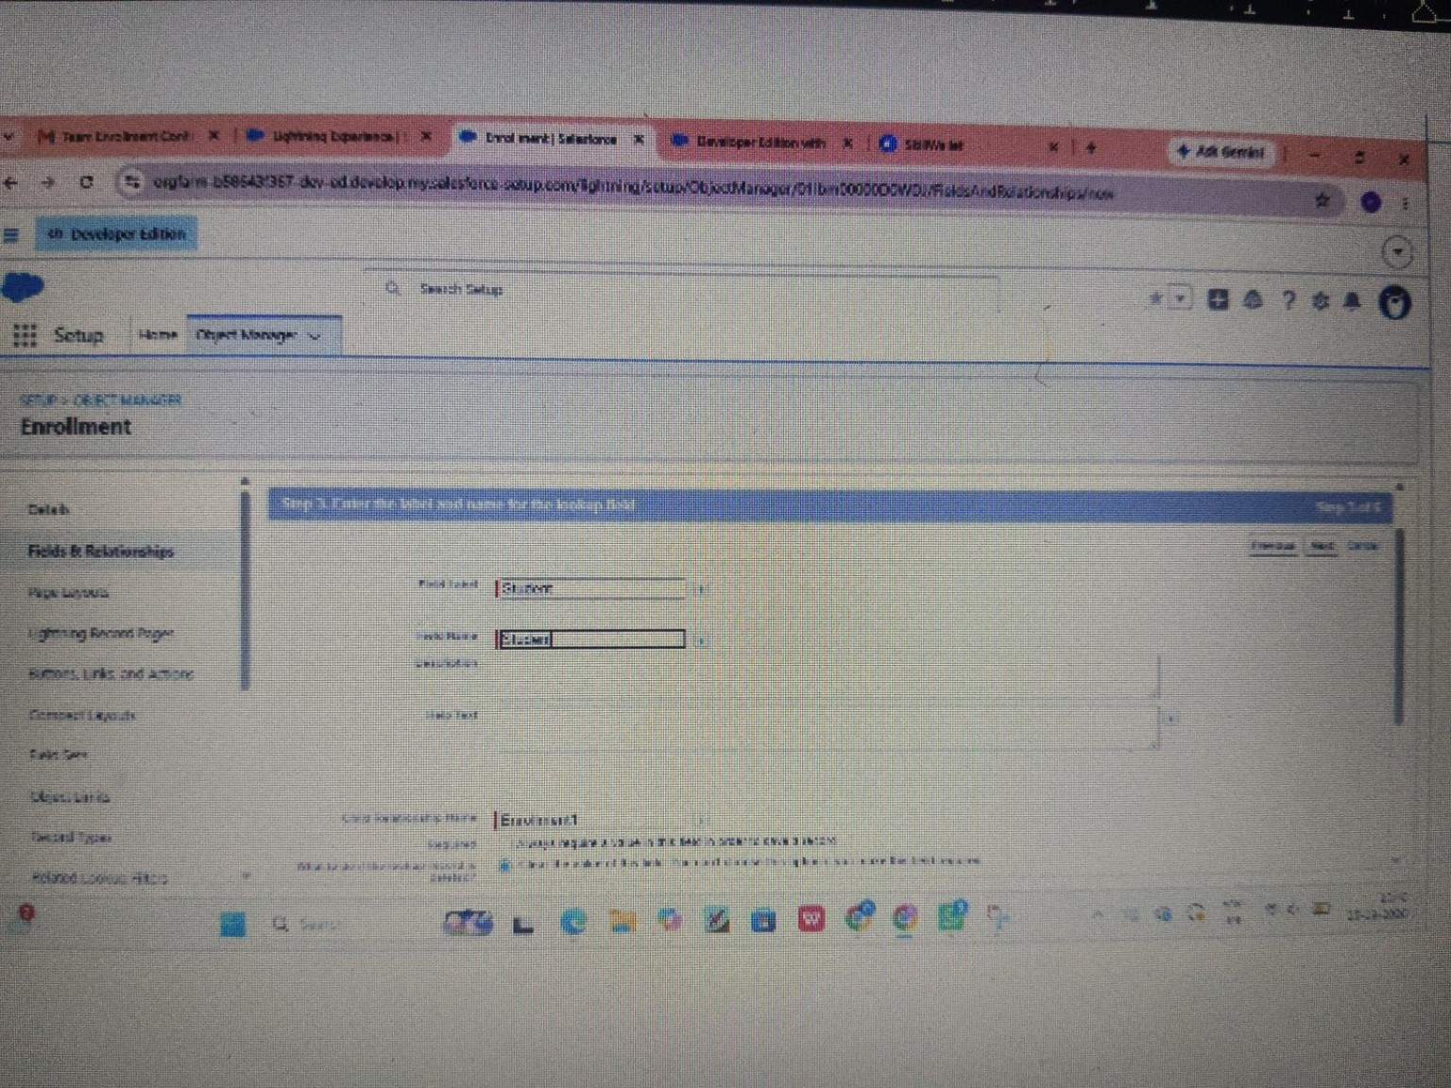
Figure 20.1 — Enrollment object configuration screen.

15. RELATIONSHIPS AND RELATED LISTS
Lookup relationships allow Enrollment to reference Student and Course records. Once the relationship is configured and the related list is placed on the page layout, users can view associated enrollment records from the parent record.
- Student → related Enrollments: shows the courses selected by the student.
- Course → related Enrollments: shows students associated with the course.
- Enrollment → Student: identifies the enrolled student.
- Enrollment → Course: identifies the selected course.
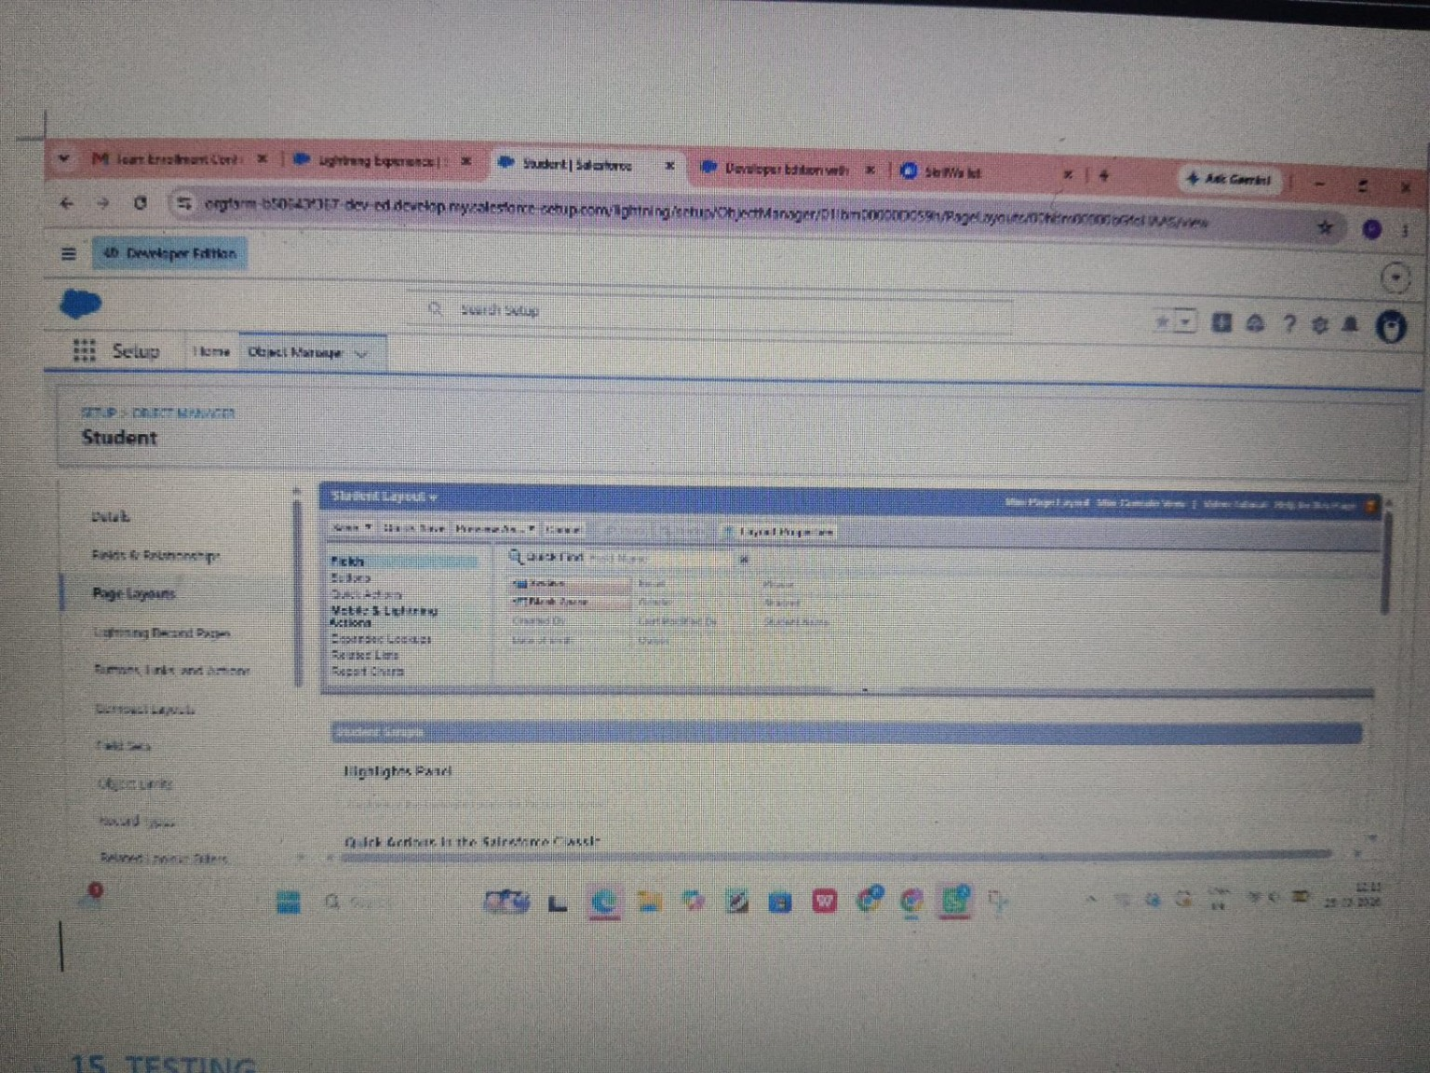
Figure 21.1 — Salesforce relationship/page configuration example.

16. USER INTERFACE
The SECMS interface is organized around familiar Salesforce record pages. Navigation can be provided for Home, Students, Courses, Enrollments, and Reports. Each record page can expose Details and Related sections so users can move between connected information.
Figure 22.1 — SECMS record page with Details, Related information, and activity area.
- Clear navigation between major modules.
- Record actions such as Edit and Delete.
- Details section for field values.
- Related section for connected records.

17. VALIDATION AND DATA QUALITY
Validation is used to prevent incomplete or unsuitable data from being stored. Required fields should be identified clearly, and business rules can be configured where necessary.
- Student name should not be left blank.
- Student email should follow a valid email format when required.
- Enrollment should reference a valid Student.
- Enrollment should reference a valid Course.
- Status should use the configured picklist values.
- Fee values should follow the expected currency format.
Figure 23.1 — Salesforce configuration example for validation/page behavior.

18. PROCESS FLOW
The enrollment process begins by opening the SECMS application and selecting or creating the required Student and Course records. The user then creates an Enrollment record, selects both lookup values, enters the remaining information, and saves the record.
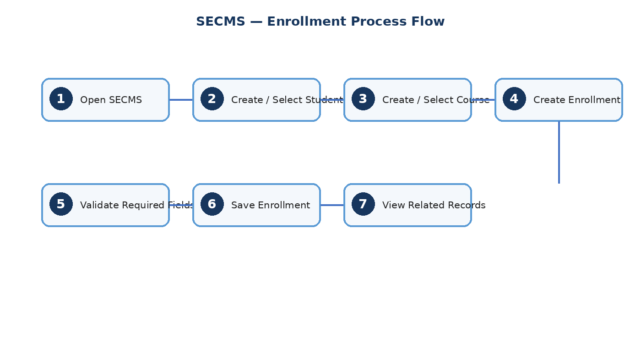
Figure 24.1 — End-to-end Student-to-Course enrollment process.

19. TESTING — TEST CASES
Testing is performed to verify that the major SECMS functions behave as expected and that invalid or incomplete input is handled appropriately.
Test Case | Input / Action | Expected Result | Status
TC01 | Open Student module | Student list/form opens correctly | Pass / Verify
TC02 | Enter valid student details | Student record is saved | Pass / Verify
TC03 | Leave required Student field empty | Validation message is displayed | Pass / Verify
TC04 | Open Course module | Course list/form opens correctly | Pass / Verify
TC05 | Enter valid course details | Course record is saved | Pass / Verify
TC06 | Create Enrollment with valid Student and Course | Enrollment is saved | Pass / Verify
TC07 | Open Student related list | Related enrollments are displayed | Pass / Verify
TC08 | Open Course related list | Related enrollments are displayed | Pass / Verify
TC09 | Edit an existing record | Updated values are stored | Pass / Verify
TC10 | Search for an existing record | Matching record is displayed | Pass / Verify

20. TESTING EVIDENCE
The project documentation includes visual evidence of the configured Salesforce environment and record-management screens. Screenshots are used to demonstrate that the objects, fields, relationships, and testing-related views were configured during the project workflow.
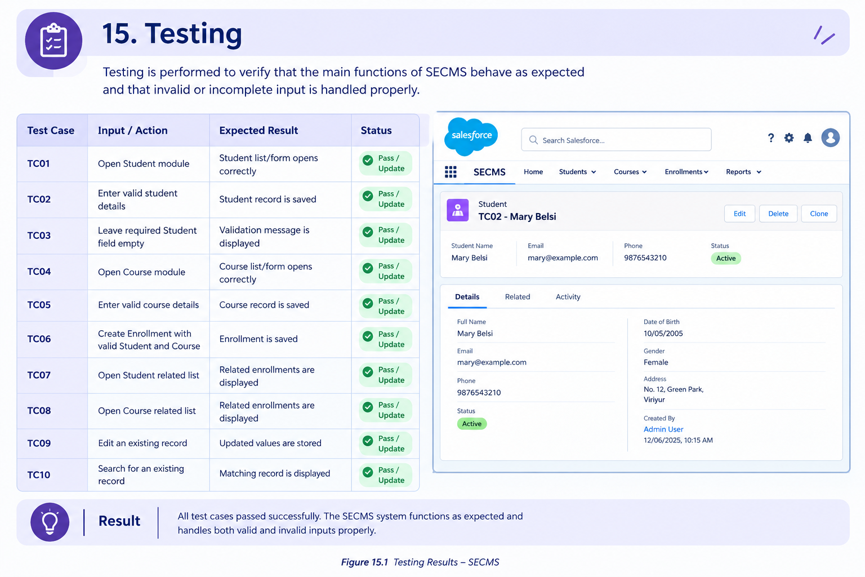
Figure 26.1 — Testing summary and documented validation evidence.

21. ADVANTAGES AND LIMITATIONS

21.1 Advantages
- Provides a connected structure for Student, Course, and Enrollment data.
- Reduces repeated entry of course details.
- Makes related academic information easier to navigate.
- Supports validation and standardized picklist values.
- Can be extended with reports, dashboards, and automation.
- Provides a practical demonstration of Salesforce data modelling.

21.2 Limitations
- The current scope focuses mainly on core academic records.
- Advanced attendance, marks, and timetable features are outside the core implementation.
- Actual access control depends on Salesforce configuration.
- Additional automation may be required for a production-scale system.

22. FUTURE ENHANCEMENTS
- Role-based access for administrators, staff, instructors, and students.
- Student self-service login and enrollment request.
- Course capacity and waitlist management.
- Automated email notifications for enrollment updates.
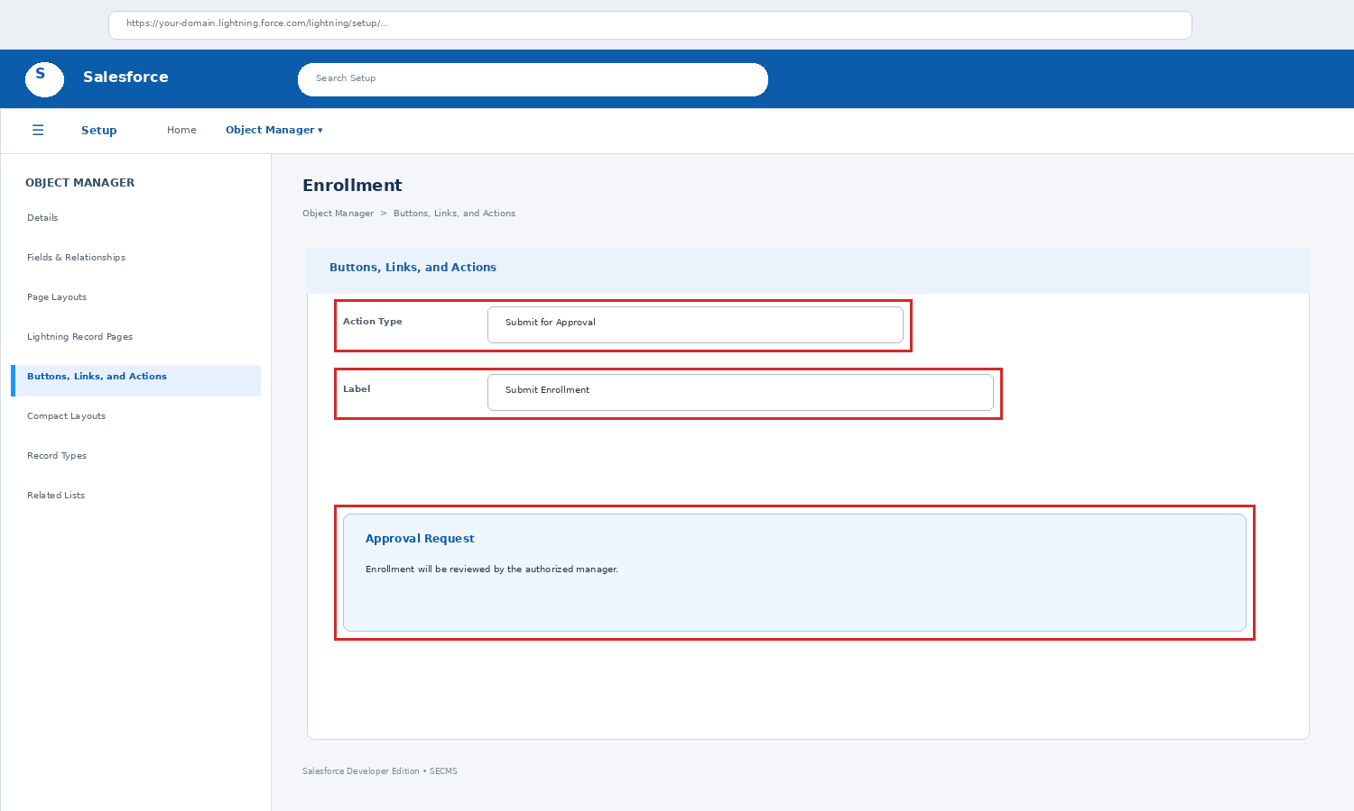
Figure: Salesforce approval/action configuration
- Approval workflow for special enrollment requests.
- Reports for course-wise and student-wise enrollment.
- Dashboards showing enrollment trends and active courses.
- Attendance and academic progress integration.
- Export of selected records to Excel or PDF.
- Mobile-friendly access and simplified student views.
These enhancements can be added incrementally without changing the basic Student–Course–Enrollment data model.

23. CONCLUSION
The Student Enrollment & Course Management System provides a structured method for organizing academic records using Salesforce platform features. The separation of Student, Course, and Enrollment data makes the system easier to understand and maintain.
The project demonstrates important Salesforce concepts including custom objects, fields, lookup relationships, page layouts, related lists, validation, record management, and testing. The same foundation can support future automation, dashboards, approval processes, and additional academic modules.
Overall, SECMS serves as a practical academic project for demonstrating how a cloud-based platform can be configured to manage connected records in a clear and maintainable manner.

Key Outcome
A connected academic record structure where Student and Course information can be maintained independently and linked through Enrollment records.

24. REFERENCES AND APPENDIX

24.1 References
- Salesforce official documentation and Trailhead learning resources.
- Academic references on database management systems and relational data modelling.
- Project notes and classroom materials related to Salesforce configuration.
- Screenshots captured during SECMS configuration and testing activities.

24.2 Screenshot Checklist
Evidence | Included Topic
Architecture / Data Model | SECMS objects and platform structure
Student Configuration | Student fields and record structure
Course Configuration | Course fields and catalogue structure
Enrollment Configuration | Student and Course lookup fields
Relationship View | Related lists and lookup connections
Record View | Details and related information
Validation Evidence | Required field / data-quality behavior
Testing Evidence | Test cases and expected outcomes

Appendix note: The screenshots in this documentation are used as project evidence and may be replaced with the final high-resolution screenshots captured from the completed Salesforce environment.

