The Modern AI and ML Development Stack, Powered by marimo
Course draft
This document contains the current course content and module plan. Interactive notebooks are represented by links to their source files and the live course preview.

Course direction
The course follows AI and ML work from prototype to production. Module 1 begins with the interactive environment used for exploration. Module 5 shows how to turn that work into a reusable script, app, or deployed workflow.

Module 1. Why Interactive Programming Environments Matter for AI and ML
Estimated time: 15 minutes
Interactive programming environments are a fundamental part of today's AI and ML development stack.
Researchers and data practitioners love notebooks because they combine code, computational output, and explanatory text into a single document.
This is quite different from software engineering. You do not simply write code, compile it, and ship it. You explore and experiment while moving between code, data, and results.
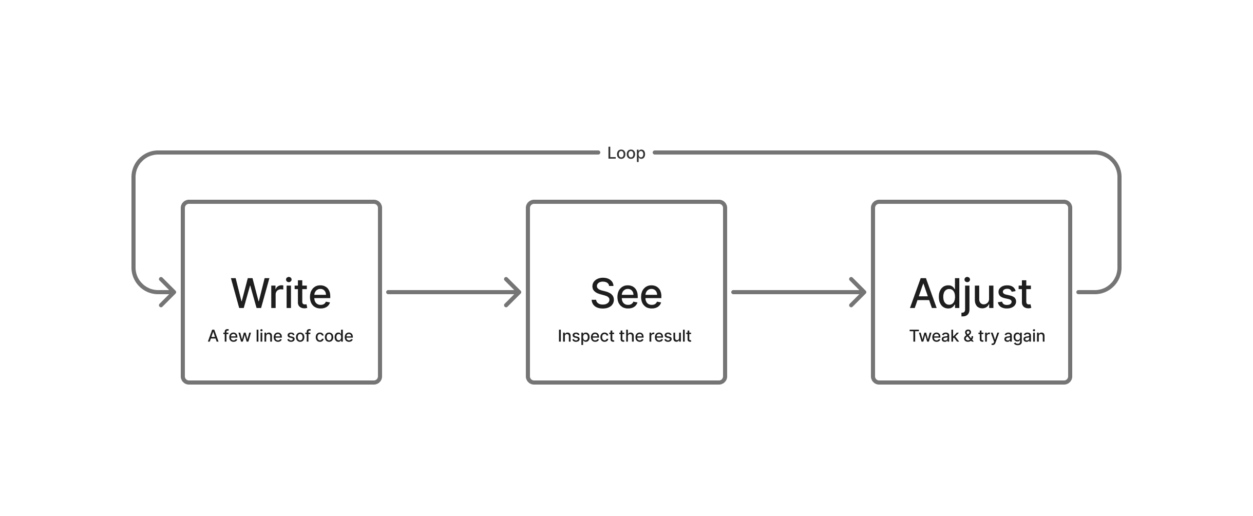
The loop between code, data, and results
This loop can happen many times during a project, and each result can change what you try next.
Interactive development environments like notebooks support this rapid feedback loop as we can view outputs alongside code. In fact, many important breakthroughs in modern AI, including early work on GPT at OpenAI, happened in notebooks.
Note Alec Radford, the first author of the original GPT paper and the researcher behind GPT-2, CLIP, DALL-E, and Whisper, did much of his work inside Jupyter Notebooks. Source

Drawbacks of traditional notebooks
Traditional notebooks are useful, but they also have serious limitations.
A large study by Pimentel et al. examined more than 1.1 million Jupyter notebooks from over 264,000 GitHub repositories. Only 24.11% executed without errors. Only 4.03% produced the same results as their stored outputs. Around 36% had cells executed out of order, while 77% had gaps in their execution counters, which can indicate hidden state.
Finding | Percentage
Executed without errors | 24.11%
Reproduced stored outputs | 4.03%
Cells executed out of order | 36%
Skips in execution counters, which can indicate hidden state | 77%

The problem stems from how traditional notebooks execute code. You run a cell and it changes the state held in memory. You then run another cell, and the state changes again. The notebook does not automatically track how one cell depends on another.
This leads to two common problems.

1. Hidden state
Consider the Jupyter notebook below, where a is set to 1, b is set to 2, and the final cell adds them together to return 3.
We then change the value of b to 11. After the cell runs, it is deleted. When a + b runs again, the notebook returns 12. The code that set b to 11 is gone, but its value remains in memory.
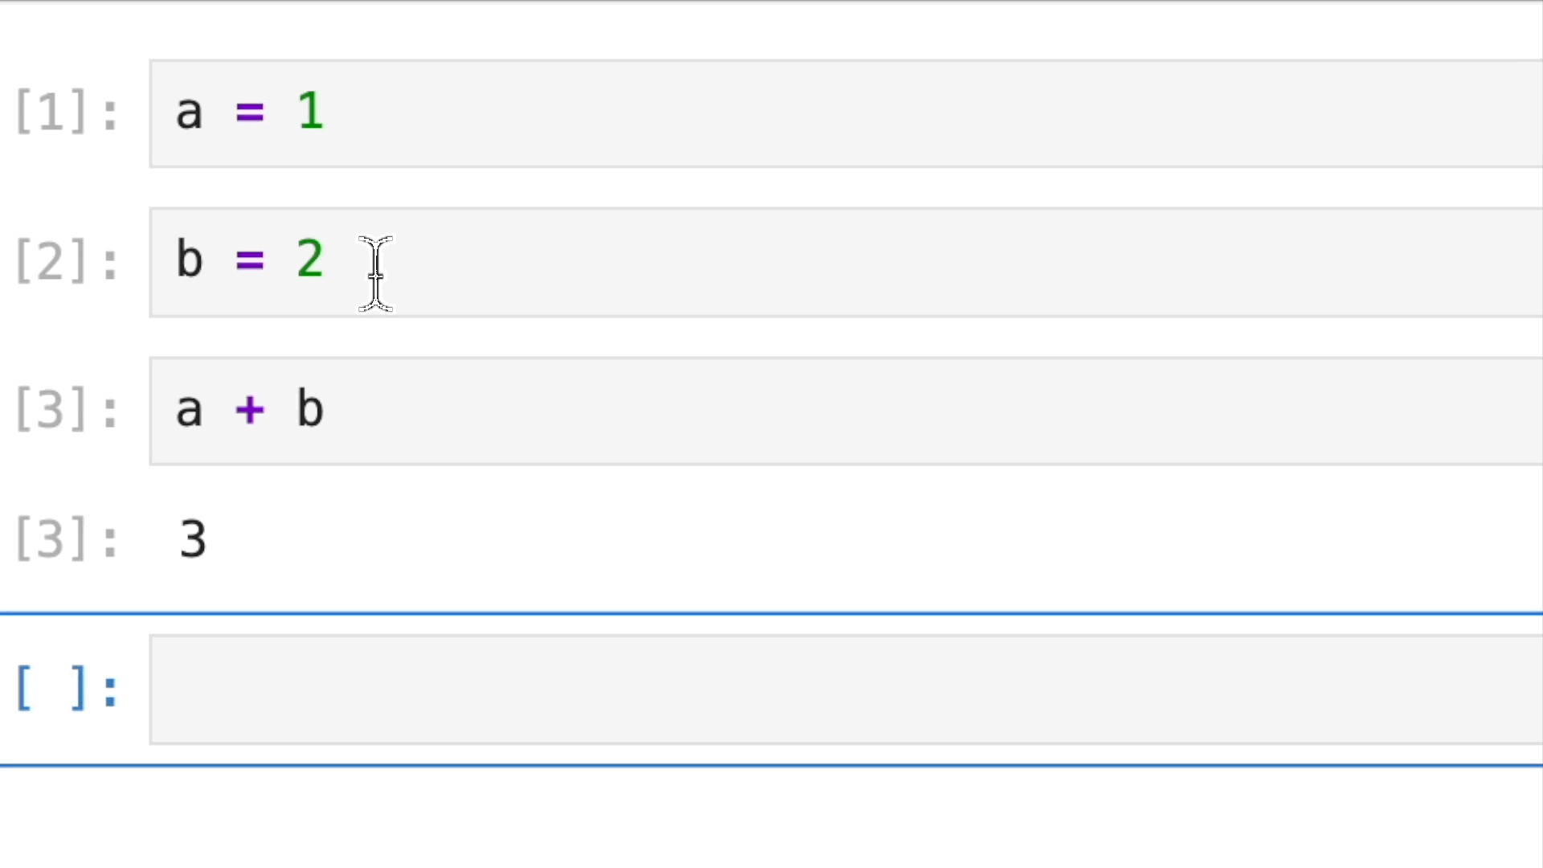
Hidden state in a traditional notebook
Hidden state Runtime information affects the result even though the visible code no longer contains the full definition.

2. Out-of-order execution
Consider another Jupyter notebook that calculates compound interest. It begins with a principal of 1,000, an annual rate of 7%, and a period of 20 years. Running the notebook calculates the final balance and creates a summary table. The years_used column shows 20 for every row.
Now suppose we change years from 20 to 50 and run only the parameter cell. Jupyter updates the value of years in memory, but it does not run the summary table cell again. The parameter cell now says 50, while the table still shows 20 in the years_used column.
This is an out-of-order execution problem. The parameter cell has run more recently than the table cell that uses it. The visible code and the stored output no longer agree. We must manually rerun the table cell to update it.
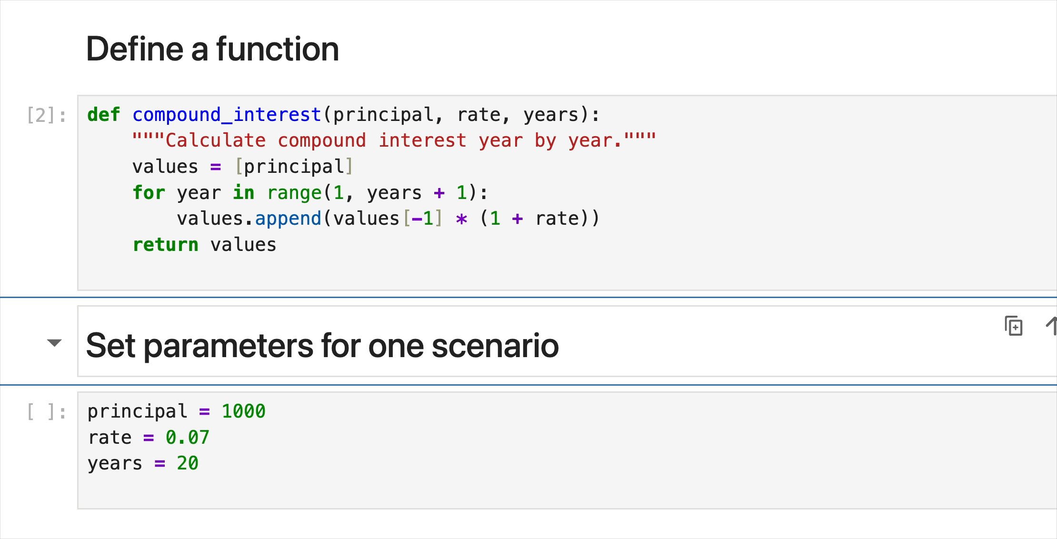
Out-of-order execution in a Jupyter notebook
Restarting the kernel and running every cell can fix these problems. People often avoid that step when a workflow must load a large dataset or train a model. Generating embeddings or running inference can also take a long time. Repeating all of that work after each change may be too expensive.

A better alternative: Reactive notebooks
Reactive notebooks provide a better alternative that tracks all variable dependencies. Reactive environments build dependency graphs that show how all cells are connected. When an input changes, every cell that depends on that input automatically reruns in the correct order.
The first reactive notebook uses the same hidden state example as the Jupyter notebook.
Interactive notebook: Hidden state in marimo
Open the notebook source or view the interactive course preview
Try it Change b from 2 to 11. Run that cell. The dependent cell updates c from 3 to 12. Next, remove the line that defines b and run the cell again. Check what happens to the cell that uses b.
Notice that the notebook invalidates the result when an input is missing. It does not continue to use the deleted value.
The next example uses the reactive compound interest workflow. Changing principal, rate, or years updates every result that depends on those values.
Interactive notebook: Reactive compound interest notebook
Open the notebook source or view the interactive course preview
Try it Change years from 20 to 50. Observe how the chart, final balance, and comparison table update together.

marimo: A reactive notebook
What you just used is marimo, a reactive Python notebook. marimo analyzes the variables that each cell defines and uses. It represents these relationships as a directed acyclic graph, or DAG. Each cell is a node in the graph. A connection from one cell to another shows that the second cell depends on a value defined by the first.
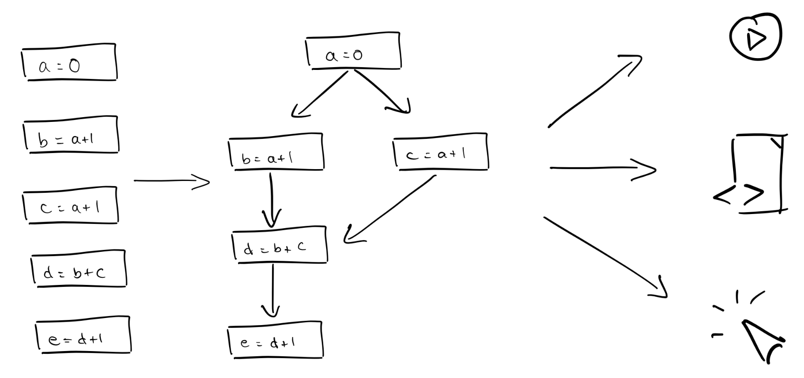
A marimo notebook represented as a directed acyclic graph
The notebook is shown on the left, with its dataflow graph in the middle. On the right, the same graph can be executed as a reactive notebook, a script, or a web app. Source: marimo
When years changes, marimo follows the DAG and runs every affected cell in the correct order. The graph is acyclic because a cell cannot depend on itself, either directly or through other cells.
The same DAG also prevents hidden state. If a cell that defines a variable is removed, marimo invalidates every cell that depends on it. Those cells cannot keep using an old value left in memory. The missing definition must be restored before the dependent cells can run.

Lazy execution
Some cells are expensive to run. Lazy execution lets you change an upstream value without running every dependent cell at once. marimo marks affected cells as stale, so you can see which results need to be updated and choose when to run them.
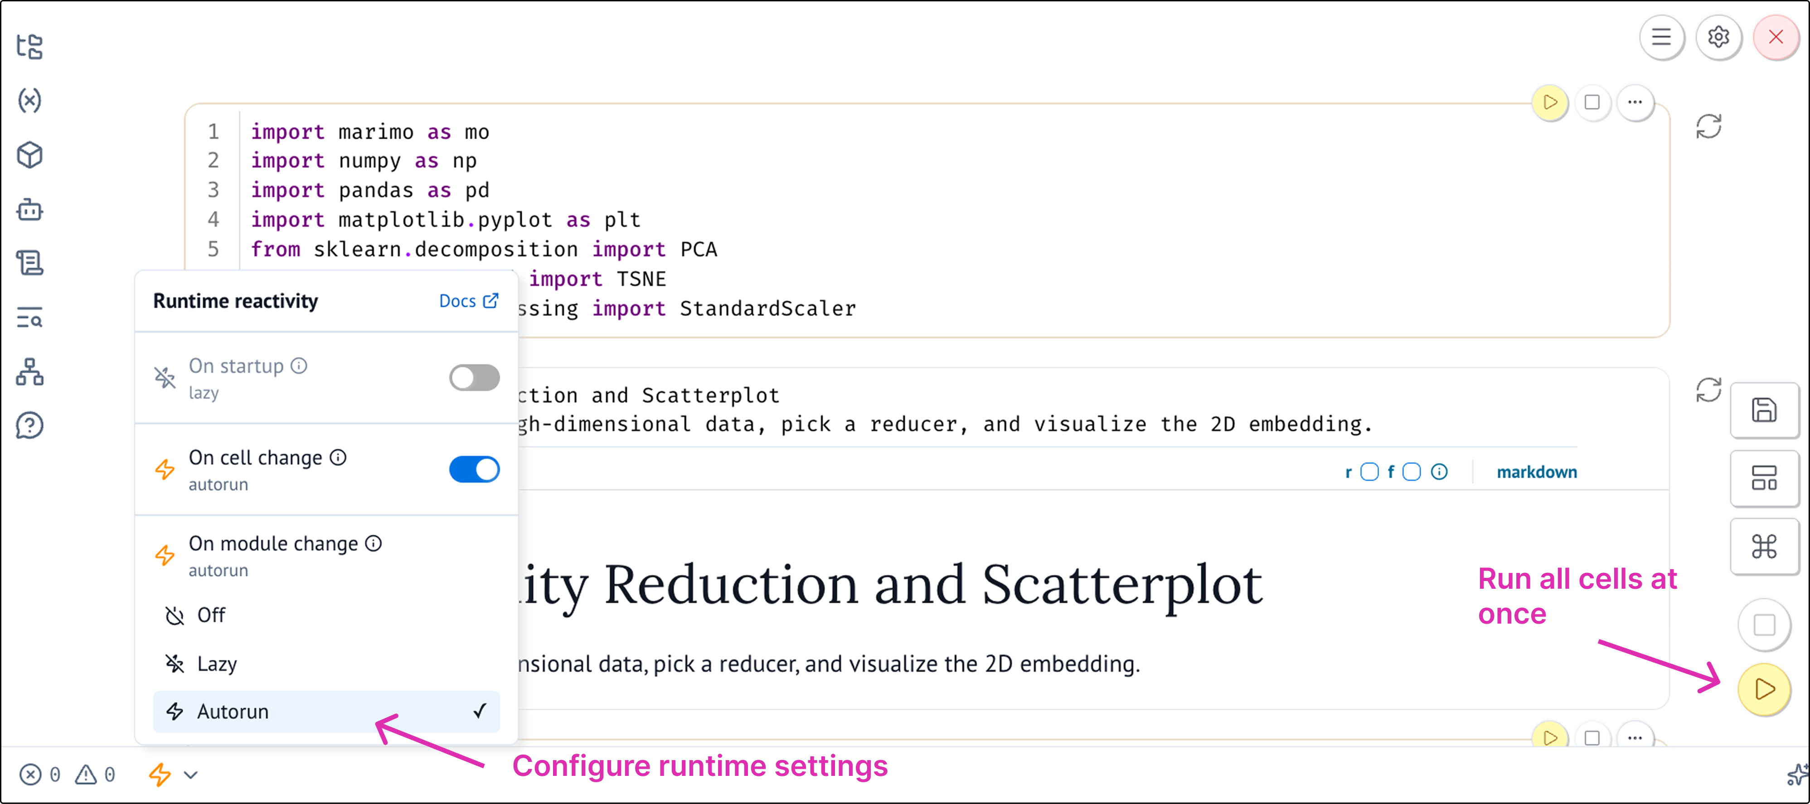
Lazy execution in marimo
Try it In the compound interest notebook, enable lazy execution. Change years, then inspect which result cells are marked as stale.

Hands on with marimo
This guided tutorial is included with marimo. It gives you a more detailed tour of the editor and explains how cells, outputs, dependencies, and notebook tools work.
Open the marimo guided tutorial
Try it Explore the panels in the notebook and see what options are available.
- Open the variables panel and see what information it shows.
- Open the dependency graph and select different cells.
- Look through the other panels in the sidebar.
- Open the menu for a cell and review the available actions.
- Open the command palette and browse the notebook commands.
You do not need to use every option. The goal is to see what is available and become familiar with the notebook interface.
If you are coming from Jupyter, you can convert an existing notebook.
Try it Run this command:
marimo convert notebook.ipynb -o notebook.py

Course question
What has been your biggest challenge with traditional notebook systems?
- I changed the code, but the outputs stayed stale.
- It works on my machine, but not yours.
- Poor Git and version control experience.
- It is hard to turn notebooks into apps or scripts.

Where the course covers each challenge
- Stale outputs: Module 1. Why interactive environments matter.
- Different machine results: Module 2. Reproducibility and trustworthy AI.
- Git and collaboration: Module 3. Interactivity and AI discovery.
- Coding agents: Module 4. AI coding agents for AI and ML.
- Moving work into production: Module 5. From prototype to production.

Summary
Traditional notebooks can depend on hidden runtime state and manual execution order. marimo tracks dependencies between cells so related code and outputs stay aligned. Lazy execution gives you control over expensive computations.
This is the first step in the course path from prototype to production. Later modules will build on this reactive foundation and show how to make notebook work reproducible and reusable.

Module 2. Reproducibility and trustworthy AI
Estimated time: 15 minutes
Learn how reproducible workflows support reliable AI and ML results.
This module is a draft. Its full lesson content will be added later.

Module 3. Interactivity and AI discovery
Estimated time: 15 minutes
Learn how interactive controls support exploration and discovery in AI and ML work.
This module is a draft. Its full lesson content will be added later.

Module 4. AI coding agents for AI and ML
Estimated time: 15 minutes
Learn how coding agents can support AI and ML development workflows.
This module is a draft. Its full lesson content will be added later.

Module 5. From prototype to production
Estimated time: 15 minutes
This module shows how to move from exploratory notebook work to a reusable result that other people can run, review, and maintain.

Learning goals
- Identify what must change before a prototype can be used by other people.
- Reuse notebook code from a script or Python module.
- Turn a notebook into an app.
- Check dependencies and expected outputs before deployment.
- Choose a suitable way to share or deploy the finished work.

Draft lesson structure

1. Define the production target
Start by deciding how someone will use the work. The result may be a script, an app, a scheduled job, or a reusable Python module.

2. Make dependencies explicit
Record the packages, data inputs, configuration, and environment needed to run the project. A second person should be able to reproduce the result without relying on hidden local state.

3. Reuse notebook code
A marimo notebook is stored as Python, so its functions and classes can be imported into other Python files. This lets the prototype become part of a larger system without copying code.

4. Test the important behavior
Add checks for the calculations and outputs that must remain stable. Run the notebook from a clean environment before sharing or deployment.

5. Publish the result
Choose whether to run the notebook as an app, execute it as a script, or include its code in another service. Document how to run it and how to update it.

Proposed hands-on activity
Learners will take one notebook from an earlier module and prepare it for another person to use. They will identify its dependencies, extract reusable code, add one check, and choose a delivery format.

