Why Interactivity Accelerates AI Discovery
Module 3 | 20 minutes
Interactivity changes how you develop and understand AI systems. Imagine your data, models, visualisations and user input working together in a single system that updates automatically. You can seamlessly move from a question to an experiment to an answer without having to leave the system. This not only saves you time, but also helps you understand the effect of each change instantly.
marimo supports this kind of interactive computation by connecting the parts of a notebook that work together. In this module, you will explore a dataset, select features, train models, and debug errors interactively in a single workflow. You will see how interactivity helps you understand the data, models, and results more quickly than a traditional notebook workflow.
Throughout this module, you will use marimo's interactive UI elements. These are controls such as radio buttons and sliders. Each control has a current value that other cells can use. When you change the value, marimo updates the cells that depend on it. We will use the word "control" for these UI elements throughout the lesson.

Data
You will work through an end-to-end AI workflow using the Adult Income dataset. The dataset comes from US Census data. The task is to predict whether a person earns more than $50K per year based on their demographic information.
Here is the path you will take:
- Inspect and preview the data.
- Explore the data visually.
- Fit and compare two models.
- Debug model errors interactively.
Each section includes an interactive marimo notebook. First, explore the notebook and try its controls. Then complete the questions in the "Try it" section.

1. Inspect the data

Raw dataframe
It is helpful to start with an overview of the data so you can understand its structure and content. marimo displays a raw dataframe as an interactive table. You can search, sort, and filter the rows. You can also inspect the data types and summary statistics for each column.
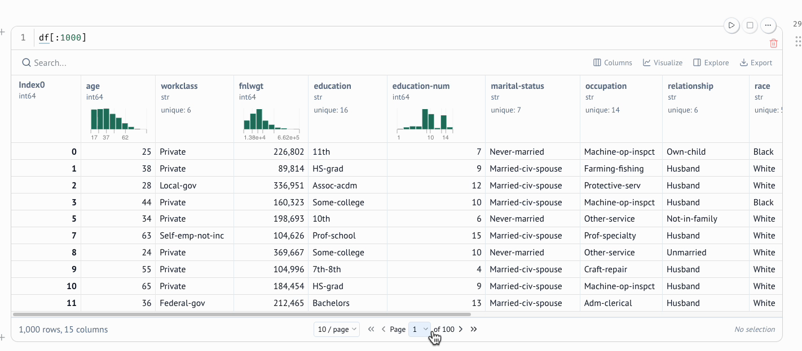
Inspect the raw dataframe in marimo.

Data editor
marimo also provides a data editor for small experiments. You can change a value and inspect the edited dataframe in another cell.
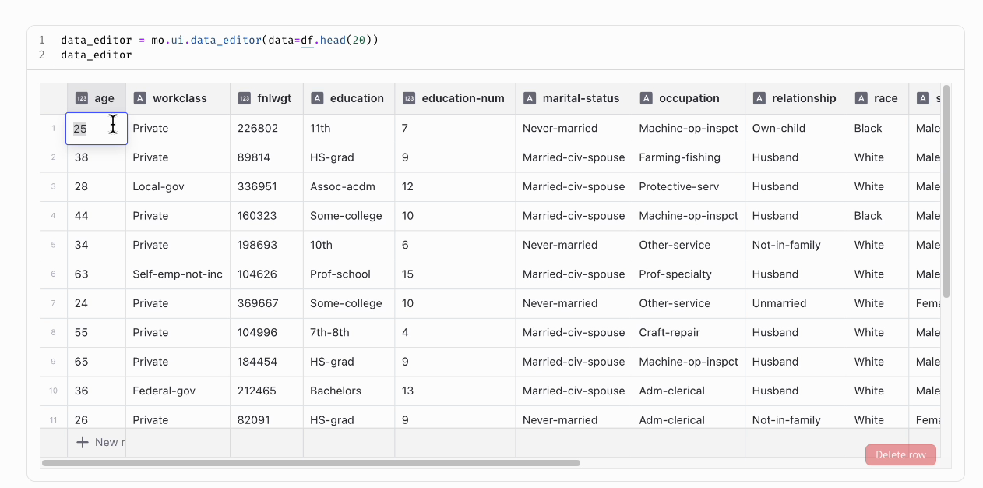
Change a value in the data editor and inspect the result.

Selectable table
There is also a table option when you want to select a subset of rows and make them available to other cells in the notebook.
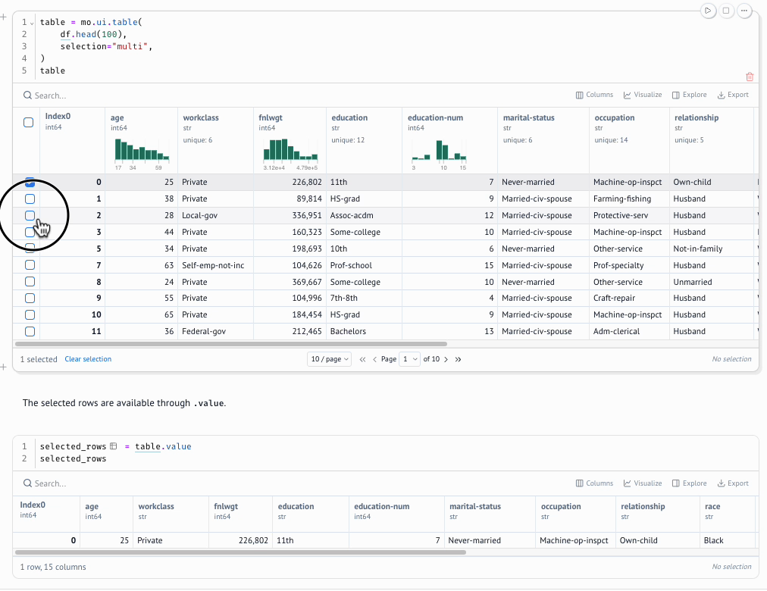
Select rows and use them in another notebook cell.
These features let you inspect and explore data in detail without writing extra code.

Try it
- Filter occupation to Sales. First, keep rows where hours-per-week is 20 or less and note the income labels. Then change the filter to 50 or more hours. Which group contains the income label 1 more often?
- Select one row with an income label of 0, which means at or below $50K. Select another row with a label of 1, which means above $50K. Compare their age, education, occupation, and hours-per-week values. Note which differences stand out.
- In the data editor, change one person's age to 60. Check that the new value appears in the edited dataframe and that the original dataframe remains unchanged.
Interactive notebook: Inspect and edit data

2. Explore data visually
After looking at the raw dataframe, it is time to move into marimo's built-in visual exploration tools. Data visualisation can help you find patterns that are difficult to see by looking at the raw data.

Data explorer
marimo's data explorer offers a chart-first approach. You can use it to explore distributions and relationships visually before deciding which features are worth selecting. The chart updates when you change the selected columns or filter the data.
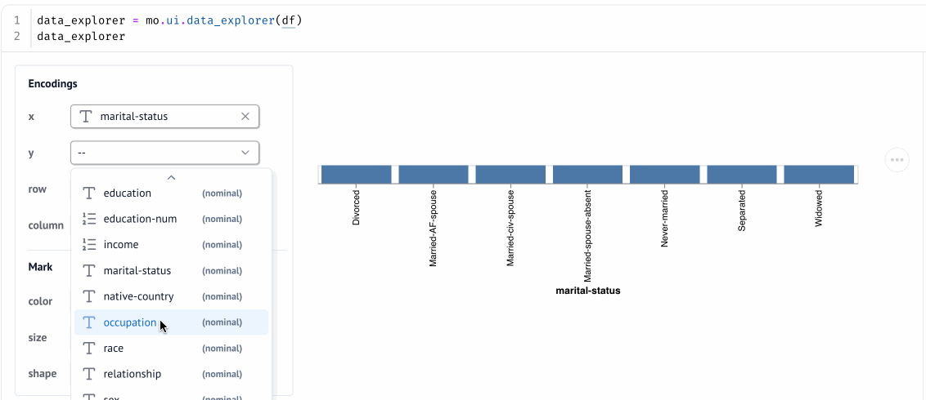
Choose fields in the data explorer and see the chart update.

Transform a dataframe
You can also use the dataframe view to build transformations such as filtering, sorting, grouping, and aggregating by selecting options. As you apply these transformations, marimo generates the matching Python code. You can view this code in the Code tab, copy it into your notebook, or use the transformed dataframe in later cells.
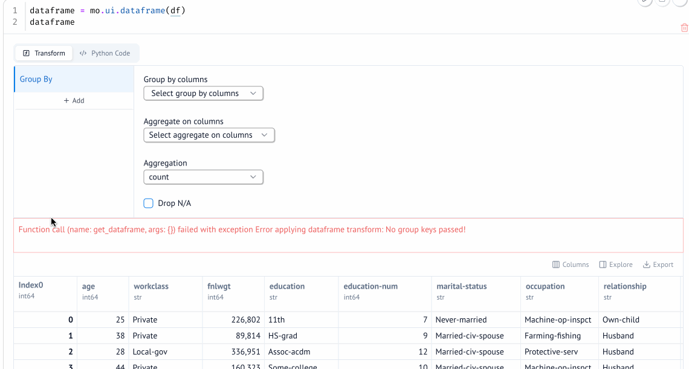
Build a dataframe transformation and inspect the generated Python code.

Try it
- Use the data explorer to create a chart that compares age with income.
- Use the dataframe view to keep people who work more than 40 hours per week.
- Inspect the filtered rows. Write down one pattern that you would like to test with a model.
Interactive notebook: Explore data visually

3. Train and evaluate models
Once you have explored the data, the next step is to train models. In this section, you will train a Decision Tree and a Random Forest on the Adult Income data. You will evaluate how well they separate the two income classes. This comparison will help you decide which model to investigate further.

Choose the features
Different features provide different information to a model. Testing several feature combinations helps you see how a column affects the results. It can also reveal features that add little useful information. marimo provides a multiselect control for this choice. You can add or remove features without editing the model code.
When the selection changes, marimo prepares the feature table again, retrains both models, and updates their scores and probability plots.
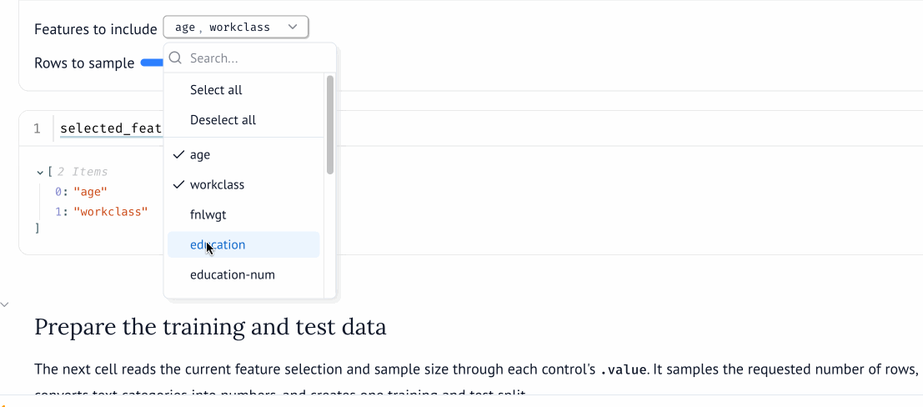
Change a model input and marimo prepares the training and test data again.

Change the sample size
The amount of training data can affect model performance and training time. Testing several sample sizes helps you see whether the results remain similar as more data is added.
You can use a marimo slider for this choice. Moving the slider changes the number of rows in the training sample. marimo then sends the new choice through the connected notebook cells.
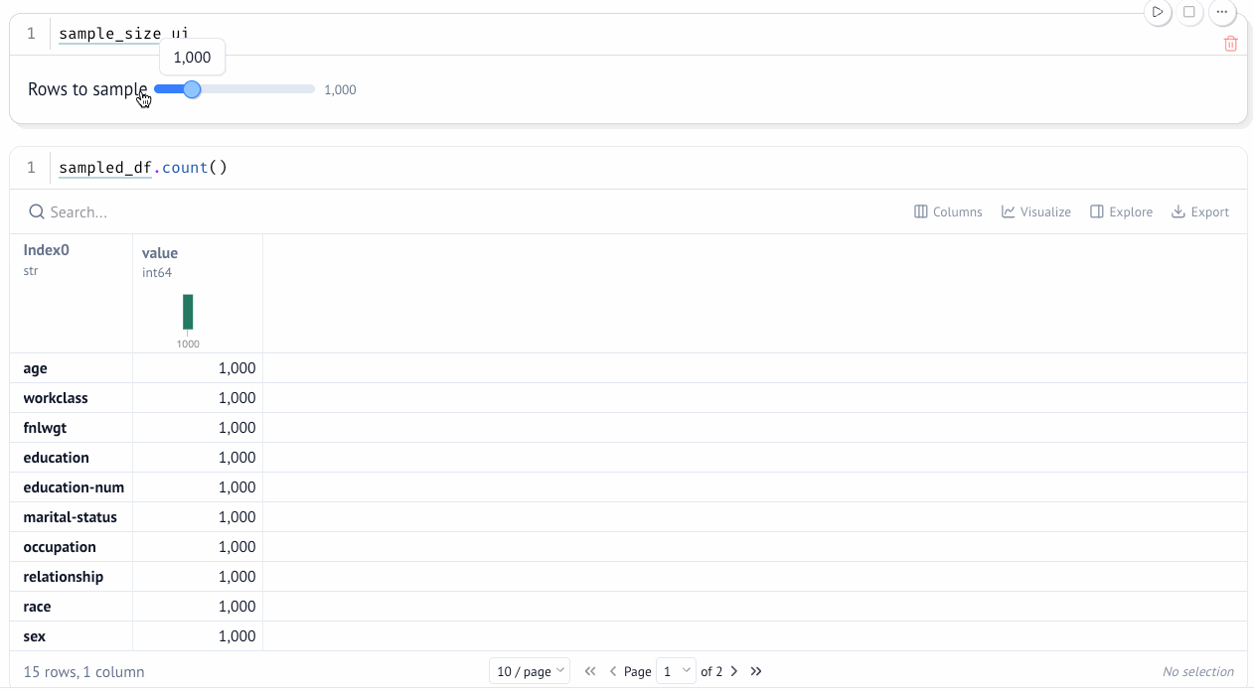
Move the slider and check that the sampled dataframe contains the selected number of rows.

One connected experiment
The feature selector and sample size slider affect the same prepared dataset, which is then passed to the models. marimo tracks these dependencies. Changing either control reruns the data preparation and model cells while leaving unrelated cells unchanged.
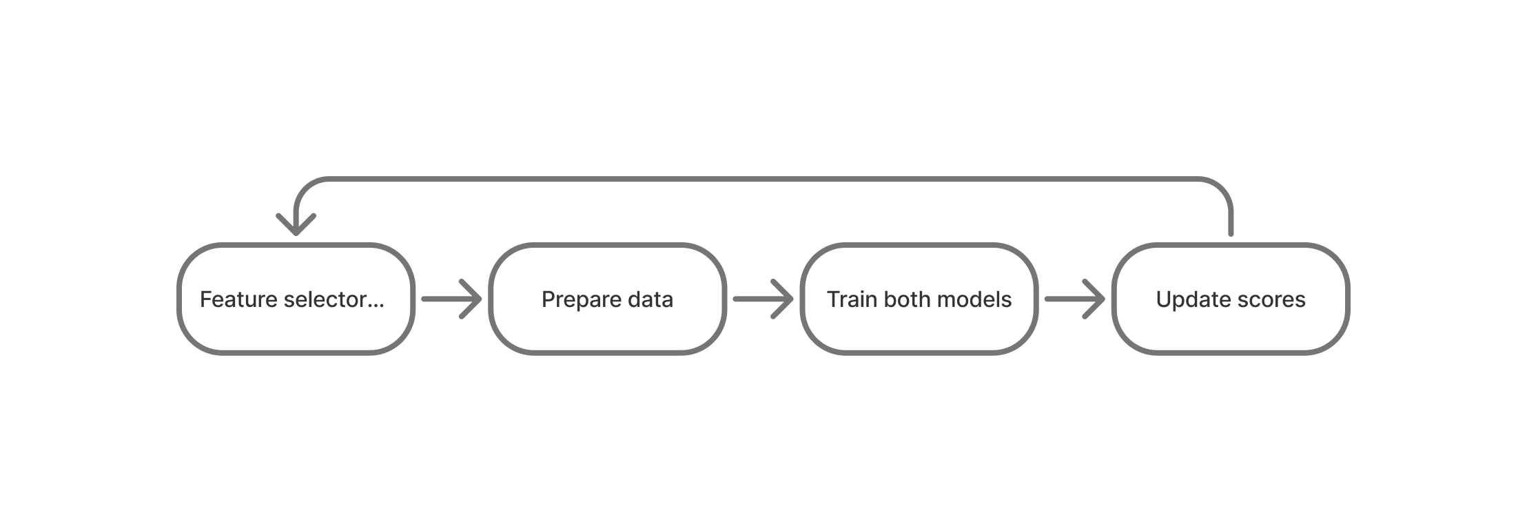
The model controls, prepared data, trained models, and results form one connected experiment.
Interactive notebook: Train and evaluate models

Try it
- Start with 1,000 rows. Select age, education-num, capital-gain, capital-loss, and hours-per-week. Record both ROC AUC scores.
- Add occupation while keeping the sample size unchanged. Which model's score changes more?
- Increase the sample size to 2,500 rows while keeping the same features. Compare the scores and probability plots with your earlier results.
- Choose which model you would investigate further. Write down the result that supports your choice.

4. Debug errors interactively
A model score gives you an overall measure of performance, but it does not show which rows the model misclassified. In the final notebook, you will choose one of the two models and explore its errors interactively.

Choose what to inspect
Here, we use marimo UI elements again to control the analysis. The model selector is a `mo.ui.radio()` control that lets you choose one model. The error type control uses another radio group to show all errors, false positives, or false negatives. The `mo.ui.slider()` control sets the classification threshold that converts predicted probabilities into class predictions.
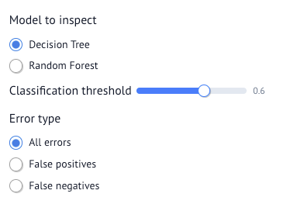
Choose the model, classification threshold, and type of error to inspect.

Change the threshold
Changing the classification threshold affects the balance between false positives and false negatives.
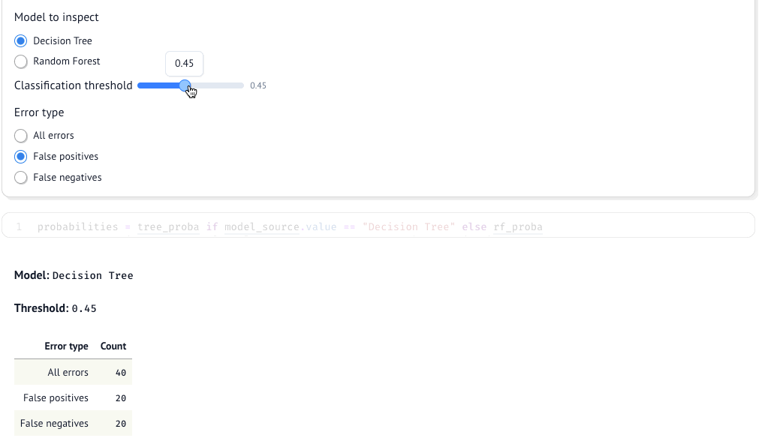
Change the threshold and compare the updated error counts.

Inspect individual errors
Select individual misclassified rows to inspect their features, predicted probabilities, true income labels, and predicted income labels.
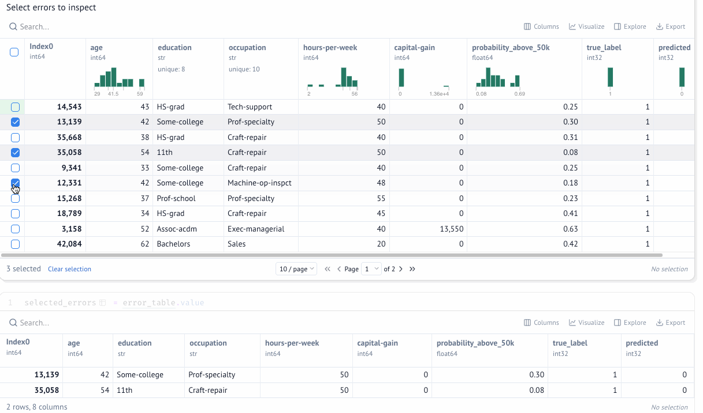
Select an error to inspect its features and prediction more closely.
marimo keeps the controls, error counts, and selected rows connected. This helps you understand how the model behaves and decide what to change in the next experiment.
Interactive notebook: Debug errors interactively

Try it
- Compare both models at a threshold of 0.5.
- Raise the threshold to 0.7 and compare the false positive and false negative counts.
- Select two errors and inspect their features. What would you change in the next experiment?
You began with individual rows and ended with individual errors. Throughout the experiment, marimo kept each stage connected to the next. You can move from one question to the next without rebuilding the workflow each time.

Check your understanding

Question 1
In a marimo notebook, what causes downstream cells to update when a user changes the multiselect control?
A. marimo reruns the entire notebook from top to bottom.
B. Only the cell containing the control runs again.
C. marimo tracks dependencies and reruns only the affected downstream cells.
D. The browser handles every update without running Python.

Question 2
In marimo, how can rows selected in mo.ui.table() be used in another cell?
A. The selection only changes how the rows look in the table.
B. The table's .value contains the selected rows as a dataframe.
C. The selected rows must be exported and loaded again.
D. marimo adds the selected rows to every cell automatically.

Question 3
What is the main difference between mo.ui.data_editor(df) and mo.ui.dataframe(df) in this workflow?
A. The data editor changes individual values, while the dataframe control builds transformations such as sorting and filtering.
B. Both edit individual values, but only the dataframe control can update downstream cells.
C. The dataframe control changes individual values, while the data editor is only for inspection.
D. There is no functional difference between them.

Answer key
1. C. marimo tracks which cells depend on the control and reruns only the affected downstream cells.
2. B. The table's .value contains the selected rows, so later cells can use them as a dataframe.
3. A. The data editor changes individual values. The dataframe control builds transformations. Both can make their current result available to downstream cells through .value.

