Module 5 From Prototype to Production
Course draft for Google Docs
An interactive notebook is a great place to begin a project because it lets you experiment and test ideas quickly. However, your requirements may change when you need to share your work with others or integrate it into a larger production system.
In this module, you will learn how to share and reuse your marimo notebook, then create a custom view of its analysis with marimo-studio.

1. Share your notebook in multiple ways

1.1 Explore the occupancy notebook
Imagine you work for a company that wants to estimate whether a meeting room is occupied from its sensor readings. Your task is to compare the predicted occupancy with the recorded occupancy and choose a decision threshold. A false positive could keep the lights on in an empty room. A false negative could turn them off while people are still there.
We will use this example throughout the module.
Explore the occupancy notebook below. The sensor data is included, so you can run the example directly in the course.
The following marimo notebook contains 8,143 sensor readings and a slider for the decision threshold. A reading is predicted as occupied when its score is at least the threshold. These controls use the widgets introduced in Module 3 (/?module=3).
Interactive notebook: Review room occupancy
About this example
This simplified course notebook is adapted from marimo-studio's original occupancy notebook (https://github.com/marimo-team/marimo-studio/blob/72376de50eb89fe8372ad55f3b341cfb439be154/examples/occupancy.py), using the UCI Occupancy Detection dataset (https://doi.org/10.24432/C5X01N). We kept its scoring rule and threshold evaluation, and made its functions reusable. Section 2 shows how to add command-line arguments and save predictions. It combines light and CO₂ readings into a score. This is a simple scoring rule, not a trained model or a probability. Its metrics describe the same observations used to define the score.
Move the threshold from 0.5 to 0.7 and inspect the error counts. The dataframe places each prediction beside the recorded occupancy, so you can inspect where they differ.

1.2 Share and export your notebook
Select the preview button in the notebook editor to open app view. It shows the controls and results without the code.
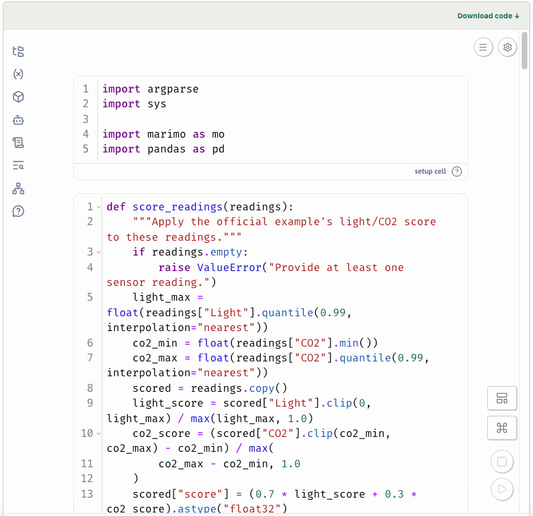
You can also export and share the notebook in multiple formats, as shown in the image below.
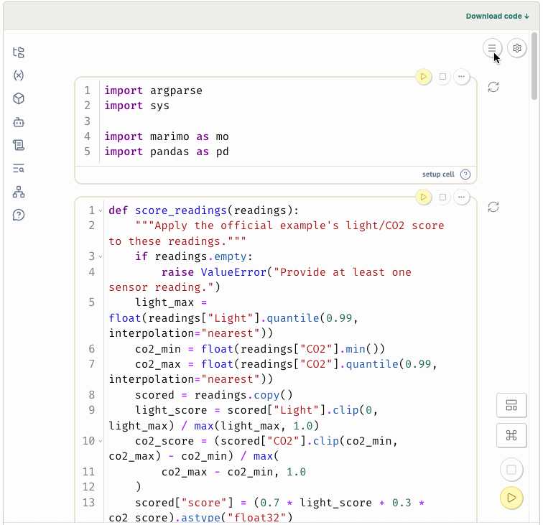

2. Use your notebook as a script or Python module

2.1 Run the notebook as a script
You can run the occupancy notebook you explored above as a script from the command line. This is useful when you want to run the same analysis repeatedly without opening the notebook interface. For example, you might want to process a batch of sensor readings and save the results for a dashboard or report.
As you saw in Module 1, a notebook cell can have a Python function name. Here, script_options is the cell that reads the input file, threshold, and output filename. The updated cells use these values when the notebook runs as a script.
Interactive notebook: Add script support to the occupancy notebook
In the notebook, the script_options cell reads three command-line arguments:
- --input specifies the sensor data file. If you leave it out, the notebook uses public/occupancy.csv.
- --threshold specifies the threshold to use.
- --output specifies where to save the predictions.
The selected_model cell uses the threshold from the command line when the file runs as a script. The save_predictions cell writes the CSV and prints the summary. In the editor, the notebook continues to use the slider.
To try it in a terminal, run the command below from the folder containing occupancy.py and the public data folder:
uv run occupancy.py \
--threshold 0.5 \
--output occupancy_predictions.csv
You should see output similar to the following:
Wrote 8143 rows to occupancy_predictions.csv
False positives: 90; false negatives: 5

2.2 Reuse the evaluation in another notebook
Another advantage of a marimo notebook is that it is a Python file. You can import its functions into another notebook instead of copying code.
You already have an occupancy notebook in Section 1.1. Its score_readings() and evaluate_occupancy() functions are already in the correct format for reuse: each is defined in its own cell and uses imports from the setup cell. When your own function follows this pattern, marimo marks it as reusable in the editor.
The notebook below imports both functions and uses them to compare three thresholds using the same sensor readings.
Try it
Adjust the thresholds in the notebook below. Compare the false positive and false negative counts for each threshold.
Interactive notebook: Import and reuse the occupancy functions

3. Create views from one notebook with marimo Studio
App view and exports let you share a notebook as it is. Sometimes, however, different audiences need different ways to use the same analysis. Copying the notebook for each audience can create versions that drift apart. Adding all the presentation code to the notebook can also make the analysis harder to read.
With marimo Studio (https://marimo.io/blog/introducing-marimo-studio), the analysis stays in one notebook while you create separate views on top of it.
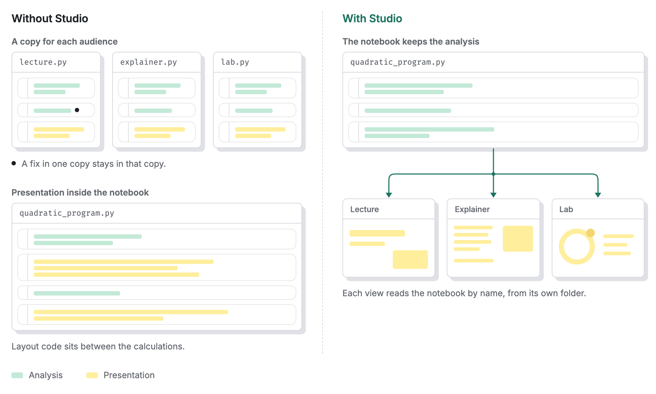
marimo Studio keeps the analysis in one notebook and gives each audience a separate view. A change to the analysis can then be used by every view. Source: Introducing marimo-studio (https://marimo.io/blog/introducing-marimo-studio).
For our occupancy analysis, the same notebook can be useful in three different ways:
- A facilities team might want a monitor showing the current occupancy results.
- Someone choosing the decision threshold might need a model review that makes false positives and false negatives easier to compare.
- A manager might want a short report summarising the results.
All three can use results from the same occupancy.py notebook. The notebook continues to contain the data and Python calculations. Each view chooses which results to show and how to arrange them.
Our notebook already calculates the selected threshold, precision and recall, false positive and false negative counts, and rows where the prediction was incorrect. A view can use these results instead of calculating them again.

3.1 Create a simple view manually
Creating a Studio view is simple. In this activity, let's create a small view from the occupancy notebook.
Start marimo Studio
This activity runs locally. Open a terminal in the course folder that contains occupancy.py, then start marimo with Studio:
uvx --with marimo-studio marimo edit occupancy.py --sandbox --watch
Studio opens occupancy.py in your browser.
With occupancy.py open, click the arrow beside the current view name in the top bar, then select Add view. Enter simple-view as the name, choose HTML document, and select Create view. If an existing view opens first, this adds simple-view alongside it.
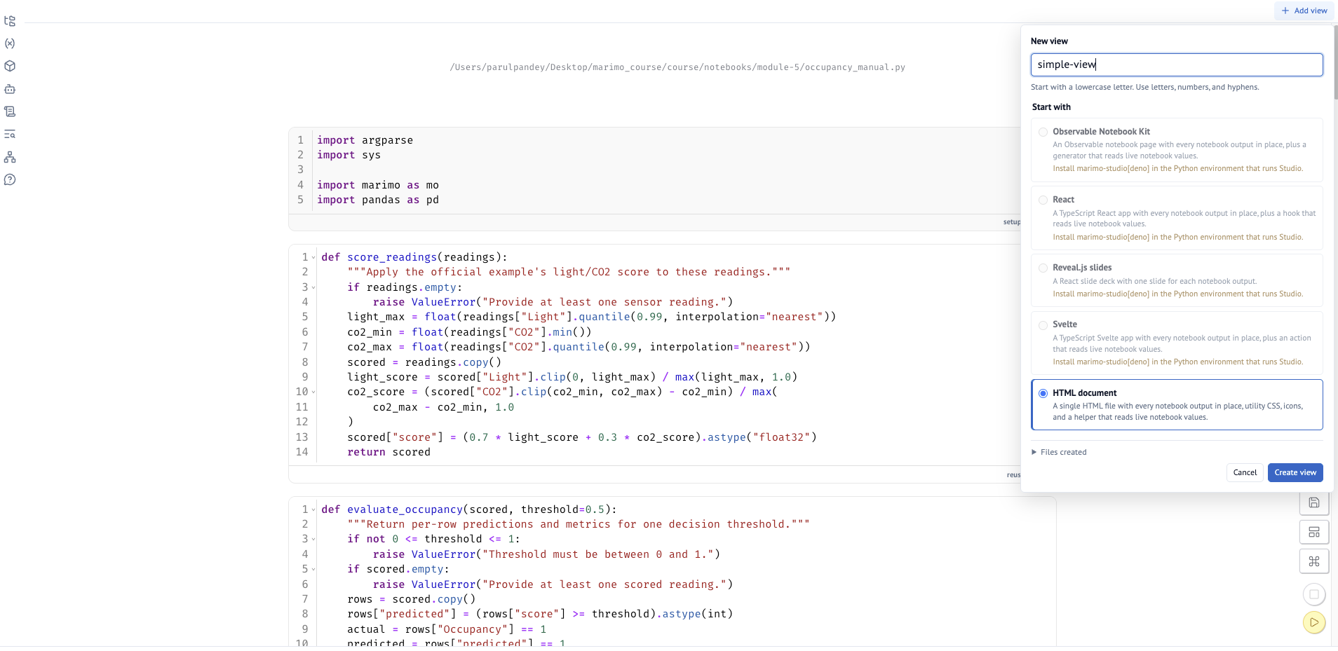
Click the Source button (<>) in the Studio toolbar. In the source panel, open index.html, select all of its contents, and replace them with:
<!doctype html>
<html>
<head>
<meta charset="utf-8" />
<title>Occupancy results</title>
</head>
<body>
<div id="app-shell">
<main>
<h1>Occupancy results</h1>
<marimo-cell name="metrics_output"></marimo-cell>
</main>
</div>
</body>
</html>
Save the file, then open Preview. The <marimo-cell> element tells Studio to render the output of the notebook cell named metrics_output inside the view.
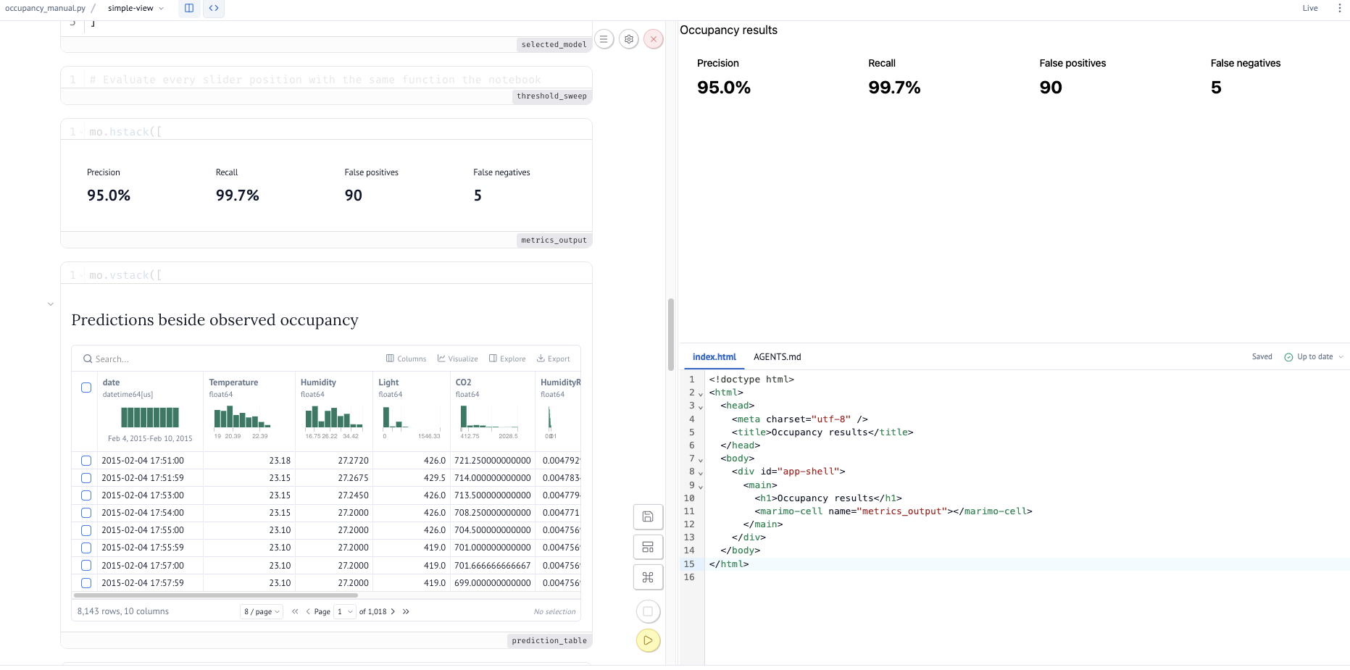
The view references the notebook's metrics_output cell. The calculation remains in occupancy.py, while the view controls where the result appears.
You could continue building the view manually, as you just saw, or take the help of a coding assistant as you'll see in the next section.

3.2 Create a monitor
Studio views can be created manually, as you just saw, or with a coding assistant. Studio works with marimo's built-in AI assistant as well as external coding agents.
Now you will use marimo's AI assistant, introduced in Module 4 (/?module=4), to build these views. Open the AI sidebar and switch it to Code Mode. You can also use another coding assistant, such as Codex or Claude Code, with the same prompts.
First, ask the agent to inspect the notebook:
Inspect occupancy.py.
Identify the notebook cells and values that contain:
- the threshold control
- precision and recall
- false positive and false negative counts
- prediction errors
List their names and briefly explain what each one contains.
Do not change any files yet.
AI assistants may word their answers differently. In our run, the important parts were:
- threshold_control contains the threshold slider.
- selected_model calculates the predictions, metrics, and error rows.
- metrics_output displays precision, recall, false positives, and false negatives.
- errors_output displays the rows where the prediction is incorrect.
The underlying calculations remain in score_readings() and evaluate_occupancy().
We can now build a view from these existing results instead of calculating them again.
Create a plain HTML Studio view named monitor for occupancy.py.
The view is for a facilities team. Show:
- the threshold control
- precision and recall
- false positive and false negative counts
Use the existing notebook cells and values. Keep all calculations in
occupancy.py. Keep the layout simple and easy to scan.
Build the view and show it in Preview.
The assistant chooses the layout, so your monitor may look slightly different from the one shown below.
Watch the monitor being created in Studio:
Video: occupancyMonitor video
You now have two separate parts of the project: occupancy.py contains the analysis and calculations, while the monitor view controls how selected results are presented.
Change the threshold in the view and check that the values shown there match the notebook.

3.3 Create a model review
The monitor gives a quick overview. Someone choosing the decision threshold needs more detail about how that threshold affects errors.
Create another Studio view named model-review for occupancy.py.
This view is for someone choosing the occupancy decision threshold. Show:
- the notebook's threshold control
- precision and recall
- false positive and false negative counts
- a table of prediction errors
Add a short explanation of a false positive, predicting occupied when the
room is empty, and a false negative, predicting empty when the room is
occupied. Use the existing notebook results. Keep all calculations in
occupancy.py. Keep the view simple and focused on comparing errors.
Build the view and show it in Preview.
Set the threshold to 0.5, then change it to 0.7. Compare the precision, recall, false positive count, false negative count, and error rows at the two thresholds.
The monitor and model review use the same analysis, but they support different tasks. The monitor gives the facilities team a quick summary, while the model review makes the effect of the decision threshold easier to inspect.
Watch the model review being created in Studio:
Video: occupancyModelReview video

3.4 Create a report
Finally, create a view for someone who wants to read the results rather than explore them in detail.
Create a Studio view named report for occupancy.py.
Make it a short report for a manager. Include:
- a short description of the occupancy task
- the selected threshold
- precision and recall
- false positive and false negative counts
- a short explanation of what the two errors mean in practice
- a short takeaway
Use the existing results from occupancy.py. Keep all calculations in the
notebook. Use a simple report layout with a title, summary metrics,
explanation, and conclusion. Build the view and show it in Preview.
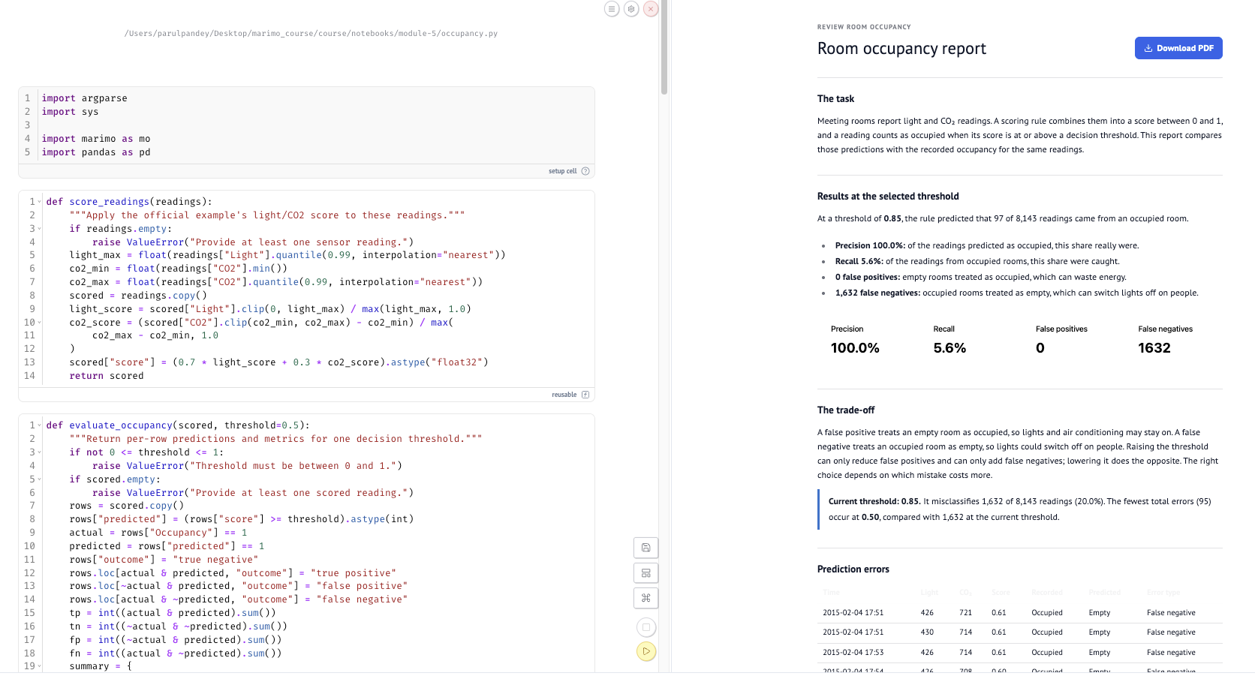
The three views now use the same occupancy.py analysis in different ways:
- Monitor: the facilities team can quickly check the results.
- Model review: the person choosing the threshold can inspect how it affects errors.
- Report: the manager can read a short summary of the analysis.
The calculations have not been copied into the views. They remain in occupancy.py, while each view presents those results for a different audience. You can also change the notebook and have those changes reflected in every view making use of the same analysis.

Check your understanding
Check your understanding: Why create separate views with marimo-studio?
- To avoid calculating the results shown in the view.
- To present the same notebook analysis in different layouts for different audiences. (correct answer)
- To automatically choose the best decision threshold.
- To make every notebook result correct.
Check your understanding: When should you run a notebook as a web app?
- When a scheduled process needs to run without an interface.
- When you only need a fixed PDF.
- When people need to use its controls without editing the code. (correct answer)
- When you want to download a dataset.
Check your understanding: When is it useful to run a notebook as a script?
- When a reader needs to change a slider in the browser.
- When you want to turn the output into a PDF.
- When you want to hide an import statement.
- When the same task needs to run repeatedly without notebook controls. (correct answer)
Check your understanding: Why would you mark a notebook function as reusable?
- So marimo always hides the function's code.
- So another notebook or Python program can import it. (correct answer)
- So the function can change the notebook layout.
- So the notebook can only run as an app.

