TITLE: Identification of Common Gene Signatures Between COVID-19 and Diabetes
OBJECTIVE: To identify common molecular signatures between COVID-19 and Diabetes and understand their regulatory networks through protein interactions, transcription factors, and miRNA co-regulation.
- Explore shared pathogenic mechanisms.
- Identify potential therapeutic targets.
- Understand regulatory networks linking both diseases.
METHODOLOGY
1. Data Collection
Downloaded gene datasets related to COVID-19 and Cardiovascular disorders from GeneCards database.
2. Common Gene Identification
Identified overlapping genes between both diseases using Venn diagram approach.
3. PPI Network Construction
Uploaded common genes into STRING database and constructed protein-protein interaction network.
4. Hub Gene Identification
Used Cytoscape with CytoHubba plugin to identify top hub genes based on degree or MCC scores.
5. Functional Enrichment Analysis
Performed GO and KEGG pathway enrichment for hub genes using Enrichr, DAVID, or ShinyGO.
6. TF-Gene Network
Constructed transcription factor-gene regulatory network using NetworkAnalyst or RegNetwork.
7. TF-miRNA Co-regulation
Built TF-miRNA co-regulation network to understand post-transcriptional regulation.

KEY RESULTS
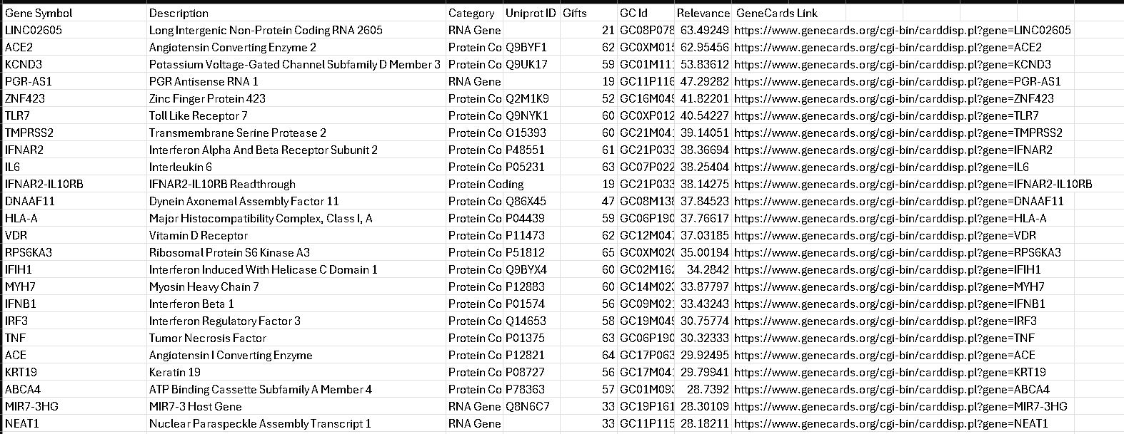
Fig1: COVID 19 Gene list
This image Shows high relevance covered in 19 associated genes with descriptions, uniprot IDs, and GenCards links
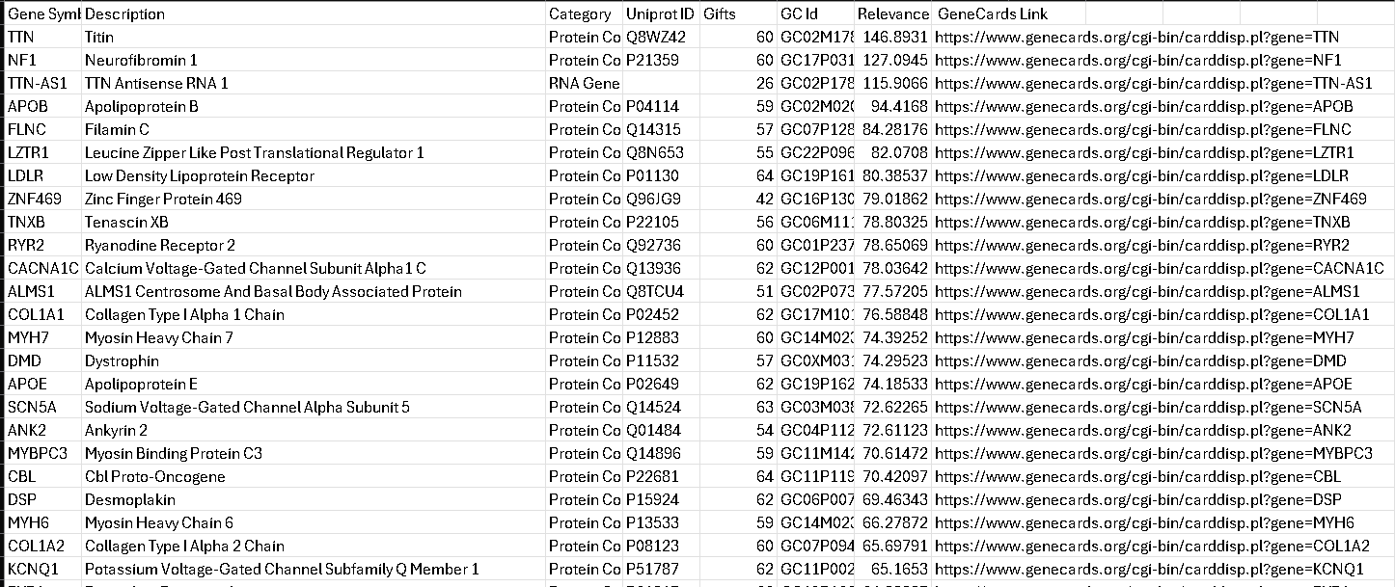
Fig2: This image shows top cardiovascular disease jeans ranked by relevance along with detailed annotation and data identifiers.

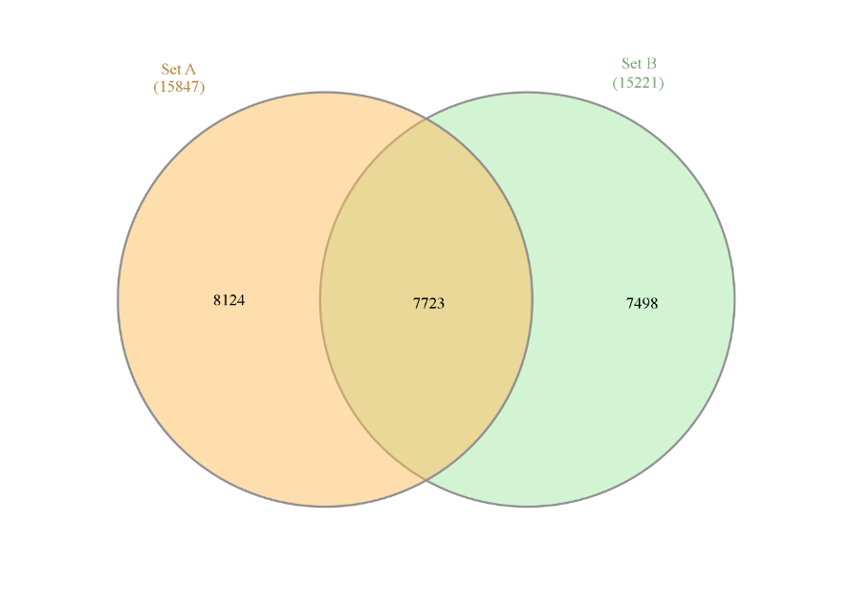
Fig3: Venn Diagram – Overlap of COVID-19 and cardiovascular disease (CVD) Genes
This Venn diagram shows the overlap between COVID-19 and cardiovascular disease gene sets, highlighting the shared genetic signatures underlying both conditions.
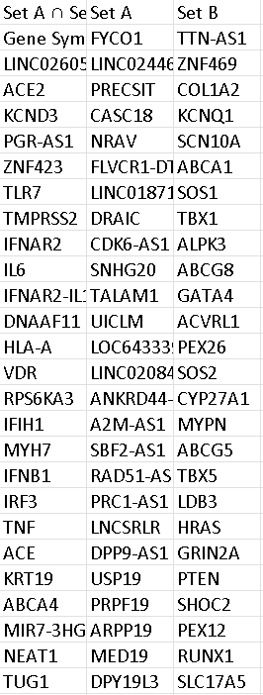
Fig4: Show the intersecting genes shared between COVID-19 and CVD along with the genes uniquely present in each sets.
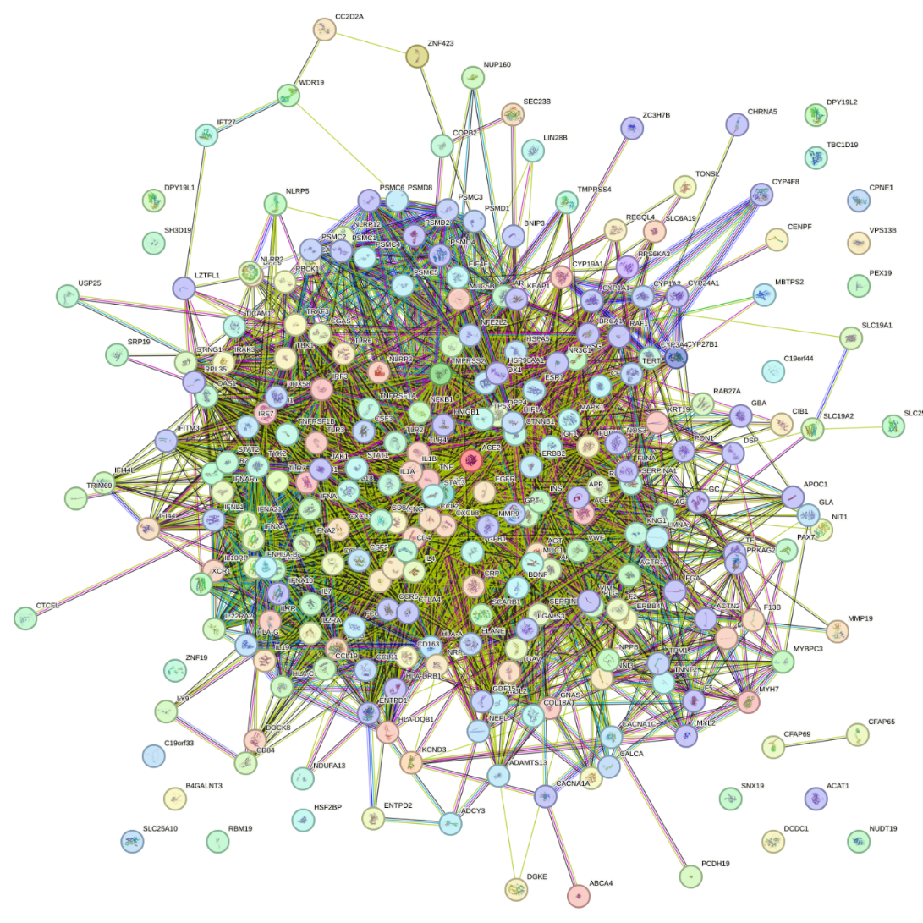

Fig5: STRING Database – Interaction Network of Common Genes
This STRING derived network visualises protein- protein interaction among these 7723 genes common to COVID-19 and CVD. Highly interconnected clusters reveal coordinated molecular functions, including cytokine signalling, immune activation, endovascular inflammation. Colour indicate functional enrichment, while dense edge reflect strong evidence of interaction. Hubs at the centre off the network suggest master regulators connecting multiple pathways relevant to disease severity. This global interaction may help identify critical biological modules that may be quotes regulated in both diseases.

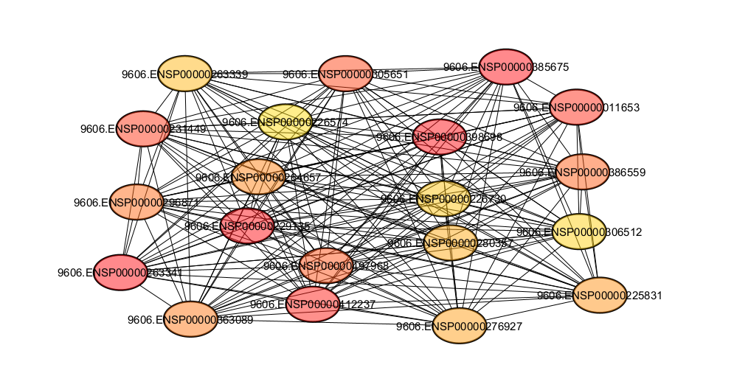
Fig6: Cytoscape – Top 20 Hub Genes (PPI Subnetwork)
This Cytoscape sub network highlighting the top 20 hub jeans ranked by degree centrality from the common gene set PPI network. Notes with warmer colour represent higher connectivity, indicating dominant regulatory roles. Hub genes form a tightly interconnected cluster, reflecting dairy involvement in key inflammatory, immunological, and vascular pathways. They act as central controller orchestrating multiple biological responses in COVID-19 and CVD. This condensed view helps prioritize candidate genes for biomarker discovery over therapeutic targeting.

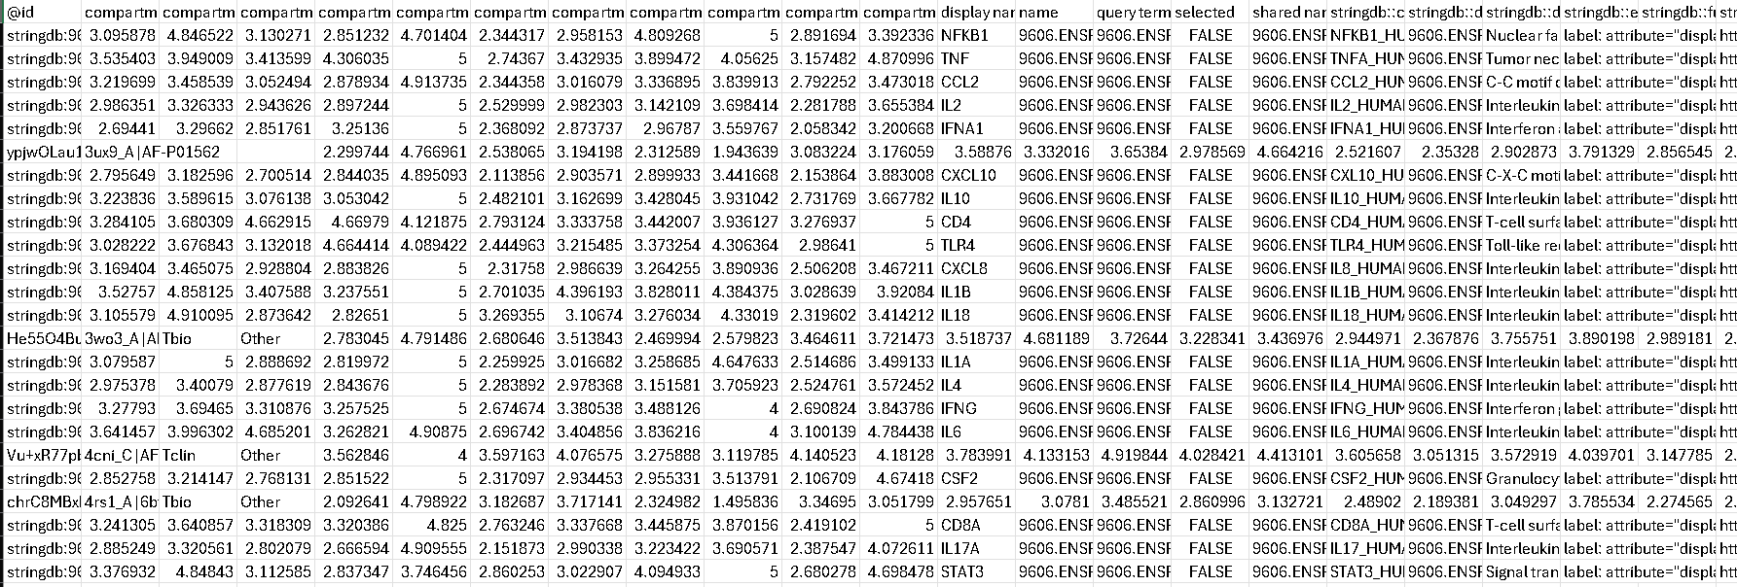
Fig7: This shows Cytoscape file contains network attributes for the top 20 sheared hub jeans derived from the COVID-19 and cardiovascular disorder venn overlap interaction.

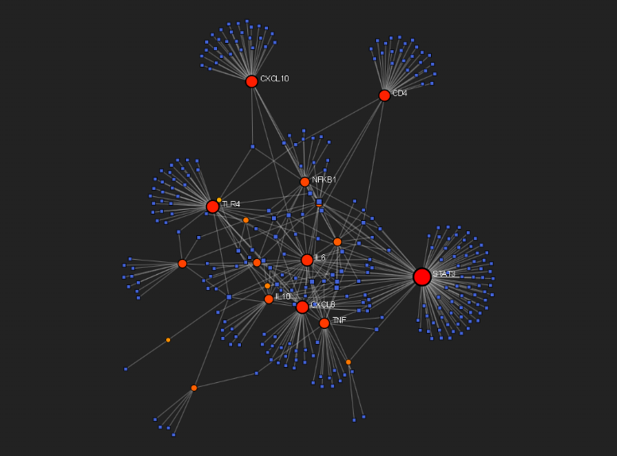
Fig8: Cytokine–Gene Interaction Network (Key Immune Regulators)
This network visualises interactions between major cytokines (red/orange nodes) and their associated genes (blue nodes). Major nodes such as TNF, IL1A, IL1B, and CXCL10 Emerge as dominant regulators. Their extensive connectivity reflects their central involvement in cytokine storm, endothelial injury, and chronic inflammation common to COVID-19 and CVD.
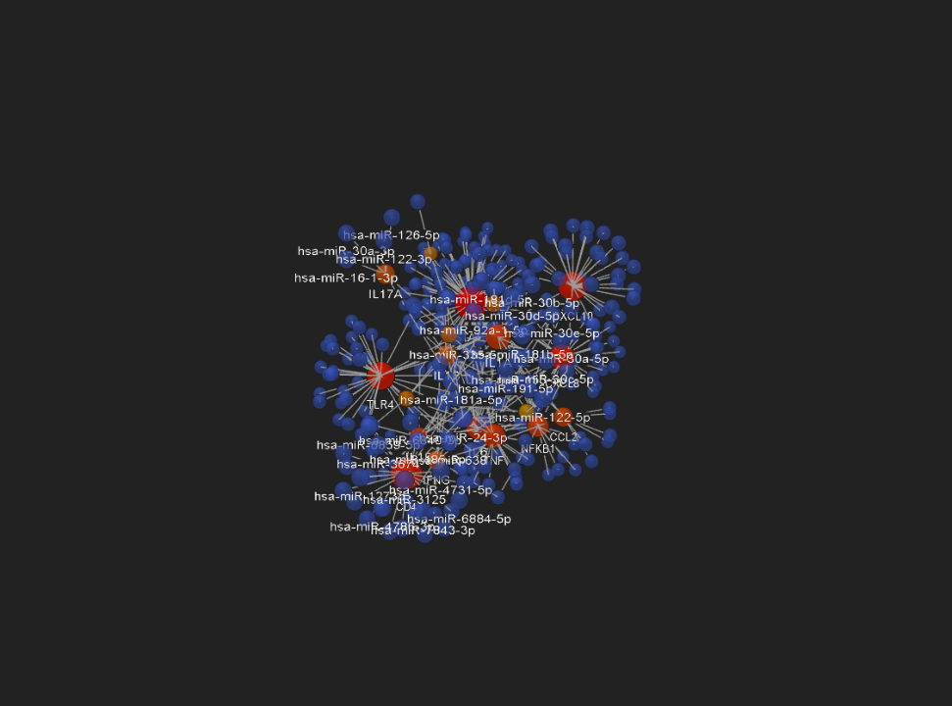
Fig9: miRNA–Target Gene Interaction Network for Top 20 Hub Genes
Dish Network displaced miRNA (orange/red nodes) interacting with the top 20 hub genes (blue nodes).highly connected miRNAs such as hsa-miR-16-5p, hsa-miR-21-5p, and hsa-miR-126-5p Regulate multiple hub genes simultaneously. The structure under scores the role of post transcriptional regulation in modulating immune response, vascular injury, end cytokine storm. These miRNA hubs may serve as sensitive biomarkers or potential intervention points in COVID-19 related cardiovascular complication the network also highlights miRNA gene feedback loop that shape disease progression.
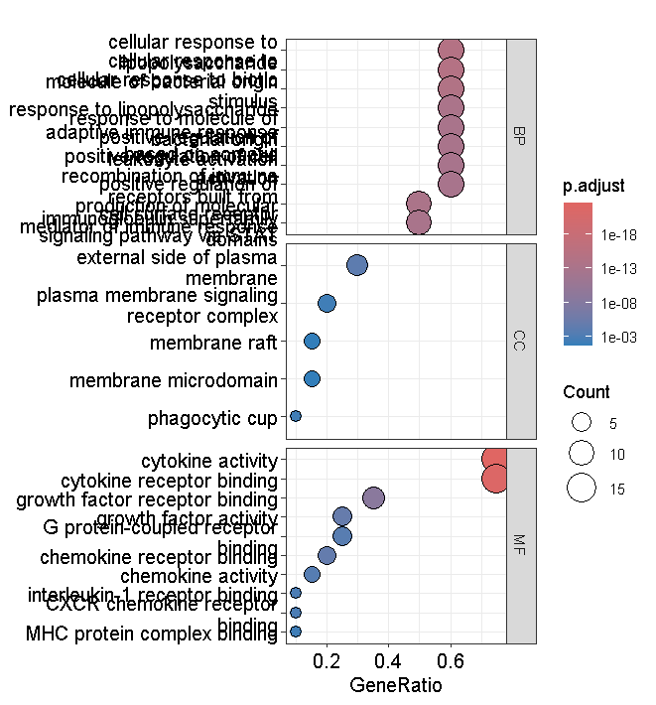

Fig8: GO enrichment Dot plot
This dot plot highlights enriched quo biological processes, cellular components, and molecular functions 4 the shared COVID-19-CVD genes, dominated by immune and cytokine related pathways.

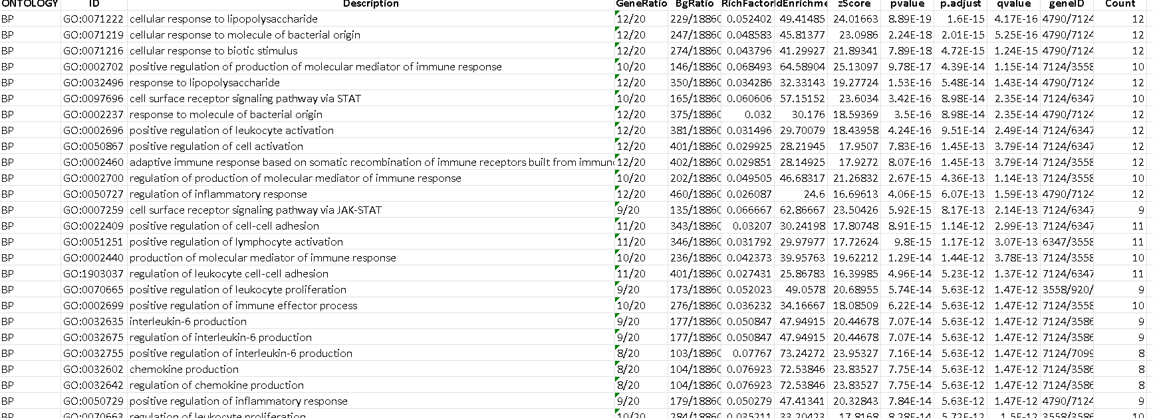
Fig9: GO Biological Process Enrichment
This shows enriched go biological processes for the common COVID 19-CVD genes, highlighting strong activation of immune and inflammatory pathways.
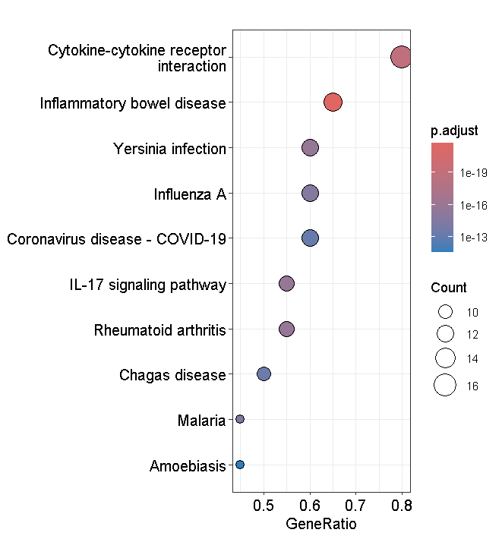
Fig10: KEGG Disease Pathway Enrichment Plot
This KEGG plot shows significant enrichment of disease pathways including COVID-19, influenza, and inflammatory disorder among the common genes.

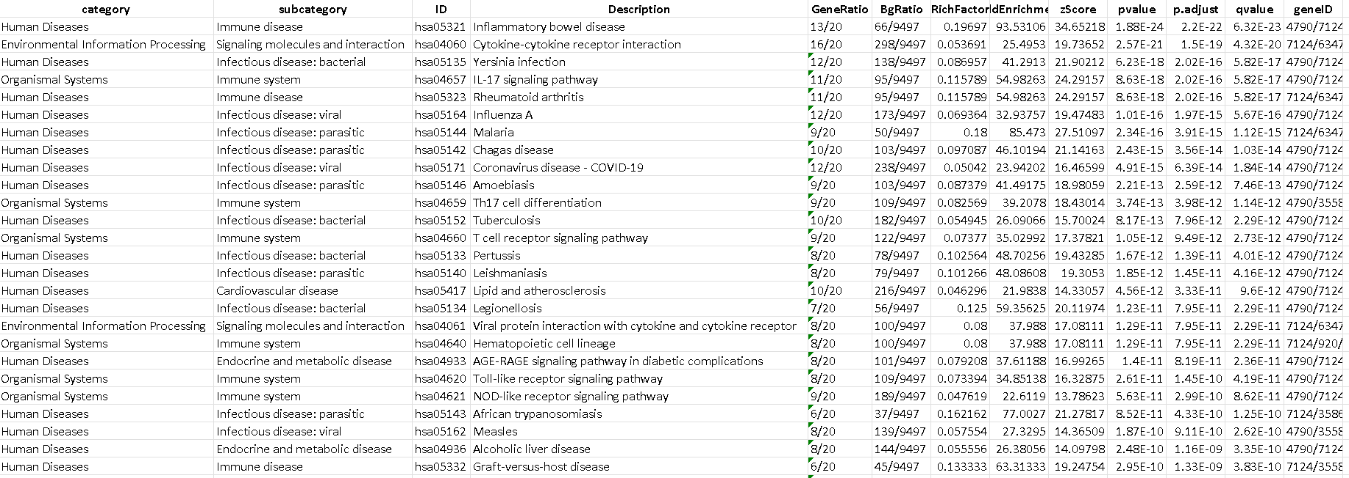
Fig11: KEGG Pathway Enrichment – Human Diseases
Show summarising KEGG disease pathways enriched in the shared genes set showing strong associations with immune disorders, infections, and cardiovascular conditions.
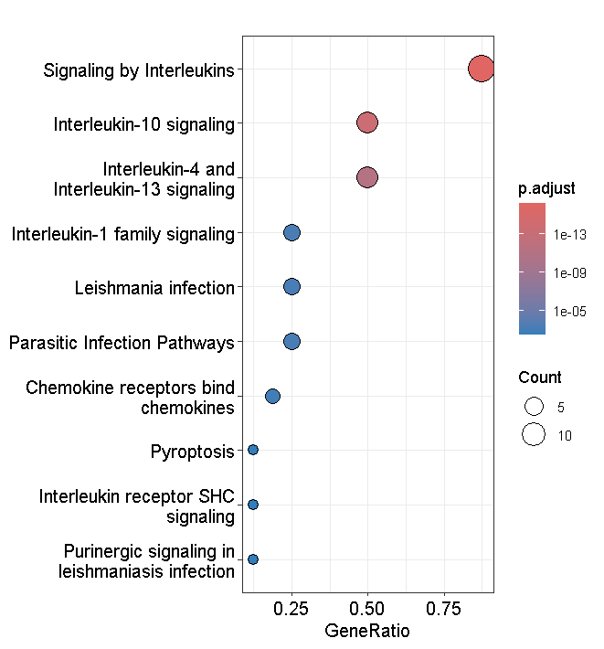
Fig12: Reactome/KEGG Cytokine & Immune Signaling Enrichment Plot
This enrichment plot depicts strong activation of interleukin and cytokine signalling pathways underscoring immune dysregulation in the shared COVID-19 - CVD gene set.
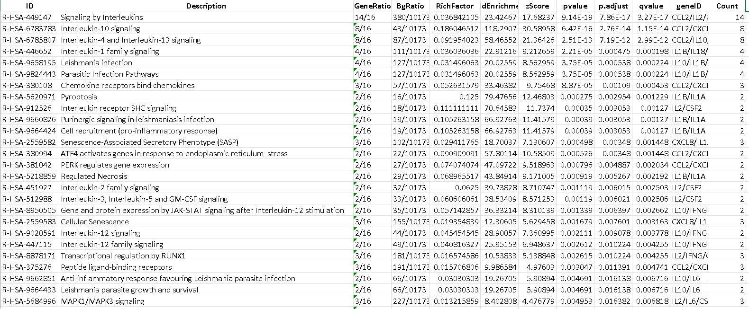
Fig13: KEGG Pathway Enrichment – Immune and Infection Pathways
This displays enriched KEGG immune and infection related pathways, revealing cytokine signalling, viral response, and host- pathogen interaction as dominant modules.
Conclusion
This study successfully identified a shared molecular signature between COVID-19 and cardiovascular disorders through an integrated analysis of gene overlap, protein- protein interactions, transcription factors, and miRNA co-regulation. The common genes were highly enriched in immune, cytokine, and inflammatory pathways indicating that dysregulated immune signalling act as a central mechanistic link between the two conditions. hub genes and network analysis further highlighted key regulators including interleukins, chemokines, and major inflammatory mediators as potential therapeutic targets. Overall, the findings provide a system level understanding of how COVID- 19 aggregates cardiovascular dysfunction and offer a foundation for developing targeting diagnostic and therapeutic strategies.

