SMVEC Page No.
XML Document is Well-Formed or not using DOM Parser in Java
SOURCE CODE:

ParsingDomDemo.java
import java.io.*;
import javax.xml.parsers.*;
import org.w3c.dom.*;
import org.xml.sax.*;
import java.util.*;

public class ParsingDomDemo
{
public static void main(String[] arg)
{
try
{
System.out.println("Enter the name of XML document");
Scanner s=new Scanner(System.in);
String file_name=s.nextLine();
File fp=new File(file_name);
if(fp.exists())
{
try
{
DocumentBuilderFactory Factory_obj=DocumentBuilderFactory.newInstance();
DocumentBuilder builder=Factory_obj.newDocumentBuilder();
InputSource ip_src=new InputSource(file_name);
Document doc = builder.parse(ip_src);
System.out.println(file_name+"is well-formed!!!");
}
catch(Exception e)
{
System.out.println(file_name+"isn't well-formed!");
System.exit(1);
}
}
else
{
System.out.print("File not found");
}
}
catch(IOException ex)
{
ex.printStackTrace();
}
}
}

SMVEC Page No.
Student.xml:-
<?xml version="1.0"?>
<student>
<Roll_No>10</Roll_No>
<Personal_Info>
<Name>Ayesha</Name>
<Address>Pune</Address>
<Phone>123456</Phone>
</Personal_Info>
<Class>Second</Class>
<Subject>Mathematics</Subject>
<Marks>100</Marks>

<Roll_No>20</Roll_No>
<Personal_Info>
<Name>Nagalakshmi</Name>
<Address>Banglore</Address>
<Phone>156438</Phone>
</Personal_Info>
<Class>Fifth</Class>
<Subject>English</Subject>
<Marks>90</Marks>

<Roll_No>30</Roll_No>
<Personal_Info>
<Name>Indu</Name>
<Address>Mumbai</Address>
<Phone>7678453</Phone>
</Personal_Info>
<Class>Fifth</Class>
<Subject>English</Subject>
<Marks>90</Marks>
</student>

SMVEC Page No.
OUTPUT:

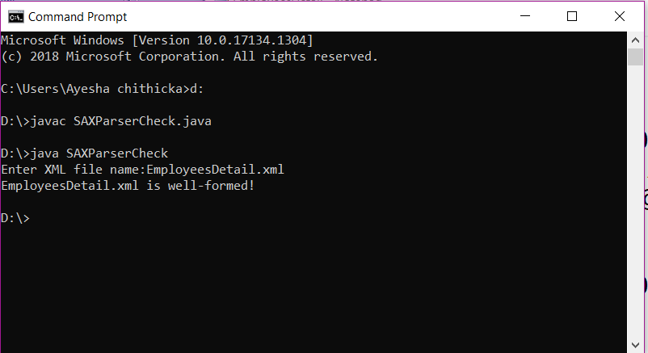
SMVEC Page No.
OUTPUT:

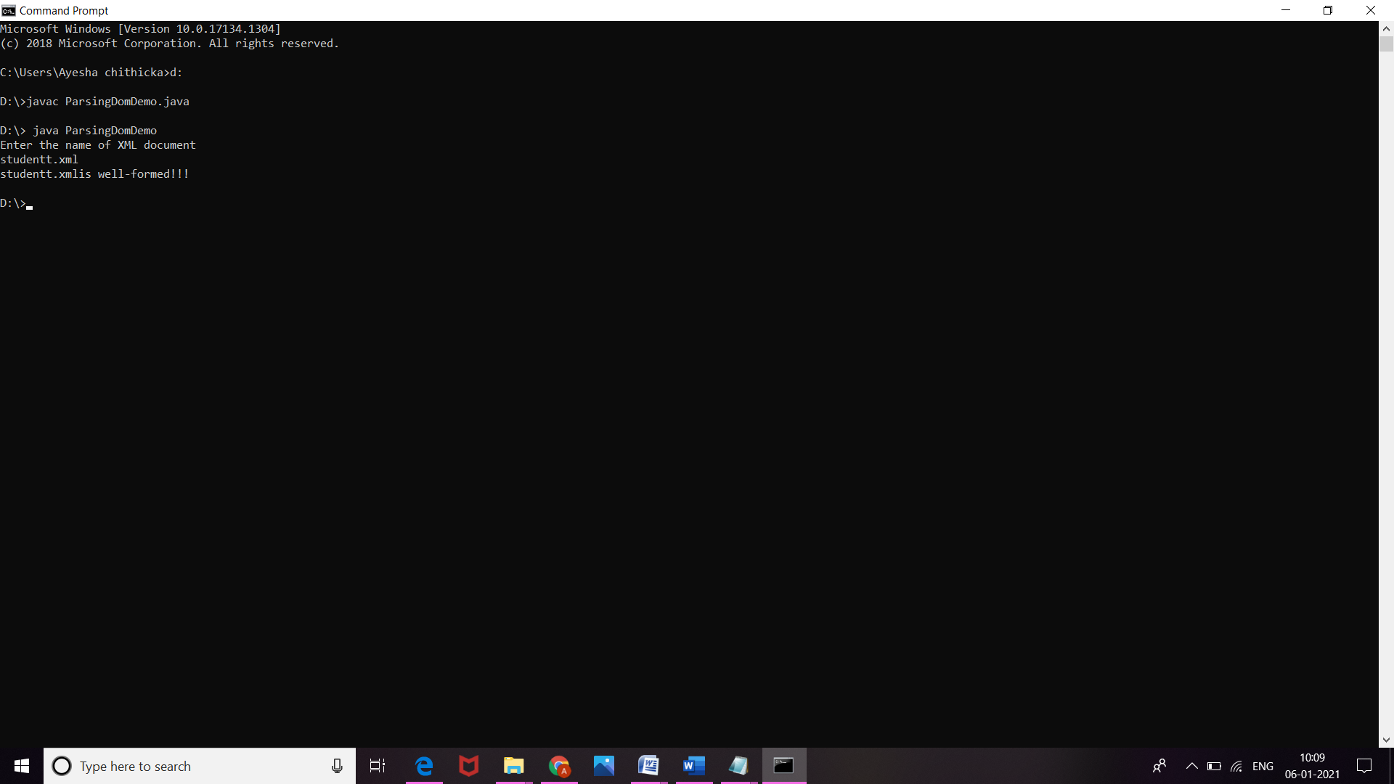
SMVEC Page No.
Reading XML document using DOM Parser in Java
SOURCE CODE:

Dom.java
import java.io.File;
import javax.xml.parsers.DocumentBuilderFactory;
import javax.xml.parsers.DocumentBuilder;
import org.w3c.dom.Document;
import org.w3c.dom.NodeList;
import org.w3c.dom.Node;
import org.w3c.dom.Element;

public class Dom
{
public static void main(String[] args)
{
try {
File inputFile = new File("XMLdom.xml");
DocumentBuilderFactory dbFactory = DocumentBuilderFactory.newInstance();
DocumentBuilder dBuilder = dbFactory.newDocumentBuilder();
Document doc = dBuilder.parse(inputFile);
doc.getDocumentElement().normalize();
System.out.println("Root element :" + doc.getDocumentElement().getNodeName());
NodeList nList = doc.getElementsByTagName("student");
System.out.println("----------------------------");
for (int temp = 0; temp < nList.getLength(); temp++)
{
Node nNode = nList.item(temp);
System.out.println("\nCurrent Element :" + nNode.getNodeName());
if (nNode.getNodeType() == Node.ELEMENT_NODE)
{
Element eElement = (Element) nNode;
System.out.println("Rank : " + eElement.getAttribute("rank"));
System.out.println("songname : " + eElement.getElementsByTagName("songname").item(0).getTextContent());
System.out.println("singer: " +
eElement.getElementsByTagName("singer").item(0).getTextContent());
System.out.println("views: " + eElement.getElementsByTagName("views").item(0).getTextContent());
System.out.println("album: " + eElement.getElementsByTagName("album").item(0).getTextContent());
}

SMVEC Page No.
}
}catch (Exception e)
{
e.printStackTrace();
}
}
}

SMVEC Page No.
Song.xml
<?xml version ="1.0" encoding="UTF-8"?>
<?xml-stylesheet type ="text/xsl" href ="idoll.xsl"?>
<class>
<song rank="1">
<songname>Euphoria</songname>
<singer>Jungkook/BTS</singer>
<views>89000000</views>
<album>20</album>
</song>
<song rank="2">
<songname>ON</songname>
<singer>BTS</singer>
<views>64000000</views>
<album>12</album>
</song>
<song rank="3">
<songname>Black Swan</songname>
<singer>BTS</singer>
<views>57000000</views>
<album>15</album>
</song>
<song rank="4">
<songname>Sweetner</songname>
<singer>Ariana</singer>
<views>47000000</views>
<album>13</album>
</song>
<song rank="5">
<songname>Bluebird</songname>
<singer>Taylor</singer>
<views>44000000</views>
<album>10</album>
</song>
</class>
SMVEC Page No.
OUTPUT:

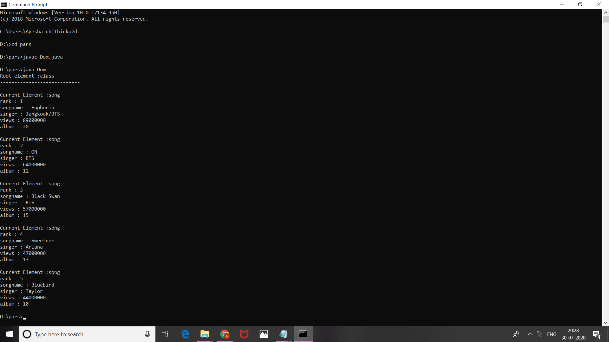
SMVEC Page No.
XML Document is Well-Formed or not using SAX Parser in Java
SOURCE CODE:

SAXParserCheck.java

import org.xml.sax.*;
import org.xml.sax.helpers.*;
import java.io.*;
import java.util.*;

public class SAXParserCheck
{
public static void main(String[] args) throws IOException
{
Scanner s=new Scanner(System.in);
System.out.print("Enter XML file name:");
String xmlFile = s.nextLine();
SAXParserCheck par = new SAXParserCheck(xmlFile);
}
public SAXParserCheck(String str)
{
try
{
File file = new File(str);
if (file.exists())
{
XMLReader reader = XMLReaderFactory.createXMLReader();
reader.parse(str);
System.out.println(str + " is well-formed!");

SMVEC Page No.
}
else
{
System.out.println("File not found: " + str);
}
}
catch (SAXException sax)
{
System.out.println(str + " isn't well-formed");
}
catch (IOException io)
{
System.out.println(io.getMessage());
}
}
}

SMVEC Page No.
EmployeeDetail.xml:

<?xml version = "1.0" ?>
<Employee-Detail>
<Employee>
<Emp_Id> 11032 </Emp_Id>
<Emp_Name> Ayesha </Emp_Name>
<Emp_E-mail> siddik33@gmail.com </Emp_E-mail>
</Employee>
<Employee>
<Emp_Id> 11022 </Emp_Id>
<Emp_Name> indu </Emp_Name>
<Emp_E-mail> ashokkumar782@gmail.com </Emp_E-mail>
</Employee>
<Employee>
<Emp_Id> 11011 </Emp_Id>
<Emp_Name> Elavarasan </Emp_Name>
<Emp_E-mail> ela@pec.in </Emp_E-mail>
</Employee>
</Employee-Detail>

SMVEC Page No.
Reading XML document using SAX Parser in Java
SOURCE CODE:

BillBoard.java:

import javax.xml.parsers.*;
import org.xml.sax.*;
import org.xml.sax.helpers.*;
import java.io.*;
import java.util.*;
public class BillBoard
{
public static void main(String[] args) throws IOException
{
Scanner s=new Scanner(System.in);
System.out.print("Enter XML file name:");
String xmlFile = s.nextLine();
BillBoard detail = new BillBoard(xmlFile);
}
public BillBoard(String str)
{
try
{
File file = new File(str);
if (file.exists())
{
SAXParserFactory parserFact = SAXParserFactory.newInstance();
SAXParser parser = parserFact.newSAXParser();
System.out.println("XML Data: ");
DefaultHandler dHandler = new DefaultHandler()
{
boolean r;
boolean sn;
boolean s;

SMVEC Page No.
public void startElement(String uri, String localName, String element_name, Attributes attributes)throws SAXException
{
if (element_name.equals("rank"))
{
r = true;
}
if (element_name.equals("songname"))
{
sn = true;
}
if (element_name.equals("singer"))
{
s = true;
}
}

public void characters(char[] ch, int start, int len) throws SAXException
{
String str = new String (ch, start, len);
if (r)
{
System.out.println("rank: "+str);
r= false;
}
if (sn)
{
System.out.println("songname:"+str);
sn = false;
}
if (s)
{
System.out.println("singer: "+str);
s = false;
}
}
};

SMVEC Page No.
parser.parse(str, dHandler);
}
else
{
System.out.println("File not found!");
}
}
catch (Exception e)
{
System.out.println("XML File hasn't any elements");
e.printStackTrace();
}
}
}

SMVEC Page No.
Song.xml:

<?xml version ="1.0" encoding="UTF-8"?>
<?xml-stylesheet type ="text/xsl" href ="idoll.xsl"?>
<class>
<rank>1</rank>
<songname>Euphoria</songname>
<singer>Jungkook/BTS</singer>
<rank>2</rank>
<songname>ON</songname>
<singer>BTS</singer>
<rank>3</rank>
<songname>Black Swan</songname>
<singer>BTS</singer>
<rank>4</rank>
<songname>Sweetner</songname>
<singer>Ariana</singer>
<rank>5</rank>
<songname>Bluebird</songname>
<singer>Taylor</singer>
</class>
SMVEC Page No.
OUTPUT:

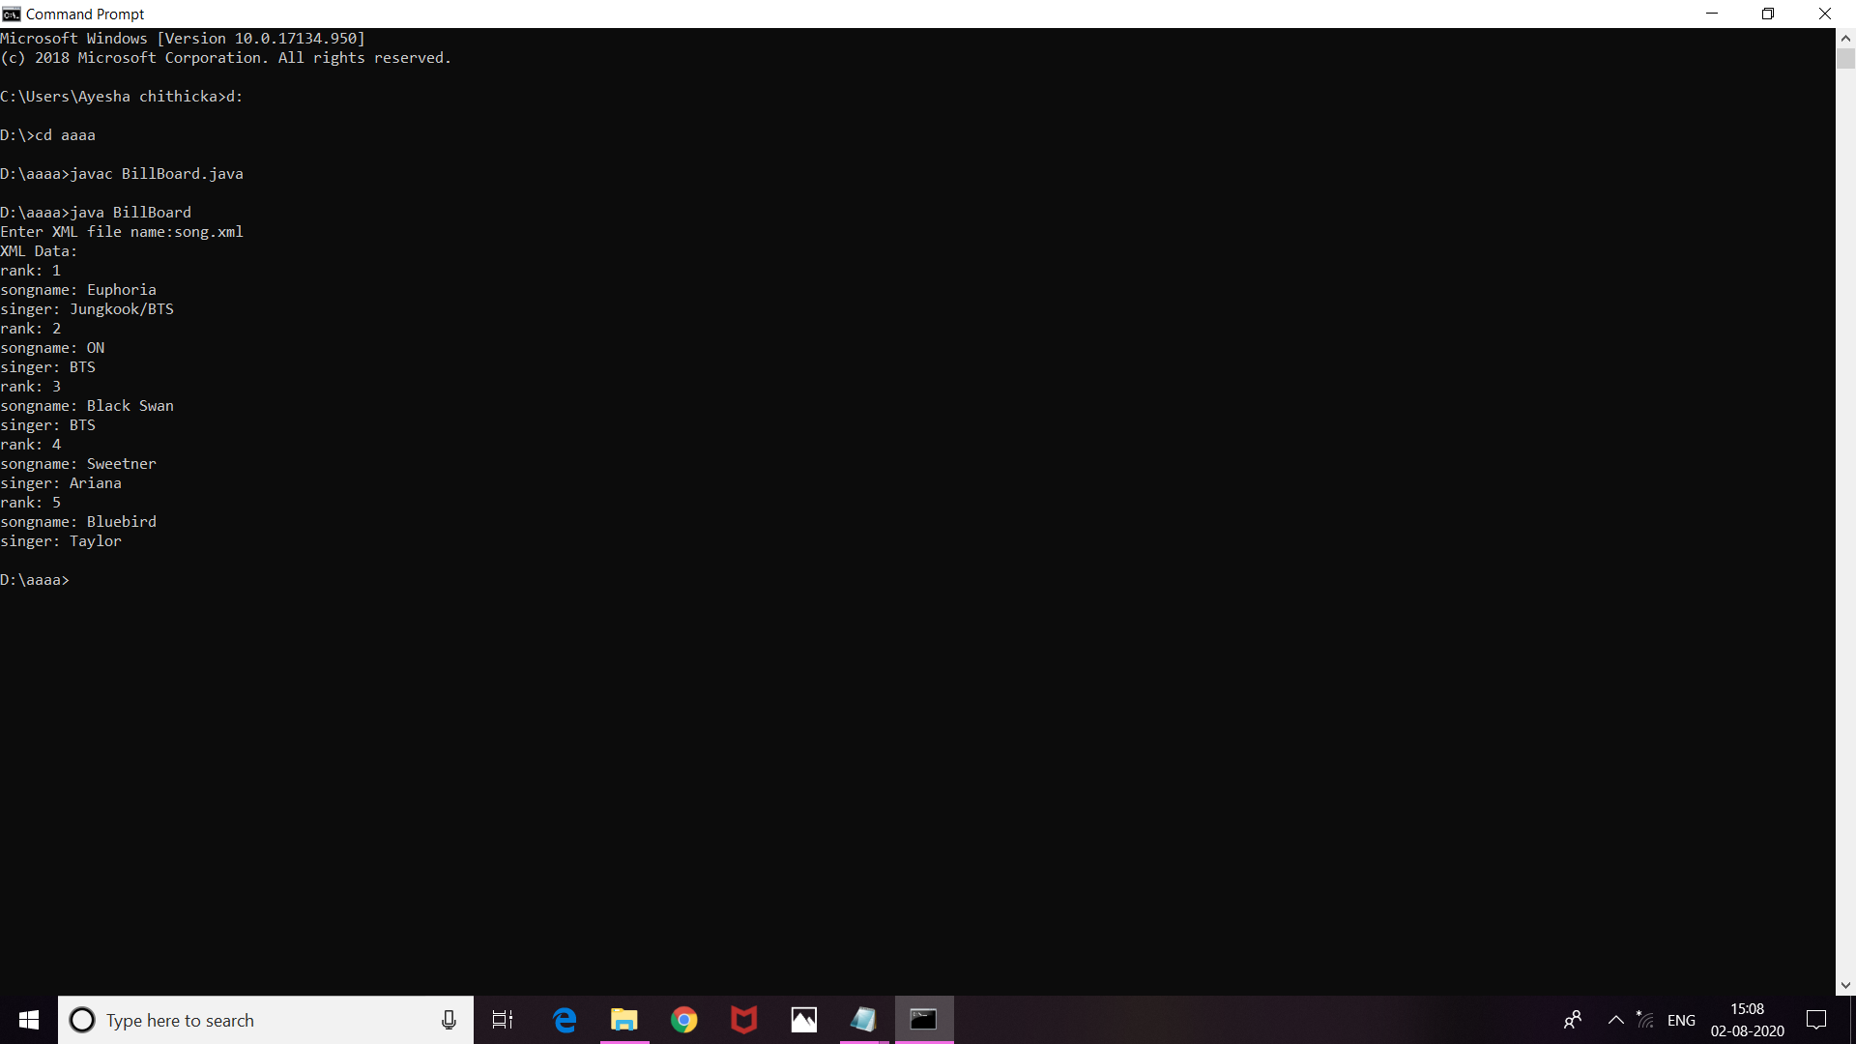
SMVEC Page No.
Displaying XML file using CSS
SOURCE CODE:

Song.xml:
<?xml version ="1.0" encoding="UTF-8"?>
<?xml-stylesheet type ="text/xsl" href ="idoll.xsl"?>
<class>
<song rank="1">
<songname>Euphoria</songname>
<singer>Jungkook/BTS</singer>
<views>89000000</views>
<album>20</album>
</song>
<song rank="2">
<songname>ON</songname>
<singer>BTS</singer>
<views>64000000</views>
<album>12</album>
</song>
<song rank="3">
<songname>Black Swan</songname>
<singer>BTS</singer>
<views>57000000</views>
<album>15</album>
</song>
<song rank="4">
<songname>Sweetner</songname>
<singer>Ariana</singer>
<views>47000000</views>
<album>13</album>
</song>
</class>
SMVEC Page No.
Idol.css:
heading{color:red;font-size:30px;
background-color:yellow;}
name{display:block;color:blue;
font-style:italic;
font-size:20pt;font weight:bold;background-color:white;}
members{display:block;color:green;font-style:italic;}
songs{display:block;color:green;font-style:italic;}
awards{display:block;color:green;font-style:italic;}
SMVEC Page No.
OUTPUT:
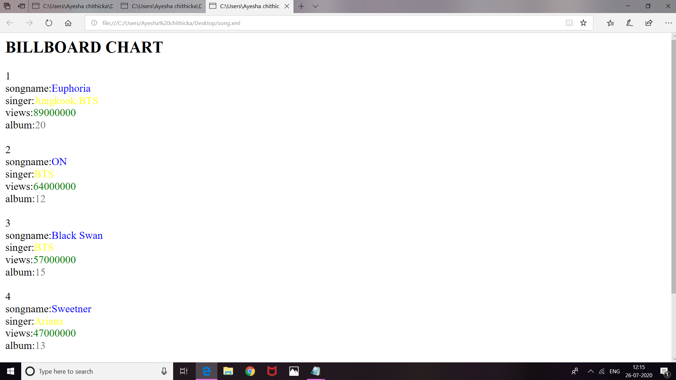
SMVEC Page No.
Displaying XML file using XSLT
SOURCE CODE:

Song.xml:

<?xml version ="1.0" encoding="UTF-8"?>
<?xml-stylesheet type ="text/xsl" href ="idoll.xsl"?>
<class>
<song rank="1">
<songname>Euphoria</songname>
<singer>Jungkook/BTS</singer>
<views>89000000</views>
<album>20</album>
</song>
<song rank="2">
<songname>ON</songname>
<singer>BTS</singer>
<views>64000000</views>
<album>12</album>
</song>
<song rank="3">
<songname>Black Swan</songname>
<singer>BTS</singer>
<views>57000000</views>
<album>15</album>
</song>
<song rank="4">
<songname>Sweetner</songname>
<singer>Ariana</singer>
<views>47000000</views>
<album>13</album>
</song>
<song rank="5">
<songname>Bluebird</songname>
<singer>Taylor</singer>
<views>44000000</views>
<album>10</album>
</song>
</class>
SMVEC Page No.
Idol.xsl:

<?xml version ="1.0" encoding="UTF-8"?>
<xsl:stylesheet version ="1.0" xmlns:xsl="http://www.w3.org/1999/XSL/Transform">
<xsl:template match="/">
<html>
<body>
<h2>BILLBOARD CHART</h2>
<table border = "1">
<tr bgcolor = "yellow">
<th>rank</th>
<th>songname</th>
<th>singer</th>
<th>views</th>
</tr>
<xsl:for-each select="class/song">
<tr>
<td><xsl:value-of select ="@rank"/></td>
<td><xsl:value-of select ="songname"/></td>
<td><xsl:value-of select ="singer"/></td>
<td><xsl:value-of select ="views"/></td>
</tr>
</xsl:for-each>
</table>
</body>
</html>
</xsl:template>
</xsl:stylesheet>

SMVEC Page No.
OUTPUT:

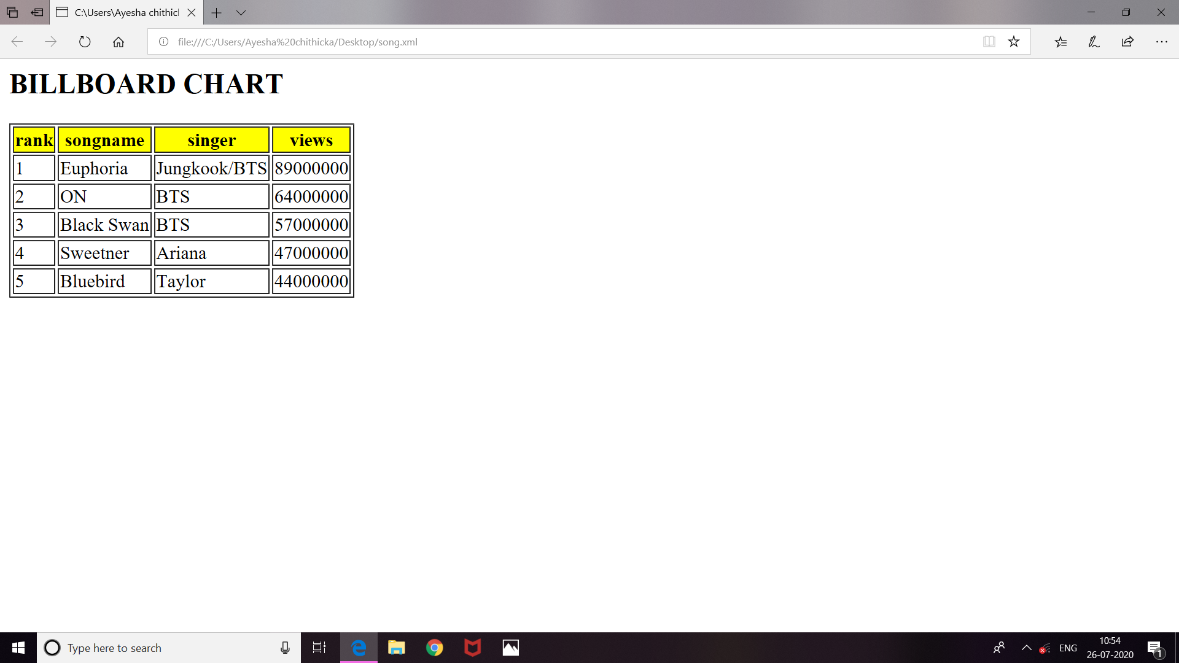
SMVEC Page No.
Simple EJB stateless program for cube of a number
SOURCE CODE:

package jk;

import javax.jws.WebService;
import javax.jws.WebMethod;
import javax.jws.WebParam;

@WebService(serviceName = "web")
public class web {

@WebMethod(operationName = "hello")
public String hello(@WebParam(name = "name") String txt) {
return "Hello " + txt + " !";
}

@WebMethod(operationName = "cube")
public int cube(@WebParam(name = "num") final int num) {
//TODO write your implementation code here:
return (num*num*num);
}
}
SMVEC Page No.
OUTPUT:

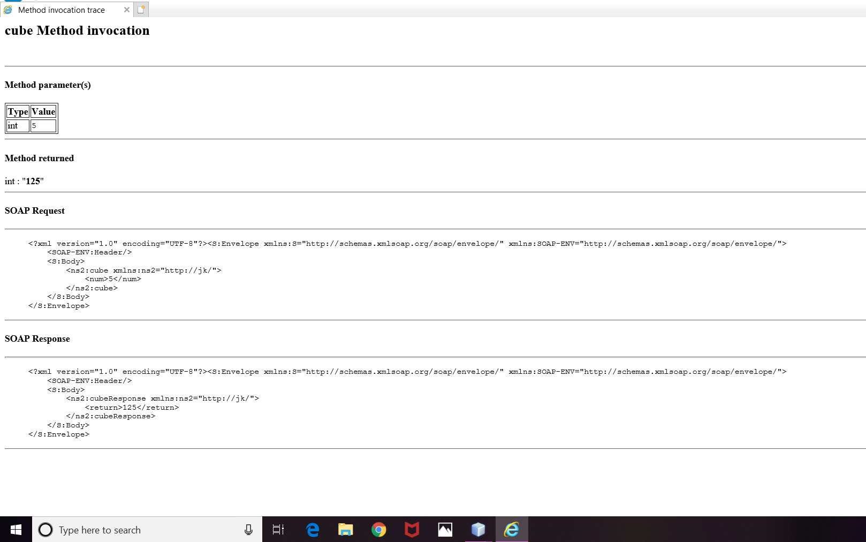

SMVEC Page No.
SMVEC Page No.
SMVEC Page No.
SMVEC Page No.
SMVEC Page No.
SMVEC Page No.
SMVEC Page No.
SMVEC Page No.
SMVEC Page No.
SMVEC Page No.
SMVEC Page No.
SMVEC Page No.
SMVEC Page No.
SMVEC Page No.
SMVEC Page No.
SMVEC Page No.
SMVEC Page No.
SMVEC Page No.
SMVEC Page No.
SMVEC Page No.
SMVEC Page No.
SMVEC Page No.
SMVEC Page No.
SMVEC Page No.
SMVEC Page No.
SMVEC Page No.
SMVEC Page No.
SMVEC Page No.
SMVEC Page No.
SMVEC Page No.
SMVEC Page No.
SMVEC Page No.
SMVEC Page No.
SMVEC Page No.
SMVEC Page No.

