

HR MANAGEMENT

Systems

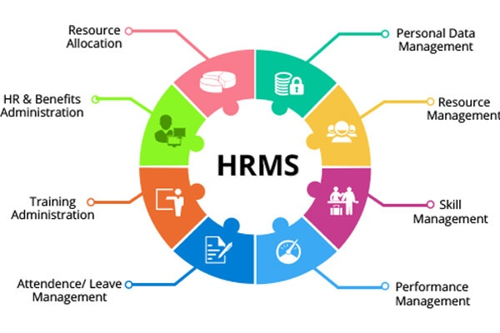

**Group No: 7 (BCA-1B2)**

**Supervised by**: **CASE INVESTIGATOR:**

MRS.DEEPIKA CHOUDHARY PARAS PARUTHI(1910992632)

**INDEX**

|  |  |  |
| --- | --- | --- |
| **s.no** | **particulars** | **page no** |
| **1.** | **Synopsis** | 3-5 |
| **2.** | **Software Requirements Specification** | 7-12 |
| **3.** | **System Analysis and Design** | 14-23 |
| **4.** | **Detailed Design** | 25-30 |
| **5.** | **Testing** | 32-53 |
| **6.** | **Snapshots** | 55-68 |

**Human Resource Management System**

**About Project**

**Human Resource Management Systems (HRMS) shape an intersection between** [**human resource management**](http://www.answers.com/topic/human-resource-management) **(HRM) and** [**information technology**](http://www.answers.com/topic/information-technology)**. It merges HRM as a discipline and in particular its basic HR activities and processes with the information technology. In this software we can add employee details according to the departments of the company. We can also add and delete department as well. We can also count the salary and generate salary slip of our employees.**

**Software Requirement Specification**

* ***Windows 98/XP***
* ***Front end tool –VB.NET***
* ***Back end tool - M.S Access (MDB)***

**Hardware Requirements:**

* **PC with Dual core Configuration**
* **Key Board and Mouse**

**FEATURES FOR HRMS:**

* **Employees Salary details.**
* **Provides resume matching details to the employees**
* **Supports more multiple Recruitment and process**
* **Supports for multiple user**
* **Stores more than one company record.**

**Brief Description**

Every organization has numerous types of resources like office equipments, finances raw materials, etc. Human resource is one of these resources. It is the most vital among all the resources of an organization. So HR functions are common to all type of organization these HR function may include recruitment, time management, management of payroll and many more. In the Scenario of handling thousands of employees, their recruitment procedure, their time scheduling and their salary slip generation according to their package and their working days may become difficult to handle manually.

**Major Modules of HRMS with Payroll Management System**

* Main Screen and login Screen
* Subject Name Entry Screen
* Resume Entry Screen
* Education Entry Screen

* Experience Details entry screen
* Job opening Entry form
* Resume Matching Form
* Interview Letter Form
* Interview marks entry form
* Employee Recruiting
* Employee Training Selection
* Employee Payment

**Key Features:**

* Maintain all Accounts automatically.
* Allow adding / updating staff
* Handle multiple companies with multiple financial years.
* Automatic updating data.

**Security Features:**

* Password facility to ensure validity of user
* Intelligent validation for each entry.
* User defined data access.
* Data secrecy

SOFTWARE REQUIREMENTS SPECIFICATION:

* **GENERAL DESCRIPTIONS**
* **SPECIFIC REQUIREMENTS**

**SOFTWARE REQUIREMENTS SPECIFICATIONS DOCUMENT**

**Introduction :**

This document provides details about the entire software requirements specification for the software Human Resource Management System(HRMS) a database for.

**Purpose :-**

The function of Human Resource Management System is generally administrative and not common to all organizations. Organizations may have formalized selection, evaluation, and payroll processes. Efficient and effective management of "Human Capital" has progressed to an increasingly imperative and complex process. The HR function consists of tracking existing employee data which traditionally includes personal histories, skills, capabilities, accomplishments and salary. To reduce the manual workload of these administrative activities, organizations began to electronically automate many of these processes by introducing specialized Human Resource Management Systems.

**Scope :-**

This software is very general purpose software. On completion of this software will be useful for many companies

**Goal:-**

The main goal of the application is to maintain the records of resumes, This software

is helpful to segregate the resumes based on the jobs.

**Major Modules of HRMS**

* Main Screen and login Screen
* Subject Name Entry Screen
* Resume Entry Screen
* Education Entry Screen
* Experience Details entry screen
* Job opening Entry form
* Resume Matching Form
* Interview Letter Form
* Interview marks entry form
* Employee Recruiting
* Employee Training Selection
* Employee Payment

**Detailed description of components**

**Main Screen and login Screen**

This is main login screen employees as to login from this point based on their provision corresponding form will be opened.

**Subject Name Entry Screen**

This is a master form to enter the subjects. Same there are other master screen where all master entry need to be entered. Provide new, save, modify and delete options. Also display in a flexgrid all entered information.

**Resume Entry Screen**

This is the main part of the project here all the collected resumes will be entered. Collect all necessary information here. Make very use friendly so user can easily entered the data here.

**Education Entry Screen**

This is part of the resume here enter all education details. These fields very useful in selection procedure. Therefore collection all education details in detail.

**Experience Details entry screen**

This information is linked to the main resume. Based resume id experience will be entered this will be help ful in the selection time. Collect the complete experience details.

**Job opening Entry form**

In this form all the openings in the company are entered. Company require new employees time to time. Here job name, required qualification. Experience will be entered, based on this resume matching will done.

**Resume Matching Form**

Based on the job opening form entry on the required parameter this search will be done. There based on the job all the possible qualifying resumes will be displayed.

**Interview Letter Form**

Who ever resumes are matching for the job, for them we need to send the letter. For the same this form is provided here select the list and prepare the letter and generate the letters. Take a print out of the generated letters send them to the applicants.

**Interview marks entry form**

After conducting the interview the marks can be entered here. To enter the marks for each applicant options are provided here. Based on this the selection list can be prepared.

**Employee Recruiting**

Once the applicant successfully selected to job then he became the employee of the company. In this form what job assigned to the employee will be specified. And also all other necessary information will be entered here.

**Employee Training Selection**

Employee who are selected for the job will put for the training. In this for all the training related information will entered.

**Employee Payment**

Payment to the Recruited Employees.

**Definitions, Acronyms and Abbreviations :-**

**1**. Administrator: The person who manages the organization.

**2**. Employee: The person who works in organization.

**3**. PIN Number: The unique id given to either Employee.

**References :-**

Programming in Visual Basic .NET by courseware development team

**Overview :-**

The following subsections provide the complete overview of the software specifications requirements documentation for the product Human Resource Management System(HRMS) the entire SRS is documented in view of both customers and the merchant and the following sub sections are arranged to give a complete outlook of the software, its perspective, features, system requirements and users know how’s.

**Product perspective :-**

This software is totally self contained and works relatively as efficient as other packages related to the subject. It provides simple database rather than complex ones for high requirements and it provides good and easy graphical user interface to both new, naïve as well as experienced users of the computers.

**System Interfaces:-**

**Interface:**

The software provides good graphical interface for the front end of the database and a good informative interface for the rear end

**Hardware Interface:-**

The system should have these hardware requirements:

* The processor should be at least Pentium 3 or above
* The processor speed should be greater than 400Mhz
* The video device should support graphics
* Ram should be or greater than 120 mb

**Software Interfaces:-**

The software requires the support of the following software for the database and other requirements

* Vb.net
* Microsoft access(mdb)

**Operations:-**

Human resource management function involves the recruitment, placement, evaluation, compensation and development of the employees of an organization. Initially, businesses used computer based information systems to:

* produce payment and payroll reports;
* maintain personnel records;
* Pursue Talent Management.

**Software adaptation requirements :-**

The software should support Microsoft .net Framework 2.0

**User characteristics :-**

* No pre knowledge of html
* No pre knowledge of database management
* Should be familiar with internet
* Should know English
* Should be able to use and do according to the graphical user interface

**Assumptions and Dependencies :-**

Cannot support multiple user interfaces.

**Performance Requirements :-**

Performance requirements are:

1. good working pc with all the requirements as stated in the hardware interfaces
2. works for medium size information databases
3. should not be overloaded

**Future Developments :-**

* multiple user interface
* support for large database
* MS SQL Server for database

**SYSTEM DESIGN**

**3.System Design**

A computer procedure is a series of operations designed to manipulate data to produce

outputs from a computer system. The procedure may be a single program or a series of programs. The detail design of the computer procedure follows acceptance by management of an outline design proposal. The aim now is to design procedures at lower levels of detail, which will define the detailed steps to be taken to produce the specified computer output. When complete, these procedure definitions together with data specifications are organized for programmers from which the required programs can be written.

**Design Tools**

Various tools are being used by system analysis to specify computer procedures. Not all of them are used here to design this project. Some of the important tools that have been made use of are:

**3.1 Input Design**: The input design is one of the important tasks in the software development. Since it helps to reduce the user work and select the correct data entry. The software includes various screens, which helps to accept the correct entry.

There are user creation, salary calculation, leave allocation, employee entry.

Screens can contain following buttons, which provides various operations.

**New:** Insert new record

**Save**: To save new record

**Modify**: To modify the record

**Delete**: To delete the record.

**Cancel:** cancel the form

**3.2 Admin form**:

This is the main form in this application. Admin form is used to create and delete the users. Only administrator can use this form,

**3.3Login form**:

This is the interface for the administrator or users can login to the system. He can enter his username, password and type. These details are checked with the details in the respective database. Text boxes are provided to enter the administrative details. A login button is provided for login purpose. The main MDI form will be enable after logging in.

**User Creation**:

This form is used to creating user for login purpose.

**Employee Resume**:

This is used to enter the new employee details to the record.

Ex: name, address, phone no…etc

**Resume Match**:

This form is used to find the employee experience and other details.

**Recruit:**

This form is used to recruit the employee for the training.

**3.4 Output design**: Output Design is most important and direct source in information to the users and administrator. Intelligent output design will improve the system relationship with user and help in decision making. For outputting we used Microsoft data grid control**.**

**Data flow diagrams:**

Data flow diagram is a graphical tool used to describe and analyze the movement of data through a system manual or automated including the process and stores of data. Data Flow Diagrams are the central tool and the basis from which other components are developed. The transformation of data from input to output, through processes, may be described logically and independently of the physical components associated with the system. The DFD is also know as a data flow graph or a bubble chart. The hierarchical DFD typically consists of a top-level diagram (Level 0) followed by cascading lower level diagrams (Level 1, Level 2…) that represent different parts of the system.

A Dataflow Diagram also known as “Bubble Chart” is used to clarify System requirements

and identifying major transformations that all become programs in System Design

**The notations used in flow diagram are:**

* **Bubble**

The Bubble represents a process or transformation that is applied to the data which changes in some way. Each bubble is assigned a number.

* **Box**

The Box represents an entity in the diagram.

* **Arrow**

The Arrow represents the data flow. All arrows in the data flow diagram are labeled. The arrowhead indicates the direction of data flow.

* **Parallel Lines**

The Parallel Linesrepresents a repository of data that is to be stored for use by one or more processes.

**Data Flow Diagram Notation**

|  |  |
| --- | --- |
|  | **Function** |
|  | **File/Database** |
|  | **Input/output** |
|  | **Flow** |

**Context Flow Diagram:**

Context Flow Diagram is a top level (also known as level 0) Data Flow Diagram. It is only contains one process node, that generalize the function of the entire system in relationship to external entities. In Context Flow Diagram

The entire system is treated as single process and all its inputs, outputs, sinks and sources are identified and shown below.

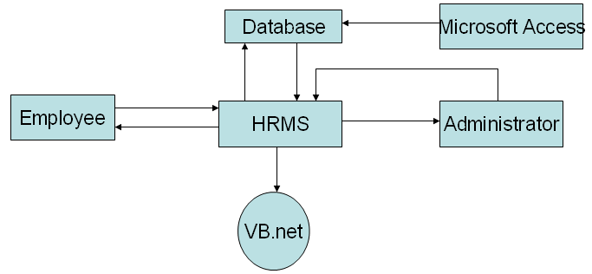

**Level 1:**

**User**

**Authenticate the user**

**View home page**

Enter password

Login failed

Login successful

**Level 2:**

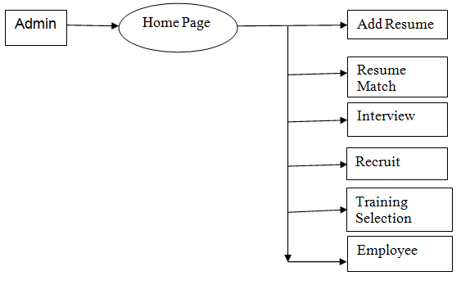

**Description**

This Process mainly explains the different screens that are available for the admin. Hear the selection of the screen depends on the admin and he can select whatever screen he wants. The different screens that are available are Add Resume, Resume Match, Interview, Recruit, Training selection and Employee

**Level 3:**

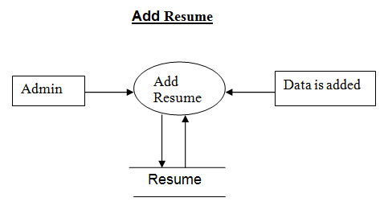

**Description**

This process clearly illustrates adding the details of the Employee such as Name, Parent name, Address, Pin Code, Phone No, Email, Gender, Date of Birth, Language, Qualification, Experience. This detail are added to the database, if any error is generated then it will be prompted to the admin otherwise we get message data is successfully added

**Level 4:**

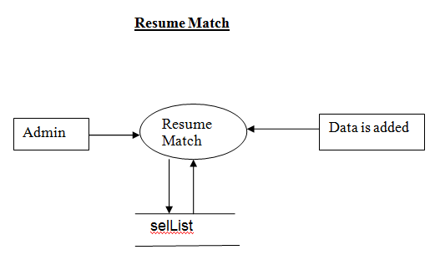

**Description**

This process clearly illustrates adding the details of the Employee such as Name, Parent name, Address, Pin Code, Phone No, Email, Gender, Date of Birth, Language, Qualification, Experience. This detail are added to the database, if any error is generated then it will be prompted to the admin otherwise we get message data is successfully added

**Level 5:**

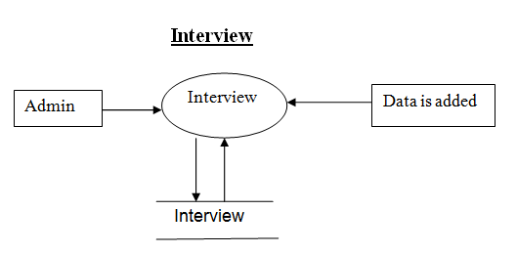

**Description**

This process clearly illustrates adding the details of the Employee such as App no, App name, Remarks, Total Marks, Total Scored, Interview Date, Interview Time. This detail are added to the database, if any error is generated then it will be prompted to the admin otherwise we get message data is successfully added.

**Level 6:**

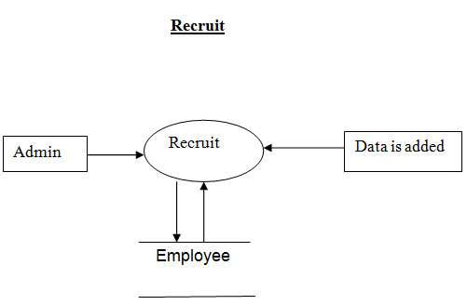

**Description**

This process clearly illustrates adding the details of the Employee such as App no, Name, Gender, DOB, Education detail, job, Salary, Join Date. This detail are added to the database, if any error is generated then it will be prompted to the admin otherwise we get message data is successfully added

**Level 7:**

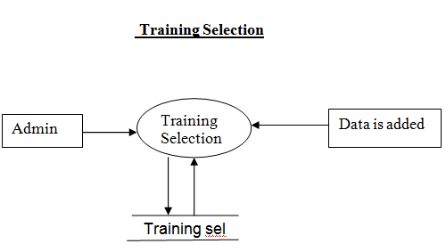

**Description**

This process clearly illustrates adding the details of the Employee such as Training Name, Batch No, From Date, To Date. This detail are added to the database, if any error is generated then it will be prompted to the admin otherwise we get message data is successfully added

**Level 8:**

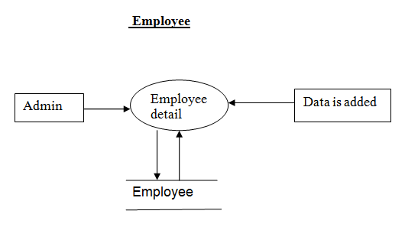

**Description**

This process clearly illustrates adding the details of the Employee such as Employee no, Employee name, Gender, DOB, Education, Job, Date of Join. This detail are added to the database, if any error is generated then it will be prompted to the admin otherwise we get message data is successfully added and also payment to the employee

**ER DIAGRAM**

Entity relationship model is the high level conceptual data model. ER model helps in depicting the entire problem requirement in the form of ER diagram. This is the application development for any given problem.

**Entity** an entity is anything that exits in the real world with an independent existence.

E.g.: Employee, Department.

**Attribute**: The properties of an entity can be described as an attribute.

E.g.: Name, Address, Phone No etc.

**Composite Attribute**: The attributes that can be sub-divided into some more attributes are called as composite attributes.

E.g.: An address is generally composed of street name, area, city, etc.

**SYMBOLS IN ER DIAGRAM**

|  |  |
| --- | --- |
|  | Represents an attribute of an entity |
|  | Represents an entity |
|  | Represents the relation between two entities |

**DETAILED DESIGN**

* **INTRODUCTION**
* **DATABASE DESIGN**

**4.DETAILED DESIGN**

**4.1 INTRODUTION:**

In the detailed design we will decide the internal logic for the module, which implements the given specification.

Detailed design is one of the levels of the design process for software items. Detailed design, which is also known as logic is also known as logic design, involves the internal design of the modules and how the specification of the module can be satisfied. Detailed design is an extension of system design.

The basic goal in detailed design is to specify the logic for the different modules that have been specified during system design. Specifying the logic will require developing an algorithm that will implement the given specifications**.**

**4.2 Database Design:**

A database is inherent collection of data with some inherent meaning, designed, built and populated with data for a specific purpose. The following guideline has been followed by the database design:

* Descriptive names for the tables, columns and indexes.
* Singular names for tables and columns.
* Proper data type for each column**.**

**DATA BASE DESIGN**

**user**

|  |  |  |  |
| --- | --- | --- | --- |
| **Field Name** | **Data Type** | **Constraints** | **Description** |
| RNo | Number | Primary key | Register Number |
| Username | Text | Not null | Register Name |
| PWord | Number | Not null | Serial Number |

**AppEd**

|  |  |  |  |
| --- | --- | --- | --- |
| **Field Name** | **Data Type** | **constraints** | **Description** |
| RNo | Number | Primary key | Register Number |
| RName | Text | Not null | Register Name |
| SlNo | Number | Not null | Serial Number |
| Course | Text | Not null | Course |
| Branch | Text | Not null | Branch |
| SC | Text | Not null | Course Starting |
| Year | Text | Not null | Year |
| Per | Text | Null | Percentage |

**AppEx**

|  |  |  |  |
| --- | --- | --- | --- |
| **Field Name** | **Data Type** | **Constraints** | **Description** |
| Rno | Number | Primary key | Register number |
| RName | Text | Not null | Register Name |
| Slno | Number | Not null | Serial Number |
| yearFrom | Text | Not null | Year From |
| yearTo | Text | Not null | Year To |
| JTitle | Text | Null | Job Title |
| JExp | Text | Null | Previous Job Experience |

**Interview**

|  |  |  |  |
| --- | --- | --- | --- |
| **Filed Name** | **Data Type** | **Constraints** | **Description** |
| JNo | Number | Primary key | Job Number |
| Jtitle | Text | Not null | Job Title |
| ANo | Number | Not null | Applier Number |
| AName | Text | Not null | Applier Name |
| intDate | Date | Not null | Date |
| IntTime | Time | Not null | Time |
| Remark | Text | Null | Remark |
| totMark | Number | Null | Total Mark |
| scoMark | Number | Null | Total Mark |

**JobOpen**

|  |  |  |  |
| --- | --- | --- | --- |
| **Filed Name** | **Data Type** | **Constraints** | **Description** |
| RNo | Number | Primary key | Register Number |
| jTitle | Text | Not null | Job Title |
| Nopost | Number | Not null | Number of vacancy |
| Ed | Text | Not null | Education |
| NoYear | Number | Not null | Year |

**MasBr**

|  |  |  |  |
| --- | --- | --- | --- |
| **Filed Name** | **Data Type** | **Constraints** | **Description** |
| cName | Text | Primary key | Customer Name |
| Year | Text | Not null | Year |

**MasEd**

|  |  |  |  |
| --- | --- | --- | --- |
| **Filed Name** | **Data Type** | **Constraints** | **Description** |
| cName | Text | Primary key | Customer Name |
| Year | Text | Not null | Year |

**MassSkill**

|  |  |  |  |
| --- | --- | --- | --- |
| **Filed Name** | **Data Type** | **Constraints** | **Description** |
| cName | Text | Primary key | Customer Name |
| Det | Text | Not null | Details |

**Resume**

|  |  |  |  |
| --- | --- | --- | --- |
| **Filed Name** | **Data Type** | **Constraints** | **Description** |
| RNo | Number | Primary key | Register Number |
| RName | Text | Not null | Register Name |
| PName | Text | Not null | Parents Name |
| Add1 | Text | Not null | Address1 |
| Add2 | Text | Null | Address2 |
| Add3 | Text | Null | Address3 |
| Pin | Text | Not null | Pin Code |
| Phone | Number | Not null | Phone Number |
| Email | Memo | Null | Email ID |
| Gender | Text | Not null | Gender |
| DOB | Date/Time | Not null | Date of Birth |
| Lang | Text | Not null | Language Known |
| Ed | Text | Not null | Education |
| Ex | Number | Not null | Extra |

**SelList**

|  |  |  |  |
| --- | --- | --- | --- |
| **Filed Name** | **Data Type** | **Constraints** | **Description** |
| pNo | Number | Primary key | Product Number |
| Ptitle | Text | Not null | Product Title |
| aNo | Number | Not null | Account Number |
| aName | Text | Not null | Account Name |
| intDate | Date/Time | not null | Date |
| intTime | Text | not null | Time |
| Letsend | Text | Not null | Sending information |

**Training**

|  |  |  |  |
| --- | --- | --- | --- |
| **Filed Name** | **Data Type** | **Constraints** | **Description** |
| tName | Text | Primary key | Training Name |
| tDays | Number | Not null | Training Days |
| Det | Text | Not null | Details |

**TrainingSel**

|  |  |  |  |
| --- | --- | --- | --- |
| **Filed Name** | **Data Type** | **Constraints** | **Description** |
| batchNo | Text | Primary key | Batch Number |
| EmpNo | Number | Not null | Employee Number |
| eName | Text | Not null | Employee Name |
| Job | Text | Not null | Job |
| tName | Text | Not null | Training Name |
| Fromdate | Date/Time | Not null | from Date |
| Todate | Date/Time | Not null | To Date |
| scoMark | Number | Not null | Scored Marks |

**Employee**

|  |  |  |  |
| --- | --- | --- | --- |
| **Filed Name** | **Data Type** | **Constraints** | **Description** |
| EmpNo | number | Primary key | Batch Number |
| eName | Text | Not null | Employee Number |
| Gender | Text | Not null | Employee Name |
| DOB | Date/Time | Not null | Job |
| ED | Text | Not null | Training Name |
| Job | Date/Time | Not null | from Date |
| Sal | Number | Not null | To Date |
| DOJ | Date/Time | Not null | Scored Marks |
| Paydate | Number | Not null | Remark |

**intlet**

|  |  |  |  |
| --- | --- | --- | --- |
| **Filed Name** | **Data Type** | **Constraints** | **Description** |
| Appno | number | Primary key | Job |
| Name | Text | Not null | Training Name |
| Msg | Text | Not null | from Date |
| intDate | Text | Not null | To Date |
| Inttime | Text | Not null | Scored Marks |
| Address | Text | Not null | Remark |

**TESTING**

* **INTRODUCTION**
* **OBJECTIVE TESTING**
* **TESTING TECHNIQUES**
* **TEST CASES**

**5.TESTING**

**5.1 Introduction:**

A project is incomplete without successful testing and implementation. A program or system design is perfect only when the communication between the user and the designer is complete and clear. A successful system design helps in efficient testing and implementation. Testing is vital to the success of the system.

* 1. **Objective of Testing:**
* Testing is a process of executing a program with the intent of finding an error.
* A good test case is the one that has high probability of finding an as-yet undiscovered error.
* A successful case is one uncovers as yet undiscovered error.

System testing is a stage of implementation, which is aimed at ensuring that the system works accurately and efficiently as per the user needs, before the live operation commences. As stated before the live operation commences. As stated before testing is vital to the success of the system. System testing makes a logic assumption that if all the parts of the system are correct, the goal will be successfully achieved. The candidate system is subjected to a variety of tests. A series of tests are performed before the system is ready for the user acceptance tests.

Different types of testing are:

* Unit Testing
* Integrated Testing
* Black Box Testing
* Validation Testing
* User Acceptance Testing

**5.3.1 Unit Testing:**

In this testing each sub module is tested individually with test data and then integrated to the overall system. Unit testing focuses verification effort on the smallest unit of the software design in the module or component. In fund flow analysis all modules of the system are tested separately. The testing was carried out during the coding stage itself. Each module was tested and it was being developed. All the modules were correct for error and finally worked satisfactorily.

**5.3.2 Integrated Testing:**

This is a systematic technique for constructing the program structure while at the same time conducting tests to uncover errors with interfacing. Data can be lost across an interface; one module can have effect on other module; sub functionality may not be achieved. The testing was done with simple data. The developed data was run successfully with the test data. The need to integrate testing is to find overall system performance. All modules are combined and tested as a whole. Here errors uncovered are corrected for next testing steps.

**5.3.3 Black Box Testing:**

It focuses on the functional requirements of the software. Black Box testing attempts to find errors in the following categories:

* Incorrect or missing functions
* Interface error
* Errors in external device access
* Performance error
* Initialization and termination errors

The above testing was successfully carried out for the developed system.

**5.3.4 Validation Testing:**

At the accumulation of integrated testing, software is completely assembled as a package, interfacing errors have been uncovered and corrected, and final series of software tests namely validation tests namely validation tests are performed. Validation succeeds when the software functions in a manner that can be easily accepted by the customer. After validation tests have been conducted, one of the possible conditions is satisfied**:**

* The functions or performance characteristics confirmed to specialization are accepted.
* The deviation from specifications is uncovered and a note of what is lacking is made.

The developed system has been tested satisfactorily and is also satisfactory. It is working efficiently.

**5.3.5 User Acceptance Testing:**

User acceptance testing is key factor for the success of any system. The system under consideration was tested for user acceptance constantly, by keeping the users informed of the progress and incorporated changes suggested, at the development time itself.

**5.6 Test Cases:**

|  |  |  |  |
| --- | --- | --- | --- |
| SERIAL NO | TEST CONDITION | EXPECTED RESULT | RESULT |
| 1 | When the user clicks “Log in” | If the username and password is correct then it has to display the main form. | Successful |
| 2 | When the admin clicks “Master” | It should display the course details, branch details, employee training, and skill details. | Successful |
| 3 | When the user clicks “Resume” | It should display the ResumeDet,Educational Det, Experience Det. | Successful |
| 4 | When the user clicks “Job Openings” | It should display the Job Opens Form. | Successful |
| 5 | When the user clicks “Resume Matching” | It should display the “Resume Matching form”. | Successful |
| 6 | When the user clicks “InterView” | It should display the Interview Details, InterView Letter. | Successful |
| 7 | When the user clicks “Recruitment” | It should display the “Recruitment Section” form. | Successful |
| 8 | When the super user clicks “Training Selection” | It should display the “Employee training selection” form. | Successful |
| 9 | When the user clicks “Trainy Test” | It should display the “Trainy Test” form. | Successful |

|  |  |  |  |
| --- | --- | --- | --- |
| 10 | When the user clicks “Employees” | It should display the Employee Detail, Payments. | Successful |
| 11 | When the user clicks “Exit” | It should comes out of program. | Successful |

**Master Form (admin):**

|  |  |  |  |
| --- | --- | --- | --- |
| SERIAL NO | TEST CONDITION | EXPECTED RESULT | RESULT |
| 1 | When the admin clicks “Course Details” | It should display the course Entry Form” | Successful |
| 2 | When the admin clicks “Branch Details” | It should display the “Branch Entry Form”. | Successful |
| 3 | When the admin clicks “Skill Details”. | It should display the “Skill Entry Form”. | Successful |
| 4 | When the admin clicks “Employee Training Course” | It should display the Training Entry Form”. | Successful |

**Course Entry Form:**

|  |  |  |  |
| --- | --- | --- | --- |
| SERIAL NO | TEST CONDITION | EXPECTED RESULT | RESULT |
| 1 | When the admin clicks “New” | Admin must able to create new course details. | Successful |
| 2 | When the super admin clicks “Save” | It should save the newly created records. | Successful |
| 3 | When the admin clicks  “Modify” | The edited record must be updated (modified) in “MasEd” table. | Successful |
| 4 | When the admin clicks “Delete” | It should delete the selected record from the “MasEd” table. | Successful |
| 5 | When the admin clicks “Close” | It should close the Course Entry Form. | Successful |

**Branch Entry Form:**

|  |  |  |  |
| --- | --- | --- | --- |
| SERIAL NO | TEST CONDITION | EXPECTED RESULT | RESULT |
| 1 | When the admin clicks “New” | Admin must able to create new branch details. | Successful |
| 2 | When the super admin clicks “Save” | It should save the newly created records. | Successful |
| 3 | When the admin clicks  “Modify” | The edited record must be updated (modified) in “MasBr” table. | Successful |
| 4 | When the admin clicks “Delete” | It should delete the selected record from the “MasBr” table. | Successful |
| 5 | When the admin clicks “Close” | It should close the Branch Entry Form. | Successful |

**Skill Entry Form:**

|  |  |  |  |
| --- | --- | --- | --- |
| SERIAL NO | TEST CONDITION | EXPECTED RESULT | RESULT |
| 1 | When the admin clicks “New” | Admin must able create new skill details. | Successful |
| 2 | When the admin clicks “Save” | It should save the newly created records. | Successful |
| 3 | When the admin clicks  “Modify” | The edited record must be updated (modified) in “MasSkill” table. | Successful |
| 4 | When the admin clicks “Delete” | It should delete the selected record from the “MasSkill” table. | Successful |
| 5 | When the admin clicks “Close” | It should close the Skill Entry Form. | Successful |

**Resume Form:**

|  |  |  |  |
| --- | --- | --- | --- |
| SERIAL NO | TEST CONDITION | EXPECTED RESULT | RESULT |
| 1 | When the user clicks “ResumeDet” | It should display the “Resume Details” Form | Successful |
| 2 | When the user clicks “Educational Det” | It should display the “Educational Details Form”. | Successful |
| 3 | When the user clicks “Experience Det”. | It should display the “Experience Details Form”. | Successful |

**Resume Detail:**

|  |  |  |  |
| --- | --- | --- | --- |
| SERIAL NO | TEST CONDITION | EXPECTED RESULT | RESULT |
| 1 | When the user clicks “New” | User must able create new Experience details. | Successful |
| 2 | When the user clicks “Save” | It should save the newly created records. | Successful |
| 3 | When the user clicks  “Modify” | The edited record must be updated (modified)and it stored in “Resume” table. | Successful |
| 4 | When the user clicks “Delete” | It should delete the selected record from the “Resume” table. | Successful |
| 5 | When the user clicks “Close” | It should close the Resume Details Form. | Successful |

**Education Details Form**

|  |  |  |  |
| --- | --- | --- | --- |
| SERIAL NO | TEST CONDITION | EXPECTED RESULT | RESULT |
| 1 | When the user clicks “New” | User must able create new Educational details and it stored in AppEd. | Successful |
| 2 | When the user clicks “Save” | It should save the newly created records. | Successful |
| 3 | When the user clicks  “Modify” | The edited record must be updated (modified) in “AppEd” table. | Successful |
| 4 | When the user clicks “Delete” | It should delete the selected record from the “AppEd” table. | Successful |
| 5 | When the user clicks “Close” | It should close the Skill Entry Form. | Successful |

**Experience Details:**

|  |  |  |  |
| --- | --- | --- | --- |
| SERIAL NO | TEST CONDITION | EXPECTED RESULT | RESULT |
| 1 | When the user clicks “New” | User must able create new Experience details and it stored in AppEx. | Successful |
| 2 | When the user clicks “Save” | It should save the newly created records. | Successful |
| 3 | When the user clicks  “Modify” | The edited record must be updated (modified) and it stored in “AppEx” table. | Successful |
| 4 | When the user clicks “Delete” | It should delete the selected record from the “AppEx” table. | Successful |
| 5 | When the user clicks “Close” | It should close the Experience Details Form. | Successful |

**Job Opens Form:**

|  |  |  |  |
| --- | --- | --- | --- |
| SERIAL NO | TEST CONDITION | EXPECTED RESULT | RESULT |
| 1 | When the user clicks “New” | User must able create new job details and it stored in JobOpen. | Successful |
| 2 | When the user clicks “Save” | It should save the newly created records. | Successful |
| 3 | When the user clicks  “Modify” | The edited record must be updated (modified) in “JobOpen” table. | Successful |
| 4 | When the user clicks “Delete” | It should delete the selected record from the “jobOpen” table. | Successful |
| 5 | When the user clicks “Close” | It should close the Job Opens Form. | Successful |

**Resume Matching:**

|  |  |  |  |
| --- | --- | --- | --- |
| SERIAL NO | TEST CONDITION | EXPECTED RESULT | RESULT |
| 1 | When the user clicks “search” | It searches the selected job post and searched items are stored in search result table. | Successful |
| 2 | When the user clicks “Save” | It should save the search results. | Successful |
| 3 | When the user clicks “Close” | It should close the Resume Matching Form. | Successful |

**Interview:**

|  |  |  |  |
| --- | --- | --- | --- |
| SERIAL NO | TEST CONDITION | EXPECTED RESULT | RESULT |
| 1 | When the user clicks “Interview Details” | It should display the “Interview Form” | Successful |
| 2 | When the admin clicks “InterView Details” | It should display the “Interview Letter Form”. | Successful |

**Interview Form:**

|  |  |  |  |
| --- | --- | --- | --- |
| SERIAL NO | TEST CONDITION | EXPECTED RESULT | RESULT |
| 1 | When the user clicks “Save” | It should save the newly created records. | Successful |
| 2 | When the user clicks “Close” | It should close the Interview Form. | Successful |

**Interview Letter Form:**

|  |  |  |  |
| --- | --- | --- | --- |
| SERIAL NO | TEST CONDITION | EXPECTED RESULT | RESULT |
| 1 | When the user clicks “Send” | It should send the Interview Letter and “Letter is sent” message should arrive. | Successful |
| 2 | When the user clicks “Close” | It should close the Interview Letter Form. | Successful |

**Recruitment Section form:**

|  |  |  |  |
| --- | --- | --- | --- |
| SERIAL NO | TEST CONDITION | EXPECTED RESULT | RESULT |
| 1 | When the user clicks “Save” | It should save the newly created records and it stored in Employee. | Successful |
| 2 | When the user clicks “Close” | It should close the Recruitment Form. | Successful |

**Employee Training Selection Form:**

|  |  |  |  |
| --- | --- | --- | --- |
| SERIAL NO | TEST CONDITION | EXPECTED RESULT | RESULT |
| 1 | When the user clicks “Save” | It should save the newly created records and it stored in “trainingSel” table. | Successful |
| 2 | When the user clicks “print” | It should prints the selected Employees record. |  |
| 3. | When the user clicks “Close” | It should close the Interview Form. | Successful |

**Trainy Test Form:**

|  |  |  |  |
| --- | --- | --- | --- |
| SERIAL NO | TEST CONDITION | EXPECTED RESULT | RESULT |
| 1 | When the user clicks “Save” | It should save the newly created records and it stored in trainingSel. | Successful |
| 2 | When the user clicks “Close” | It should close the Trainy Test Form. | Successful |

**Employees Form**

|  |  |  |  |
| --- | --- | --- | --- |
| SERIAL NO | TEST CONDITION | EXPECTED RESULT | RESULT |
| 1 | When the user clicks “Employee Detail” | It should display the “Empdetails” Form | Successful |
| 2 | When the user clicks “Payments” | It should display the “Payment Form”. | Successful |

**Empdetail Form:**

|  |  |  |  |
| --- | --- | --- | --- |
| SERIAL NO | TEST CONDITION | EXPECTED RESULT | RESULT |
| 1 | When the user clicks “New” | User must able create new Employee details and it stored in Employee table. | Successful |
| 2 | When the user clicks “Save” | It should save the newly created records. | Successful |
| 3 | When the user clicks  “Modify” | The edited record must be updated (modified)and stored in “Employee” table. | Successful |
| 4 | When the user clicks “Delete” | It should delete the selected record from the “Employee” table. | Successful |
| 5 | When the user clicks “Close” | It should close the Emp detail Form. | Successful |

**Payment Form:**

|  |  |  |  |
| --- | --- | --- | --- |
| SERIAL NO | TEST CONDITION | EXPECTED RESULT | RESULT |
| 1 | When the user clicks “New” | User must able create new Employee payment details and it stored in Employee table. | Successful |
| 2 | When the user clicks “Save” | It should save the newly created records. | Successful |
| 3 | When the user clicks “Delete” | It should delete the selected record from the “Employee” table. | Successful |
| 4 | When the user clicks “Close” | It should close the Payment Form. | Successful |

**Snapshots**

**LOGIN FORM**

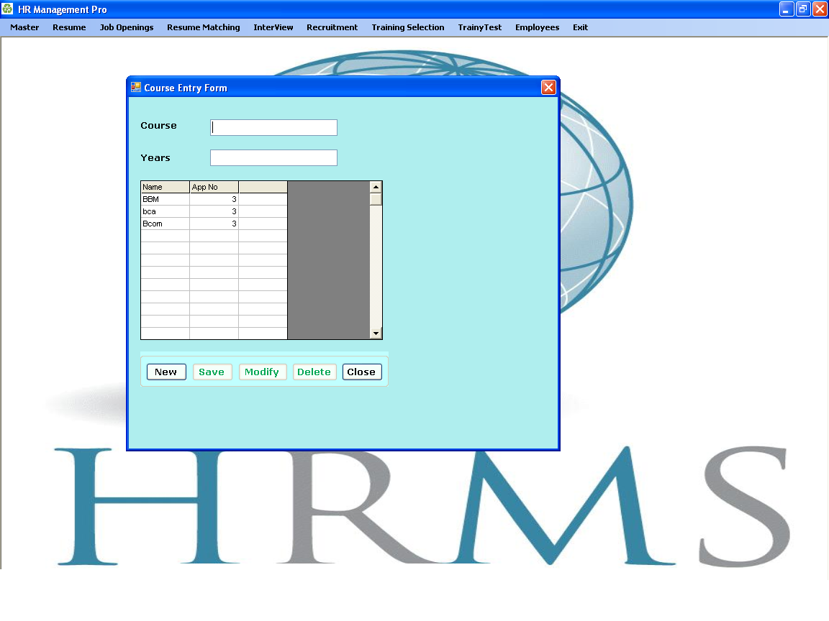**Course Entry Form**

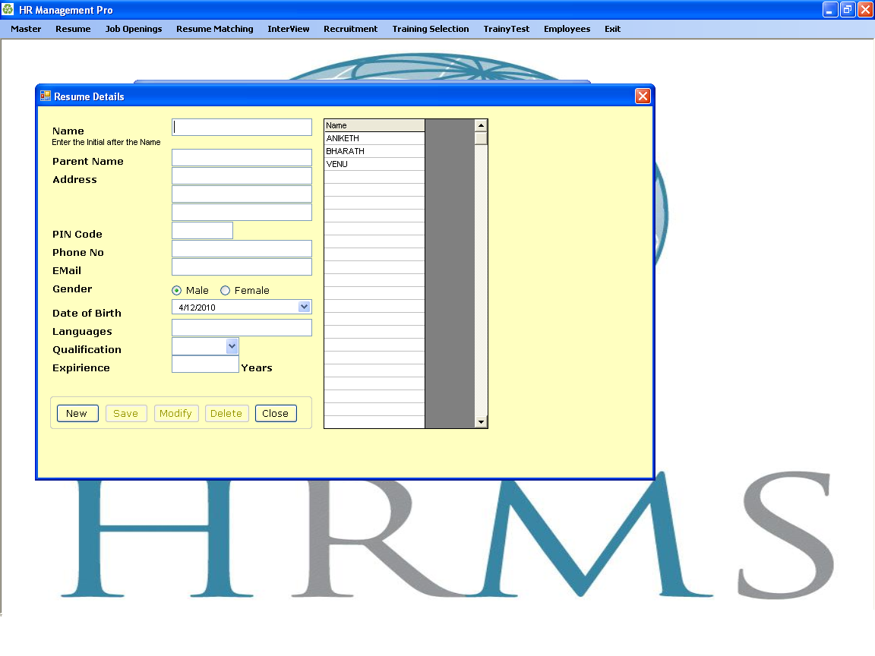**Resume Details**

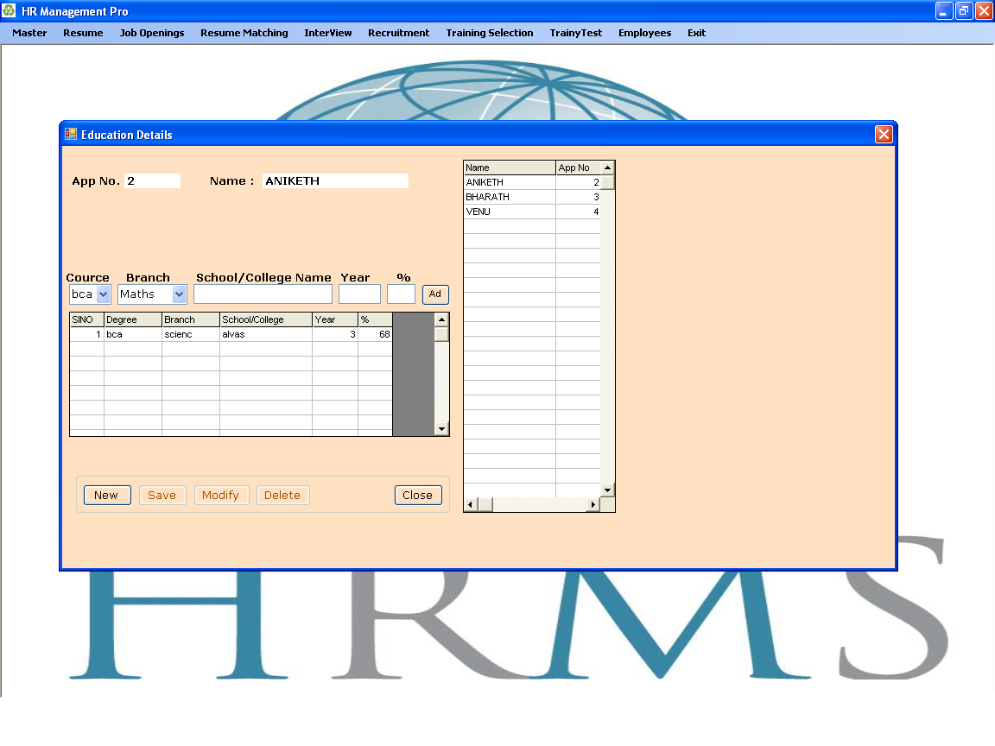**Education Details**

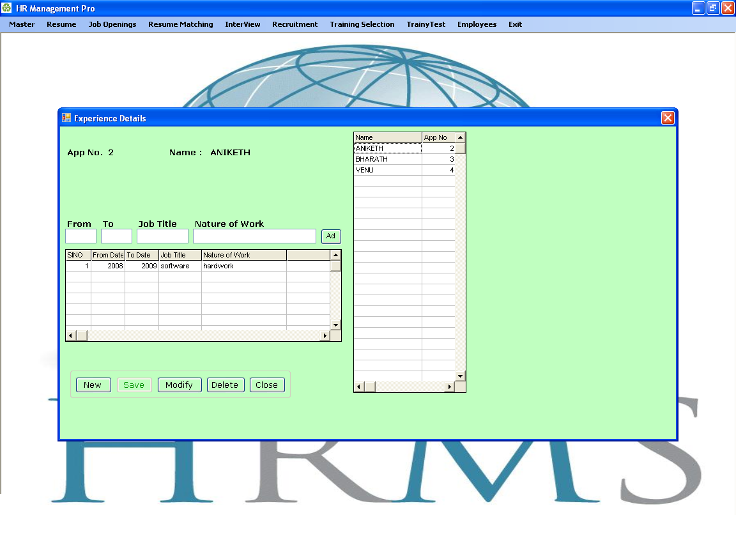**Experience Details**

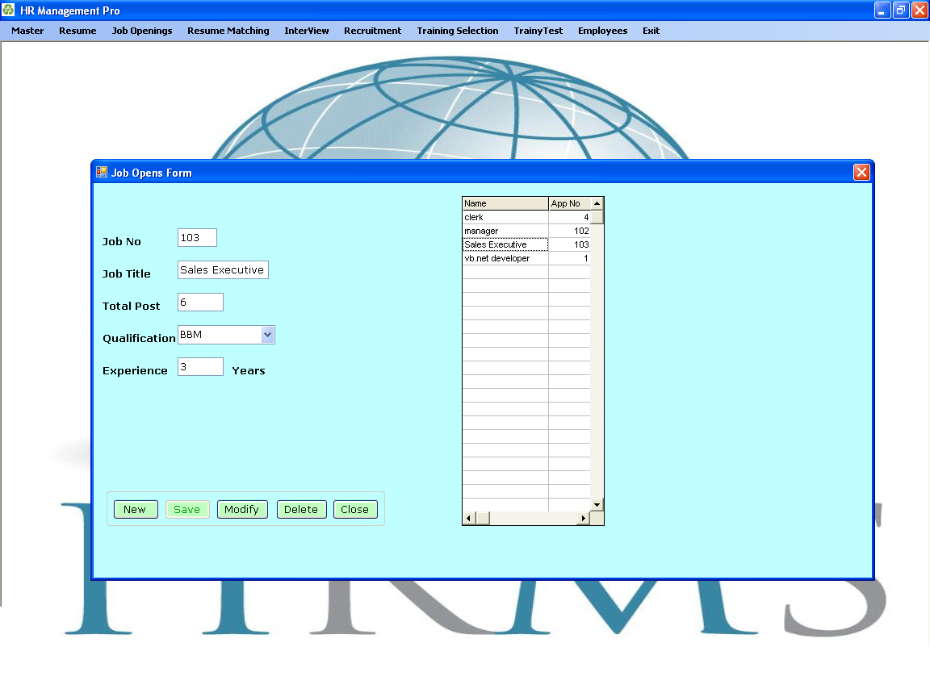**Job Opens Form**

**Resume Matching**

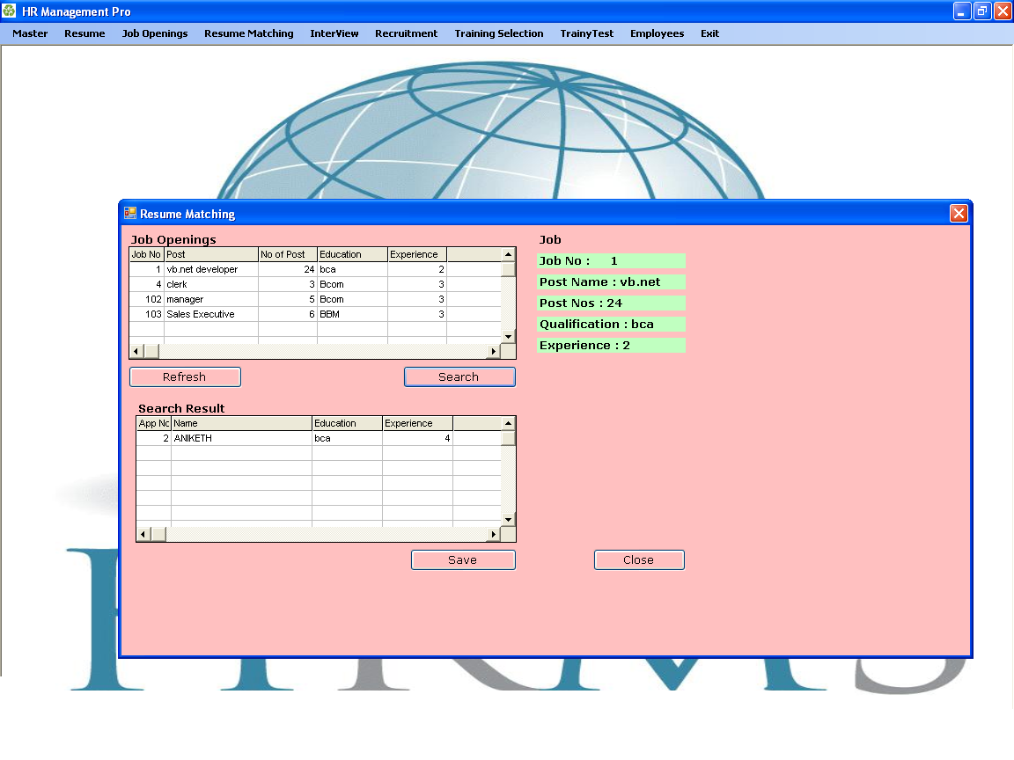

**Interview marks entry form**

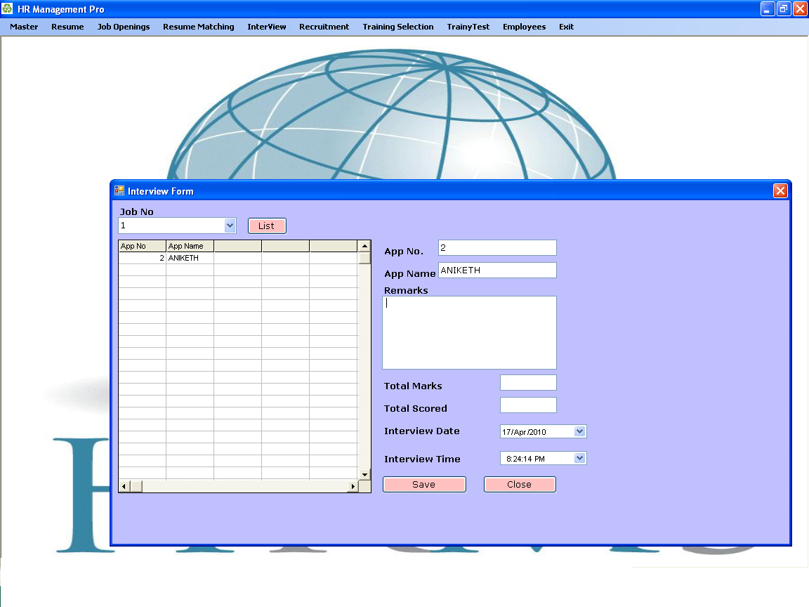

**Interview Letter Form**

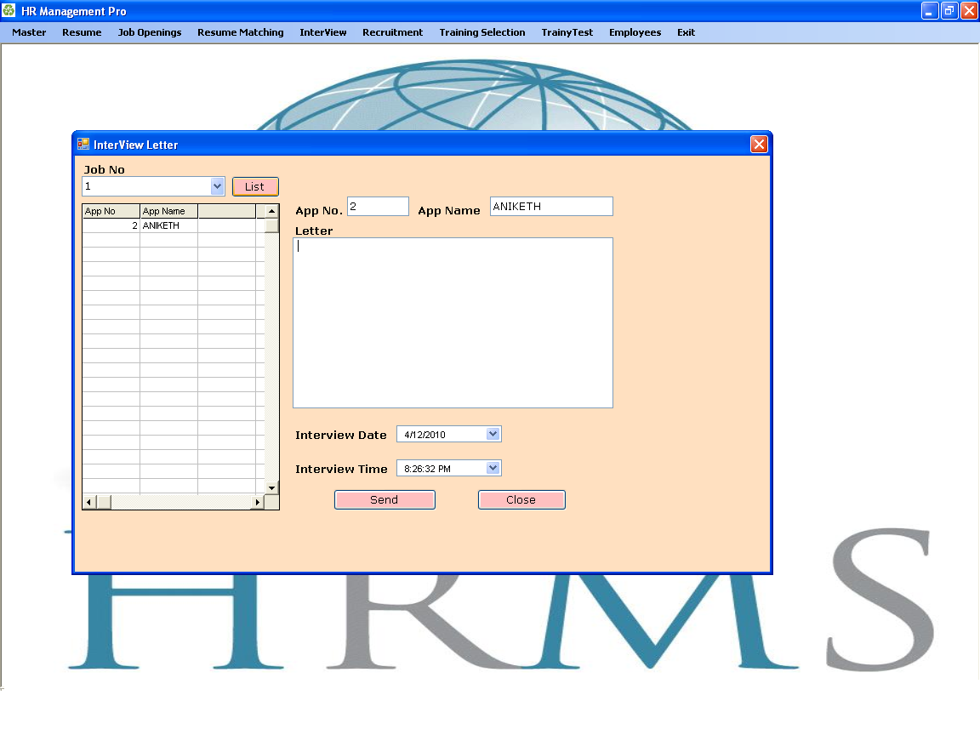

**Employee Recruiting**

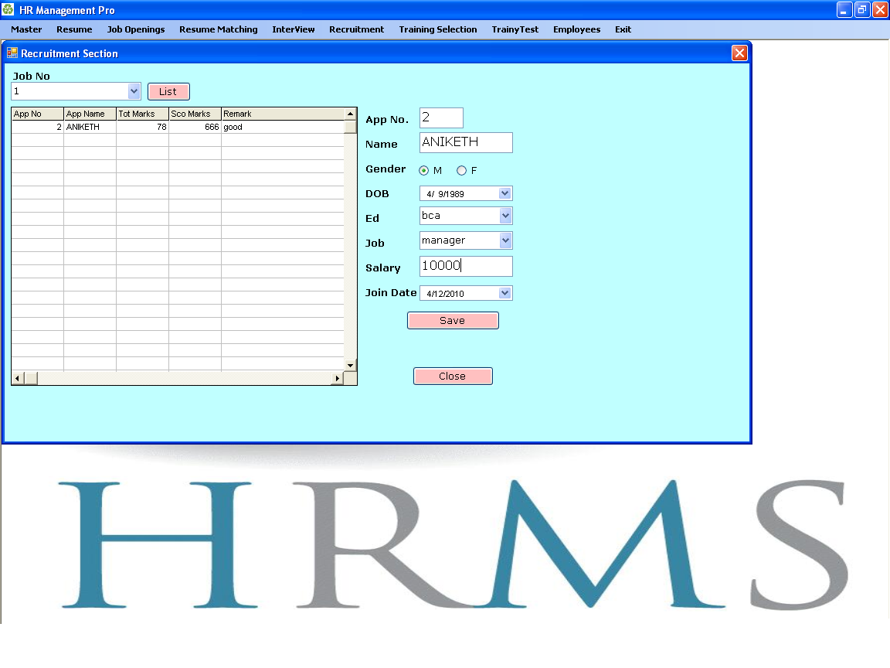

**Employee Training Selection**

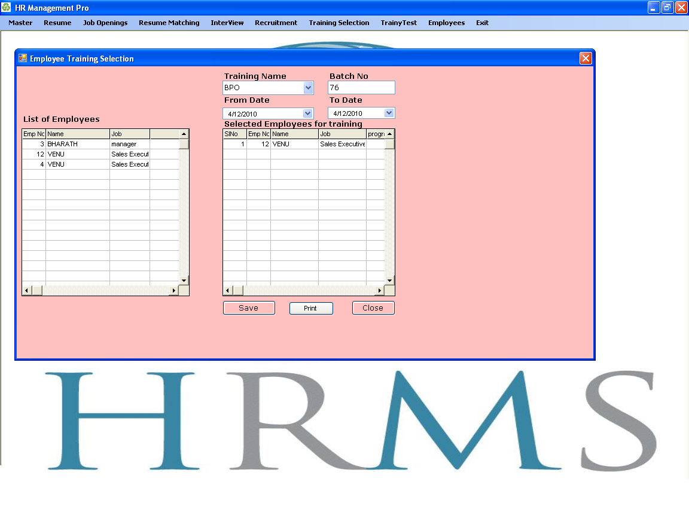

**Training Test**

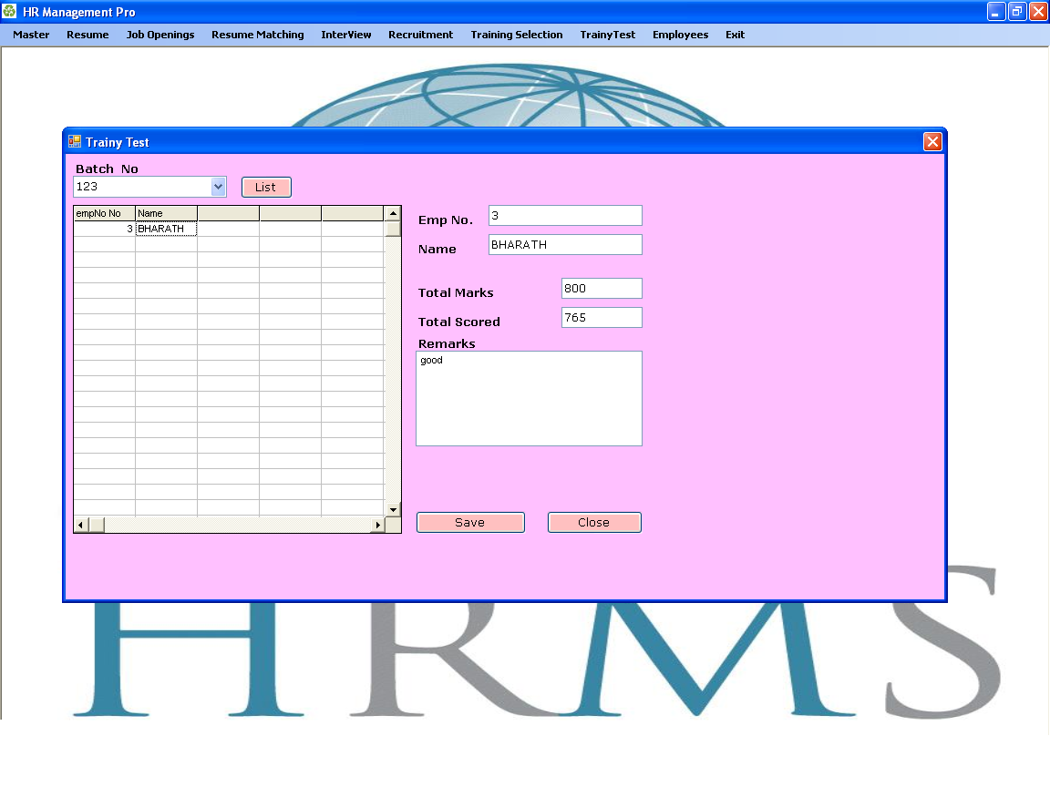

**Employee Details**

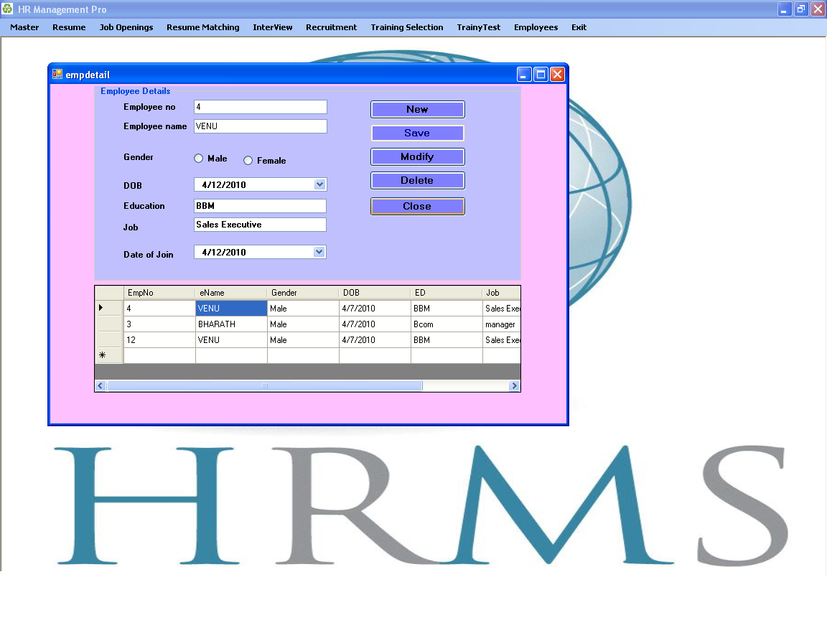

**Payment Details**

