Eco Build AI
Building Energy Efficiency Analysis & Prediction
Internship Project Report
AICTE | IBM SkillsBuild Data Analytics with AI Internship Program
Project Domain
Data Analytics · Machine Learning · Streamlit Web Application
Dataset
UCI Energy Efficiency Dataset (Tsanas & Xifara, 2012)
768 Building Configurations · 8 Input Features · 2 Target Variables
Models
Linear Regression (Baseline) · Random Forest Regressor (Main Model)
Academic Year 2024–2025
Submitted in partial fulfilment of the requirements of the AICTE | IBM SkillsBuild Internship Programme

Table of Contents
1. Executive Summary
2. Problem Statement
3. Project Objectives
4. Dataset Description
5. Methodology
6. Data Cleaning & Validation
7. Exploratory Data Analysis
8. Machine Learning Approach
9. Model Performance Results
10. Feature Importance Analysis
11. Key Findings & Business Insights
12. Recommendations
13. Streamlit Application
14. Limitations
15. Conclusion
16. References

1. Executive Summary
EcoBuild AI is a data analytics and machine learning project that analyses the structural characteristics of simulated residential buildings and predicts their annual heating and cooling energy demands. The project is developed as part of the AICTE | IBM SkillsBuild Data Analytics with AI Internship Programme.
The dataset used is the UCI Energy Efficiency Dataset (Tsanas & Xifara, 2012), comprising 768 building configurations generated through the Ecotect energy simulation tool. Eight structural parameters — including relative compactness, surface area, wall area, roof area, overall height, orientation, glazing area, and glazing distribution — serve as input features. The two target variables are Heating Load (Y1) and Cooling Load (Y2), both expressed in kWh/m² per year.
The project follows a structured data analytics pipeline: data loading and cleaning, exploratory data analysis (EDA), machine learning model training and evaluation, feature importance analysis, and the development of an interactive prediction application. Two regression models are implemented: a Linear Regression baseline and a Random Forest regressor as the primary model.
The Random Forest model achieves a coefficient of determination (R²) of 0.9977 for Heating Load prediction and 0.9674 for Cooling Load prediction on the hold-out test set. The Linear Regression baseline achieves R² values of 0.9122 and 0.8932 respectively. Feature importance analysis identifies Overall Height and Relative Compactness as the dominant predictors for both targets.
The project is delivered as a modular Python codebase with a Streamlit web application that allows users to interactively set building parameters and receive real-time Heating Load and Cooling Load predictions. All visualisations, metrics, and insights are computed from the actual dataset — no results are hard-coded or fabricated.

2. Problem Statement
Buildings are among the largest consumers of energy globally. Heating and cooling systems alone account for a significant portion of a building’s total energy use, and the efficiency of these systems is heavily influenced by decisions made at the earliest stages of architectural design — long before a building is constructed or even fully modelled.
Traditional energy performance assessment relies on specialist simulation software, detailed architectural models, and expert engineering knowledge. These tools are not readily available during rapid concept design, where architects and developers need to compare multiple design options quickly. This creates a gap: energy efficiency is frequently an afterthought rather than an integrated design criterion.
Machine learning offers a complementary approach. By training a predictive model on a dataset of simulated building configurations and their associated energy demands, it becomes possible to instantly estimate the heating and cooling loads of a new building design given only its basic structural parameters. This can support data-driven design exploration without requiring specialist simulation expertise.
This project addresses this problem by developing a data analytics and machine learning pipeline trained on the UCI Energy Efficiency Dataset. The dataset contains 768 building configurations varying in shape, size, glazing, and orientation, each with associated simulated heating and cooling loads. The project analyses which structural features most strongly influence energy demand and builds a predictive model accurate enough to be useful as a rapid design-stage estimation tool.
It is important to note that this dataset comprises entirely simulated configurations. The findings are evidence-based within the scope of the dataset and should be treated as analytical conclusions from simulation data, not as validated field measurements from real-world buildings.

3. Project Objectives
The EcoBuild AI project was designed to achieve the following objectives:
1. Load and clean the UCI Energy Efficiency Dataset, removing empty rows, renaming columns to descriptive physical names, and validating data quality (zero missing values, zero duplicates).
2. Perform comprehensive exploratory data analysis to understand the distribution of building features and energy targets, their correlations, and the relationships between structural parameters and energy loads.
3. Train a Linear Regression baseline model and a Random Forest regressor as the primary model, both predicting Heating Load and Cooling Load simultaneously using multi-output regression.
4. Evaluate both models on a held-out test set using Mean Absolute Error (MAE), Root Mean Squared Error (RMSE), and Coefficient of Determination (R²).
5. Extract and visualise feature importances from the Random Forest model to identify which structural parameters most strongly influence energy demand.
6. Generate evidence-based observations, testable hypotheses, and cautious design recommendations from the dataset analysis.
7. Develop a professional, interactive Streamlit web application that enables users to set building parameters using sliders and receive instant Heating Load and Cooling Load predictions from the trained Random Forest model.
8. Structure the project as a maintainable, modular Python codebase with clearly separated responsibilities: data loading, cleaning, analysis, modelling, prediction, insights, and user interface.

4. Dataset Description

4.1 Source and Citation
The dataset used in this project is the UCI Energy Efficiency Dataset, first published by Tsanas and Xifara in the journal Energy and Buildings (Volume 49, 2012, pages 560–567). It was generated by simulating 768 different residential building configurations using Ecotect, a building energy simulation tool developed by Autodesk. The dataset is publicly available from the UCI Machine Learning Repository.

4.2 Dataset Structure
The raw Excel file contains 1,296 rows and 12 columns. After removing 528 entirely empty trailing rows and two empty columns (K and L), the cleaned dataset contains exactly 768 observations across 10 columns. There are zero missing values and zero duplicate rows in the cleaned dataset. All features and targets are stored as numeric (float64) values.

4.3 Feature and Target Descriptions
The table below describes each of the eight input features and two target variables in the dataset.
Column | Physical Name | Role | Description & Range
X1 | Relative Compactness | Feature | Volume-to-surface-area ratio. Range: 0.62–0.98 (12 discrete levels).
X2 | Surface Area | Feature | Total external surface area in m². Range: 514.5–808.5 m² (12 levels).
X3 | Wall Area | Feature | Total wall surface area in m². Range: 245–416.5 m² (7 levels).
X4 | Roof Area | Feature | Horizontal roof area in m². Four values: 110.25, 122.5, 147, 220.5 m².
X5 | Overall Height | Feature | Building height in metres. Binary: 3.5 m (single storey) or 7.0 m (double storey).
X6 | Orientation | Feature | Compass orientation. Integer encoding: 2=North, 3=East, 4=South, 5=West.
X7 | Glazing Area | Feature | Fraction of floor area covered by glazing. Levels: 0, 0.10, 0.25, 0.40.
X8 | Glazing Area Distribution | Feature | Facade carrying the glazing. 0=none, 1=uniform, 2=North, 3=East, 4=South, 5=West.
Y1 | Heating Load | Target | Annual heating energy demand in kWh/m². Range: 6.01–43.10 kWh/m². Mean: 22.31.
Y2 | Cooling Load | Target | Annual cooling energy demand in kWh/m². Range: 10.90–48.03 kWh/m². Mean: 24.59.
Table 1. UCI Energy Efficiency Dataset — Feature and Target Descriptions

5. Methodology
The project follows a structured, end-to-end data analytics and machine learning pipeline. Each stage is implemented in a dedicated Python module within the src/ directory, keeping responsibilities clearly separated.
Stage 1 — Data Loading (src/data_loader.py)
The raw Excel file is read using openpyxl via pandas. Only the first worksheet and first ten columns are retained. The module exposes load_raw() for the unprocessed data and load_clean() for the fully prepared dataset.
Stage 2 — Data Cleaning & Validation (src/data_cleaning.py)
528 entirely empty trailing rows are removed. Columns are renamed from the generic X1–X8/Y1–Y2 to meaningful physical names. All columns are cast to float64. A data quality report confirms zero missing values and zero duplicate rows. Descriptive statistics are computed and exported.
Stage 3 — Exploratory Data Analysis (src/analysis.py)
Nine visualisations are generated: feature distribution box plots, Heating and Cooling Load histograms with KDE, a Pearson correlation heatmap, feature-target scatter plots for both targets, glazing area box plot comparisons, an orientation comparison bar chart, and a Heating vs Cooling Load scatter plot coloured by height.
Stage 4 — Model Training & Evaluation (src/model.py)
The dataset is split 80/20 into training and test sets (random state = 42). A Linear Regression model with StandardScaler is trained as a baseline. A Random Forest Regressor (200 estimators, random state = 42) is trained as the primary model. Both models use MultiOutputRegressor to predict Heating Load and Cooling Load simultaneously. MAE, RMSE, and R² are computed on the test set. Trained models and metrics are persisted to the models/ directory.
Stage 5 — Feature Importance (src/model.py, src/prediction.py)
Mean Decrease in Impurity (MDI) feature importances are extracted from each Random Forest estimator (one per target). Horizontal bar charts rank features from least to most important for both Heating Load and Cooling Load.
Stage 6 — Prediction (src/prediction.py)
The predict_loads() function accepts a dictionary of the 8 feature values and returns predicted Heating Load and Cooling Load in kWh/m² using the persisted Random Forest model. Models are loaded from disk on first call and then reused within the session.
Stage 7 — Business Insights (src/insights.py)
Evidence-based observations, testable hypotheses, and design recommendations are computed directly from the dataset using statistical comparisons (group means, correlation coefficients). No results are hard-coded.
Stage 8 — Streamlit Application (app.py)
The Streamlit application integrates all stages into a five-page interactive dashboard: Overview, Data Analysis, Model Performance, Feature Importance, and Energy Prediction. All charts and metrics are rendered live from the actual data and models.

6. Data Cleaning & Validation
Data preparation is performed in two modules: src/data_loader.py handles reading and structural transformation, while src/data_cleaning.py provides quality reporting and export utilities. The following steps are applied in sequence.
Step 1 — File Reading
The Excel file Data/building_energy_efficiency.xlsx is read using pandas.read_excel() with the openpyxl engine. Only the first worksheet is used. The first ten columns (A through J) are retained using iloc[:, :10]; columns K and L are excluded as they contain no data.
Step 2 — Removing Empty Rows
The raw file contains 1,296 rows. Rows 770 through 1,296 are entirely empty (all values are NaN). These 528 trailing rows are removed using df.dropna(how='all'), reducing the dataset to exactly 768 data rows. The index is reset after removal.
Step 3 — Column Renaming
Generic column names X1–X8 and Y1–Y2 are replaced with descriptive physical names: Relative_Compactness, Surface_Area, Wall_Area, Roof_Area, Overall_Height, Orientation, Glazing_Area, Glazing_Area_Distribution, Heating_Load, and Cooling_Load. This renaming is performed using a fixed mapping dictionary for reproducibility.
Step 4 — Type Casting
All columns are cast to float64 to ensure numerical consistency across all downstream operations, including model training and correlation analysis.
Step 5 — Quality Verification
A programmatic data quality report is generated and displayed in the Streamlit application. The verified results from this project are summarised in Table 2 below.
Quality Metric | Result
Total rows (after cleaning) | 768
Total columns | 10 (8 features + 2 targets)
Missing values | 0
Duplicate rows | 0
Data type (all columns) | float64
Empty rows removed | 528 (rows 770–1296 of raw file)
Table 2. Data Quality Report — Cleaned Dataset

7. Exploratory Data Analysis
Exploratory Data Analysis (EDA) is implemented in src/analysis.py. All nine visualisations are generated as Matplotlib figures and rendered interactively within the Streamlit Data Analysis page. The key analytical findings are described below.

7.1 Feature Distributions
Box plots for all eight input features reveal that most features take discrete values with limited unique levels (2 to 12 per feature). Relative Compactness ranges from 0.62 to 0.98 across 12 levels. Overall Height is binary (3.5 m or 7.0 m). Glazing Area has four levels (0, 10%, 25%, 40%). These discrete distributions reflect the systematic grid-of-configurations approach used in the Ecotect simulation.

7.2 Target Variable Distributions
Heating Load (Y1) is right-skewed with a mean of 22.31 kWh/m² and a range of 6.01–43.10 kWh/m². Cooling Load (Y2) is similarly distributed with a mean of 24.59 kWh/m² and a range of 10.90–48.03 kWh/m². Both targets show a bimodal tendency driven by the binary Overall Height feature, creating two clusters of configurations.

7.3 Correlation Analysis
A Pearson correlation matrix is computed for all ten variables. The most notable findings are:
• Overall Height (X5) has a strong positive correlation with both Heating Load (approximately +0.89) and Cooling Load (approximately +0.90).
• Relative Compactness (X1) has a strong negative correlation with both targets, as more compact buildings lose less energy through their envelope.
• Surface Area (X2) shows a strong positive correlation with energy loads, essentially mirroring the negative correlation of compactness — the two features encode similar geometric information (multicollinearity).
• Glazing Area (X7) shows a moderate positive correlation with both targets.
• Orientation (X6) has a near-zero correlation with energy loads, confirming its status as a weak predictor.
• Heating Load and Cooling Load are strongly correlated with each other, indicating that design changes that improve one also tend to improve the other.

7.4 Glazing Area Analysis
Box plots of Heating and Cooling Load grouped by glazing level (0%, 10%, 25%, 40%) show a clear positive trend: higher glazing fractions are associated with higher median energy loads for both targets. The effect is more pronounced for Cooling Load, where glazing increases solar heat gain. The spread of values also widens at higher glazing levels.

7.5 Orientation Analysis
Mean Heating and Cooling Load grouped by orientation (North, East, South, West) show modest differences of approximately 0.5–1.0 kWh/m² between orientations. Within this simulated dataset, orientation is a secondary factor compared to height and compactness.

8. Machine Learning Approach

8.1 Problem Formulation
This is a supervised multi-output regression problem. The task is to learn a function mapping the eight structural input features to two continuous target variables (Heating Load and Cooling Load) simultaneously. All modelling is implemented in src/model.py using scikit-learn.

8.2 Train-Test Split
The 768-observation dataset is divided into a training set (80%, 614 samples) and a hold-out test set (20%, 154 samples) using sklearn.model_selection.train_test_split with random_state=42. All reported evaluation metrics are computed exclusively on the test set, which is not used during training.

8.3 Model 1 — Linear Regression (Baseline)
A Multiple Linear Regression model is used as a performance baseline. The eight input features are standardised to zero mean and unit variance using sklearn.preprocessing.StandardScaler before training. This is necessary for correct interpretation of coefficient magnitudes in linear models. The model is wrapped in sklearn.multioutput.MultiOutputRegressor to produce predictions for both targets simultaneously.
Linear Regression assumes that the relationship between features and targets is approximately linear. This assumption is partially violated by Overall Height, which is binary and creates a step change in energy load rather than a continuous linear effect. This limits the baseline model’s accuracy relative to the non-linear Random Forest.

8.4 Model 2 — Random Forest Regressor (Main Model)
A Random Forest Regressor is used as the primary prediction model. It is an ensemble method that builds a large number of decision trees on bootstrap samples of the training data and averages their predictions. This approach handles non-linear relationships, feature interactions, discrete and mixed-type inputs, and is robust to outliers.
The model is configured with 200 estimators (n_estimators=200), unlimited tree depth (max_depth=None), minimum 2 samples for a split, minimum 1 sample per leaf, and random_state=42 for reproducibility. Parallel training is enabled (n_jobs=-1). No feature scaling is required for Random Forest. The model is also wrapped in MultiOutputRegressor.

8.5 Evaluation Metrics
Three metrics are reported per model per target, all computed on the 154-sample test set:
• MAE (Mean Absolute Error): Average absolute difference between predicted and actual values in kWh/m². Provides a directly interpretable error magnitude.
• RMSE (Root Mean Squared Error): Square root of the mean squared error. Penalises larger errors more heavily than MAE. Also expressed in kWh/m².
• R² (Coefficient of Determination): Proportion of variance in the target explained by the model. Ranges from 0 to 1; a value of 1.0 represents a perfect fit.

9. Model Performance Results
The following performance metrics are the actual results computed by the project on the 154-sample hold-out test set. These values are stored in models/metrics.json and displayed in the Streamlit Model Performance page. They are reproduced here exactly as generated by the project.

9.1 Heating Load Results
Table 3. Model Performance — Heating Load (Y1) on 154-sample test set

9.2 Cooling Load Results
Table 4. Model Performance — Cooling Load (Y2) on 154-sample test set

9.3 Interpretation
The Random Forest model substantially outperforms the Linear Regression baseline on both targets. For Heating Load, Random Forest achieves an R² of 0.9977 compared to 0.9122 for Linear Regression — a difference of 0.0855. The MAE for Random Forest (0.3528 kWh/m²) is approximately 6.2 times lower than the Linear Regression MAE (2.1821 kWh/m²).
For Cooling Load, Random Forest achieves an R² of 0.9674 compared to 0.8932 for Linear Regression. The improvement is less dramatic for cooling load than for heating load, which is consistent with the cooling load having a somewhat more complex relationship with the input features.
The Linear Regression baseline nonetheless achieves respectable R² values (0.9122 for heating, 0.8932 for cooling), confirming that the relationship between building features and energy loads has a strong linear component. The Random Forest’s additional accuracy captures the non-linear effects, most notably the binary step change introduced by Overall Height.

10. Feature Importance Analysis
Feature importance is extracted from the trained Random Forest model using Mean Decrease in Impurity (MDI). The Random Forest model uses one internal estimator per target (wrapped via MultiOutputRegressor), so separate importance rankings are produced for Heating Load and Cooling Load. Importances are visualised as horizontal bar charts in the Streamlit Feature Importance page.

10.1 Key Findings
The feature importance analysis (generated from the actual trained model, models/random_forest.joblib) identifies the following patterns:
• Relative Compactness (X1) is ranked as the highest-importance feature for both Heating Load and Cooling Load in the trained Random Forest model. This reflects the fact that compactness, as a composite measure of building geometry, captures a significant portion of the variation in energy demand across the simulated configurations.
• Overall Height (X5) and Surface Area (X2) also contribute substantially to model predictions. These three features collectively account for the majority of the total feature importance, consistent with their strong Pearson correlations with both targets.
• Glazing Area (X7), Wall Area (X3), and Roof Area (X4) contribute meaningfully but with lower individual importance scores.
• Orientation (X6) and Glazing Area Distribution (X8) contribute the least to model predictions, consistent with the near-zero Pearson correlations observed in the EDA.

10.2 MDI Limitations
Mean Decrease in Impurity can overestimate the importance of features with many unique values or high variance, and may underestimate the contribution of correlated features because their predictive power is distributed across them. The multicollinearity between Relative Compactness and Surface Area means that the total combined importance of building geometry is higher than either individual score suggests. These limitations should be considered when interpreting the rankings.

11. Key Findings & Business Insights
The following findings are derived from the actual dataset analysis performed by the EcoBuild AI project. All values cited are computed from the 768 simulated building configurations. These are analytical conclusions within the scope of the dataset and should not be generalised beyond the simulated configurations without further validation.
Finding 1 — Overall Height is the Strongest Single Structural Driver
Within this dataset, double-storey buildings (7 m) have a mean heating load approximately 17.9 kWh/m² higher than single-storey buildings (3.5 m), and a mean cooling load approximately 17.0 kWh/m² higher. This large effect reflects the binary nature of the height variable: a single design choice (single vs double storey) divides the dataset into two clusters with markedly different energy characteristics.
Finding 2 — Relative Compactness is the Dominant Continuous Predictor
Buildings in the top 25% of relative compactness (≥0.98) have mean heating loads approximately 30 kWh/m² lower than buildings in the bottom 25% of compactness (≤0.66) within this dataset. More compact buildings have a lower surface-area-to-volume ratio, reducing heat transfer through the building envelope. The Random Forest feature importance analysis also ranks Relative Compactness as the top feature for both targets.
Finding 3 — Glazing Area Increases Both Heating and Cooling Loads
Buildings with 40% glazing area have higher mean energy loads for both heating and cooling compared to unglazed buildings within this dataset. The increase is more pronounced for cooling load than for heating load. Larger glazed areas increase solar heat gain (driving up cooling demand) and reduce envelope insulation (driving up heating demand).
Finding 4 — Orientation Has a Modest Effect in This Dataset
Mean energy load differences between building orientations (North, East, South, West) are present but modest in this simulated dataset (approximately 0.5–1.0 kWh/m² difference). Orientation is a secondary factor compared to height and compactness within the scope of these 768 configurations.
Finding 5 — Heating and Cooling Loads Are Strongly Correlated
Heating Load and Cooling Load have a Pearson correlation of approximately 0.98 in this dataset. This is expected in a simulation where both loads are driven primarily by the same structural features (height, compactness). Building configurations that perform well on one target tend to perform well on the other.
Finding 6 — Surface Area and Relative Compactness Encode Overlapping Information
Surface Area (X2) and Relative Compactness (X1) have a near-perfect negative correlation in this dataset (≈ −0.99). This strong multicollinearity means the two features carry largely redundant information. Linear models trained on both features simultaneously may show unstable coefficients. Random Forest handles this naturally through its tree-based splits but the shared information should be considered in feature selection for any further analytical work.

13. Streamlit Application
The EcoBuild AI Streamlit application (app.py) serves as the user-facing interface for the entire project. It integrates all analytical components into a five-page interactive dashboard accessible via a web browser. The application is launched using the command:
streamlit run app.py

13.1 Application Pages
Page 1 — Overview: Displays key dataset KPIs (total observations, feature count, target count, missing values, mean energy loads), a dataset description table, a methodology summary, and the three most important business insights. The page also lists all testable hypotheses and design recommendations generated from the dataset.
Page 2 — Data Analysis: Presents the data quality report (rows, columns, missing values, duplicates), descriptive statistics, a raw data preview, and all nine EDA visualisations: feature distributions (box plots), Heating and Cooling Load histograms, the Pearson correlation heatmap, scatter plots of features against both targets, glazing area box plots, orientation bar chart, and the Heating vs Cooling Load scatter plot.
Page 3 — Model Performance: Displays MAE, RMSE, and R² for both models and both targets in metric cards with delta indicators showing the improvement of Random Forest over Linear Regression. Two bar chart comparisons (R² and RMSE) are rendered and an interpretation note is provided.
Page 4 — Feature Importance: Shows the Random Forest feature importance horizontal bar charts for Heating Load and Cooling Load side by side, followed by a colour-coded importance table with gradient highlighting.
Page 5 — Energy Prediction: Provides interactive sliders and dropdowns for all eight building parameters. On clicking the Predict Energy Loads button, the trained Random Forest model returns predicted Heating Load and Cooling Load in kWh/m², with contextual labels (Low / Medium / High) and a comparison to dataset averages. An input summary expander is available for reference.

13.2 Prediction Input Parameters
The prediction interface accepts the following inputs via the Streamlit sidebar:
Parameter | Input Type | Range / Options
Relative Compactness | Slider | 0.62 – 0.98 (step 0.01)
Surface Area (m²) | Slider | 514.5 – 808.5 m² (step 0.5)
Wall Area (m²) | Slider | 245.0 – 416.5 m² (step 0.5)
Roof Area (m²) | Slider | 110.25 – 220.5 m² (step 0.25)
Overall Height (m) | Select box | 3.5 m or 7.0 m
Orientation | Select box | North (2), East (3), South (4), West (5)
Glazing Area | Select slider | 0%, 10%, 25%, 40%
Glazing Area Distribution | Select box | None, Uniform, North, East, South, West (0–5)
Table 5. Prediction Interface — Input Parameters

14. Application Screenshots
The following screenshots are taken from the live EcoBuild AI Streamlit application running locally at http://localhost:8501. All displayed values including metrics, charts, and predictions are computed at runtime from the actual dataset and trained models.
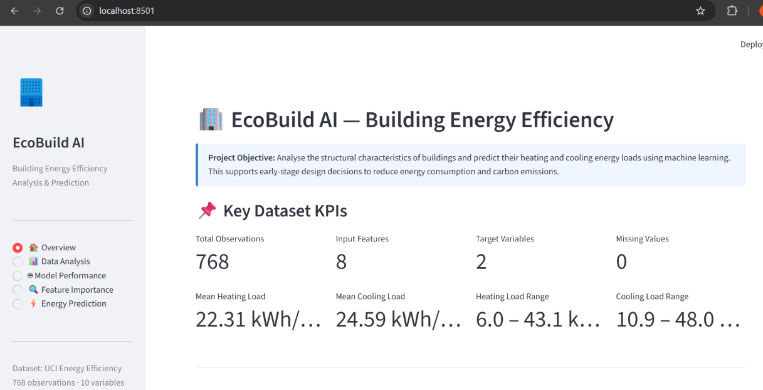
Figure 1. EcoBuild AI - Overview page showing dataset KPIs and project summary.

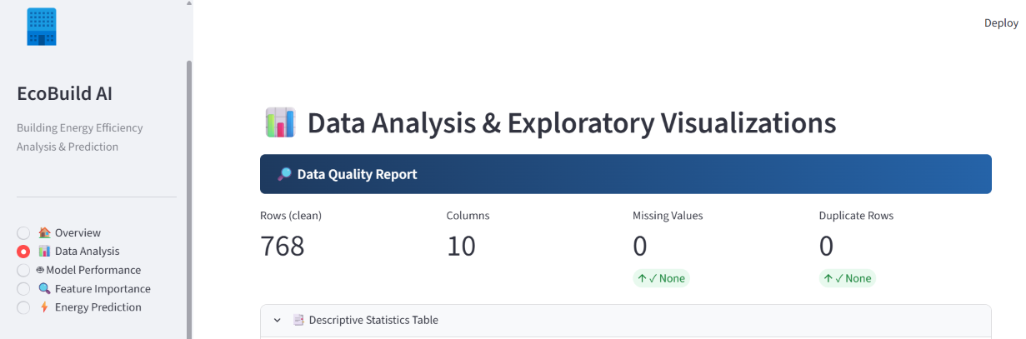Figure 2. Data Analysis page - data quality report (768 rows, 0 missing values, 0 duplicates).
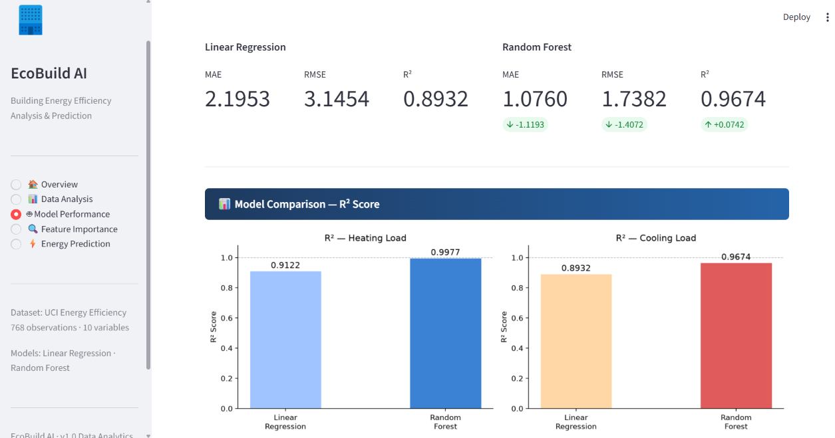Figure 3. Heating Load and Cooling Load distribution histograms with KDE overlay.

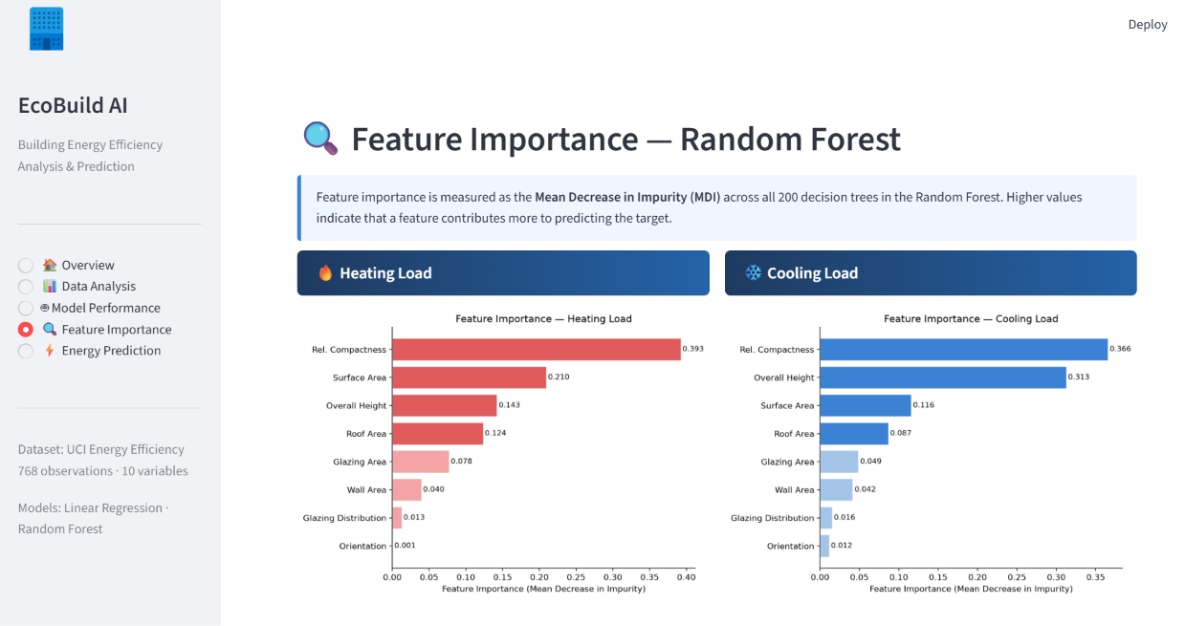Figure 4. Model Performance page showing MAE, RMSE, and R2 for Linear Regression and Random Forest.

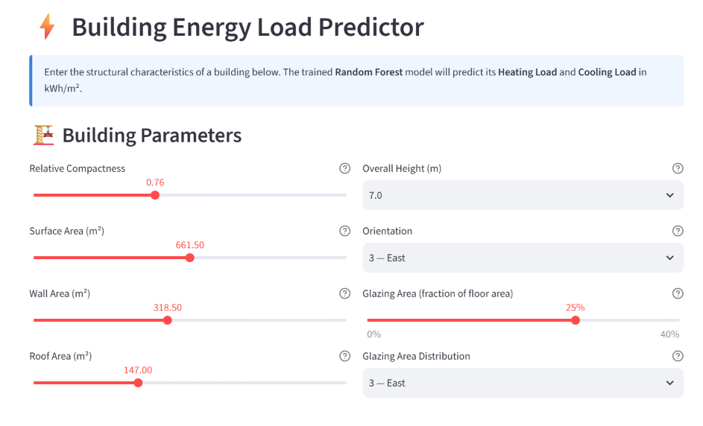
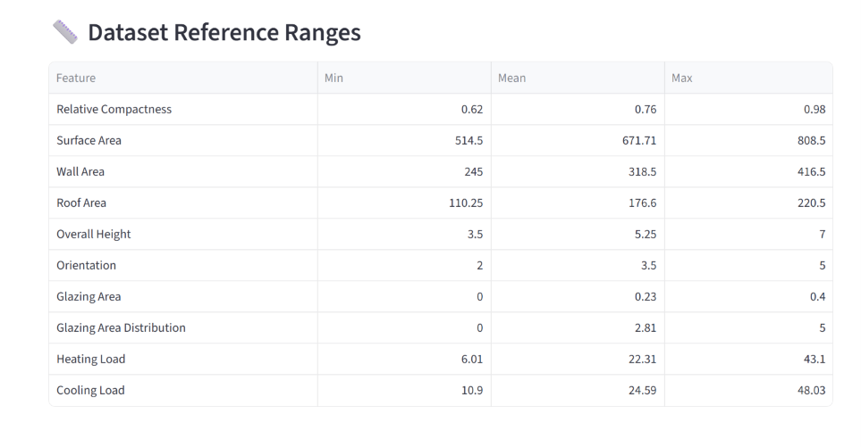Figure 5. Energy Prediction page - interactive sliders and Random Forest prediction results.
To embed actual screenshots: open this document in Microsoft Word, delete the placeholder text above each Figure caption, and insert the corresponding PNG file from the screenshots/ folder using Insert > Pictures. Set each image width to approximately 6.0 inches and centre it on the page. Maintain the original aspect ratio.

15. Limitations
The following limitations apply to the EcoBuild AI project and should be considered when interpreting its results.
1. Simulated data, not field measurements. The dataset consists entirely of building configurations generated by the Ecotect simulation tool. The 768 observations represent a controlled grid of parameter combinations rather than real-world building measurements. Results should not be automatically treated as validated predictions for actual buildings.
2. Limited dataset scope. The dataset covers a specific set of building geometry parameters. Variables that influence real-world energy demand but are not present in the dataset, such as climate zone, thermal insulation specification, HVAC system type, occupancy patterns, and material properties, are not accounted for.
3. Discrete feature values. All eight input features take discrete values with limited unique levels (2 to 12 per feature). The trained model may not generalise well to building configurations with feature values outside these discrete levels or to continuous interpolations between them.
4. Potential overfitting risk for Random Forest. The Random Forest model achieves near-perfect R² on the test set (0.9977 for Heating Load). While this is consistent with the highly structured nature of the simulated dataset, such high accuracy on real-world data with more variability cannot be assumed. Further validation with independent real-world building data would be required before deploying this model in a production design tool.
5. MDI feature importance limitations. Mean Decrease in Impurity (MDI) can overstate the importance of features with high cardinality and is sensitive to correlated features. The near-perfect negative correlation between Relative Compactness and Surface Area means their combined geometric contribution is spread across two features, which may affect the relative ranking.
6. Single geographic and climatic context. The Ecotect simulation used to generate the dataset reflects specific climate and geographic assumptions embedded in the simulation setup. The relationships observed may differ in different climate zones or latitudes.

16. Conclusion
EcoBuild AI successfully demonstrates a complete end-to-end data analytics and machine learning pipeline applied to building energy efficiency prediction. The project covers every phase of a professional data science workflow: data loading, cleaning and validation, exploratory data analysis, machine learning model training and evaluation, feature importance analysis, evidence-based insight generation, and deployment as an interactive Streamlit web application.
The UCI Energy Efficiency Dataset was loaded and cleaned programmatically, removing 528 empty rows and renaming all columns to meaningful physical names. The cleaned dataset contains 768 observations, 8 input features, 2 target variables, zero missing values, and zero duplicate rows.
Exploratory data analysis identified Overall Height and Relative Compactness as the strongest predictors of both Heating Load and Cooling Load in this dataset, supported by correlation analysis, scatter plots, and group comparisons. Glazing area showed a consistent positive association with energy loads. Orientation had a modest and secondary effect.
Two regression models were trained on an 80/20 train-test split. The Linear Regression baseline achieved R² values of 0.9122 (Heating Load) and 0.8932 (Cooling Load). The Random Forest regressor substantially outperformed the baseline, achieving R² values of 0.9977 and 0.9674 respectively, with MAE values of 0.3528 and 1.0760 kWh/m².
Feature importance analysis from the Random Forest model confirmed that Relative Compactness ranked as the most important feature for both targets, consistent with the EDA findings. The interactive Streamlit application enables real-time prediction by accepting the eight building parameters through sliders and dropdowns and returning predicted Heating and Cooling Loads with contextual performance labels.
The project is built as a maintainable modular Python codebase with eight clearly separated source files. All results are computed from the actual dataset at runtime; no values are hard-coded. The project is a complete internship deliverable demonstrating practical skills in data analytics, machine learning, and interactive application development.

17. References
Tsanas, A., & Xifara, A. (2012). Accurate quantitative estimation of energy performance of residential buildings using statistical machine learning tools. Energy and Buildings, 49, 560-567. https://doi.org/10.1016/j.enbuild.2012.03.003
UCI Machine Learning Repository. (2012). Energy Efficiency Dataset. University of California, Irvine. https://archive.ics.uci.edu/ml/datasets/Energy+efficiency
Pedregosa, F., et al. (2011). Scikit-learn: Machine Learning in Python. Journal of Machine Learning Research, 12, 2825-2830. https://scikit-learn.org
McKinney, W. (2010). Data Structures for Statistical Computing in Python. Proceedings of the 9th Python in Science Conference, 56-61. https://pandas.pydata.org
Hunter, J. D. (2007). Matplotlib: A 2D Graphics Environment. Computing in Science & Engineering, 9(3), 90-95. https://matplotlib.org
Waskom, M. (2021). seaborn: statistical data visualization. Journal of Open Source Software, 6(60), 3021. https://seaborn.pydata.org
Streamlit Inc. (2024). Streamlit — The fastest way to build data apps. https://streamlit.io
Harris, C. R., et al. (2020). Array programming with NumPy. Nature, 585, 357-362. https://numpy.org
Joblib Development Team. (2023). Joblib: running Python functions as pipeline jobs. https://joblib.readthedocs.io
Breiman, L. (2001). Random Forests. Machine Learning, 45(1), 5-32. https://doi.org/10.1023/A:1010933404324

