### AN INTERNSHIP REPORT ON

**AWS CLOUD VIRTUAL INTERNSHIP**

submitted in the partial fulfilment of the requirement for the award of degree of

### BACHELOR OF TECHNOLOGY

### Submitted by

POTHUREDDY VIJAYAMAHALAKSHMI 20NE1A05D7

### Under the esteemed guidance

**DR.R.LALU NAIK**



### DEPARTMENT OF COMPUTER SCIENCE AND ENGINEERING

**(Approved by AICTE & Affiliated to JNTUK,Kakinada,Accredited by NAAC & NBA)**

**JONNALAGADDA,Narasaraopeta,Guntur (Dt.)**

**2022-2023**

**TIRUMALA ENGINEERING COLLEGE**

**DEPARTMENT OF COMPUTER SCIENCE AND ENGINEERING**

**CERTIFICATE**

### This is certify that the Internship report entitled as “AWS Cloud Virtual Internship” is a bonafide work done by POTHUREDDY VIJAYAMAHALAKSHMI(20NE1A05D7)in partial fulfilment of the requirements for the award of the degree of BACHELOR OF TECHONOLOGY in the Department of COMPUTER SCIENCE AND ENGINEERING during the 2022-2023.

**DR.R.LALU NAIK** **Dr.A.BALAJI,MTECH**

PROJECT GUIDE & COORDINATOR HEAD OF THE DEPARTMENT

EXTERNAL EXAMINER

# INDEX

|  |  |  |
| --- | --- | --- |
| **S.NO** | **CONTENT** | **PAGENO** |
| 1 | Declaration | i |
| 2 | Acknowledgement | ii |
| 3 | Abstract | iii |
| 4 | **Chapter-1 : Executive Summary** | 1 |
| 1.1 : Course Learning Objectives | 2 |
| 1.2 : Course Outcomes |
| 5 | **Chapter-2 : Overview of the organization** | |
| 2.1 : Introduction of the Organization | 3 |
| 2.2 : Vision, Mission and values of the organization |
| 6 | **Chapter-3 : Internship Part** | |
| 3.1 : Details of Working Condition | 4 |
| 3.2 : Software Requirements |
| 3.3 : Hardware Requirements |
| 7 | **Chapter-4: Weekly Report** | |
| 4.1 : Week-1 report | 5 |
| 4.2 : Week-2 report | 7 |
| 4.3 : Week-3 report | 9 |
| 4.4 : Week-4 report | 11 |
|  | 4.5 : week-5 report | 13 |
|  | 4.6 : week-6 report | 15 |
|  | 4.7 : week-7 report | 17 |
|  | 4.8 : week-8 report | 19 |
|  | 4.9 : week-9 report | 21 |
|  | 4.10:week-10 report | 23 |

|  |  |  |
| --- | --- | --- |
| 8 | Chapter – 5: Outcomes Description | |
| 5.1: Describe the work environment you have experienced | 25 |
| 5.2: Describe the real time technical skills you have acquired |
| 5.3: Describe the managerial skills you have acquired |
| 5.4: Describe how you could improve your communication skills |
| 5.5: Describe how could enhance your abilities in group discussions, participation in teams, contribution as a team  member, reading a team/activity | 26 |
| 9 | Photos and links and certificate | 27 |
| 10 | Student self-evaluation of the short-term internship | 30 |

## Declaration

### I am MAHALAKSHMI POTHUREDDY student of BACHELOR

OF TECHONOLOGY Program, Reg. No.: of the Department of COMPUTER SCIENCE AND ENGINEERING**,** TIRUMALA Engineering College do hereby declare that I have completed the mandatory internship from 5th september, 2022 To 26th november, 2022 in EDUSKILLS under the Faculty guideship of M.SRIKANTH Department of CSE of TIRUMALA Engineering College.

### MAHALAKSHMI POTHUREDDY

20NE1A05D7

## Acknowledgements

I wish to express my thanks to various personalities who are responsible for the completion of Internship. First of all,I would like to thank the **Dr. Satya Ranjan Biswal** of **EduSkills**for giving me the opportunity to do internship within the organization.

I am extremely thankful to our beloved Principal , **Dr. Y.V NARAYANA** for his kind attention and valuable guidance throughout the course.

I express my deep-felt gratitude to **Dr. A.BALAJI**, Head, Department of Computer Science and Engineering and my Guide **Dr.R.LALU NAIK** whose valuable guidance and unstinting encouragement enable me to accomplish my internship successfully in time.

I extend my sincere thanks to all other Teaching and Non-Teaching Staff of CSE department for their cooperation and encouragement during the course. I have no words to acknowledge the warm affection, constant inspiration and encouragement that I receive from my parents.

I affectionately acknowledge the encouragement received from my friends and those who involved in giving valuable suggestions and clarifying my doubts which had really helped me in successful completion of my internship.

By

POTHUREDDYVIJAYAMAHALAKSHMI

### 20NE1A05D7

## Abstract

Main objective of this internship is to learn and gain knowledge about Cloud Technology. Demand for the cloud has shot through the roof since the beginning of the pandemic, as businesses try to build resiliency and AWS if the Pioneer.

Cloud computing is a growing technology which could change traditional IT systems. It is important to know whether value can be added for organizations through using cloud computing.Cloud computing has recently emerged as a new paradigm for hosting and delivering services over the Internet. Cloud computing is attractive to business owners as it eliminates the requirement for users to plan for provisioning and allows enterprises to start from the small and increase resources only when there is a rise in service demand. However, even though cloud computing offers huge opportunities to the IT industry, the development of cloud computing technology is currently at its infancy, with many issues still to be addressed.

Cloud computing has gained a lot of publicity in the current world of I.T. Cloud computing is the use of the Internet for the tasks performed on the computer and it is visualized as the next generation architecture of IT Enterprise. The ‘Cloud’ represents the internet and it related to several technologies and the convergence of various technologies has emerged to be called cloud computing. In comparison to conventional ways Cloud Computing moves application software and databases to the large data centres, where the data and services will not be fully trustworthy. Cloud computing is set of resources and services offered through the Internet.

**Certification from Internship Organization**

# CHAPTER-1: EXECUTIVE SUMMARY

With a vision to create an industry-ready workforce who will eventually become leaders in emerging technologies, EduSkills & AICTE launches ‘Virtual Internship’ program on Cloud Technology, supported by Amazon Web Services (AWS). Demand for the cloud has shot through the roof since the beginning of the pandemic, as businesses try to build resiliency and AWS if the Pioneer.

This internshipconsists one foundation level courses. My task is to complete the below- mentioned course by learning respective concepts of AWS

#### AWS Academy Cloud Foundations

Academy Cloud Foundations course provides a detailed overview of cloud concepts, AWS core services, security, architecture, pricing, and support.

* 1. **Course Learning Objectives**
     + Internships are generally thought of to be reserved for college students looking to gain experience in a particular field. However, a wide array of people can benefit from Training Internships in order to receive real world experience and develop their skills.
     + An objective for this position should emphasize the skills you already possess in the area and your interest in learning more
     + Internships are utilized in a number of different career fields, including architecture, engineering, healthcare, economics, advertising and many more.
     + Some internships are used to allow individuals to perform scientific research while others are specifically designed to allow people to gain first-hand experience working.
     + Utilizing internships is a great way to build your resume and develop skills that can be emphasized in your resume for future jobs. When you are applying for a Training Internship, make sure to highlight any special skills or talents that can make you stand apart from the rest of the applicants so that you have an improved chance of landing the position.

## Course Outcomes

Student will be able to

1. Enhance the technical knowledge by using Modern Tools
2. Become a team leader by participating in the Team work
3. Enhance communication skills by participate in the Group discussions
4. Acquire the Project Managerial Skills and will estimating the project cost
5. Improve the lifelong learning skills by learning the new technologies on theirown.

# CHAPTER-2: OVERVIEW OF THE ORGANIZATION

## INTRODUCTION OF THE ORGANIZATION

EduSkills is a Non-profit organization which enables Industry 4.0 ready digital workforce in India. Our vision is to fill the gap between Academia and Industry by ensuring world class curriculum access to our faculties and students. We want to completely disrupt the teaching methodologies and ICT based education system in India. We work closely with all the important stakeholders in the ecosystem Students, Faculties, Education Institutions and Central/State Governments by bringing them together through our skilling interventions. Our three-pronged engine targets social and business impact by working holistically on Education, Employment and Entrepreneurship.

## VISION:

Transforming the vision of ‘Skilled India’ and Education for to benefit the education ecosystem by providing 360-degree holistic solutions to all the stakeholders.

## MISSION:

To positively impact 1 million beneficiaries by 2024.

## VALUES:

* + - To provide innovative learning aids and services in the education sector.
    - To connect industry-ready professionals, researchers, advanced learners, educators and entrepreneurs who can take best care of stake holders.
    - To extend cutting-edge research, publications and consultancy.
    - To progress global knowledge and skills for the next generation.

# CHAPTER-3: INTERNSHIP PART

## Details of working Conditions:

* + - This internship is a 10 weeksshort period which discussing about the AWS concepts and services. The classes are conducted in online live sessions for 2 weeks.
    - It consists of knowledge checks, guided and challenge labs for every module.

## SOFTWARE REQUIREMENTS:

* + - VISUAL STUDIO CODE
    - Any Browser
    - Notepad
    - Putty
    - Pageant

## HARDWARE REQUIREMENTS:

* + - Computer/Laptop
    - RAM: At least 4GB
    - DISK SPACE: At least 1GB
    - Processor: Minimum inteli5 8 gen processor

# CHAPTER-4: WEEKLY REPORT

## (AWS Cloud Foundations Course) ACTIVITY LOG FOR THE FIRST WEEK

|  |  |  |  |
| --- | --- | --- | --- |
| **DAY & DATE**  **(Week_1)** | **BRIEF DESCRIPTION OF THE DAILY ACTIVITY** | **LEARNING OUTCOME** | **Person In-charge**  **Signature** |
| Day_1 (05-09-2022) | Introduction Cloud Concepts Overview | I have learnt the cloud computing advantages of the cloud. |  |
| Day_2 (06-09-2022) | [Introduction to AWS](https://awsacademy.instructure.com/courses/23888/modules/items/1958990) | I have learnt aws service overview |  |
| Day_3 (07-09-2022) | Cloud economics and building | **I have learnt pricing concepts of aws total cost of owner ship** |  |
| Day_4 (08-09-2022) | AWS Billing | I learnt overall concepts of aws billing &cost management |  |
| Day_5 (09-09-2022) | AWS Organizations | I have learnt aws global infrastructure over view |  |
| Day_6  (10-09-2022) | Introduction AWS Global  Infrastructure Overview | I have learnt overall global infrastructure |  |

**WEEK-1:(From 05-09-2022 to 10 -09-2022)**

## Objective of activity done:

Cloud Concepts Overview and Cloud economics and billing

## Detailed Report:

In this week, I have learned how to:

* Define different types of cloud computing models
* Describe six advantages of cloud computing
* Recognize the main AWS service categories and core services
* Review the AWS Cloud Adoption Framework
* Explored the fundamental of AWS pricing
* Reviewed TCO concepts
* Reviewed an AWS Pricing Calculator estimate
* Reviewed the Billing dashboard
* Reviewed Technical Support options and costs

## ACTIVITY LOG FOR THE SECOND WEEK

|  |  |  |  |
| --- | --- | --- | --- |
| **DAY & DATE**  **(Week_2)** | **BRIEF DESCRIPTION OF THE DAILY ACTIVITY** | **LEARNING OUTCOME** | **Person In-charge**  **Signature** |
| Day_1 (12-09-2022) | Introduction AWS Services | I have learnt AWS Services & Service Categories |  |
| Day_2 (13-09-2022) | AWS Cloud Security | I have learnt [AWS Shared](https://awsacademy.instructure.com/courses/23888/modules/items/1959053) [Responsibility Model,](https://awsacademy.instructure.com/courses/23888/modules/items/1959053) [AWS IAM](https://awsacademy.instructure.com/courses/23888/modules/items/1959056) |  |
| Day_3 (14-09-2022) | I have learnt [Securing a New AWS](https://awsacademy.instructure.com/courses/23888/modules/items/1959062) [Account](https://awsacademy.instructure.com/courses/23888/modules/items/1959062), [Securing Accounts](https://awsacademy.instructure.com/courses/23888/modules/items/1959065), [Securing Data](https://awsacademy.instructure.com/courses/23888/modules/items/1959067) |  |
| Day_4 (15-09-2022) | LAB-1 | I have practised Introduction to AWS IAM |  |
| Day_5 (16-09-2022) | Networking and Content Delivery | I have learnt [Networking Basics](https://awsacademy.instructure.com/courses/23888/modules/items/1959091), VPC Security |  |
| Day_6 (17-09-2022) | Lab-2 | I have practised launching a web server and building VPC |  |

**WEEK-2:(From 12-09-2022 to 17-09-2022)**

## Objective of activity done:

AWS Cloud Security,Networking and Content Delivery

## Detailed Report:

In this week, I have learned how to:

* Identify the difference between AWS Regions, Availability Zones, and edge locations
* Identify AWS service and service categories
* Recognize the shared responsibility model
* Identify the responsibility of the customer and AWS
* Recognize IAM users, groups, and roles
* Describe different types of security credentials in IAM
* Identify the steps to securing a new AWS account
* Explore IAM users and group
* Recognize how to secure AWS data
* Recognize AWS compliance programs

## ACTIVITY LOG FOR THE THIRD WEEK

|  |  |  |  |
| --- | --- | --- | --- |
| **DAY & DATE**  **(Week_3)** | **BRIEF DESCRIPTION OF THE DAILY ACTIVITY** | **LEARNING OUTCOME** | **Person In-charge**  **Signature** |
| Day_1  (19-09-2022) | Introduction Compute | I have learnt Compute Services Overview |  |
| Day_2  (20-09-2022) | Lab-3 | I have practised Introduction to Amazon EC2 |  |
| Day_3  (21-09-2022) | AWS Lambda | I have learnt Introduction to AWS Lambda,Introduction to AWS Elastic Beanstalk |  |
| Day_4  (22-09-2022) | Introduction To Storage | I have learnt [AWS EBS](https://awsacademy.instructure.com/courses/23888/modules/items/1959177), Console Demonstrations |  |
| Day_5  (23-09-2022) | Lab-4 | I have practised working with EBS |  |
| Day_6  (24-09-2022) | AWS glacier | I have learnt [AWS S3 Glacier](https://awsacademy.instructure.com/courses/23888/modules/items/1959195) |  |

**WEEK-3:(From 19-09-2022 to 24-09-2022)**

## Objective of activity done:

Introduction Compute and Introduction to Storage

## Detailed Report:

In this week, I have learned how to:

* Provide an overview of different AWS compute services in the cloud
* Demonstrate why to use Amazon Elastic Compute Cloud (Amazon EC2)
* Identify the functionality in the Amazon EC2 console
* Perform basic functions in Amazon EC2 to build a virtual computing environment
* Identify Amazon EC2 cost optimization elements
* Demonstrate when to use AWS Elastic Beanstalk
* Demonstrate when to use AWS Lambda
* Identify how to run containerized applications in a cluster of managed servers
* Identify the different types of storage
* Explain Amazon S3
* Identify the functionality in Amazon S3
* Explain Amazon EBS
* Identify the functionality in Amazon EB
* Explain Amazon EFS
* Identify the functionality in Amazon EF
* Explain Amazon S3 Glacier
* Identify the functionality in Amazon S3 Glacier
* Differentiate between Amazon EBS, Amazon S3, Amazon EFS, and Amazon S3 Glacier

## ACTIVITY LOG FOR THE FOURTH WEEK

|  |  |  |  |
| --- | --- | --- | --- |
| **DAY & DATE**  **(Week_4)** | **BRIEF DESCRIPTION OF THE DAILY ACTIVITY** | **LEARNING OUTCOME** | **Person In-charge**  **Signature** |
| Day_1  (03-10-2022) | Databases | I have learnt Amazon RDS, Console Demonstration – RDS, DynamoDB concepts |  |
| Day_2  (04-10-2022) | Lab-5 | I have practised build a database server |  |
| Day_3 (05-10-2022) | Cloud Architecture | I have learnt [Security](https://awsacademy.instructure.com/courses/23888/modules/items/1959252), reliability concepts |  |
| Day_4 (06-10-2022) | [I have learnt High Availability,](https://awsacademy.instructure.com/courses/23888/modules/items/1959261) [AWS Trusted Advisor](https://awsacademy.instructure.com/courses/23888/modules/items/1959264) |  |
| Day_5 (07-10-2022) | Introduction to Auto Scaling and Monitoring | I have learn Amazon cloud watch,load balancer concepts |  |
| Day_6 (08-10-2022) | Lab-6 | I have practised scale & load balance your architecture |  |

**WEEK-4:(From 03-10-2022 to 08-10-2022)**

## Objective of activity done:

Databases, Cloud Architecture and Introduction to Auto Scaling and Monitoring.

## Detailed Report:

In this week, I have learned how to:

* Explain Amazon Relational Database Service (Amazon RDS)
* Identify the functionality in Amazon RDS
* Explain Amazon DynamoDB
* Identify the functionality in Amazon DynamoDB
* Explain Amazon Redshift, Explain Amazon Aurora
* Perform tasks in an RDS database, such as launching, configuring, and interacting
* Describe the AWS Well
* Architected Framework, including the six pillars
* Identify the design principles of the AWS Well, Architected Framework
* Explain the importance of reliability and high availability
* Identify how AWS Trusted Advisor helps customers
* Interpret AWS Trusted Advisor recommendations
* Indicate how to distribute traffic across Amazon Elastic Compute Cloud (Amazon EC2)
* Instances using Elastic Load Balancing.
* Identify how Amazon CloudWatch enables you to monitor AWS resources and applications in real time
* Explain how Amazon EC2 Auto Scaling launches and releases servers in response to workload Changes.
* Perform scaling and load balancing tasks to improve an architecture

## ACTIVITY LOG FOR THE FIFTH WEEK

|  |  |  |  |
| --- | --- | --- | --- |
| **DAY & DATE**  **(Week_5)** | **BRIEF DESCRIPTION OF THE DAILY ACTIVITY** | **LEARNING OUTCOME** | **Person In-charge**  **Signature** |
| Day_1  (10-10-2022) | MODULE 1-INTRODUCTION VIDEO AND SECTION VIDEOS | I have learnt cloud concepts Overview |  |
| Day_2  (11-10-2022) | KNOWLEDGE CHECK FOR MODULE1 | I have completed the knowledge Check in module 1 |  |
| Day_3  (12-10-2022) | MODULE 2-INTRODUCTION VIDEO AND SECTION VIDEOS | I have learnt cloud economics and billing |  |
| Day_4  (13-10-2022) | KNOWLEDGE CHECK FOR MODULE 2 | I have completed the knowledge check in module 2 |  |
| Day_5  (14-10-2022) | MODULE 3-INTRODUCTION VIDEO AND SECTION VIDEOS | I have learnt aws global infrastructure overview |  |
| Day_6  (15-10-2022) | KNOWLEDGE CHECK FOR MODULE 3 | I have completed the knowledge check in module 3 |  |

**WEEK-5:(From 10-10-2022 to 15-10-2022)**

## Objective of activity done:

Cloud Concepts Overview , Cloud economics and billing ,and AWS Global Infrastructure Overview

## Detailed Report:

In this week, I have learned how to:

* Define different types of cloud computing models
* Describe six advantages of cloud computing
* Recognize the main AWS service categories and core services
* Review the AWS Cloud Adoption Framework
* Explored the fundamental of AWS pricing
* Reviewed TCO concepts
* Reviewed an AWS Pricing Calculator estimate
* Reviewed the Billing dashboard
* Reviewed Technical Support options and costs

## ACTIVITY LOG FOR THE SIXTH WEEK

|  |  |  |  |
| --- | --- | --- | --- |
| **DAY & DATE**  **(Week_6)** | **BRIEF DESCRIPTION OF THE DAILY ACTIVITY** | **LEARNING OUTCOME** | **Person In-charge**  **Signature** |
| Day_1  (17-10-2022) | MODULE 4-INTRODUCTION VIDEO AND SECTION VIDEOS | I have learnt aws cloud security |  |
| Day_2  (18-10-2022) | COMPLETED LAB 1 INTRODUCTION TO AWS IAM | I have completed lab 1 introduction to Aws IAM |  |
| Day_3  (19-10-2022) | KNOWLEDGE CHECK FOR MODULE 4 | I have completed the knowledge check in module 4 |  |
| Day_4  (20-10-2022) | MODULE 5-INTRODUCTION VIDEO AND SECTION VIDEOS | I have learnt networking and content delivery |  |
| Day_5  (21-10-2022) | COMPLETED LAB 2 BUILD YOUR VPC AND LAUNCH A WEB SERVER | I have completed lab 2 build your vpc and launch a web server |  |
| Day_6  (22-10-2022) | KNOWLEDGE CHECK FOR MODULE 5 | I have completed the knowledge check in module 5 |  |

**WEEK-6:(From 17-10-2022 to 22-10-2022)**

## Objective of activity done:

AWS Cloud Security,Networking and Content Delivery

## Detailed Report:

In this week, I have learned how to:

* Identify the difference between AWS Regions, Availability Zones, and edge locations
* Identify AWS service and service categories
* Recognize the shared responsibility model
* Identify the responsibility of the customer and AWS
* Recognize IAM users, groups, and roles
* Describe different types of security credentials in IAM
* Identify the steps to securing a new AWS account
* Explore IAM users and group
* Recognize how to secure AWS data
* Recognize AWS compliance programs

## ACTIVITY LOG FOR THE SEVENTH WEEK

|  |  |  |  |
| --- | --- | --- | --- |
| **DAY & DATE**  **(Week_7)** | **BRIEF DESCRIPTION OF THE DAILY ACTIVITY** | **LEARNING OUTCOME** | **Person In-charge**  **Signature** |
| Day_1  (24-10-2022) | MODULE 6 INTRODUCTION VIDEO AND 1,2 SECTION VIDEOS | I have learnt introduction compute |  |
| Day_2  (25-10-2022) | **3,4 SECTION VIDEOS AND CONSOLE DEMONSTARATION EC2** | I have practised Introduction to Amazon EC2 |  |
| Day_3  (26-10-2022) | LAB 3 INTRODUCTION TO AMAZON EC2 | I have completed lab 3 introduction to amazon ec2 |  |
| Day_4  (27-10-2022) | 5,6,7 SECTION VIDEOS | I have learnt AWS lambda cost optimizers and container services |  |
| Day_5  (28-10-2022) | **AWS LAMBDA AND SECTION AND AWS ELASTICBEANSTALK** | I have learnt introduction to AWS Elastic Beanstalk |  |
| Day_6  (29-10-2022) | KNOWLEDGE CHECK FOR MODULE 6 | I have completed the knowledge check in module 6 |  |

**WEEK-7:(From 24-10-2022 to 29-10-2022)**

## Objective of activity done:

Introduction Compute

## Detailed Report:

In this week, I have learned how to:

* Provide an overview of different AWS compute services in the cloud
* Demonstrate why to use Amazon Elastic Compute Cloud (Amazon EC2)
* Identify the functionality in the Amazon EC2 console
* Perform basic functions in Amazon EC2 to build a virtual computing environment
* Identify Amazon EC2 cost optimization elements
* Demonstrate when to use AWS Elastic Beanstalk

## ACTIVITY LOG FOR THE EIGTH WEEK

|  |  |  |  |
| --- | --- | --- | --- |
| **DAY & DATE**  **(Week_8)** | **BRIEF DESCRIPTION OF THE DAILY ACTIVITY** | **LEARNING OUTCOME** | **Person In-charge**  **Signature** |
| Day_1  (07-11-2022) | MODULE 7-INTRODUCTION VIDEO AND SECTION 1VIDEO AND CONSOLE DEMONSTARTION EBS | I have learnt introduction to storage |  |
| Day_2  (08-11-2022) | LAB 4 WORKING WITH EBS | I have completed lab 4 working with ebs |  |
| Day_3  (09-11-2022) | SECTION 2 VIDEO AND CONSOLE DEMONSTRATION S3 | I have learnt Introduction to AWS |  |
| Day_4  (10-11-2022) | SECTION 3 VIDEO AND CONSOLE DEMONSTRATION S3 AND EFS | I have learnt AWS EFS |  |
| Day_5  (11-11-2022) | SECTION 4 VIDEO AND AWS S3 GLACIER | I have learnt AWS S3 GLACIER |  |
| Day_6  (12-11-2022) | KNOWLEDGE CHECK FOR MODULE 7 | I have completed the knowledge check in module 7 |  |

**WEEK-8:(From 07-11-2022 to 12-11-2022)**

## Objective of activity done:

Introduction to Storage

Detailed Report:

In this week, I have learned how to:

* Demonstrate when to use AWS Lambda
* Identify how to run containerized applications in a cluster of managed servers
* Identify the different types of storage
* Explain Amazon S3
* Identify the functionality in Amazon S3
* Explain Amazon EBS
* Identify the functionality in Amazon EB
* Explain Amazon EFS
* Identify the functionality in Amazon EF
* Explain Amazon S3 Glacier
* Identify the functionality in Amazon S3 Glacier
* Differentiate between Amazon EBS, Amazon S3, Amazon EFS, and Amazon S3 Glacier

ACTIVITY LOG FOR THE NINTH WEEK

|  |  |  |  |
| --- | --- | --- | --- |
| **DAY & DATE**  **(Week_3)** | **BRIEF DESCRIPTION OF THE DAILY ACTIVITY** | **LEARNING OUTCOME** | **Person In-charge**  **Signature** |
| Day_1  (14-11-2022) | MODULE 8-INTRODUCTION VIDEO AND SECTION 1 VIDEO AND CONSOLE DEMONSTRATION | I have learnt introduction to databases |  |
| Day_2  (15-11-2022) | LAB 5 BUILD A DATA BASE SERVER | I have completed lab 5 build a data base server |  |
| Day_3  (16-11-2022) | SECTION 2 VIDEO AND CONSOLE DEMONSTRATION-DYNAMODB | I have learnt Introduction to Amazon DynamoDB |  |
| Day_4  (17-11-2022) | SECTION 3 VIDEO | I have learnt Amazon Redshift |  |
| Day_5  (18-11-2022) | SECTION 4 VIDEO | I have learnt Amazon aurora |  |
| Day_6  (19-11-2022) | KNOWLEDGE CHECK FOR MODULE 8 | I have completed the knowledge check in module 8 |  |

**WEEK-9:(From 14-11-2022 to 19-11-2022)**

## Objective of activity done:

Introduction to Databases

Detailed Report:

In this week, I have learned how to:

* Explain Amazon Relational Database Service (Amazon RDS)
* Identify the functionality in Amazon RDS
* Explain Amazon DynamoDB
* Identify the functionality in Amazon DynamoDB
* Explain Amazon Redshift, Explain Amazon Aurora
* Perform tasks in an RDS database, such as launching, configuring, and interacting

ACTIVITY LOG FOR THE TENTH WEEK

|  |  |  |  |
| --- | --- | --- | --- |
| **DAY & DATE**  **(Week_3)** | **BRIEF DESCRIPTION OF THE DAILY ACTIVITY** | **LEARNING OUTCOME** | **Person In-charge**  **Signature** |
| Day_1  (21-11-2022) | MODULE 9 INTRODUCTION VIDEO AND SECTION 1,2,3 VIDEO | I have learnt cloud architecture |  |
| Day_2  (22-11-2022) | SECTION 4,5,6,7,8 VIDEO | I have practised the architecture to cloud |  |
| Day_3  (23-11-2022) | KNOWLEDGE CHECK FOR MODULE 9 | I have completed the knowledge check in module 9 |  |
| Day_4  (24-11-2022) | MODULE 10 INTRODUCTION VIDEO AND SECTION 1,2,3 | I have learnt introduction to Auto scaling and monitoring |  |
| Day_5  (25-11-2022) | LAB 6 SCALE AND LOAD BALANCE YOUR ARCHITECTURE | I have completed the lab 6 scale and load balance your architecture |  |
| Day_6  (26-11-2022) | KNOWLEDGE CHECK FOR MODULE 10 | I have completed the knowledge check in module 10 |  |

**WEEK-10:(From 21-11-2022 to 26-11-2022)**

## Objective of activity done:

Cloud Architecture and Introduction to Auto Scaling and Monitoring.

## Detailed Report:

In this week, I have learned how to:

* Describe the AWS Well
* Architected Framework, including the six pillars
* Identify the design principles of the AWS Well, Architected Framework
* Explain the importance of reliability and high availability
* Identify how AWS Trusted Advisor helps customers
* Interpret AWS Trusted Advisor recommendations
* Indicate how to distribute traffic across Amazon Elastic Compute Cloud (Amazon EC2)
* Instances using Elastic Load Balancing.
* Identify how Amazon CloudWatch enables you to monitor AWS resources and applications in real time
* Explain how Amazon EC2 Auto Scaling launches and releases servers in response to workload Changes.
* Perform scaling and load balancing tasks to improve an architecture

# CHAPTER-5: OUTCOMES DESCRIPTION

## Describe the work environment you have experienced :

My work environment is complete gone virtual. I've found that this type of environment iseasy for me to complete internship in time without disturbance of my academic studies.

## Describe the real time technical skills you have acquired :

Technical skills I have acquired:

* + 1. Networking
    2. Data Storage Fundamentals
    3. Security Foundations
    4. Deployment
    5. Architectural design principles

## Describe the managerial skills you have acquired :

Managerial skills I have acquired.

* + 1. Planning
    2. Critical Thinking
    3. Industry Knowledge
    4. Problem solving and decision-making

## Describe how you could improve your communication skills :

These eight tips can help maximize my communication skills for the success of an organization and my career:

* + 1. Be clear and concise
    2. Prepare ahead of time
    3. Watch your tone
    4. Practice active listening

## Describe the technological developments you have observed and relevant to the subject area of training:

#### Learning Outside the Classroom Environment :

Various technology trends in education keep changing the digital world. Mobile- based devices have taken learning outside of the classroom. With eLearning growing in popularity, students can learn at their own pace and time.

#### Social Media in Learning:

Who would have ever thought that social media would one day be accepted as part of the learning process? The technological trends in teaching and learning are rapidly changing every day.

#### Interactivity in Classroom :

Bringing technology into the classroom has made classrooms lively and interactive. With eBooks, the course content can be embedded with videos, augmented reality, audio files etc. Unlike a printed book, eBook allows for more interaction to take place

***PHOTOS***

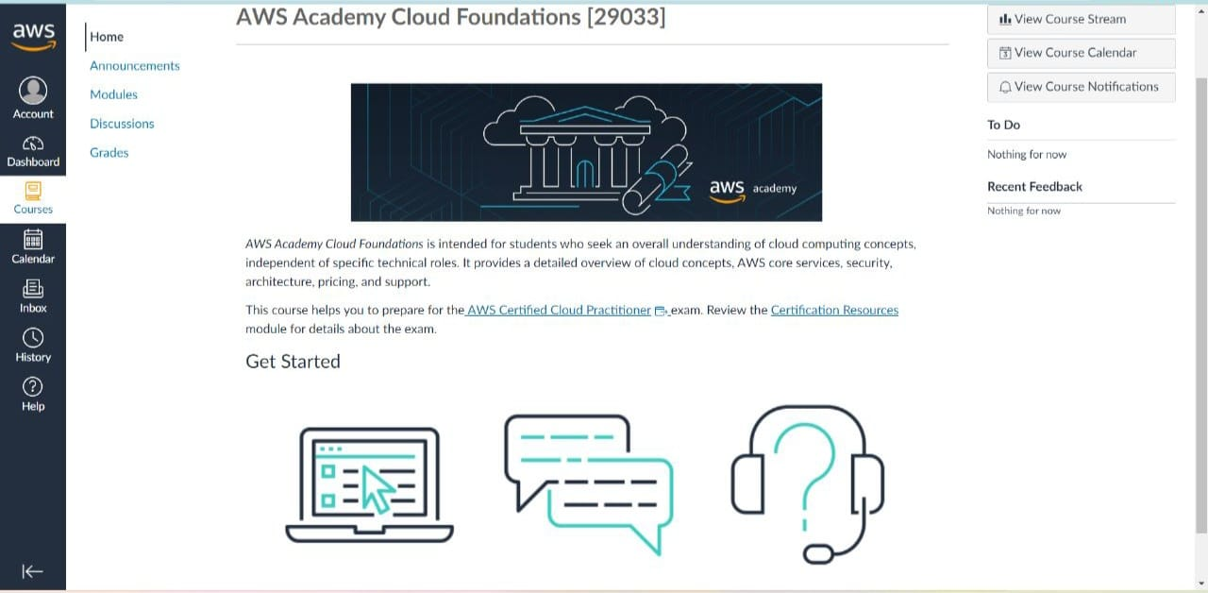

## Links

**Course login:**

**<https://awsacademy.instructure.com/login/canvas>**

## Course completion certificates and Badges:

AWS Academy Graduate - AWS Academy Cloud Foundations link

<https://www.credly.com/badges/82d72833-c2f6-45c9-bb4a-cc107468de1c/public_url>

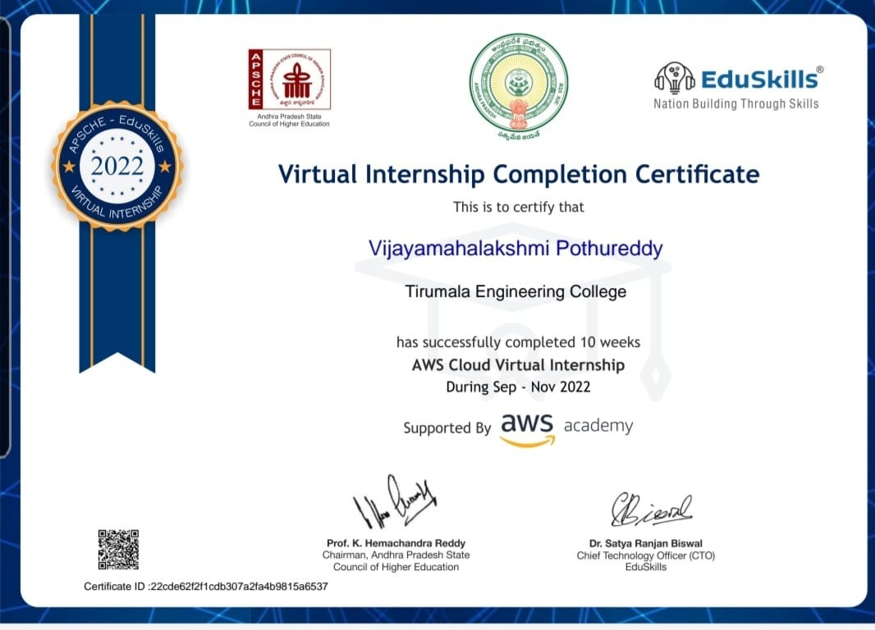

**student Self Evaluation of the Short-Term Internship**

**Student Name:**MAHALAKSHMI POTHUREDDY

**Roll Number**: 20NE1A05D7

**Term of Internship**: From 5-9-2022 to 26-11-2022

**Organization Name:** EduSkills (Sponsored by AICTE)

Please rate your performance in the following areas:

Rating Scale: Letter grade of CGPA calculation to be provided

|  |  |  |  |  |  |  |
| --- | --- | --- | --- | --- | --- | --- |
| **1.** | Oral communication | 1 | 2 | 3 | 4 | 5 |
| **2.** | Written communication | 1 | 2 | 3 | 4 | 5 |
| **3.** | Initiative | 1 | 2 | 3 | 4 | 5 |
| **4.** | Interaction with staff | 1 | 2 | 3 | 4 | 5 |
| **5.** | Attitude | 1 | 2 | 3 | 4 | 5 |
| **6.** | Dependability | 1 | 2 | 3 | 4 | 5 |
| **7.** | Ability to learn | 1 | 2 | 3 | 4 | 5 |
| **8.** | Planning and organization | 1 | 2 | 3 | 4 | 5 |
| **9.** | Professionalism | 1 | 2 | 3 | 4 | 5 |
| **10.** | Creativity | 1 | 2 | 3 | 4 | 5 |
| **11.** | Quality of work | 1 | 2 | 3 | 4 | 5 |
| **12.** | Productivity | 1 | 2 | 3 | 4 | 5 |
| **13.** | Progress of learning | 1 | 2 | 3 | 4 | 5 |
| **14.** | Adaptability to organization’s culture/policies | 1 | 2 | 3 | 4 | 5 |
| **15.** | OVERALL PERFORMANCE | 1 | 2 | 3 | 4 | 5 |

Mahalakshmi pothureddy

Signature of the Student