Expense Tracker with Monthly Analytics- Report

# Objective

Build a tool to manage personal expenses with charts.

# Tools & Technologies

* Java
* JavaFX
* SQLite
* JFreeChart

# Features

* Design database schema for categories and expenses.
* Forms for adding/editing expenses.
* Connect Java with SQLite using JDBC.
* Generate monthly summaries using SQL queries.
* Display pie and bar charts with JFreeChart.
* Export data as CSV.

# Database Schema

|  |  |
| --- | --- |
| Table | Columns |
| categories | id (PK), name |
| expenses | id (PK), category_id (FK), description, amount, date |

# Deliverables

* Application JAR file
* Screenshots of charts (Pie and Bar)
* Database file (SQLite)
* CSV export functionality
* Project Report (this document)

# Sample Charts

Pie Chart - Expenses by Category

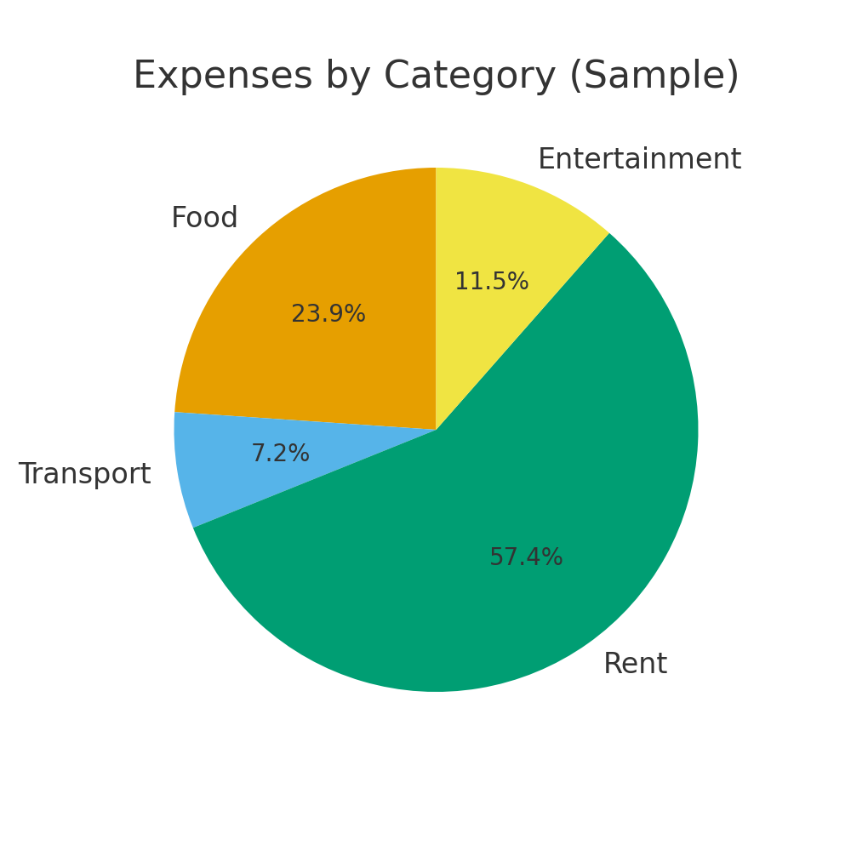

Bar Chart - Daily Expenses

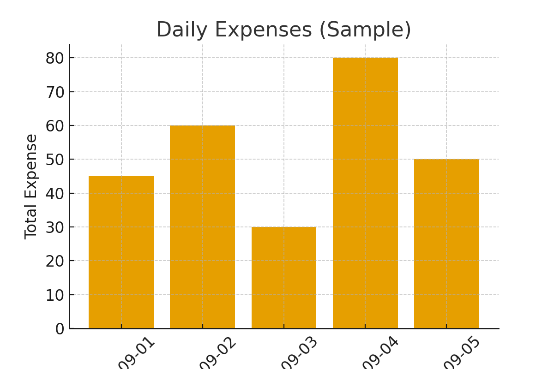

# Conclusion

The Expense Tracker provides a simple yet powerful way to manage personal expenses. With an intuitive JavaFX interface, persistent storage in SQLite, and data visualization through JFreeChart, users can easily track, analyze, and export their financial data.