**Resume**

**Name: PARVATHI S** 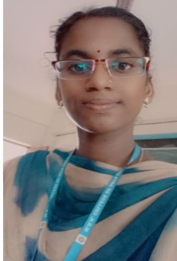

**Email id:** [**parvathisundararajan7@gmil.com**](mailto:parvathisundararajan7@gmil.com)

**Mobile Number: 8608229491**

**Address:** 139 vanniyar melastreet

Thirunarayur&post

kattumannar Koil(t.k)

Cuddalore district(608303).

Objective :

**To be a successful and to work for an organization with full zeal and aiming at not only authority ’s satisfaction bull also overall personal development.**

**Personal Profile:**

**Name : PARVATHI S**

**Father’s Name : Sundararajan .R**

**Date of Birth : 13.04.2004**

**Gender : Female**

**Nationality : Indian**

**Religion : Hindu**

**Languages Known : Tamil , English**

**Permanent Address : 139 vanniyar melastreet**

**Thirunarayur&post**

**kattumannar Koil(t.k)**

**District(608303).**

**Contact Number : 8608229491**