**API TEST PLAN**

***Create an API for yourself from OpenWeather website to test the corresponding website data***

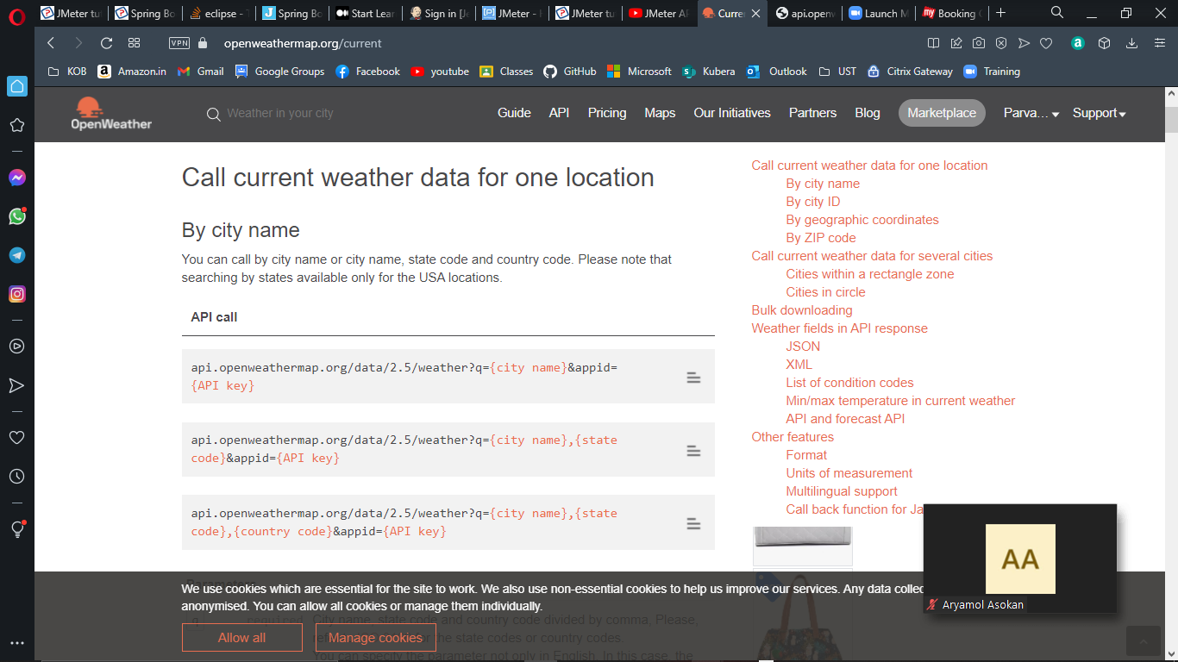

***API link for weather for city Kolkata***

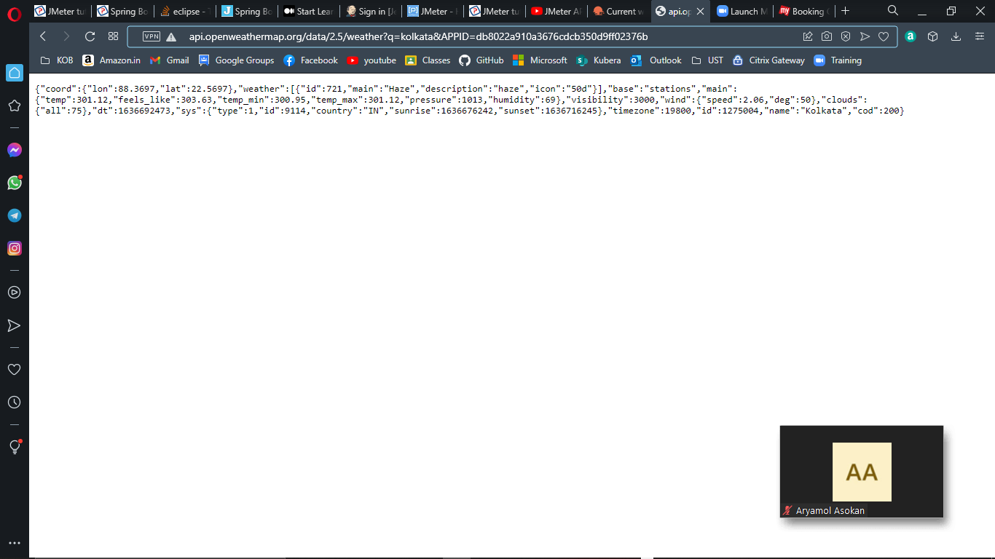

***Create a Thread group and HTTP Request inside it***

***And Provide the IP, Path and the Parameters of our link***

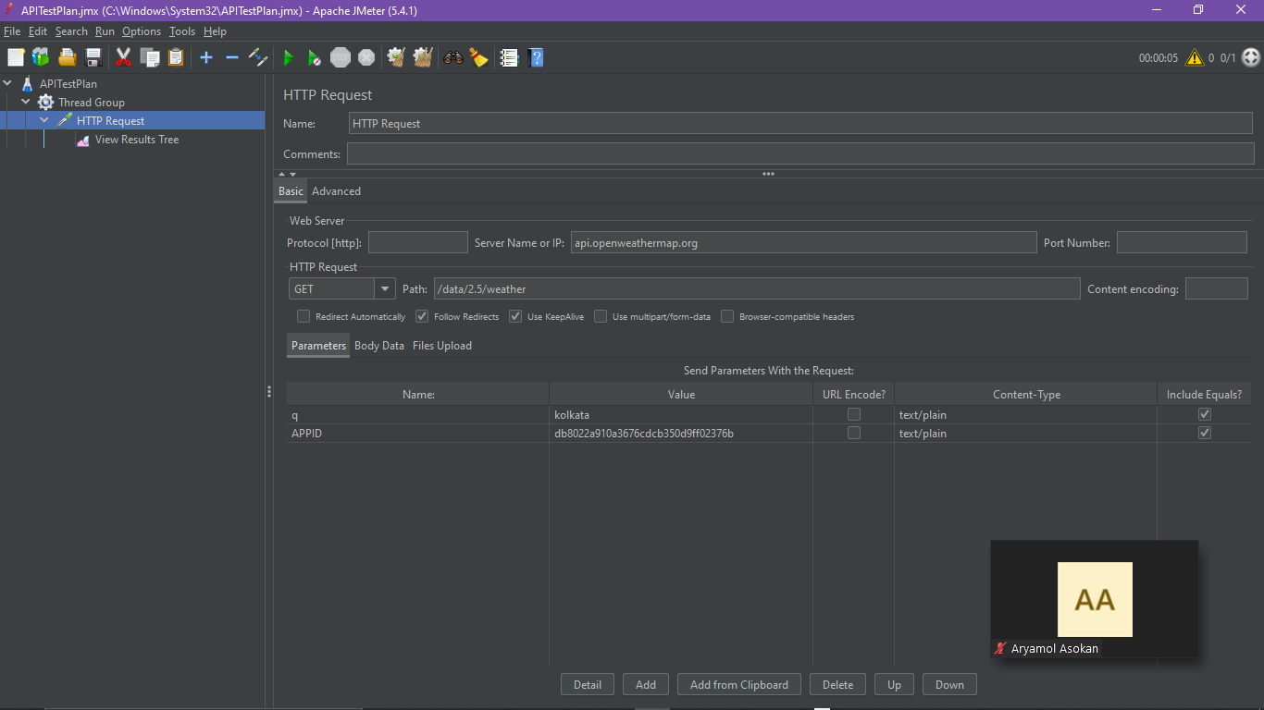

***View Result Tree- Sampler Result(TEST PASSED)***

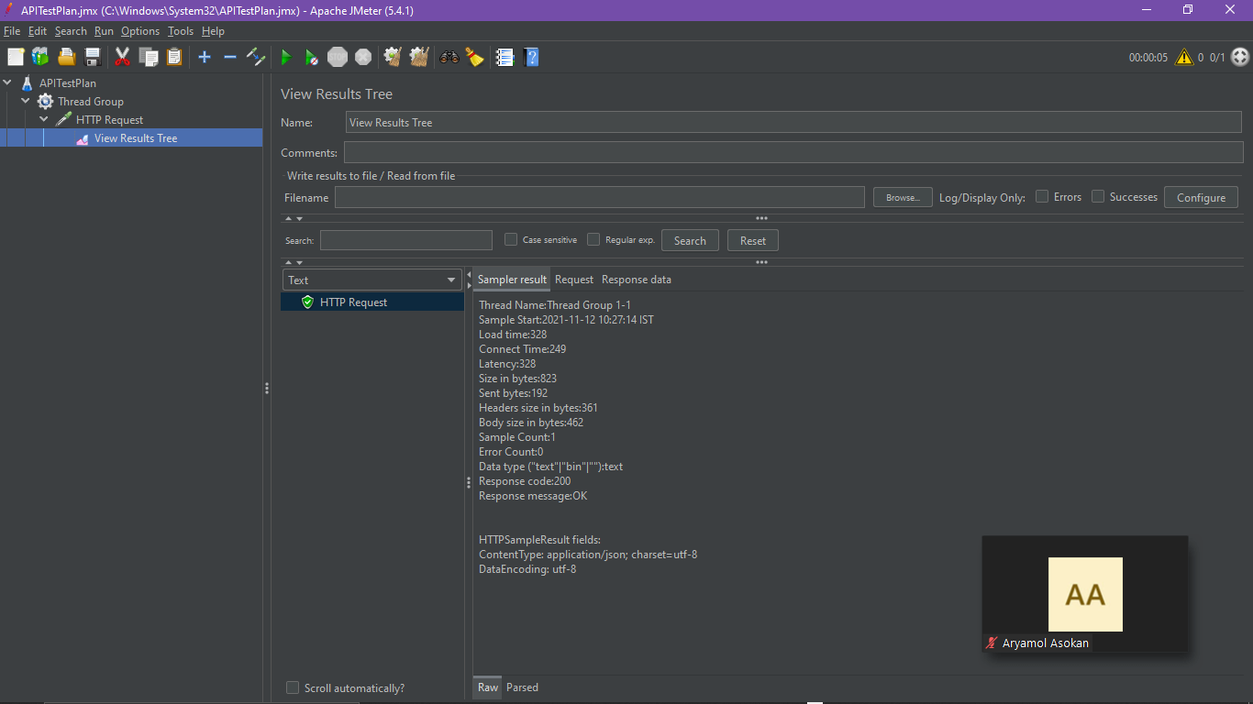

***View Result Tree- Responds Data***

***We can see the exact data here that we see inside the link***

