***Assertions-*** *Check the Responds*

* When you send your request to the server, you will get a response.
* If you want to do some checks on the response like whether you have receive the correct response code or you want to check some text in the response code or to test the format of the response all these checks will come under assertions.

*Responds Assertion*

Add->Assertion-> responds assertion

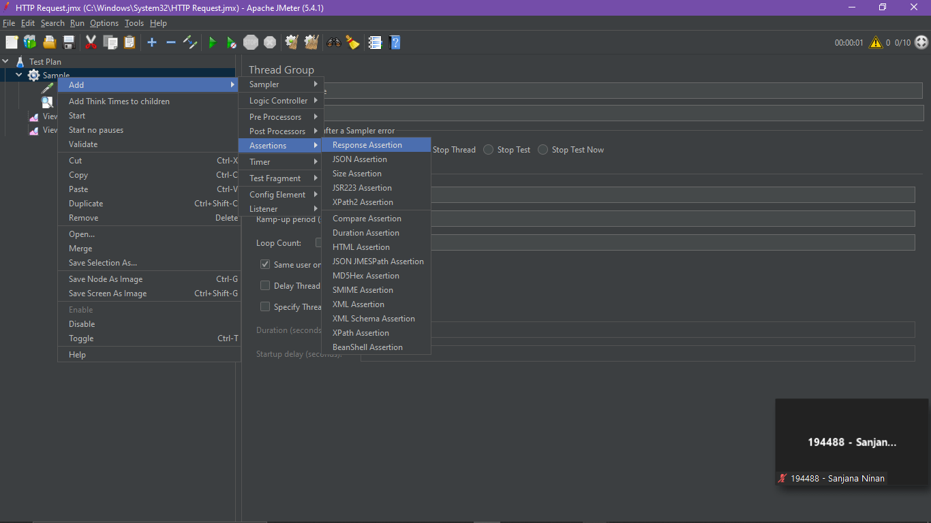

Test Assertion 200(Assertion Passed)

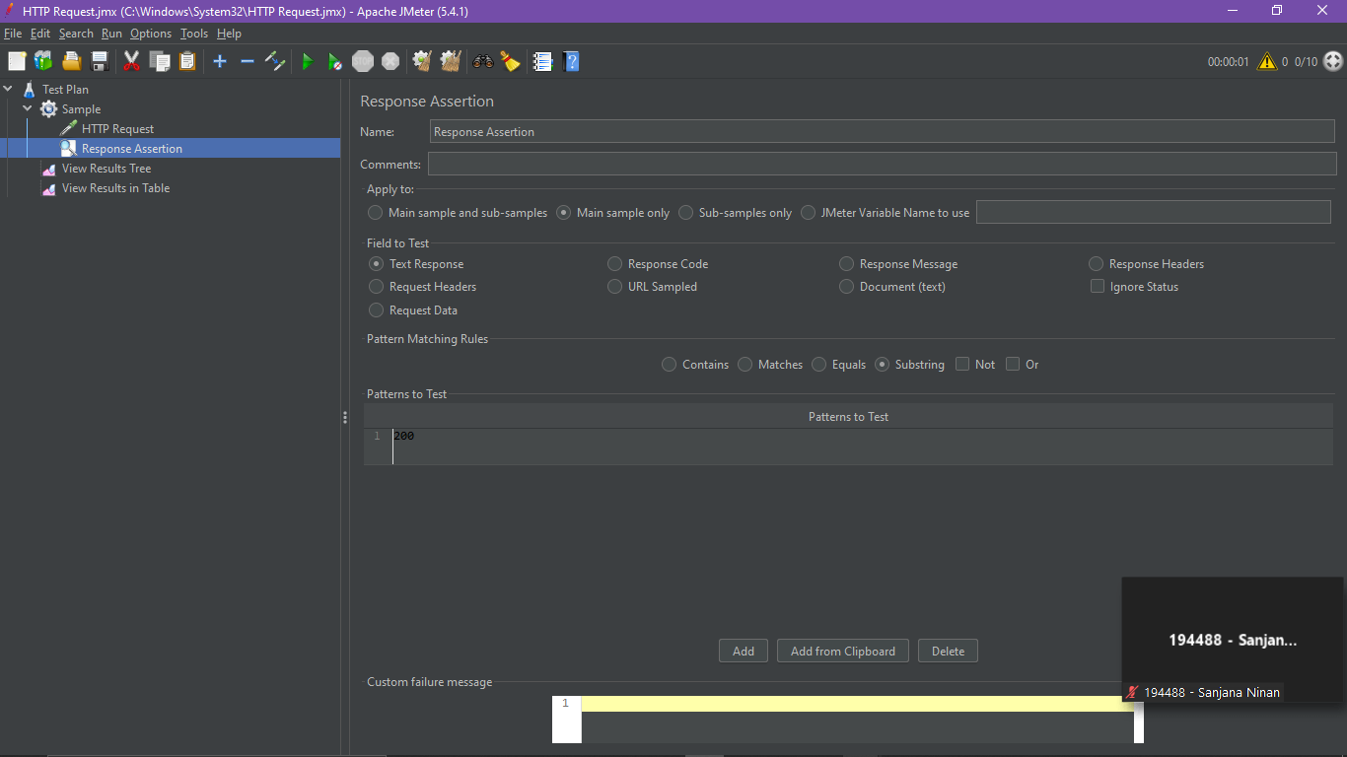

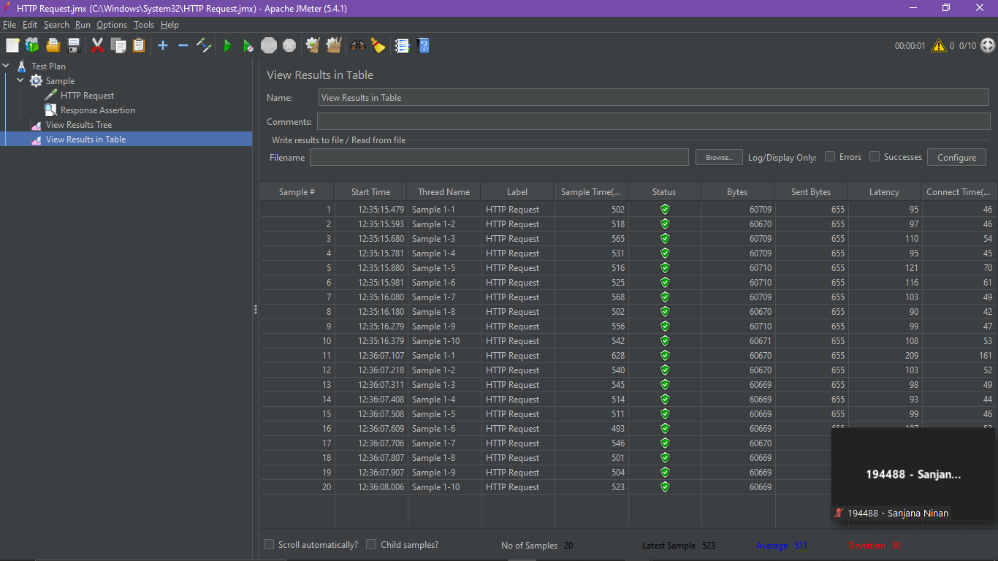

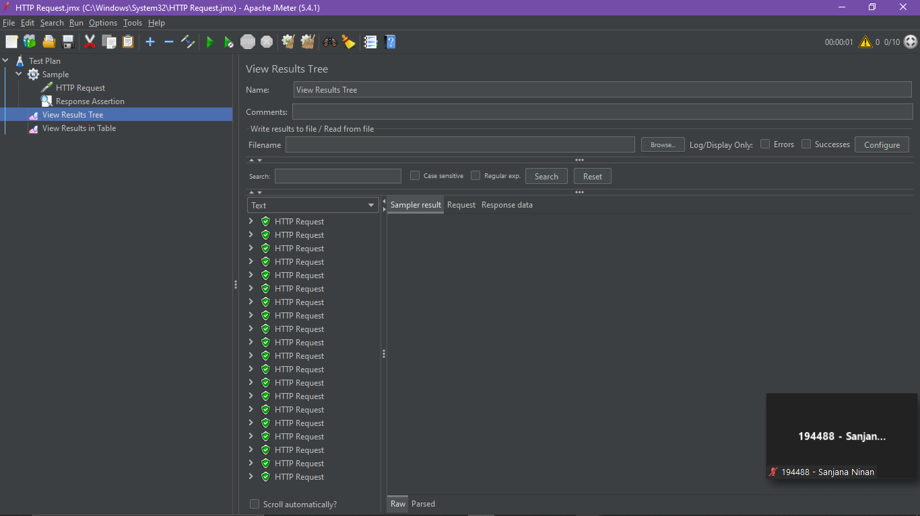

Test Assertion 201(Assertion Failed)

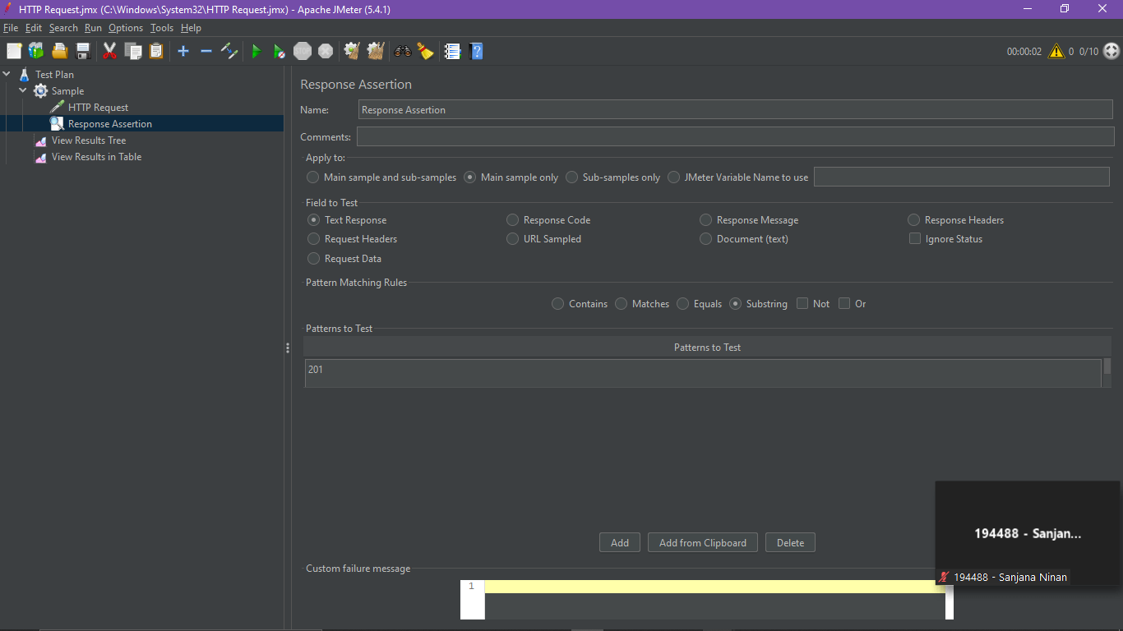

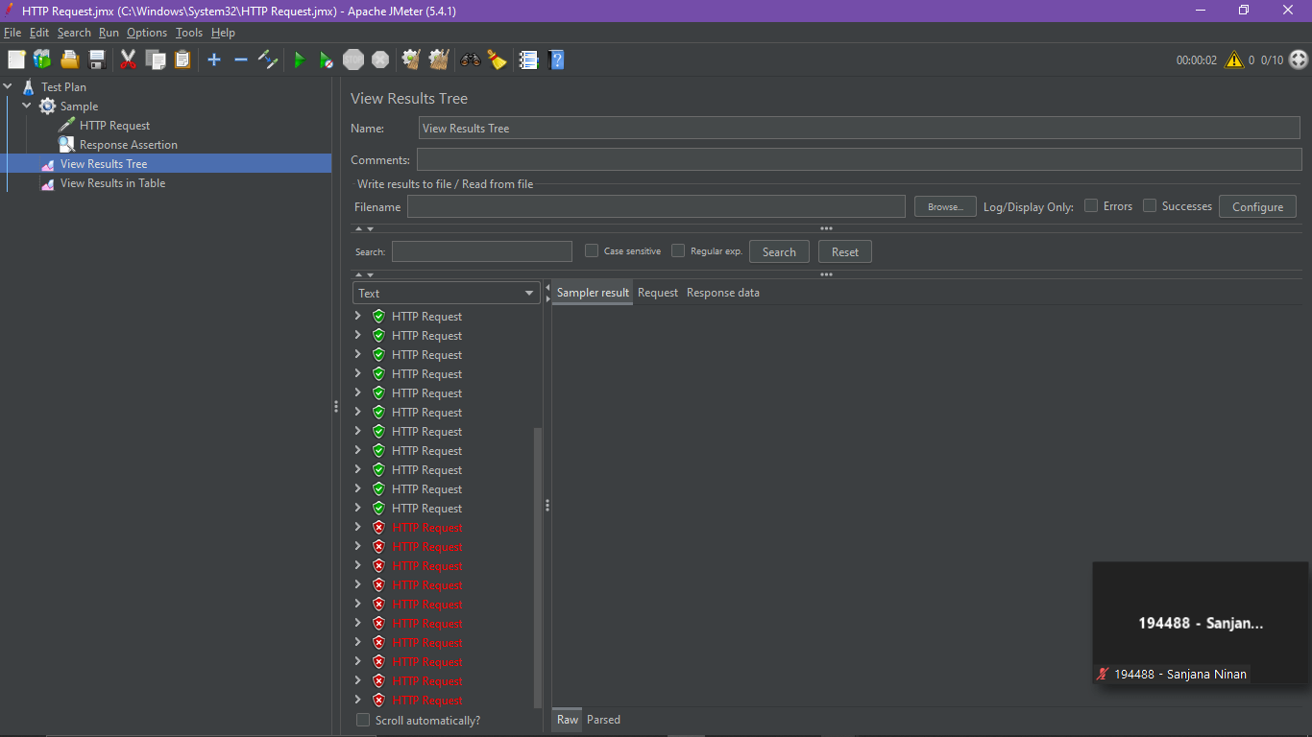

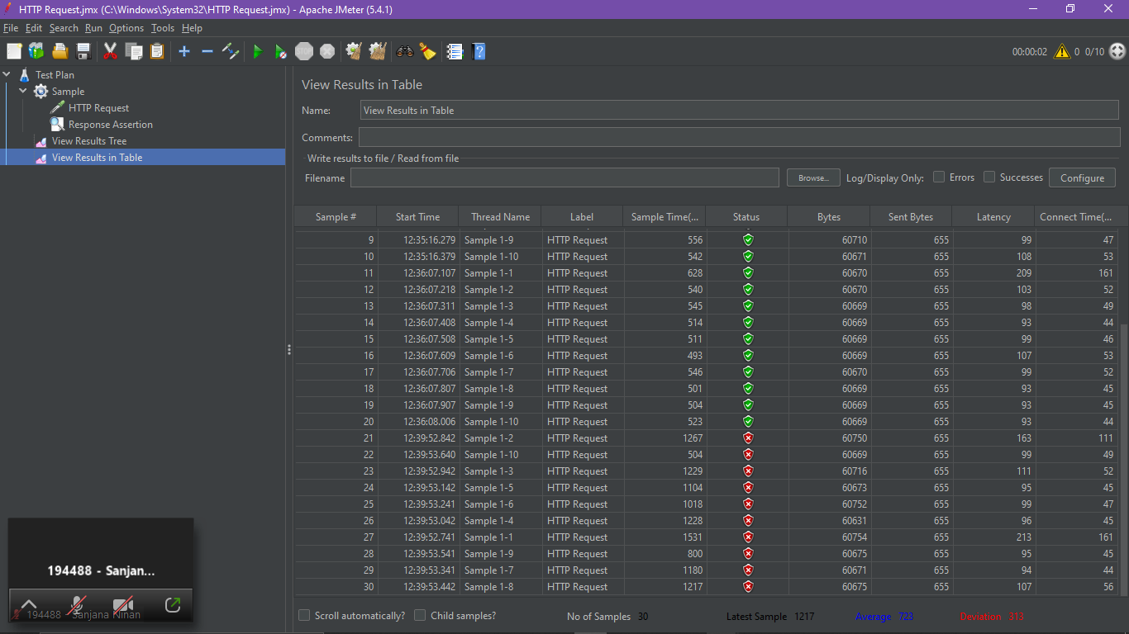

Assertion Results

*Add-> Listener-> Assertion Results*

Assertion Result (passed for 200)

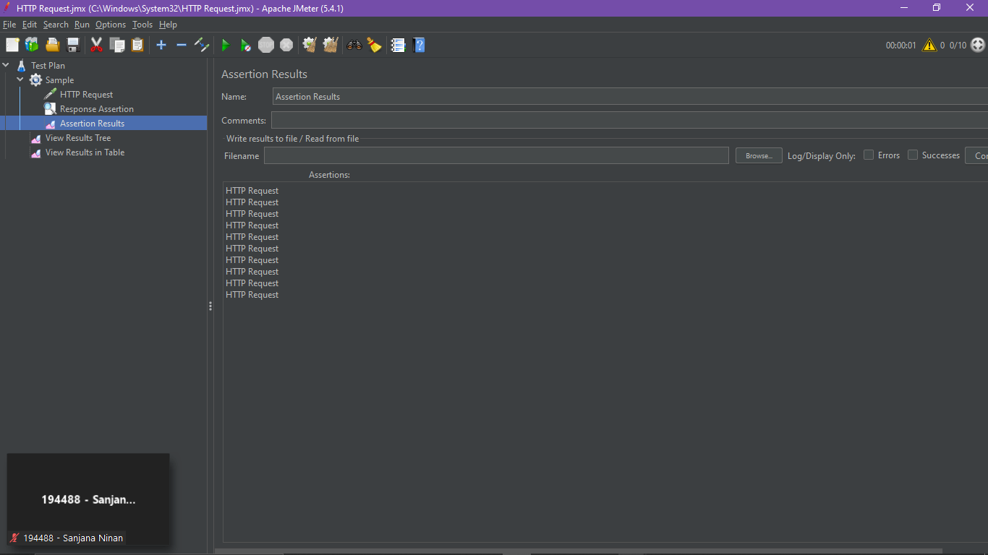

Assertion Results (failed for 201)

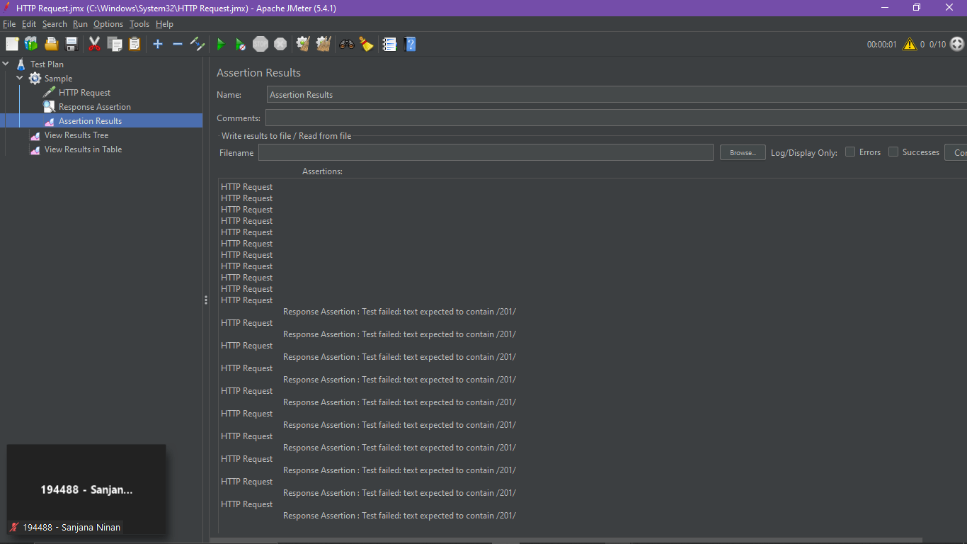

**Duration Assertion**

Checking the duration of the response. We can apply it to Main sample and sub samples, Main sample only or Sub-samples only.

*Add-> Assertion-> Duration Assertion*

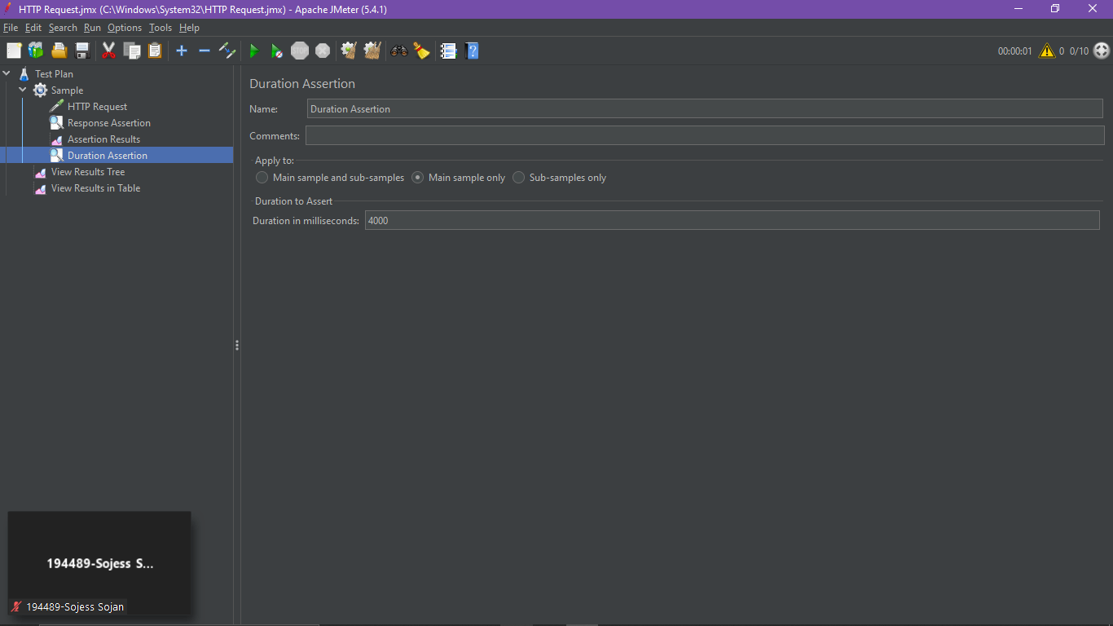

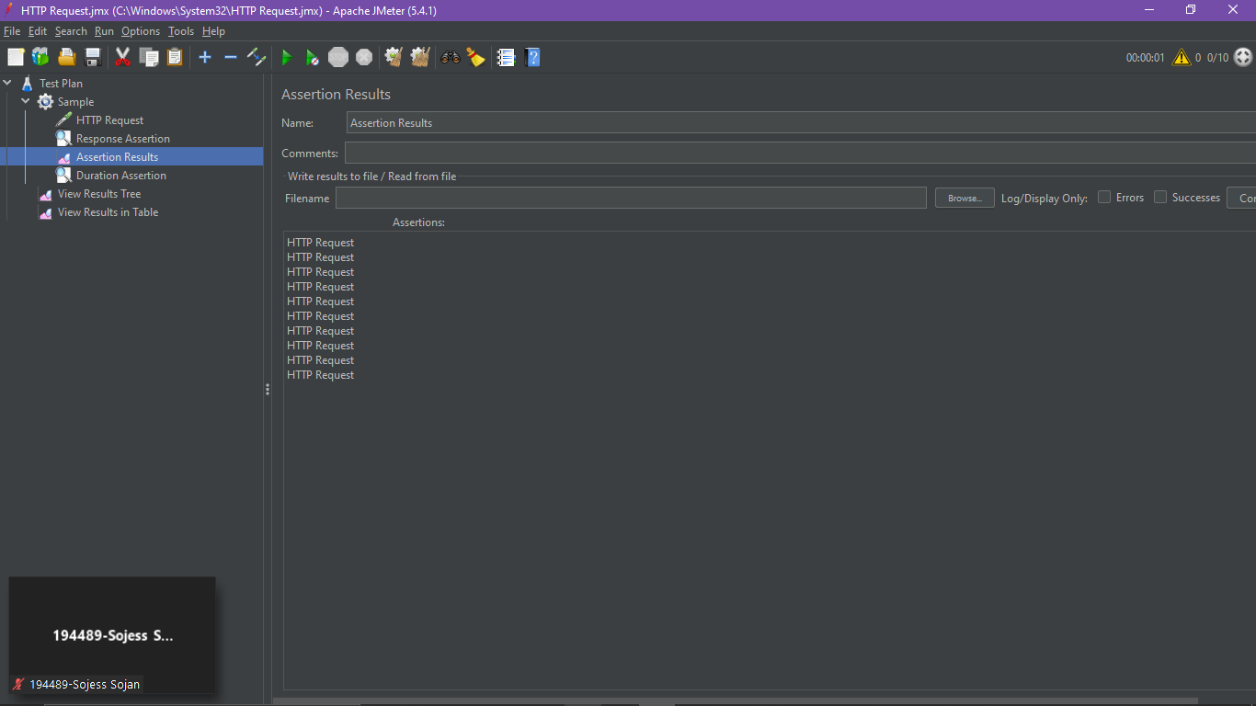

**Size Assertion**

As name indicates it is related to the response size.

Add-> Assertion-> Size Assertion

*Assertion failed for size in byte 140640 sign as ‘=’*

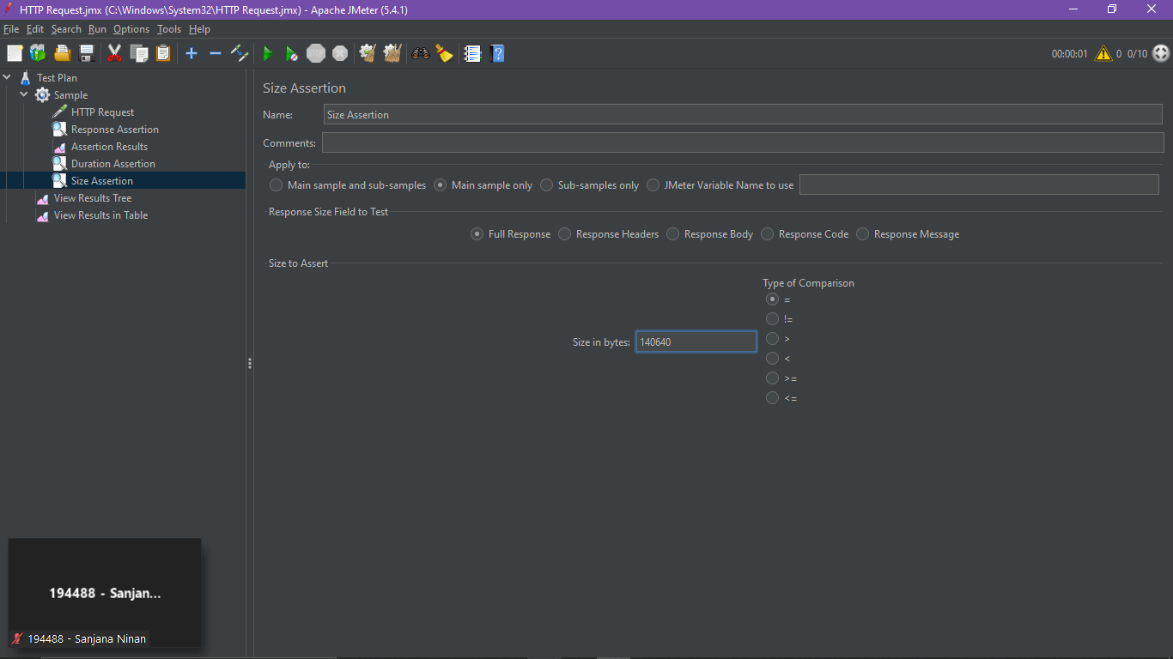

*Assertion passed for size in byte 140640 sign as ‘<’*

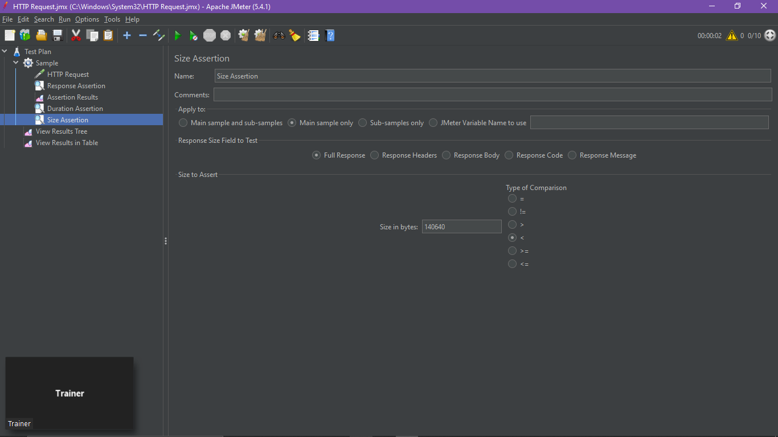

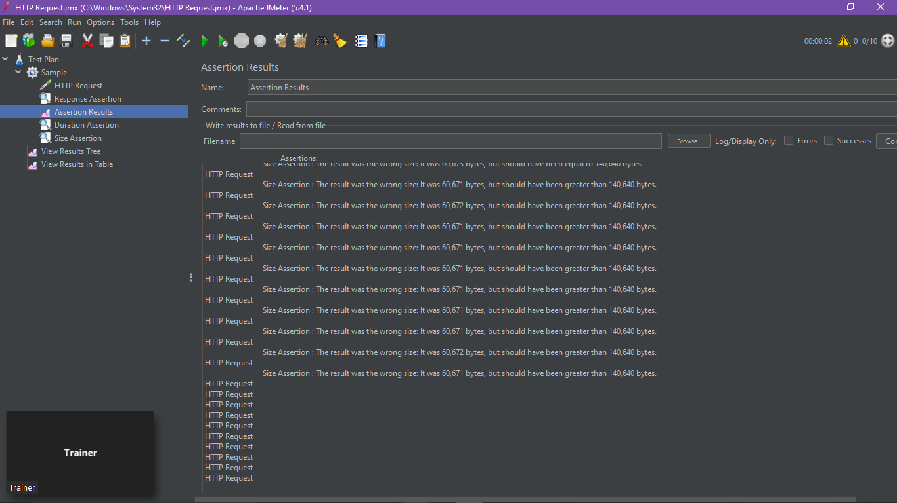

**HTML Assertion**

Test the format of the response. It checks whether the format is valid HTML or not.If it is not a valid HTML it will throw some errors and fail the assertion.

* ***Error Threshold:*** To provide the count of errors which can be ignored and considered the request as pass.
* ***Warning Threshold:*** The number of warnings which can be ignored and considered the request as pass.

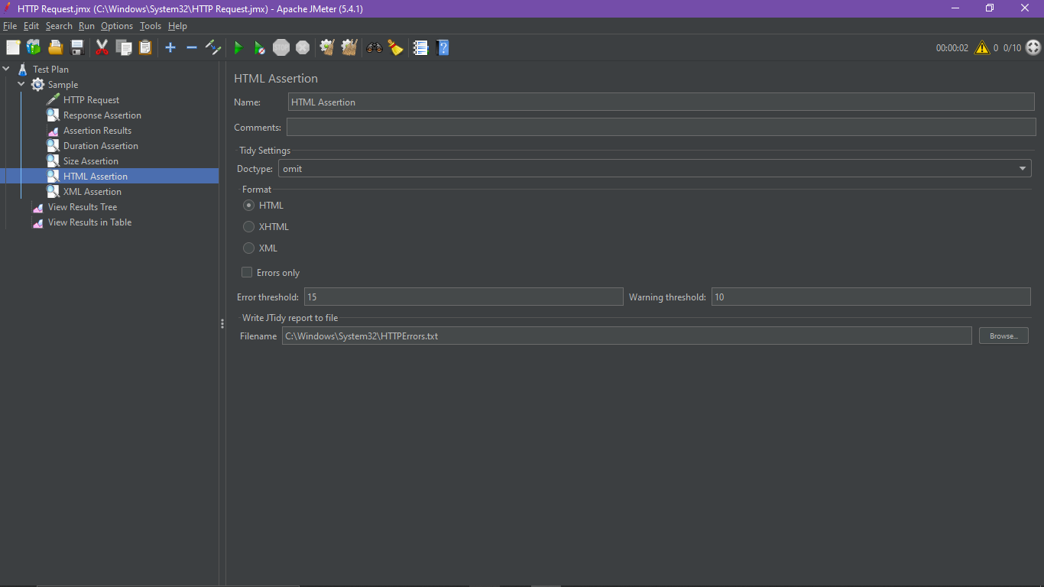

**XML Assertion**

This will check the format, if it is a valid XML it will pass otherwise it will fail.

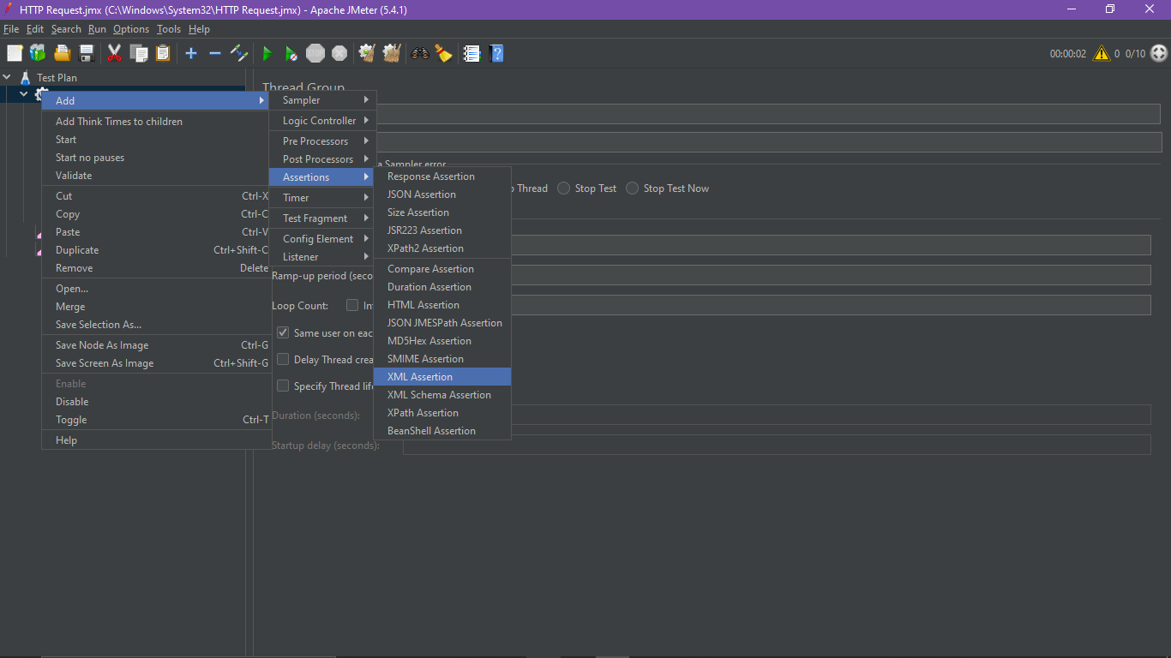

XML Assertion failed and it says that the markup in the document preceding the root element must be well-formed.

