**CSV CONFIG TEST PLAN**

***Create a csv file in notepad with 2 rows of data***

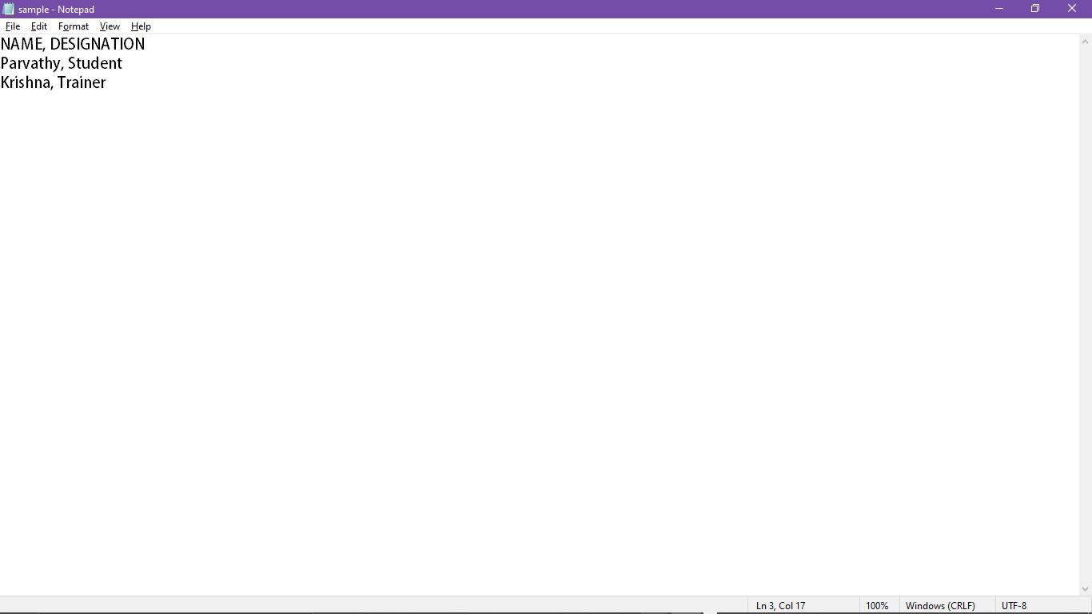

***Add csv file to jmeter****(Add->Config element-> CSV Data set Config)*

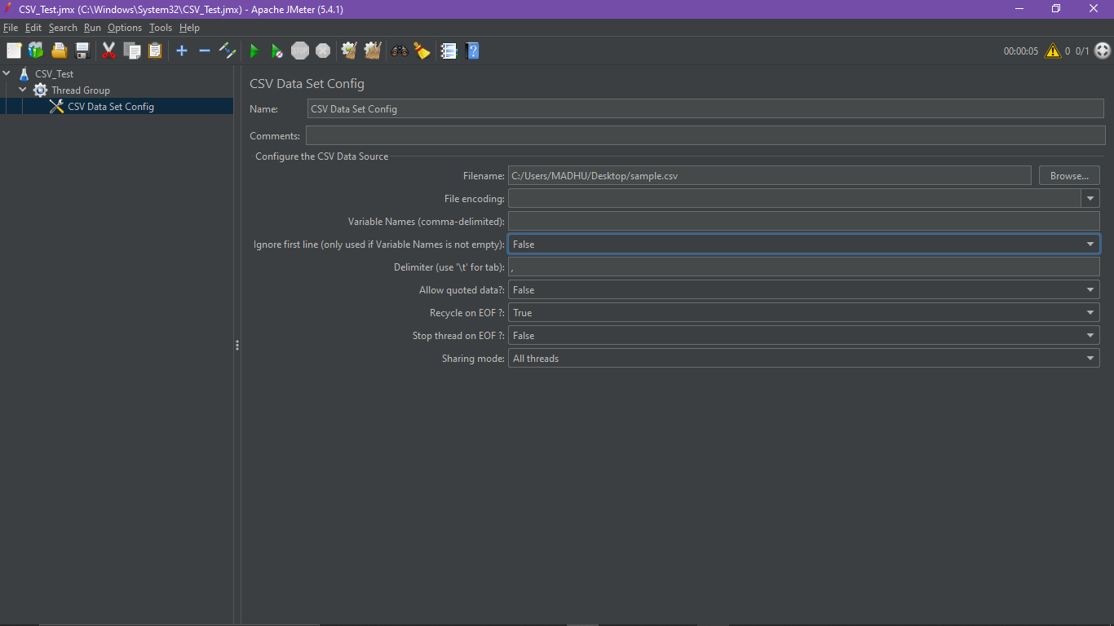

***We will get an output like this because we have 2 data but we provided ony 1 use. So only 1 thread will be executed. And first dta will be displayed***

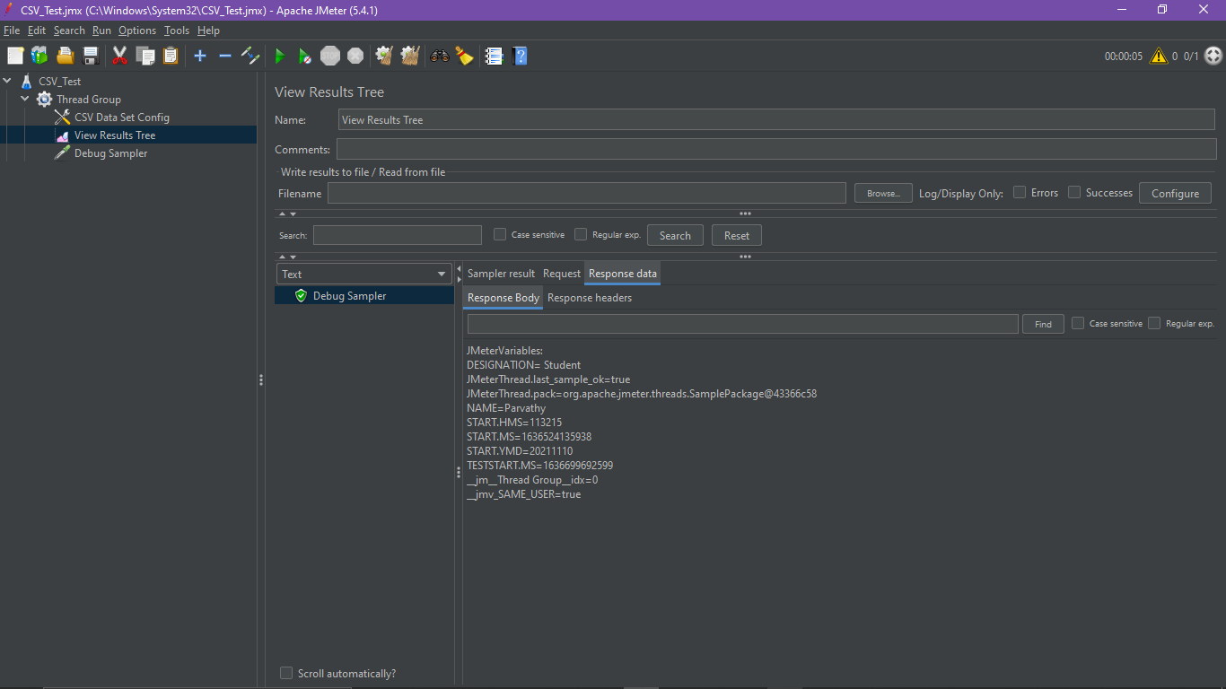

***Add 2 Users***

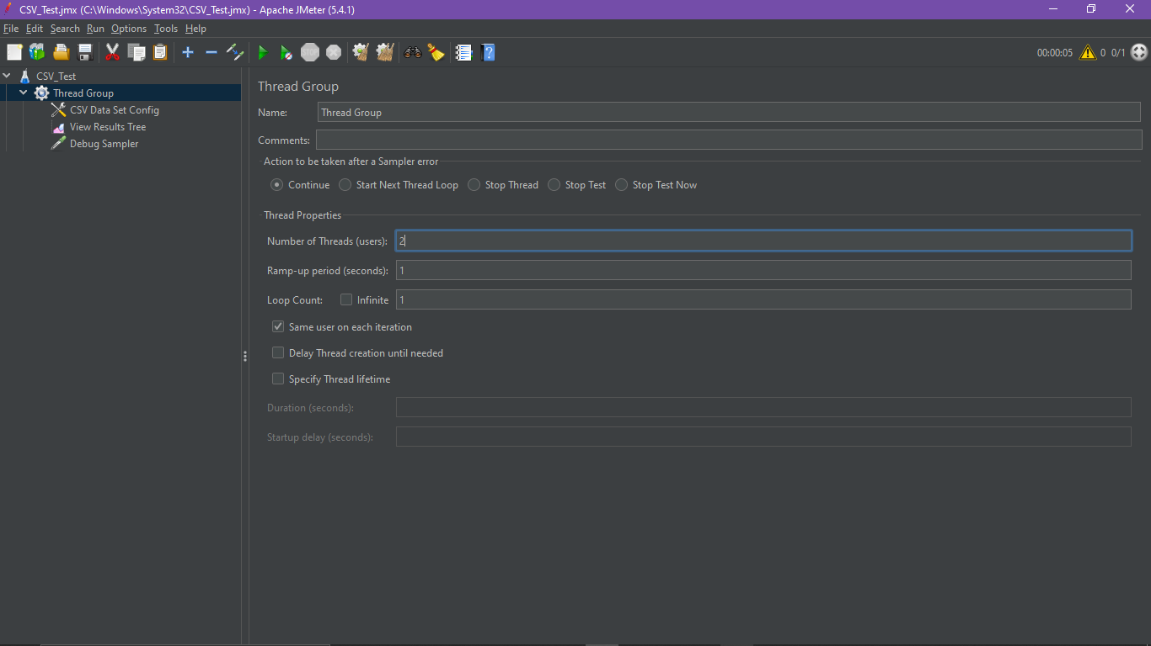

***We will get 2 data as output***

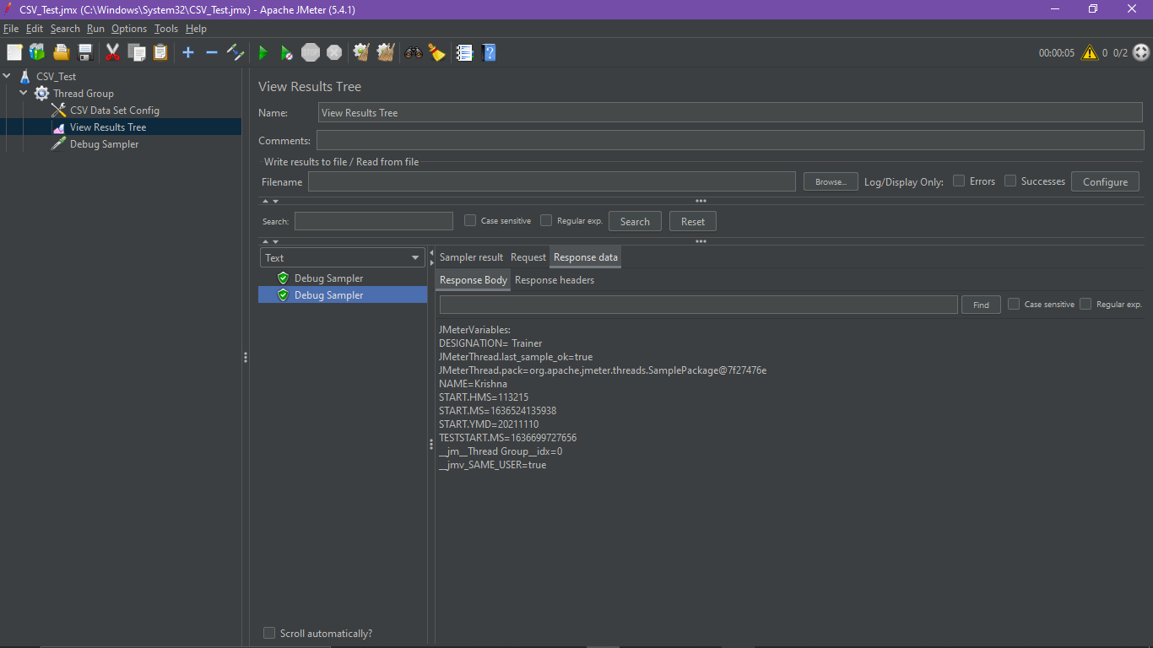

***We add 5 users/thread then we get 5 output with repeating the data***

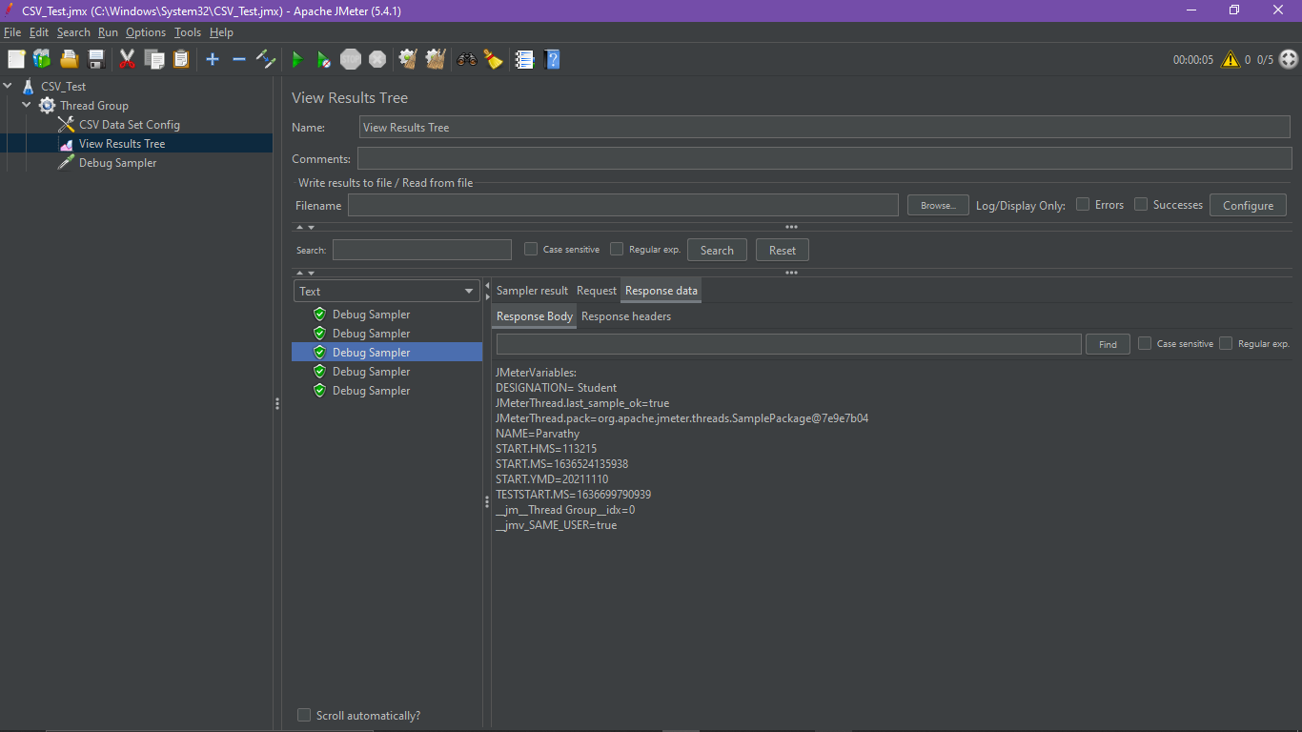

***Set Recycle on EOF - true***

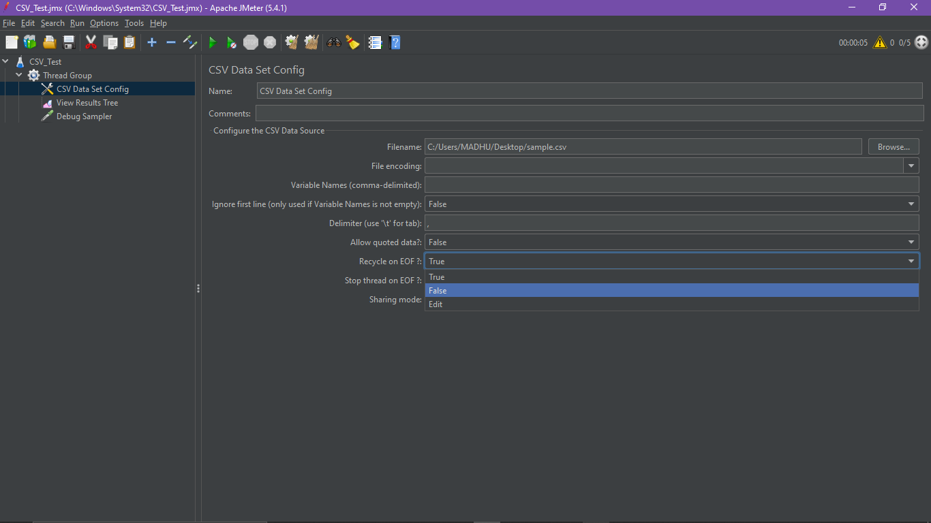

***We will get EOF output after 2nd thread***

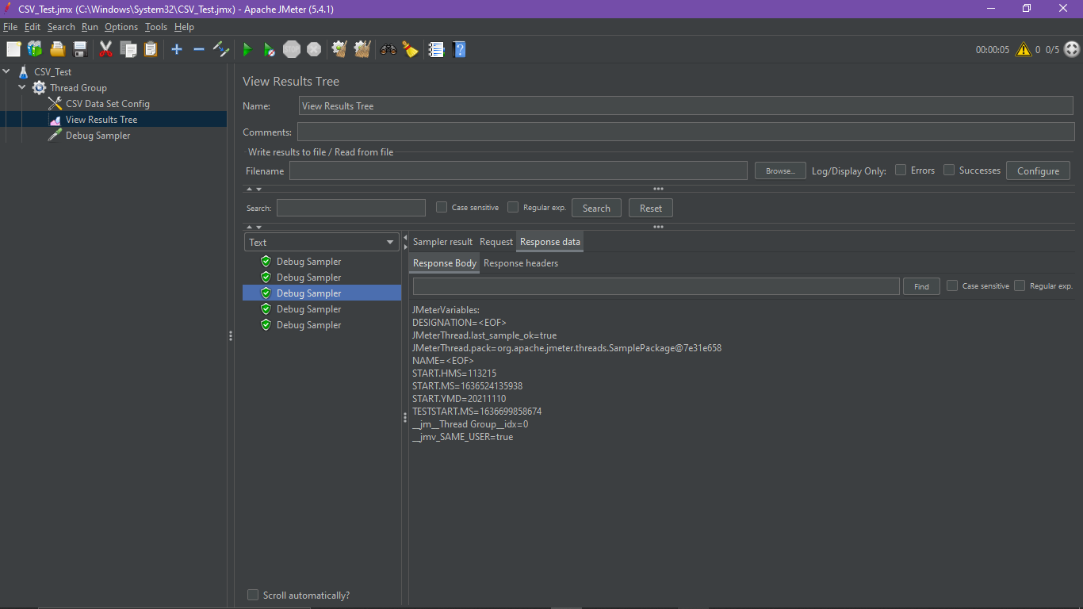

***Set Stop thread at EOF- true***

