**HTTP Request Default TEST PLAN**

***Add-> config element-> HTTP Request Defaults***

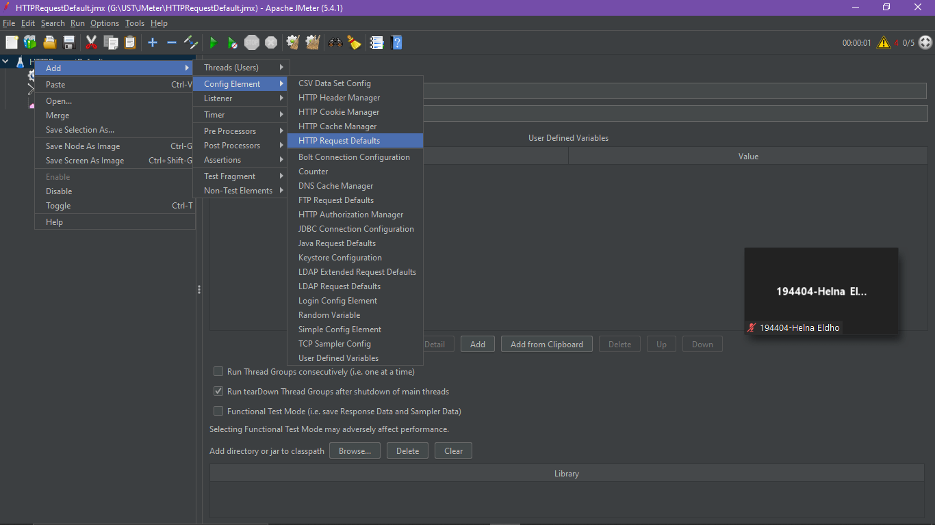

***Add IP and protocol***

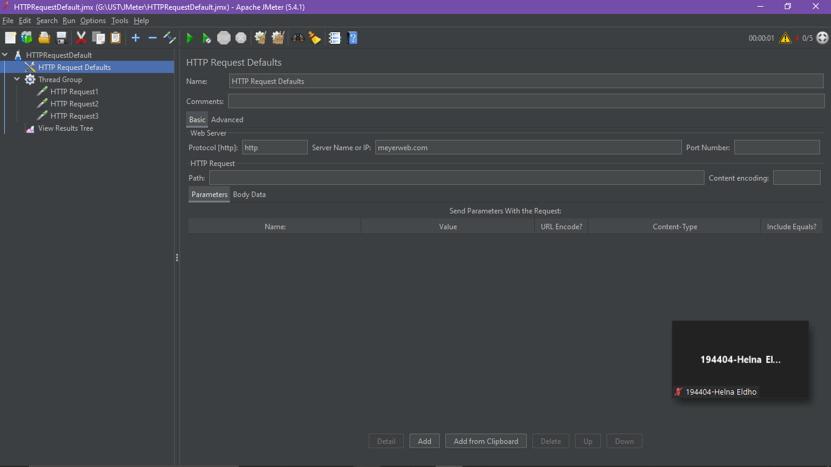

***Add 3 HTTP Request Inside thread group and add diferent path for each request***

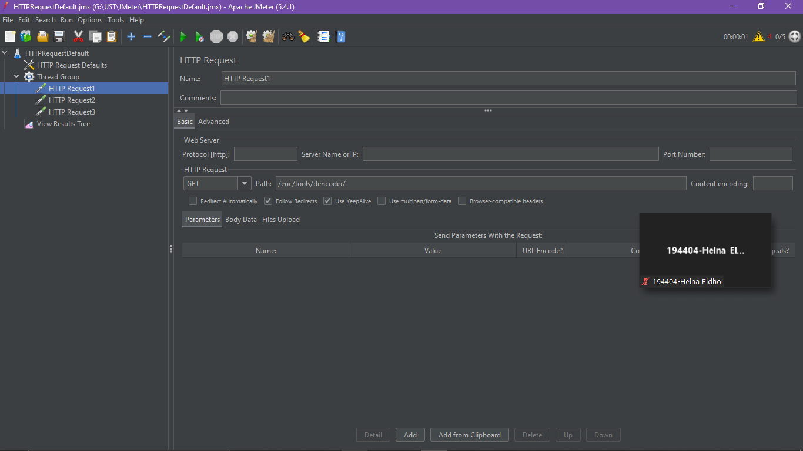

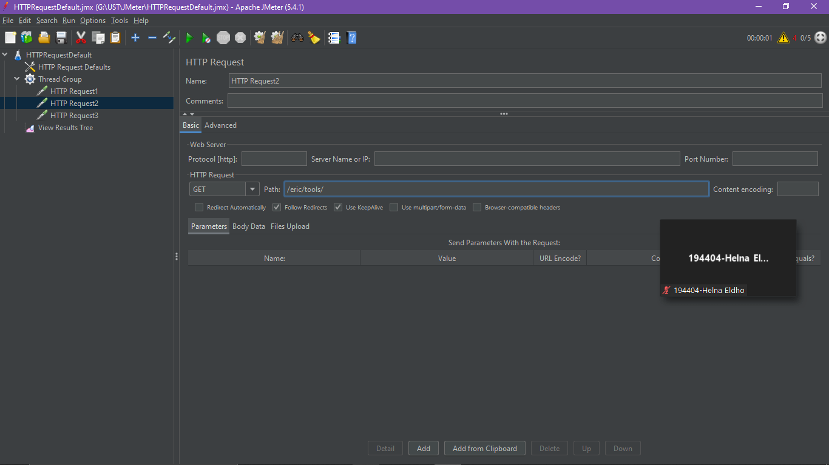

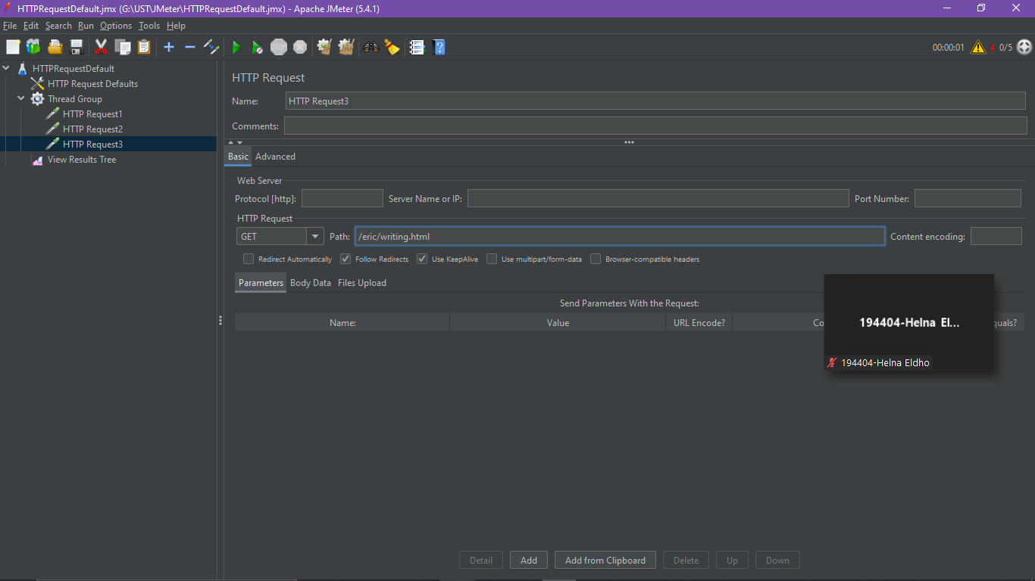

***And the output of test becomes(Second request is failed due to invalid path)***

