**CONTROLLERS**

***Add Thread Group, with loop count 2 and 2 HTTP Requests***

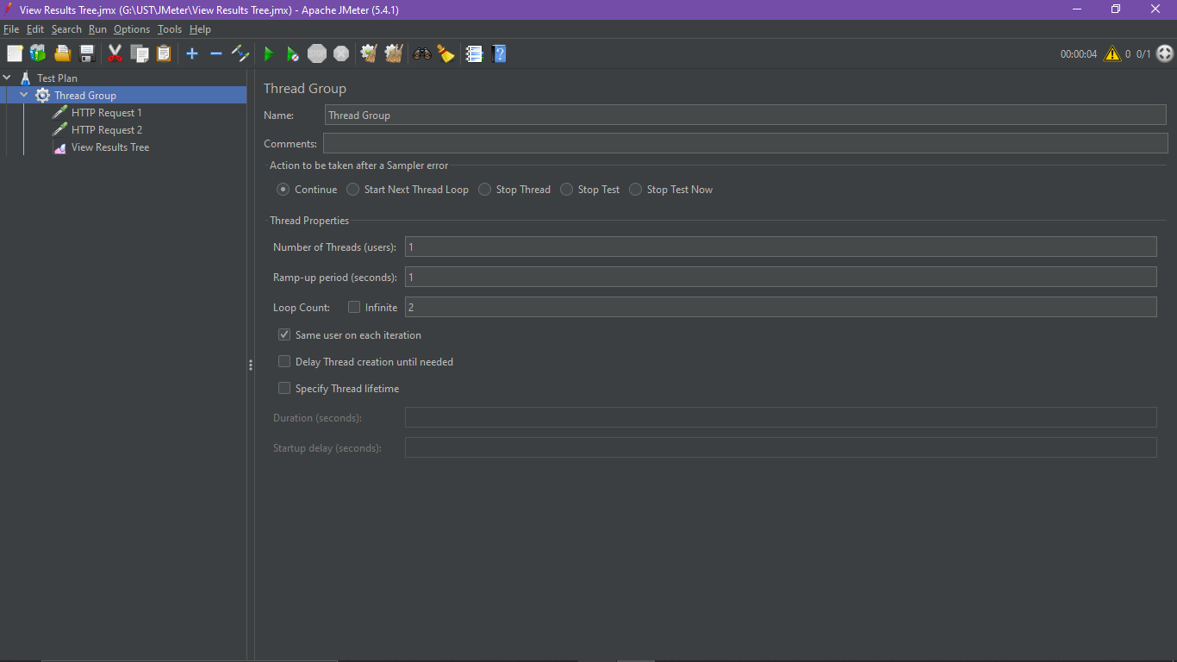

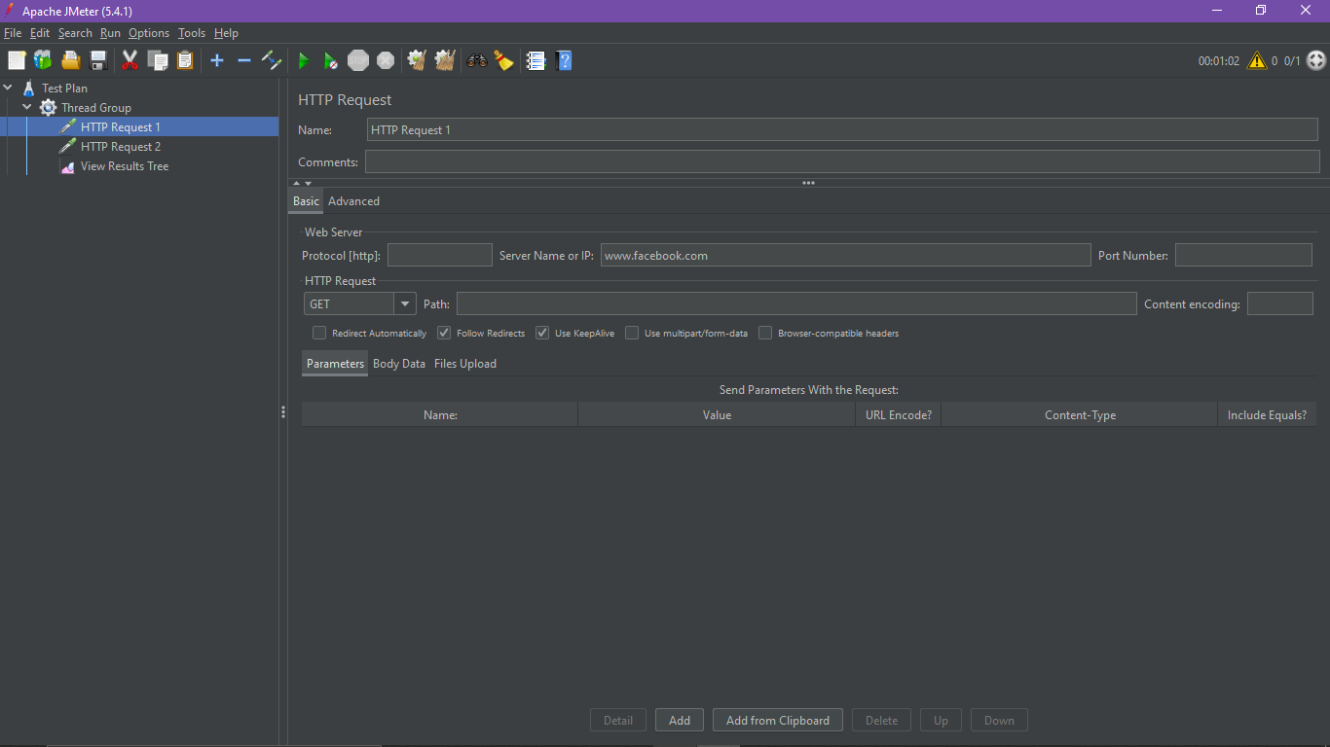

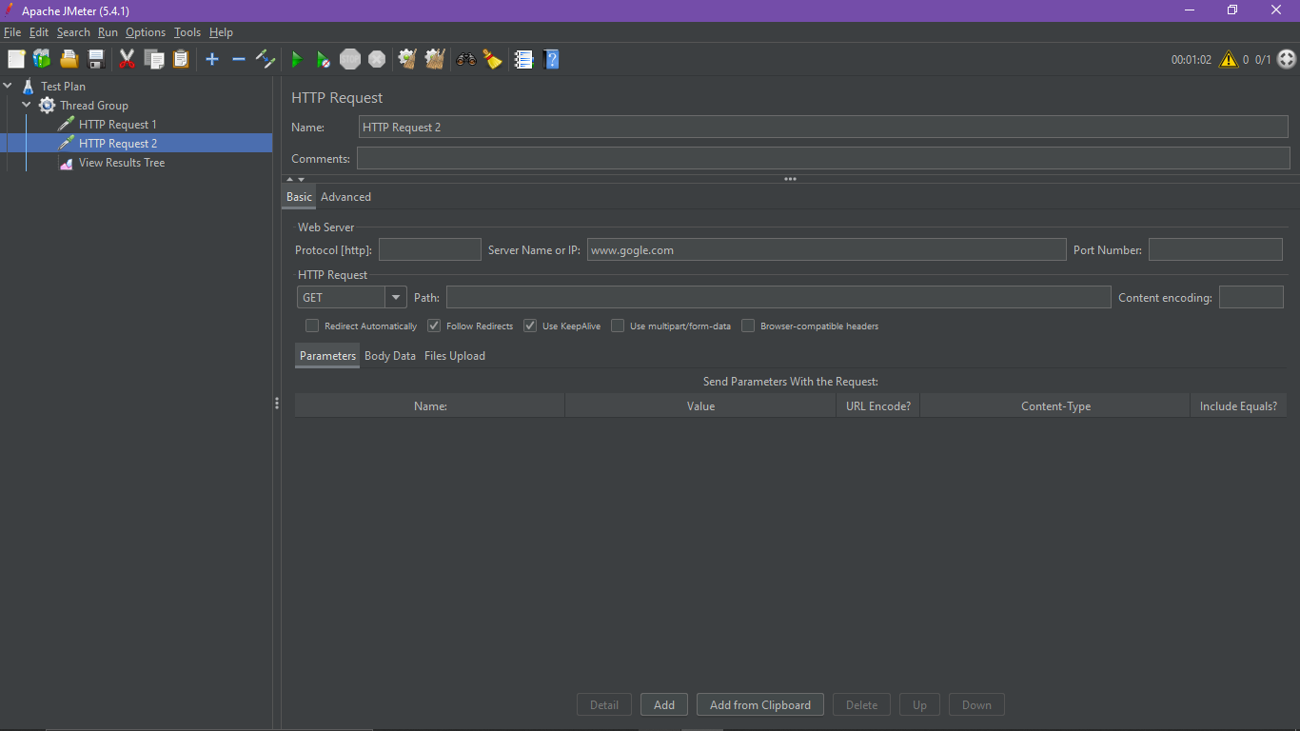

***Output:***

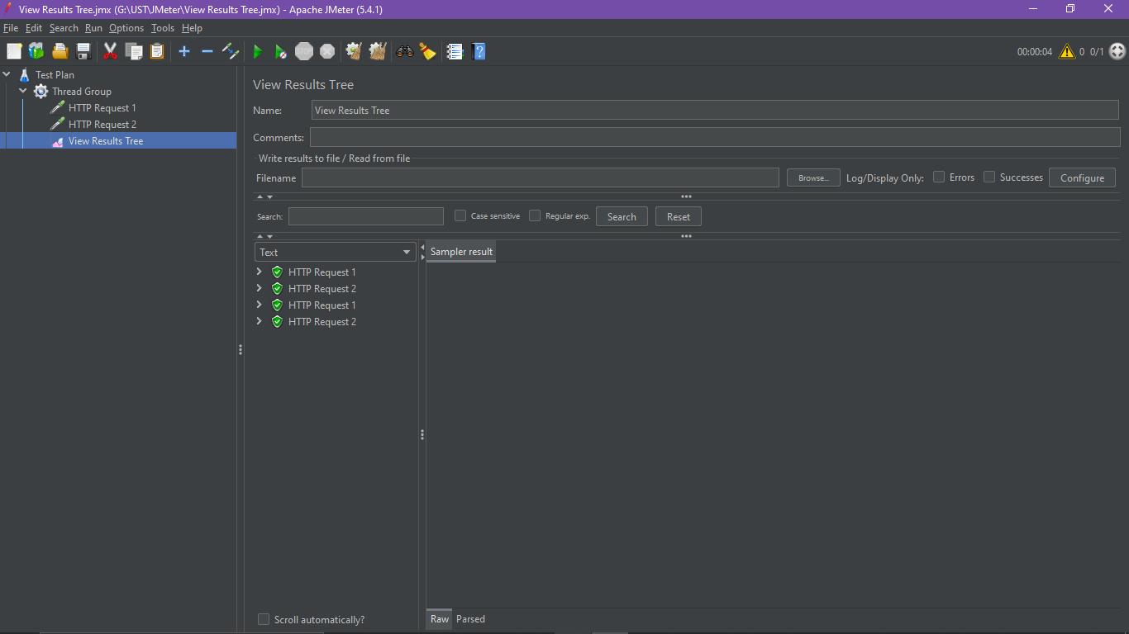

***SIMPLE CONTROLLER-*** *used to group the request*

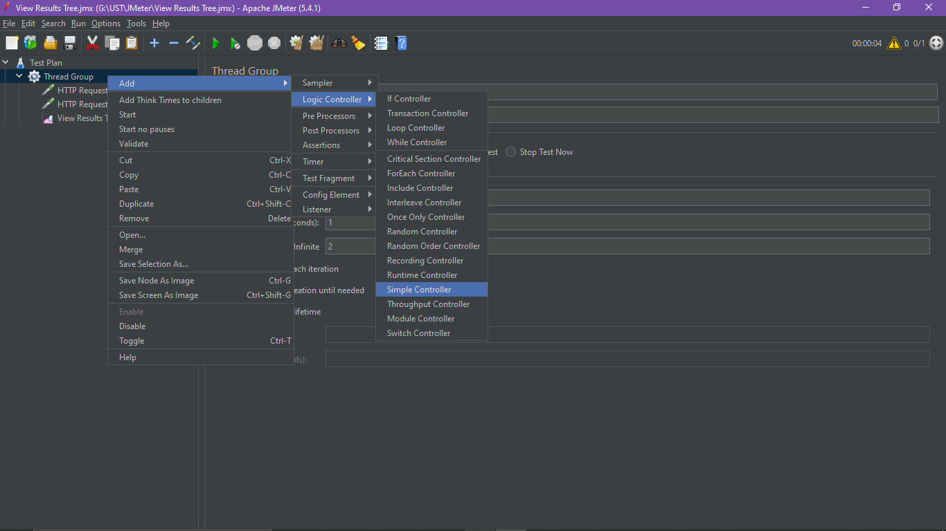

***Add 2 HTTP request inside simple controller***

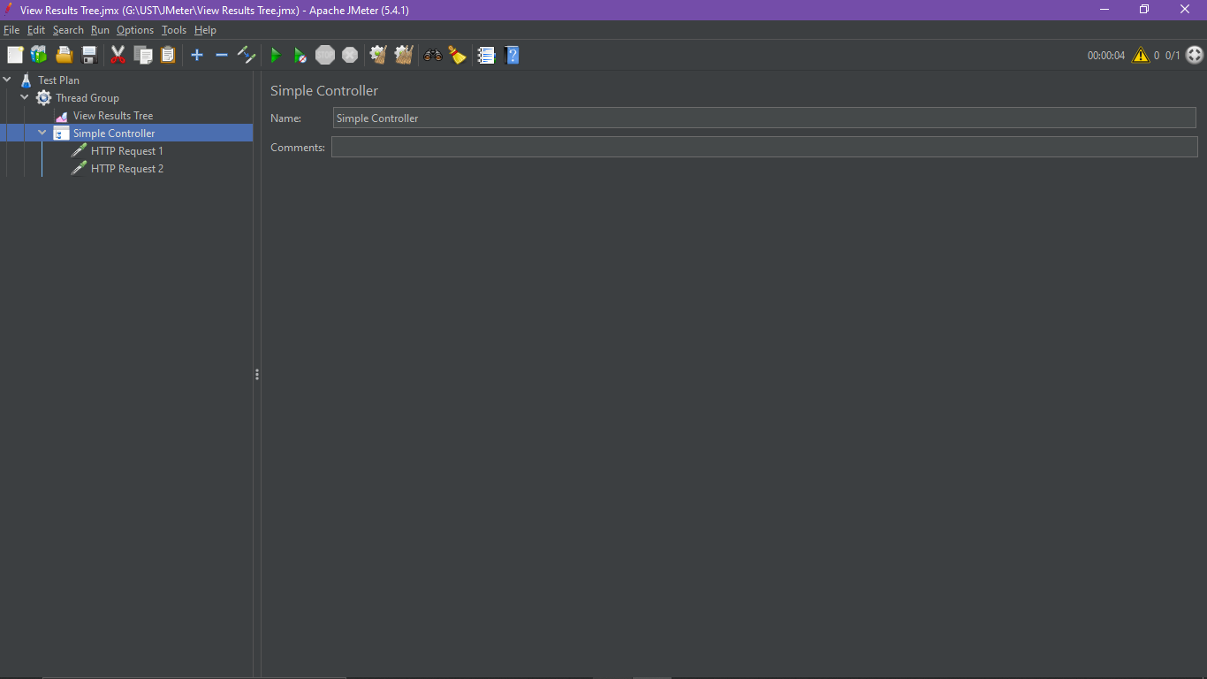

***Create new HTTP request***

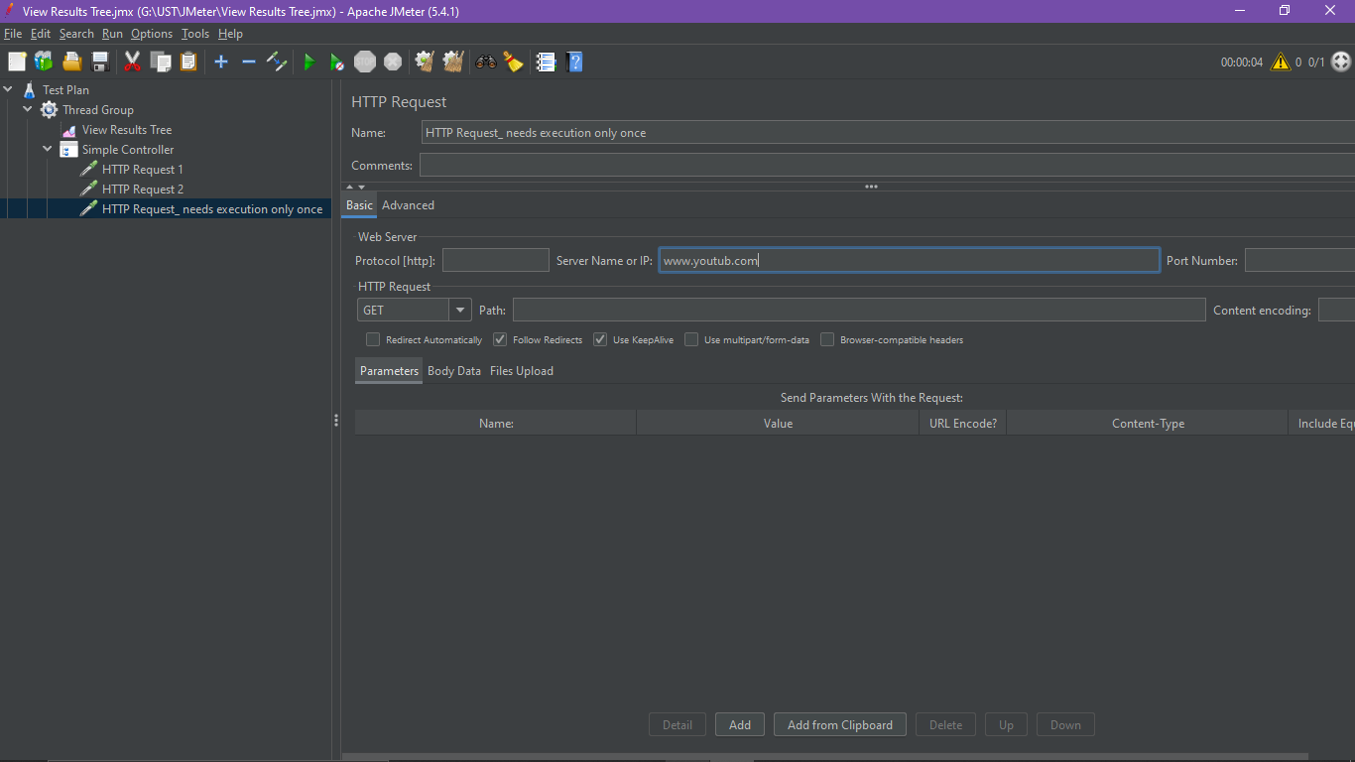

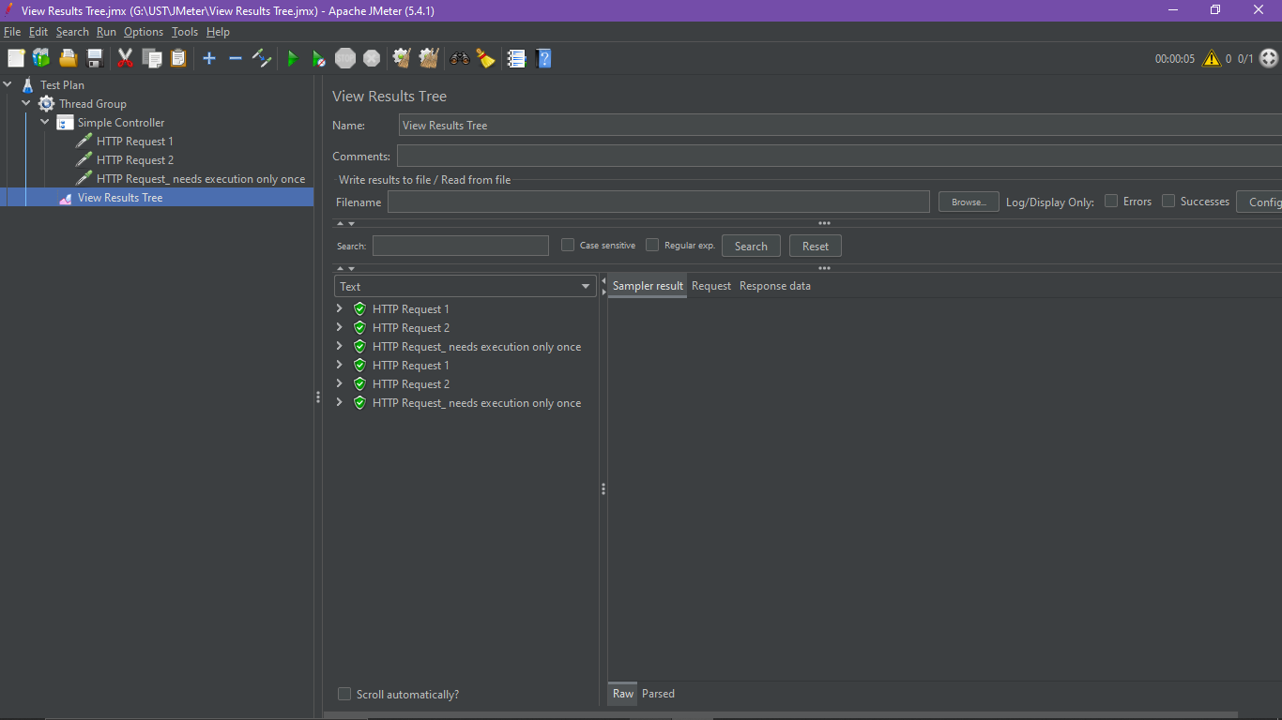

***But we need that new request should run only once***

***Once Only Controller:-*** *it execute only one time*

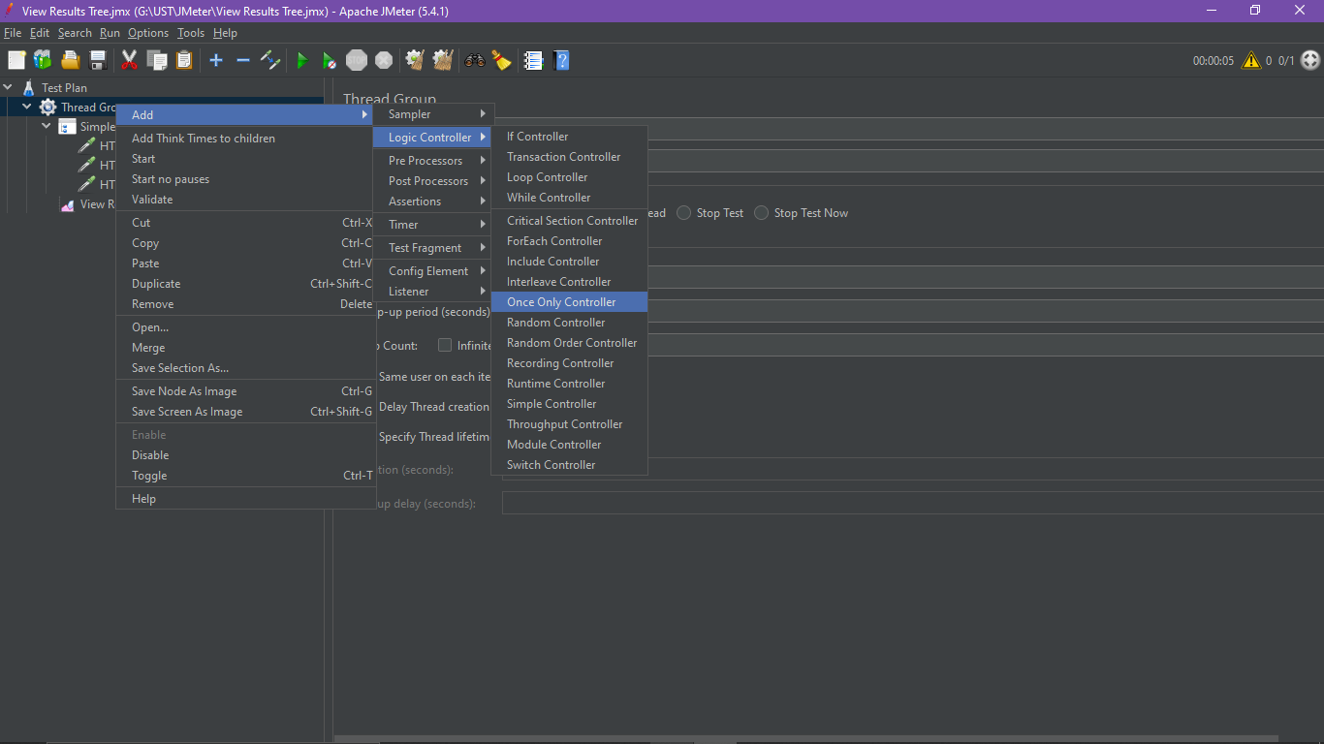

***Place the those request inside this controller to execute only once***

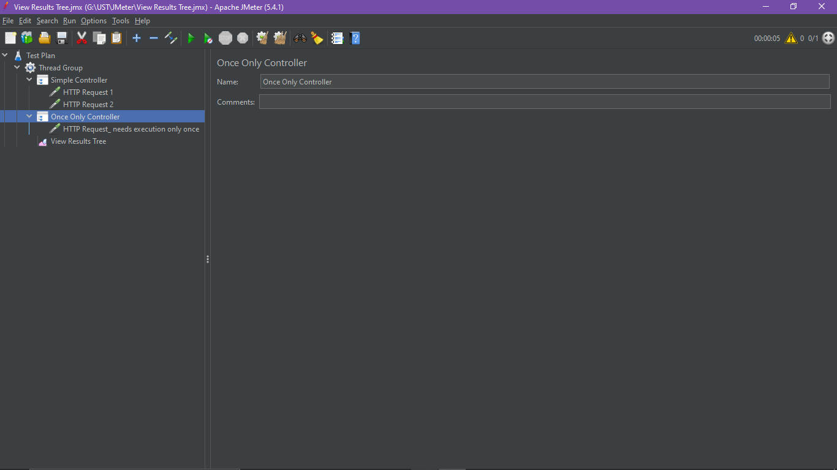

***Output:***

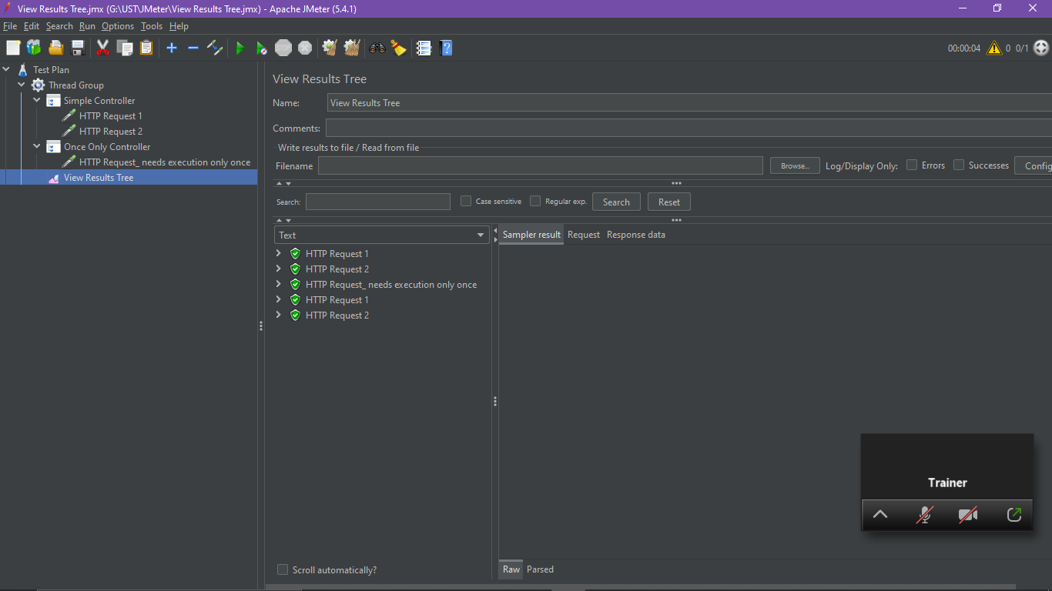

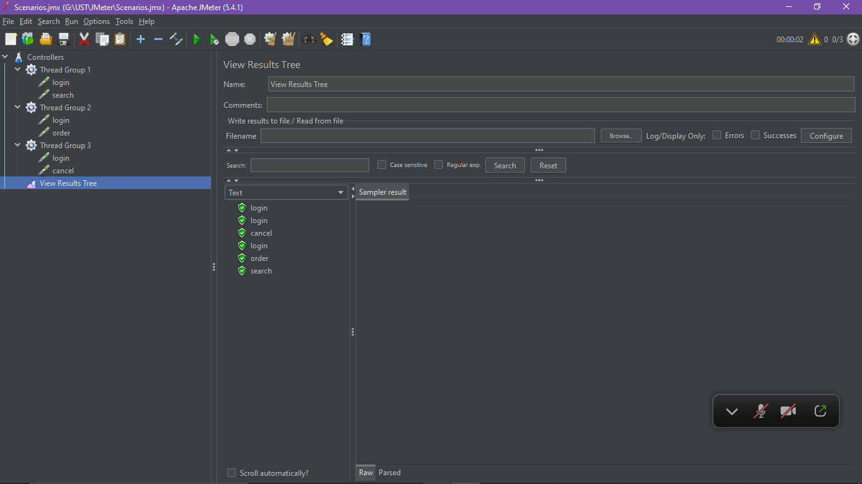

***We can see login in repeated in each HTTP requests***

***Test Fragment-***  *it will help us to write the repeating codes inside one module. We can just call the test fragment when it is necessary*

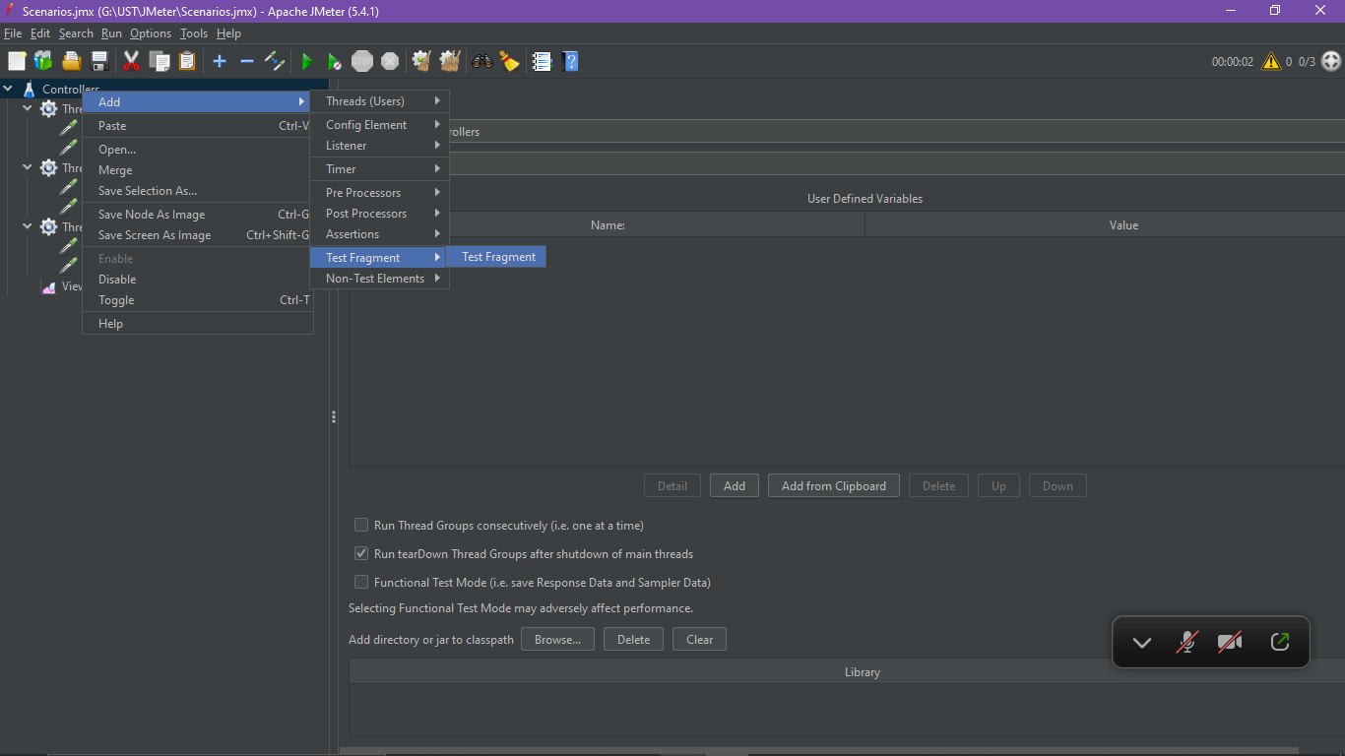

***Module Controller:*** *will act as module which will execute any other threads*

***Scenarios- 1.login&search 2.login&order 3.login&cancel****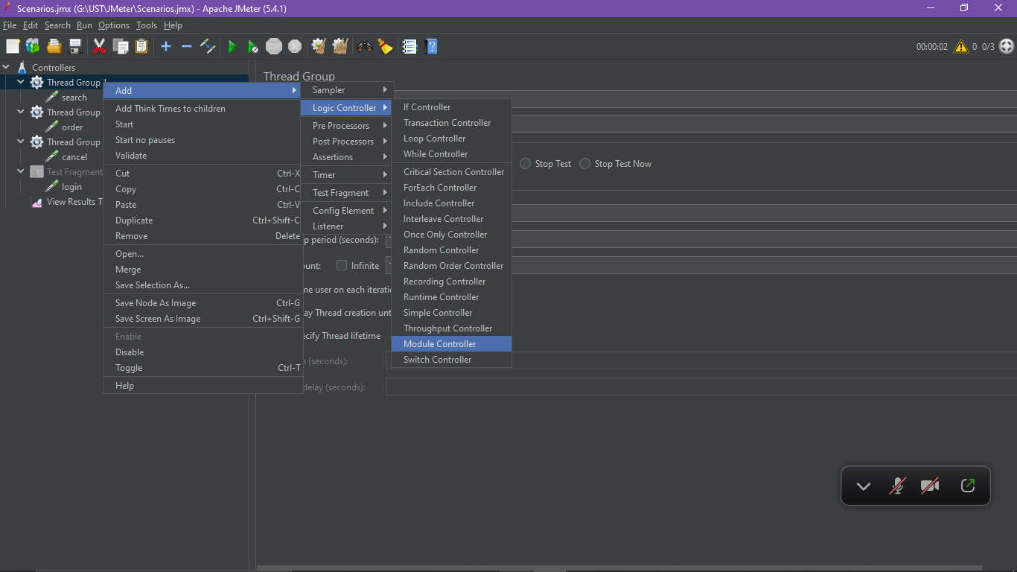*

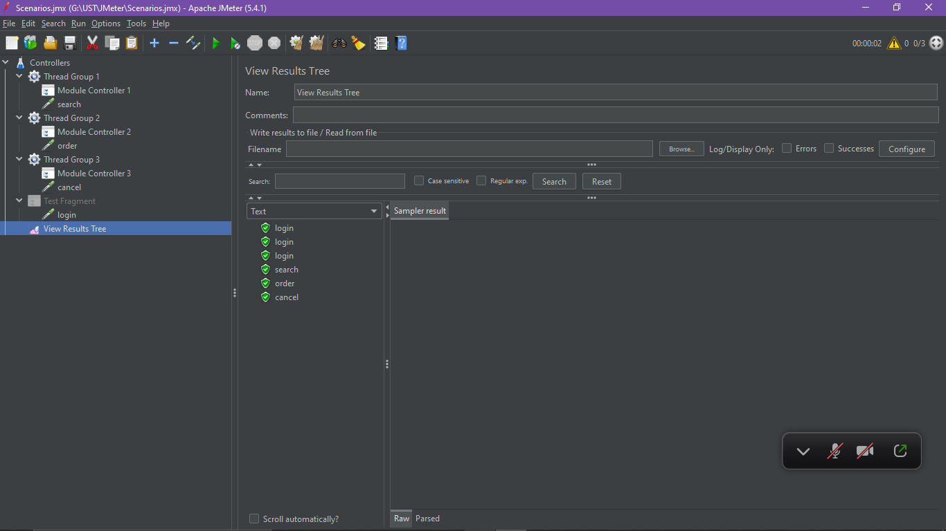

***Include Controller***

***Scenarios: 1.login 2.search 3.order 4.cancel***

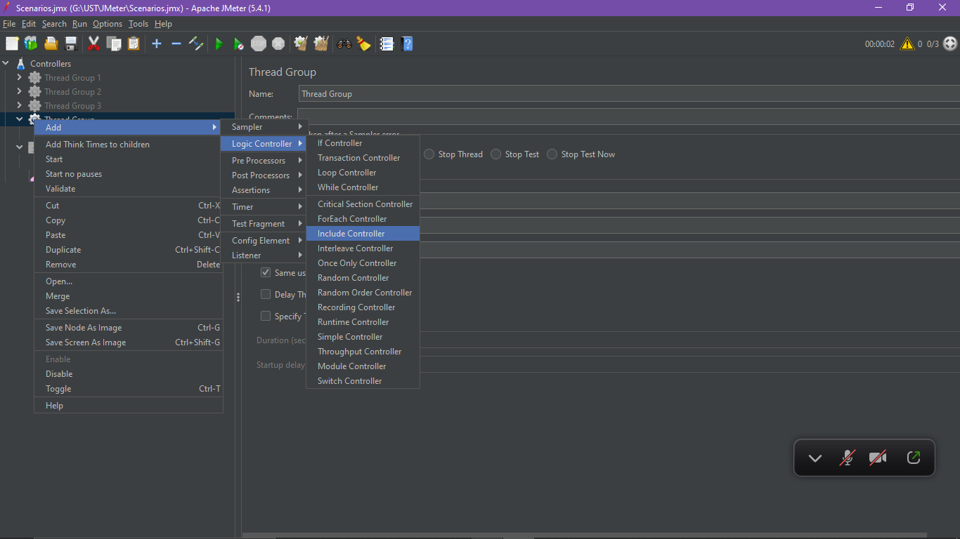

***Save the login request as test fragment***

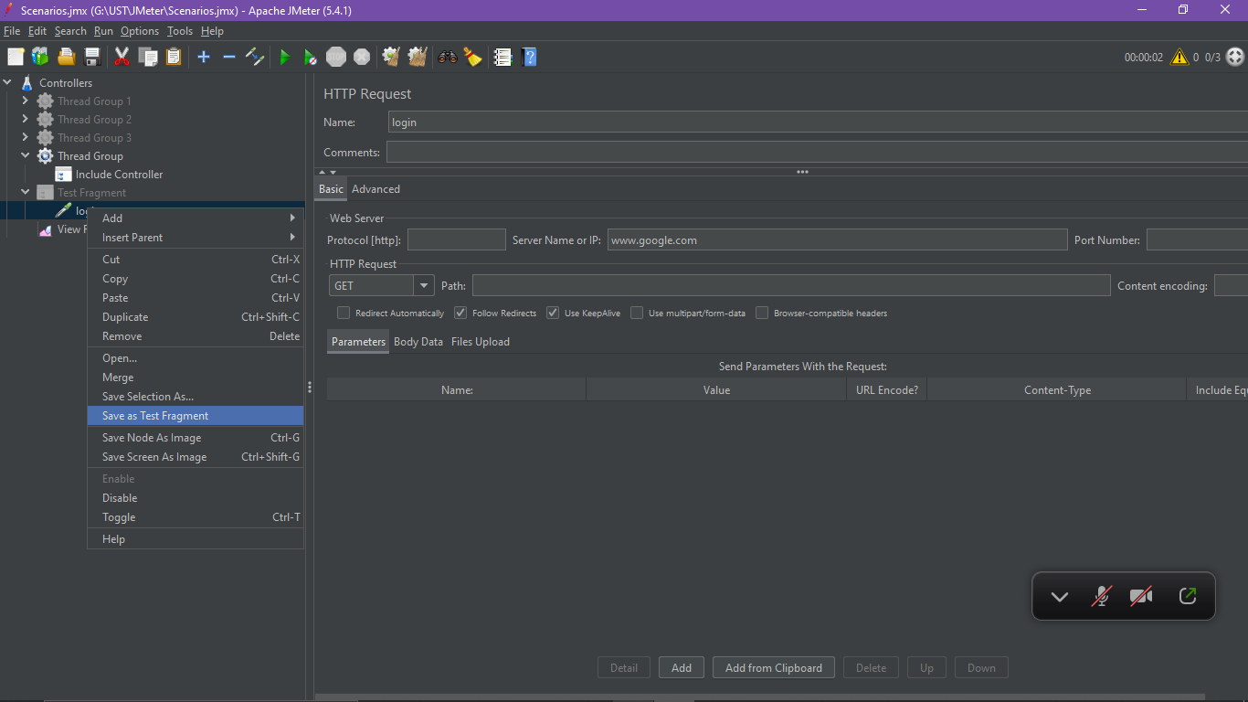

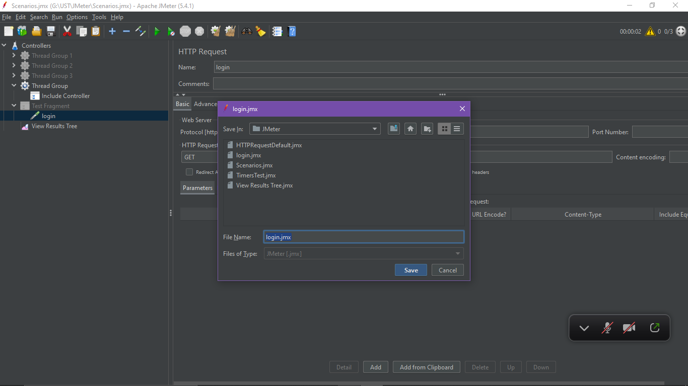

***Browse the saved test fragment over include controller***

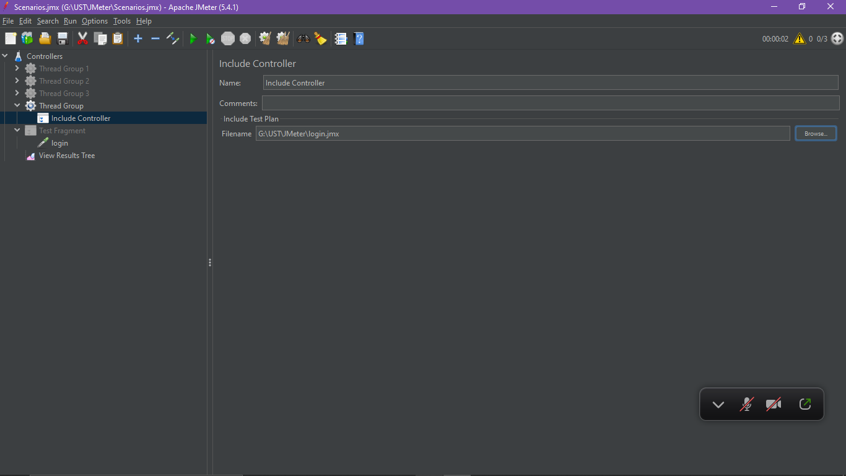

***Paste all the scenarios after the include controller***

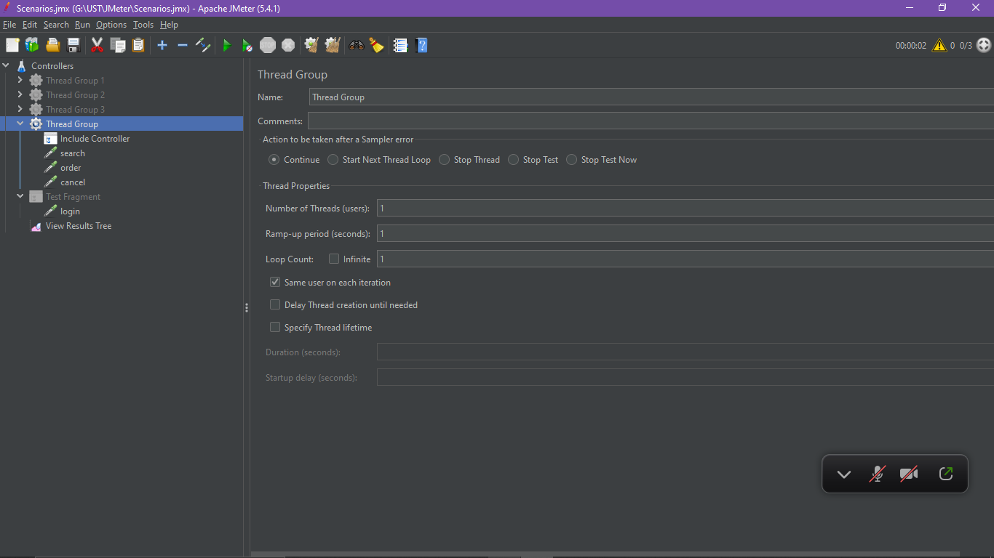

***We can see login will executes only 1 time***

