**TIMER**

***CONSTANT TIMER***

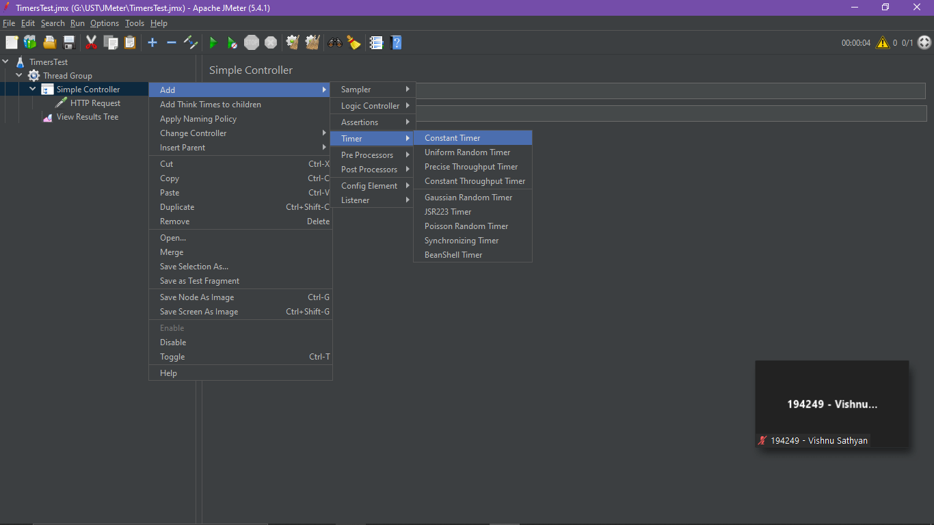

***Set the time for 5 seconds***

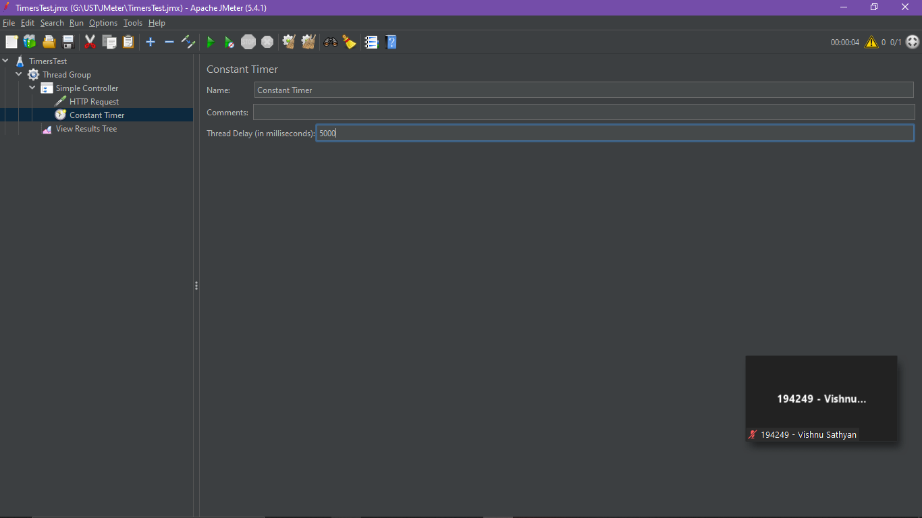

***It will start test after 5 seconds***

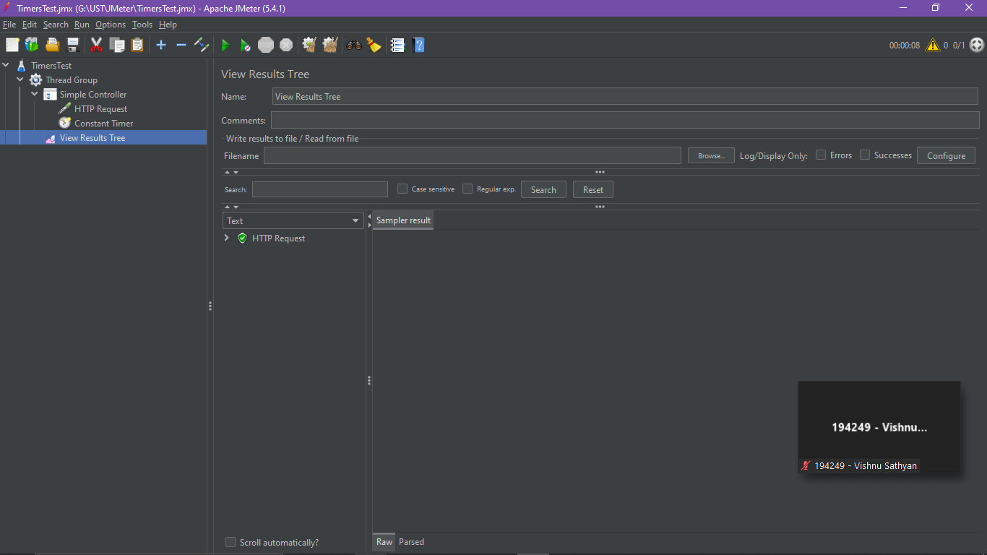

***Give multiple Timer for multiple HTTP Request***

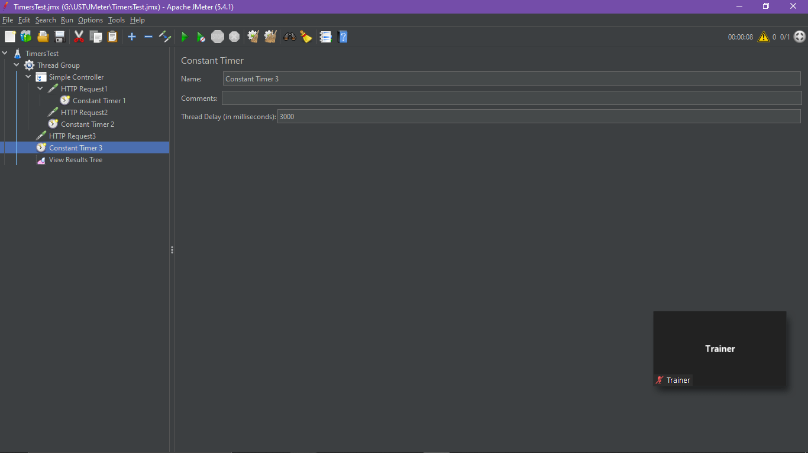

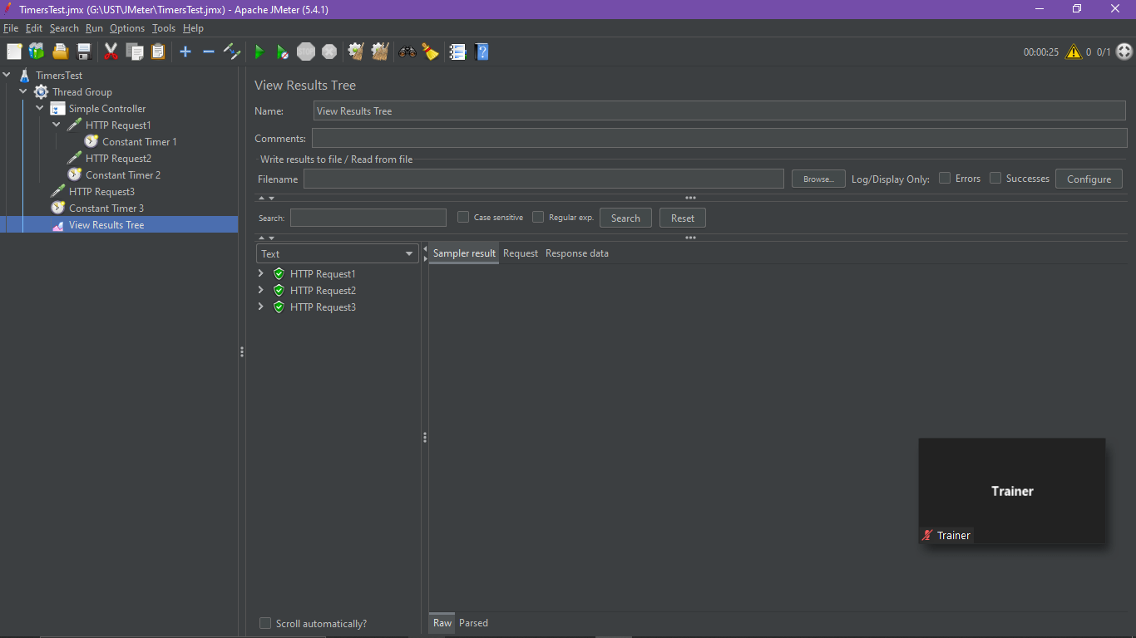

***UNIFORM RANDOM TIMER***

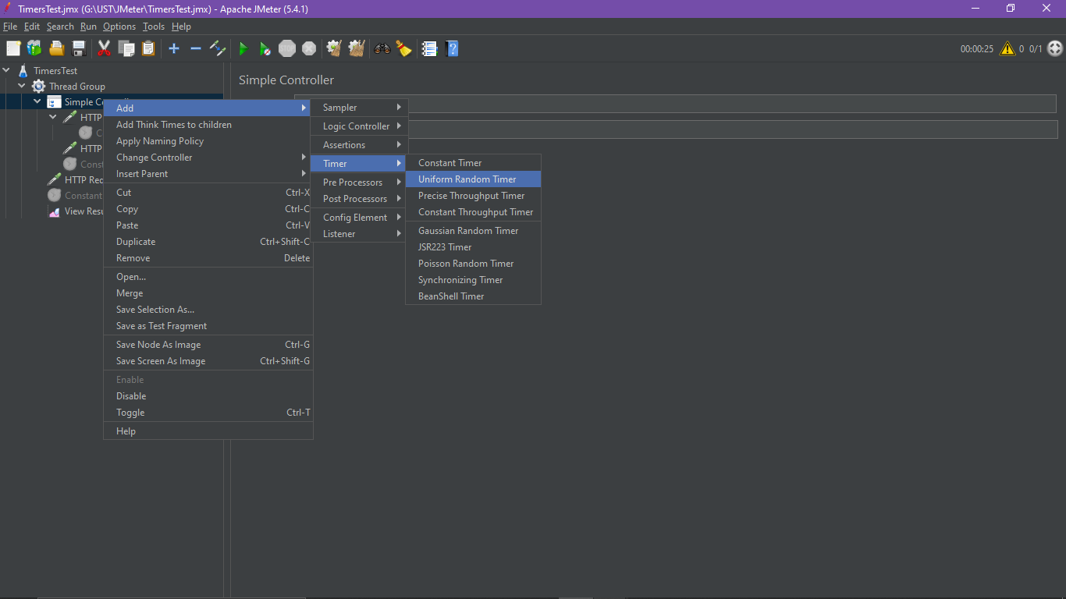

***0.X * Random Delay Maximum + Constant Delay Offset(X=>0…9)***

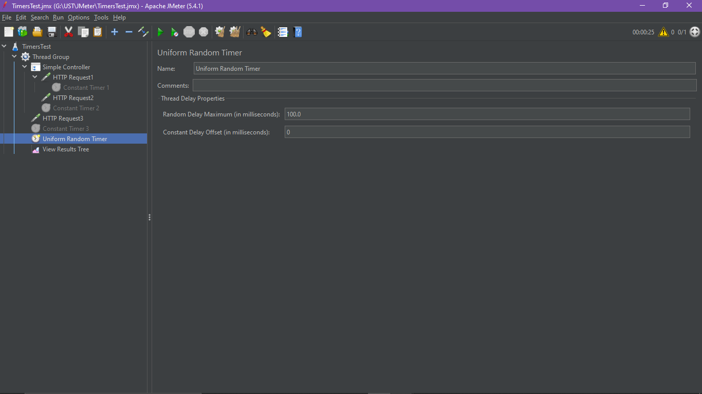

***Output:-***

