**POSTMAN**

* Postman is an Application Programming Interface (API) testing tool.
* API acts like an interface between a couple of applications and establishes a connection between them.
* Download postman from here <https://www.postman.com/downloads/>

***GET Request in postman***

* A GET request is used to obtain details from the server and does not have any impact on the server.
* The GET request does not update any server data while it is triggered.
* The server only sends its Response to the request

This is the interface of postman and I create a Collection called Collection_GET and gonna perform GET operation

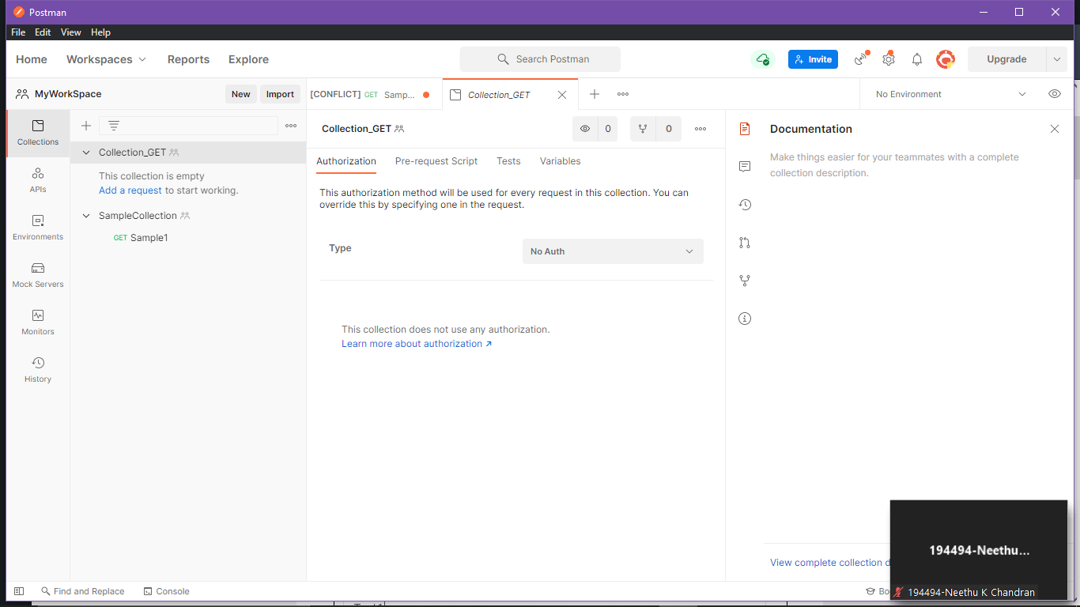

New-> HTTP Request

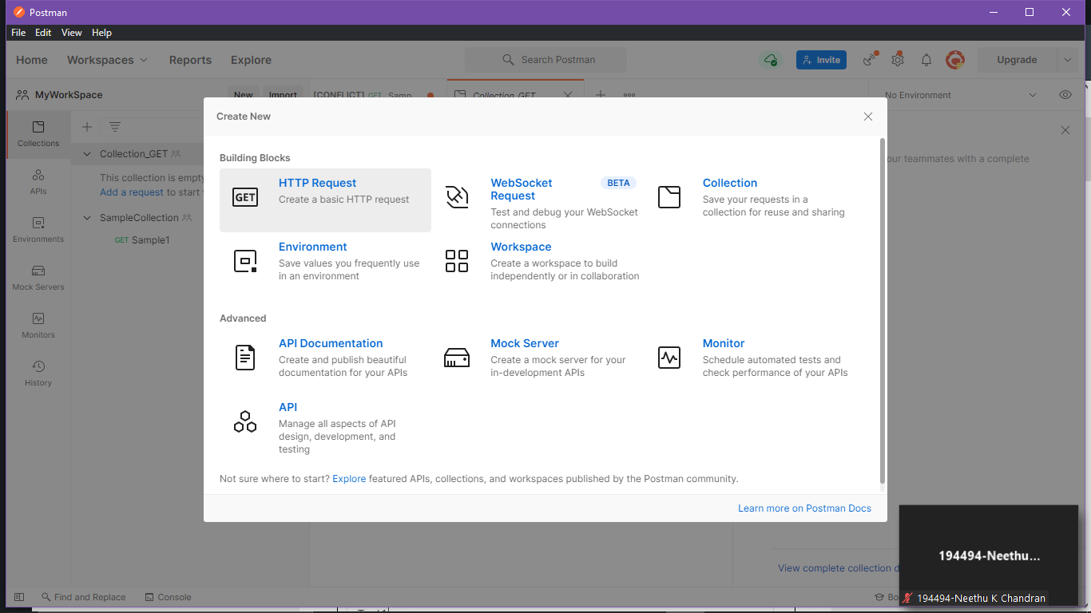

Add this url there <https://www.tutorialspoint.com/index.htm> and hit Send button

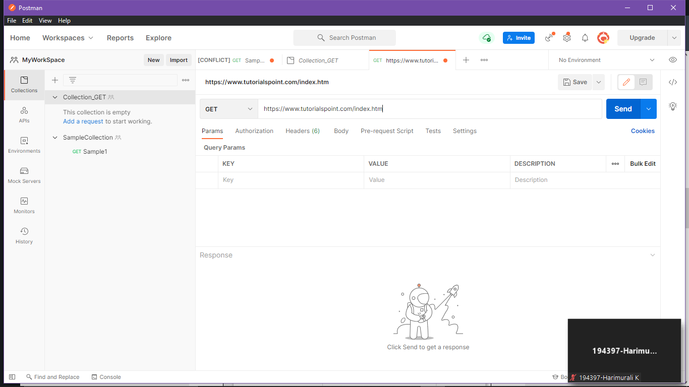

See the result as Raw data

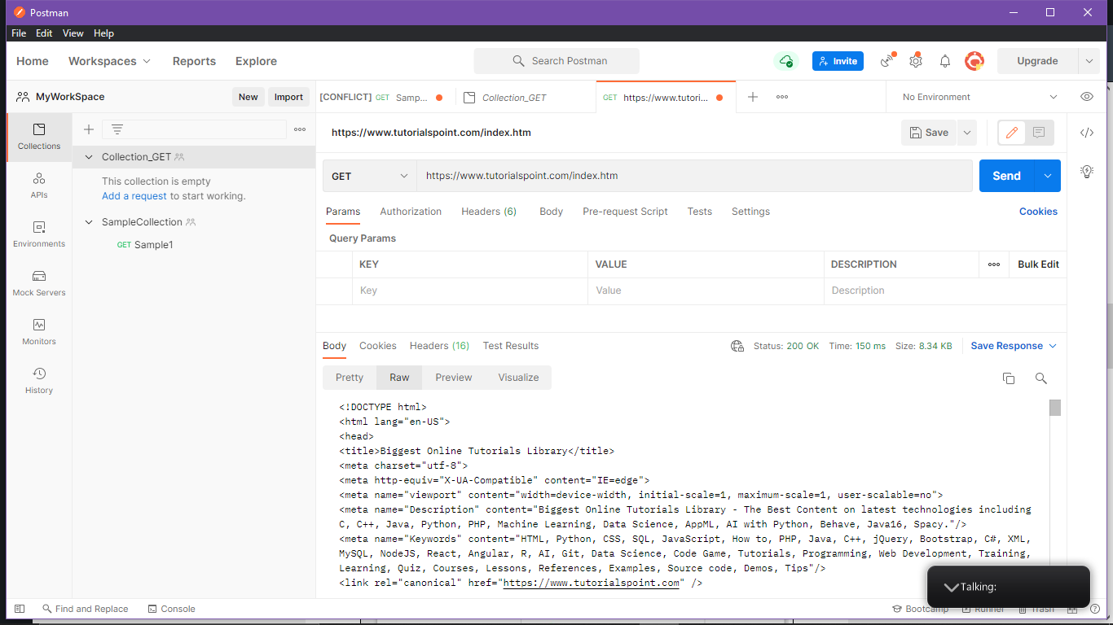

Body-> preview

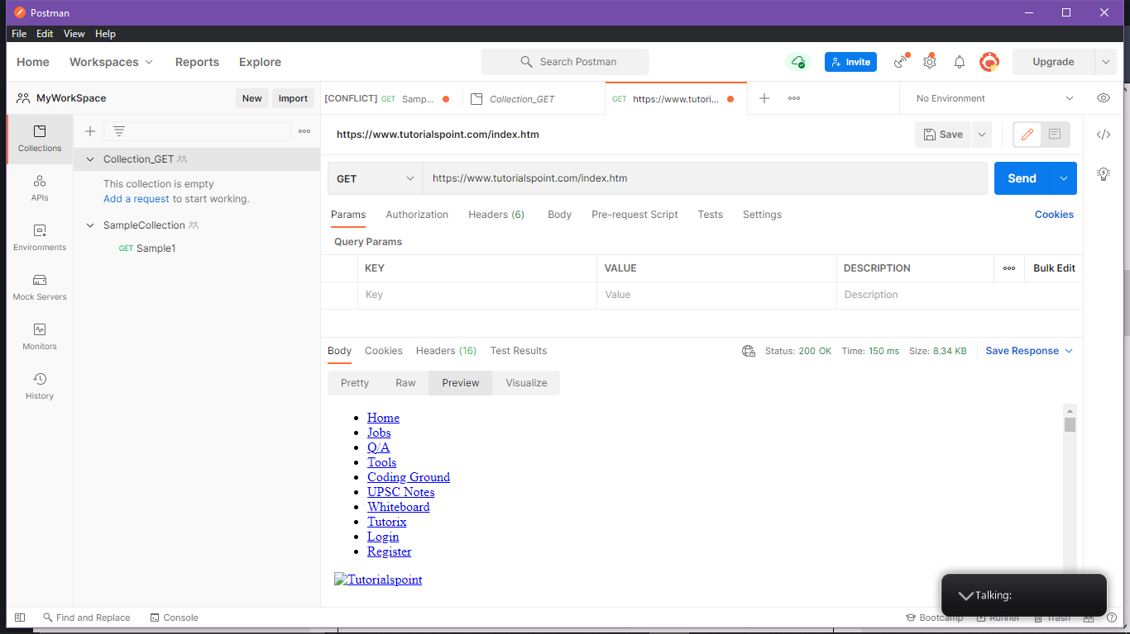

Headers

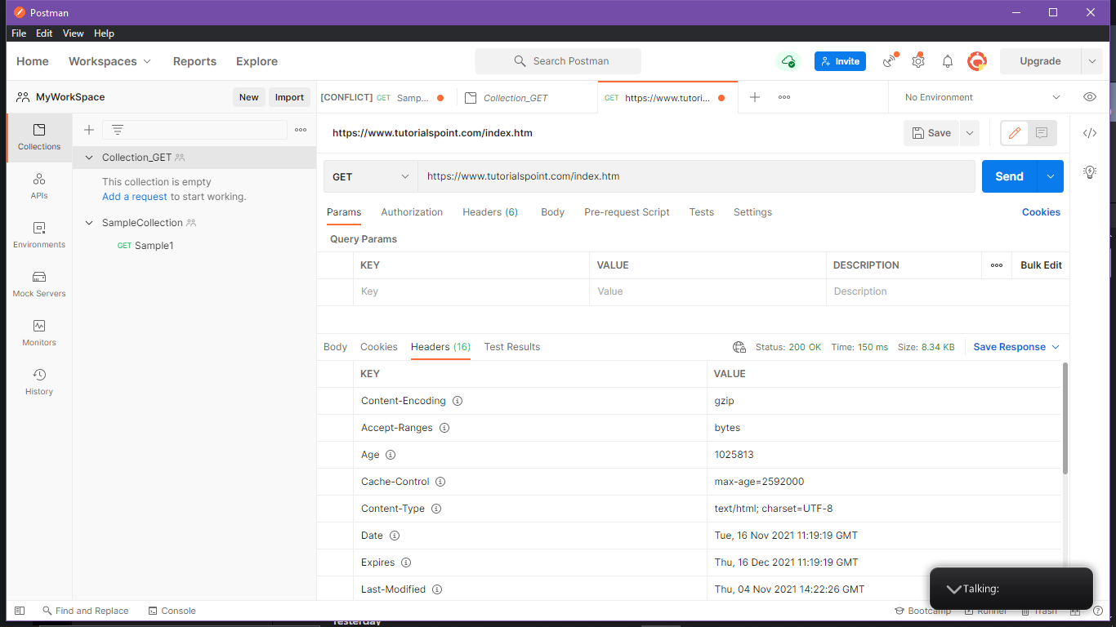

***POST Request in postman***

* Postman POST request allows appending data to the endpoint.
* This is a method used to add information within the request body in the server.
* It is commonly used for passing delicate information.

New->Request

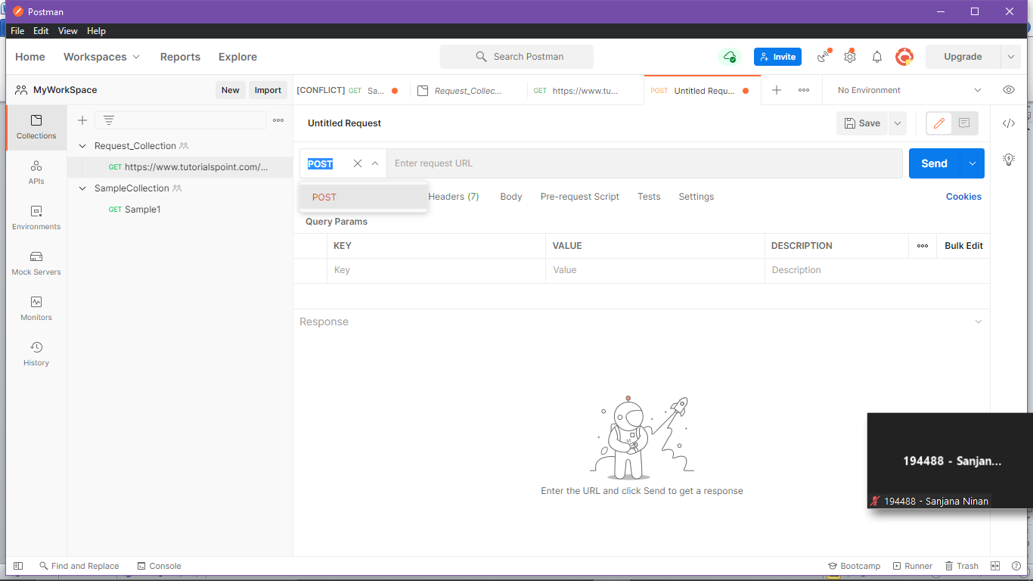

https://jsonplaceholder.typicode.com/users

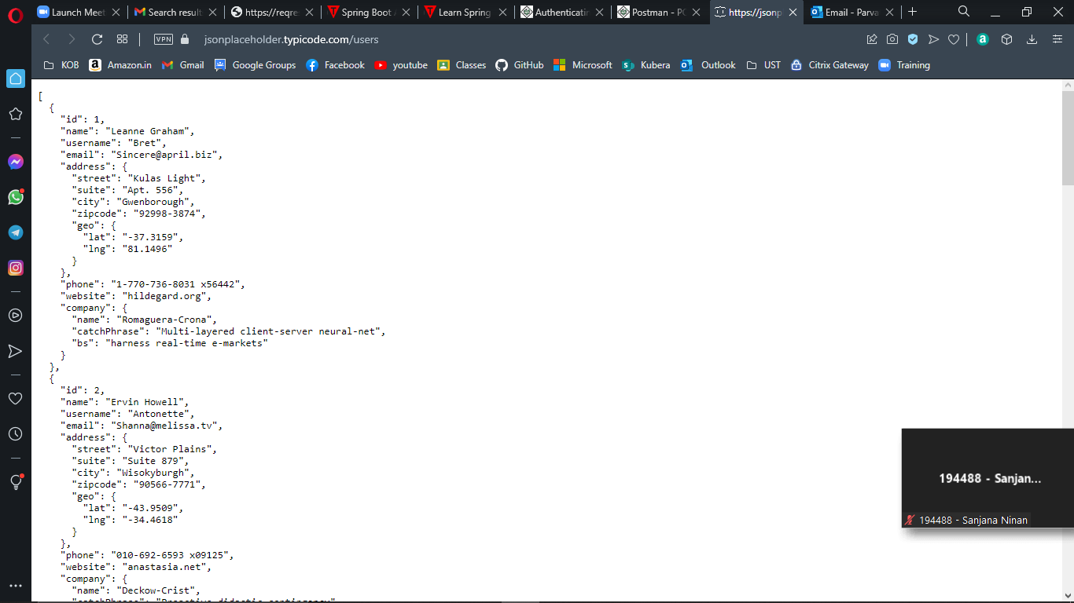

Paste the link in postman and Send

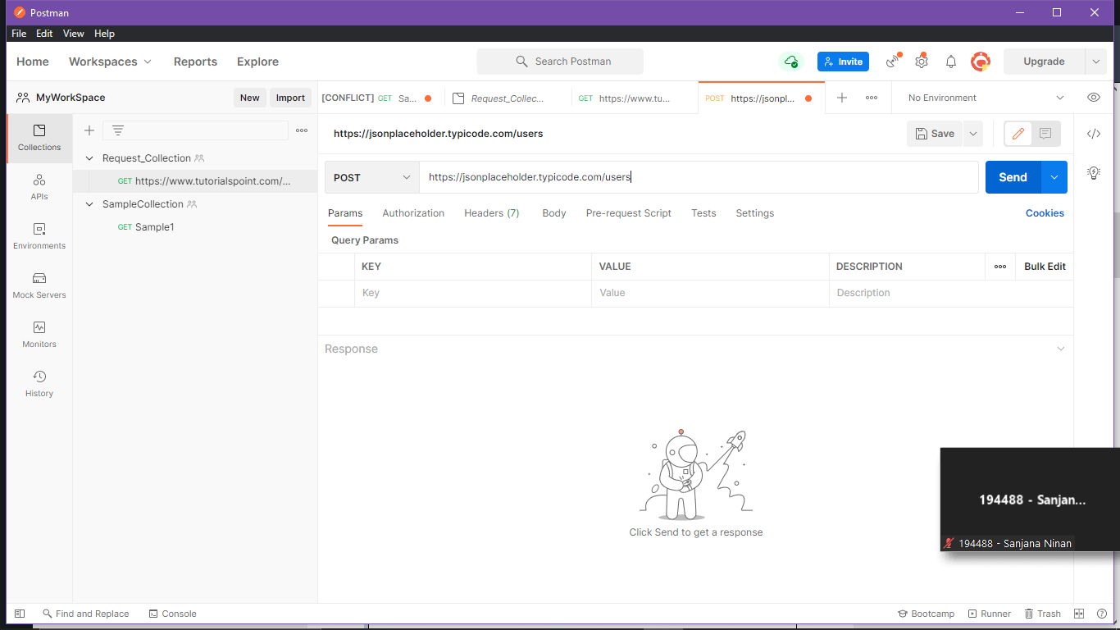

Above Body-> raw then make Text as JSON

Then paste the code there

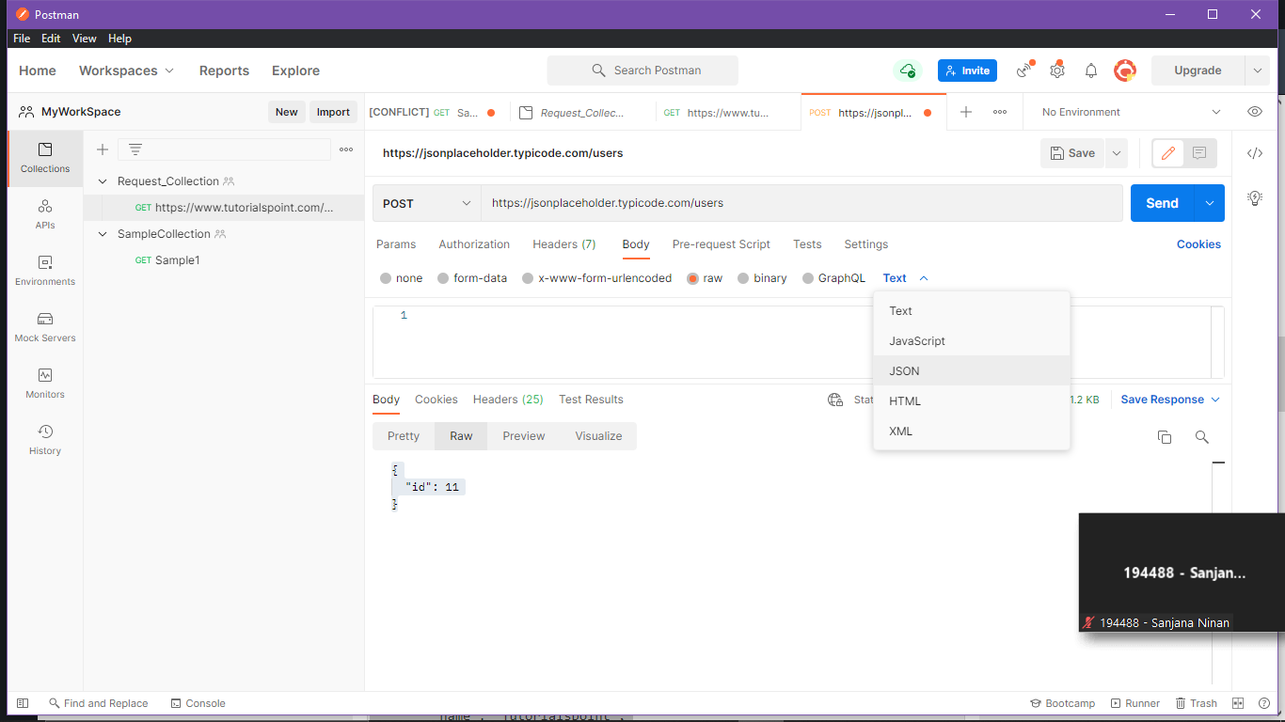

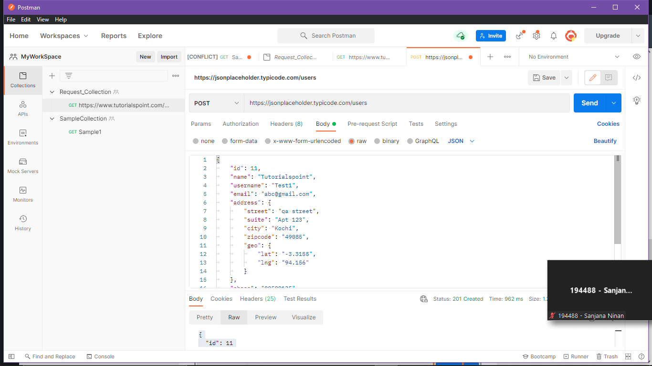

Hit Send button for the Responds

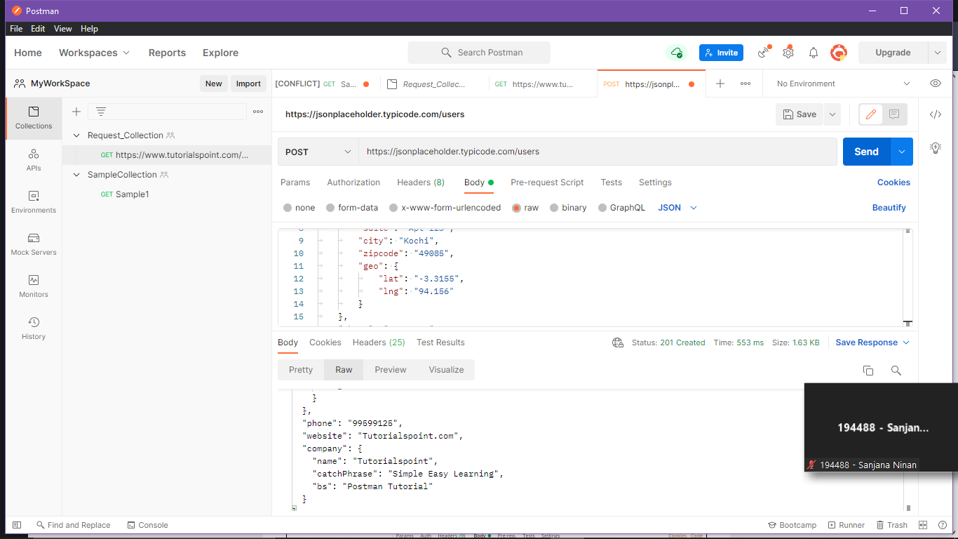

***PUT Request in postman***

* A Postman PUT request is used to pass data to the server for creation or modification of a resource.
* The difference between POST and PUT is that POST request is not idempotent.
* This means invoking the same PUT request numerous times will always yield the same output.
* But invoking the same POST request numerous times will create the similar resource more than one time.

Before creating a PUT request, we shall first send a GET request to the server on an endpoint − <http://dummy.restapiexample.com/api/v1/employees>

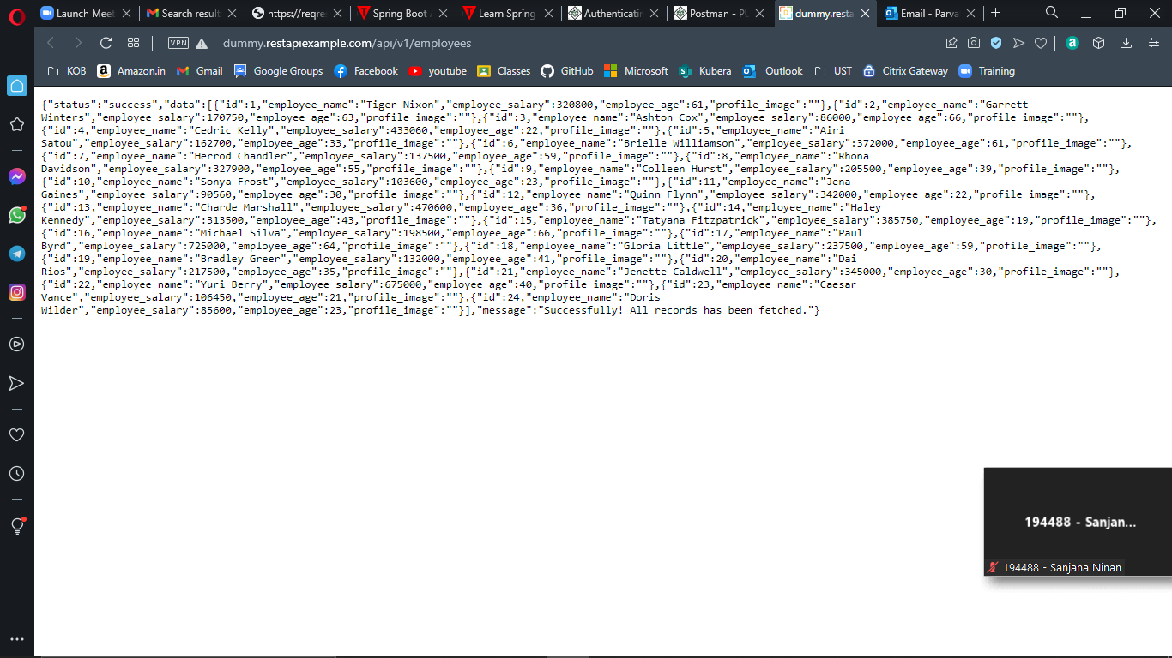

New-> HTTP Request -> GET <http://dummy.restapiexample.com/api/v1/employees>

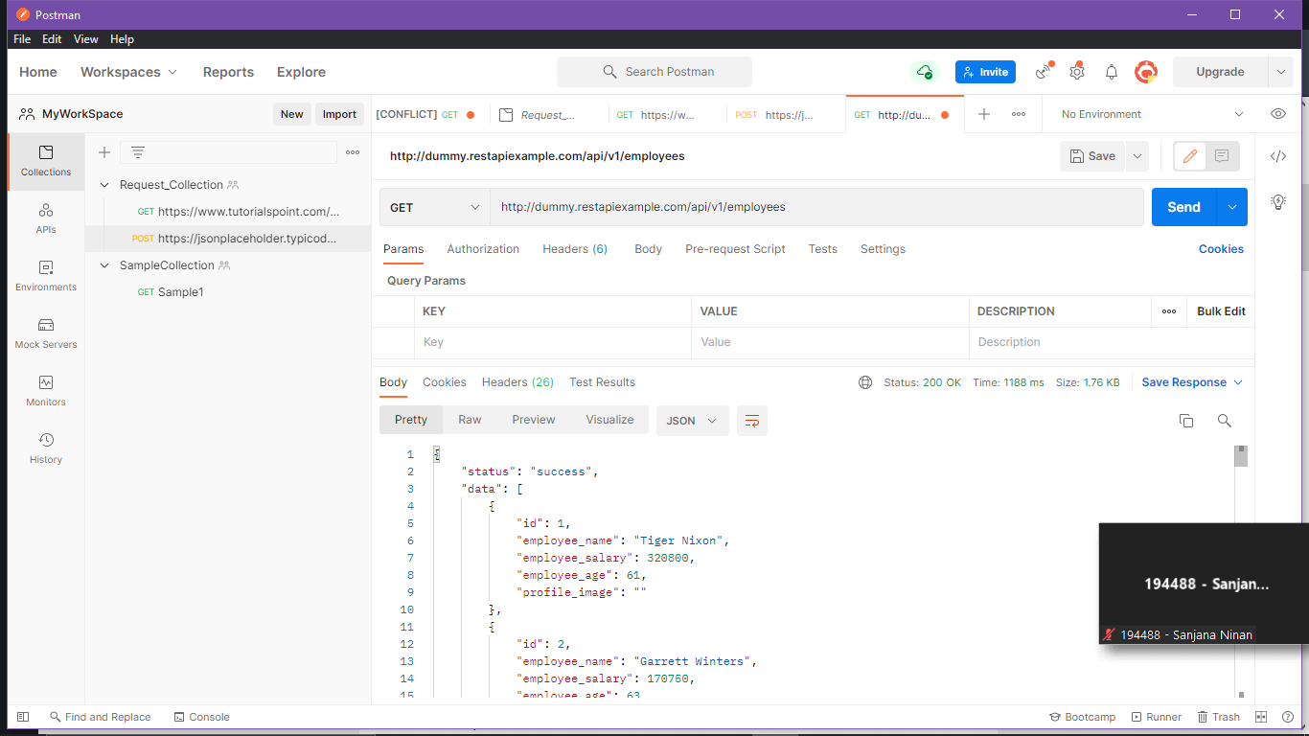

Now, let us update the **employee_salary** and **employee_age** for the id 21 with the help of the PUT request.

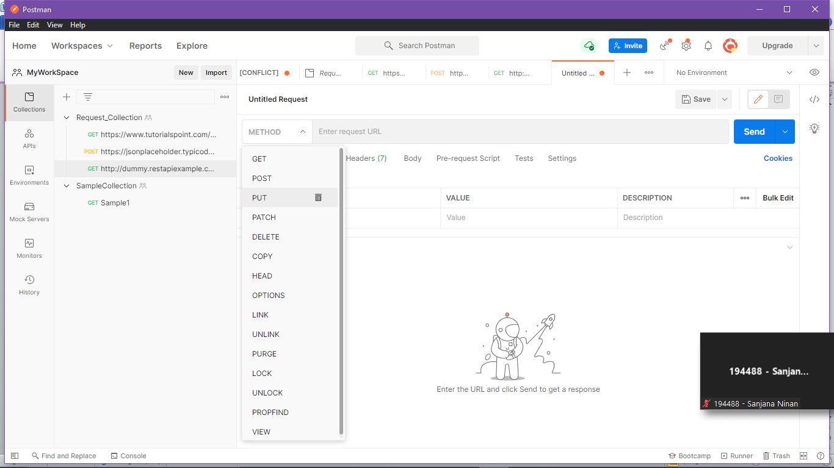

Above Body->raw and JSON

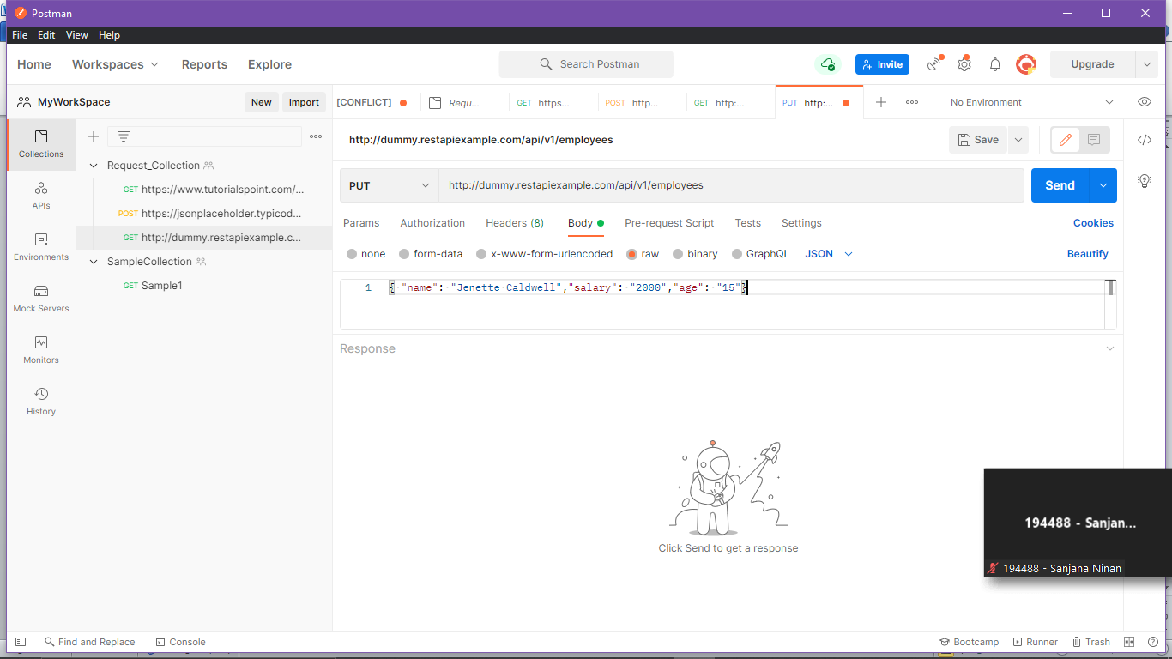

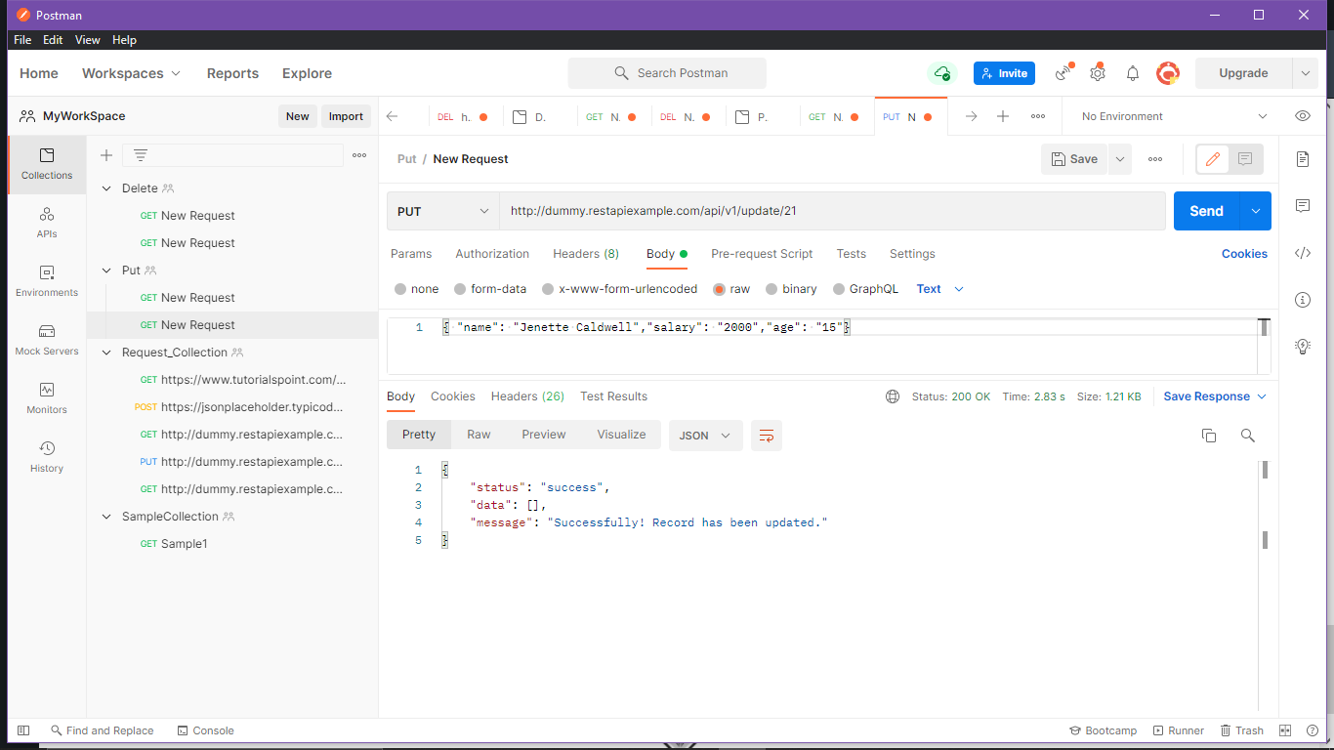

***DELETE Request in postman***

* Postman DELETE request deletes a resource already present in the server.
* The DELETE method sends a request to the server for deleting the request mentioned in the endpoint. Thus, it is capable of updating data on the server.

Before creating a DELETE request, we shall first send a GET request to the server on the endpoint: <http://dummy.restapiexample.com/api/v1/employees>

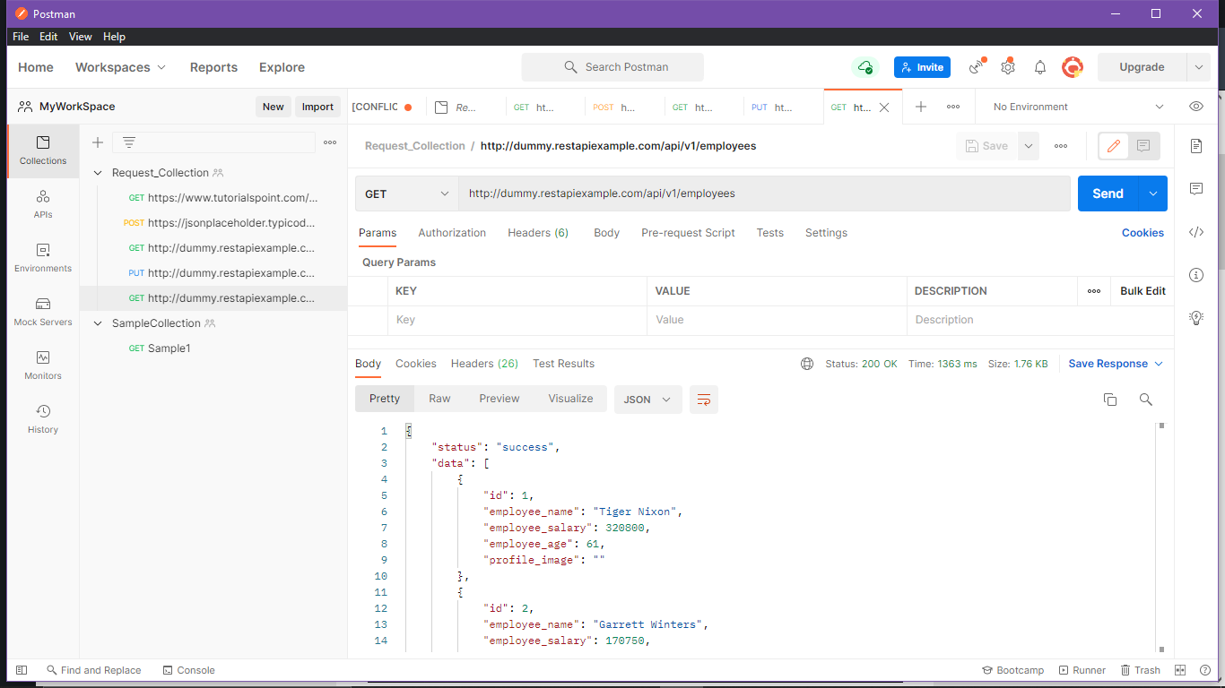

The Request name (Test1) gets reflected on the Request tab. We shall select the option **DELETE** from the HTTP request dropdown.

Then enter the URL - <http://dummy.restapiexample.com/api/v1/delete/2>(endpoint for deleting the record of id 2) in the address bar.

