**Pytest Using Pycharm**

**Install pycharm**

<https://www.jetbrains.com/pycharm/download/#section=windows>

**install pip and pytest**

*Go to pycharm File-> Settings-> Project:python Project-> python Interpreter*

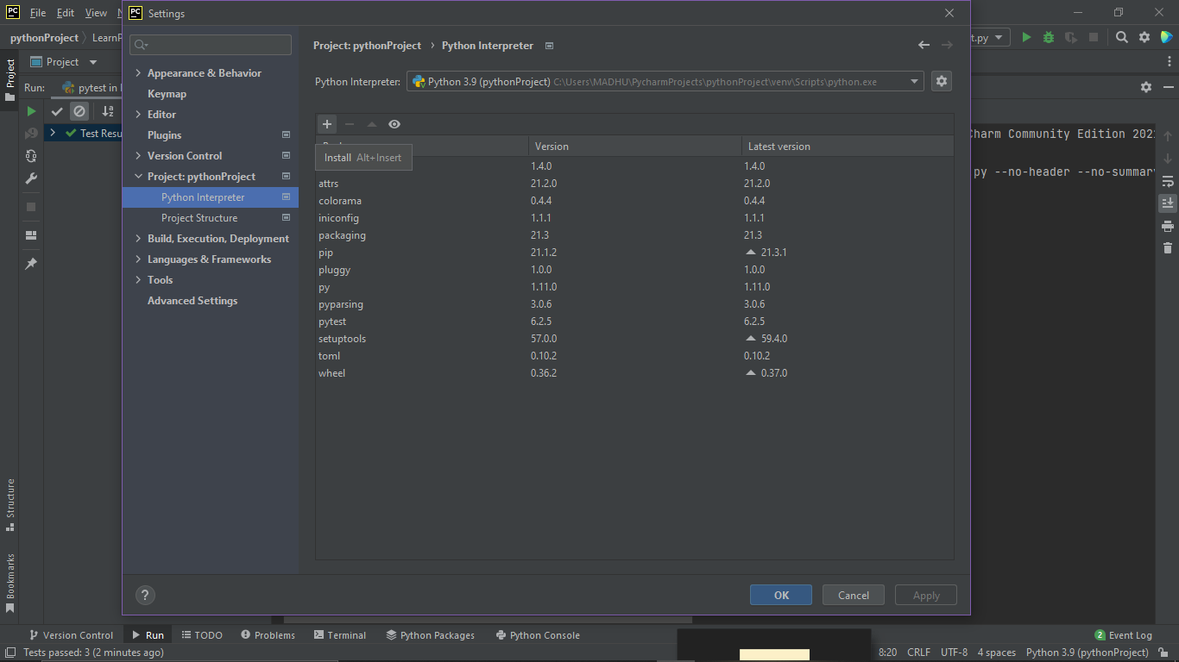

*Click on add button and add pip, pytest packages or you can download it though cmd: here I downloaded it*

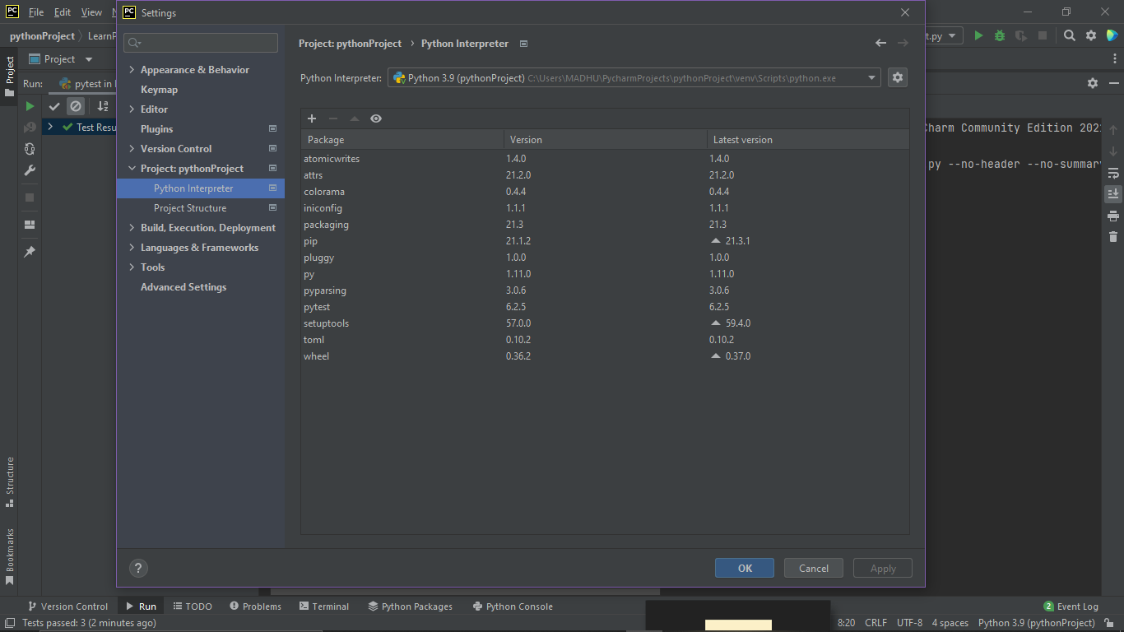

**First Program**

File-> new Project-> (named)LearnPytest

Right click on it and add python file named as login_test.py

*Note: the name should either start with* ***test_*** *or* ***_test***

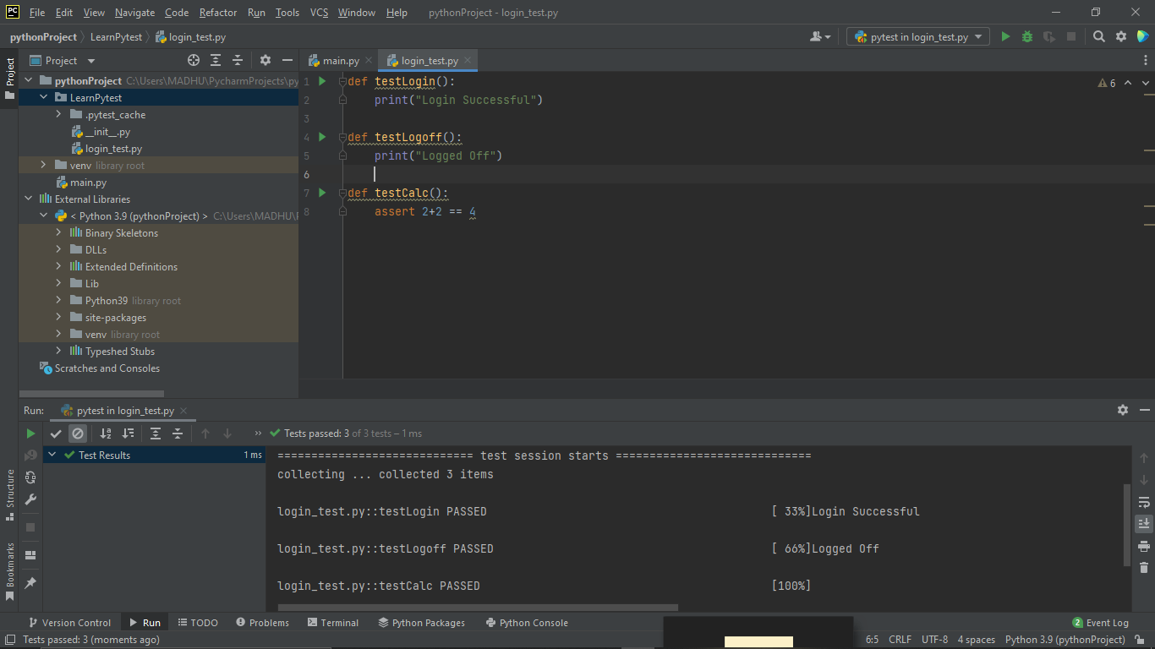

**Grouping Testcases using markers**

Create one more python file addItems_test

And add the previous example Login_test method Loggoff

import pytest  
  
def testLogin():  
 print("Login Successful")  
  
@pytest.mark.sanity // Added  
def testLogoff():  
 print("Logged Off")  
  
def testCalc():  
 assert 2+2 == 4

AddItems_test.py

import pytest  
  
@pytest.mark.sanity  
def testLogin():  
 print("Login Successful")  
  
def testLogoff():  
 print("Logged Off")  
  
def testCalc():  
 assert 2+2 == 4

Run in Cmd

>pytest -m sanity

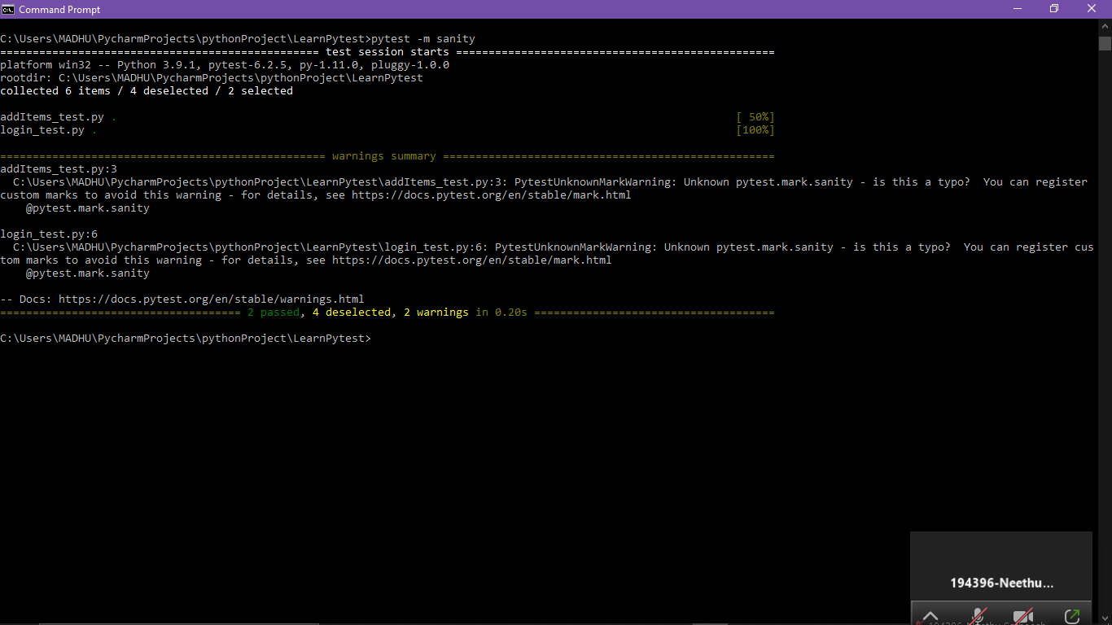

@pytest.mark.regression @pytest.mark.sanity -🡪 custom markers

@pytest.mark.xfail :

@pytest.mark.skip : skip the test cases

