**SELENIUM:**

* Selenium is an automated tool used for testing web applications.
* Selenium supports a variety of programming languages through the use of drivers specific to each language.Languages supported by Selenium include C#, Java, Perl, PHP, Python and Ruby.Currently, Selenium Web driver is most popular with Java and C#.
* Selenium test scripts can be coded in any of the supported programming languages and can be run directly in most modern web browsers.
* Browsers supported by Selenium include Internet Explorer, Mozilla Firefox, Google Chrome and Safari.

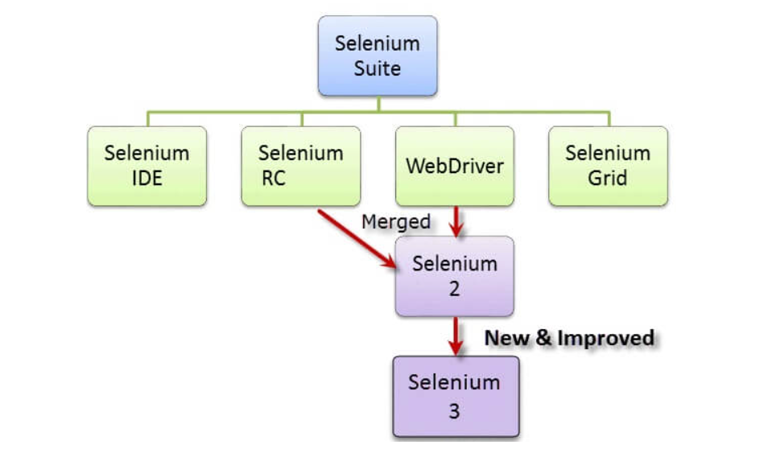

| **Tool** | **Why Choose?** |
| --- | --- |
| **Selenium IDE** | To learn about concepts on automated testing and Selenium, including:  Selenese commands such as type, open, clickAndWait, assert, verify, etc.  Locators such as id, name, xpath, css selector, etc.  Executing customized JavaScript code using runScript  Exporting test cases in various formats.  To create tests with little or no prior knowledge in programming.  To create simple test cases and test suites that you can export later to RC or WebDriver.  To test a web application against Firefox and Chrome only. |
| **Selenium RC** | To design a test using a more expressive language than Selenese  To run your test against different browsers (except HtmlUnit) on different operating systems.  To deploy your tests across multiple environments using Selenium Grid.  To test your application against a new browser that supports JavaScript.  To test web applications with complex AJAX-based scenarios. |
| **WebDriver** | To use a certain programming language in designing your test case.  To test applications that are rich in AJAX-based functionalities.  To execute tests on the HtmlUnit browser.  To create customized test results. |
| **Selenium Grid** | To run your Selenium RC scripts in multiple browsers and operating systems simultaneously.  To run a huge test suite, that needs to complete in the soonest time possible. |

* The WebDriver proves itself to be **better than both Selenium IDE and Selenium RC** in many aspects. I
* t implements a more modern and stable approach in automating the browser’s actions. WebDriver, unlike Selenium RC, does not rely on JavaScript for Selenium Automation Testing.
* **It controls the browser by directly communicating with it.**

**What is Selenium Webdriver?**

* **Selenium Webdriver is an open-source collection of APIs which is used for testing web applications.**
* **The Selenium Webdriver tool is used for automating web application testing to verify that it works as expected or not.**
* **It mainly supports browsers like Firefox, Chrome, Safari and Internet Explorer. It also permits you to execute cross-browser testing.**
* **WebDriver also enables you to use a programming language in creating your test scripts (not possible in Selenium IDE).**
* **You can now use conditional operations like if-then-else or switch-case. You can also perform looping like do-while.**

***To work with Selenium web driver the below are needed:***

* *Eclipse*
* *Java*
* *Selenium Web driver APIs*

[Downloads | Selenium](https://www.selenium.dev/downloads/)

To import all the jar files onto the project build path.

Sample 1

**import** org.openqa.selenium.By;

**import** org.openqa.selenium.WebDriver;

**import** org.openqa.selenium.chrome.ChromeDriver;

**public** **class** Sample1 {

**public** **static** **void** main(String[] args) {

// **TODO** Auto-generated method stub

System.*setProperty*("webdriver.chrome.driver", "G:\\UST\\WebDriver\\chromedriver.exe");

WebDriver d=**new** ChromeDriver();

d.navigate().to("http://www.google.com/");

d.findElement(By.*name*("csi").*tagName*("csi"));

String s= d.getTitle();

System.***out***.println(s);

s.equals("Google");

}

}

**What are Locators?**

* Locator is a command that tells Selenium IDE which GUI elements ( say Text Box, Buttons, Check Boxes etc) its needs to operate on.

|  |  |  |
| --- | --- | --- |
| Method | Syntax | Description |
| By ID | driver.findElement(By.id (<element ID>)) | Locates an element using the ID attribute |
| By name | driver.findElement(By.name (<element name>)) | Locates an element using the Name attribute |
| By class name | driver.findElement(By.className (<element class>)) | Locates an element using the Class attribute |
| By tag name | driver.findElement(By.tagName (<htmltagname>)) | Locates an element using the HTML tag |
| By link text | driver.findElement(By.linkText (<linktext>)) | Locates a link using link text |
| By partial link text | driver.findElement(By.partialLinkText (<linktext>)) | Locates a link using the link's partial text |
| By CSS | driver.findElement(By.cssSelector (<css selector>)) | Locates an element using the CSS selector |
| By XPath | driver.findElement(By.xpath (<xpath>)) | Locates an element using XPath query |

**Selenium IDE installation:**

Selenium IDE is available only as Firefox and Chrome plug-in, we assume that you have already installed Mozilla Firefox browser in your system.

<https://addons.mozilla.org/en-us/firefox/addon/selenium-ide/I>