**IS 665 Data Analysis for Information Systems**

**Stats Lab II. Using Excel To Build Pivot Table**

**Business Case:** Robert Jones is a manager of several sales organizations at Global Bike Inc. and his responsibilities are monitoring and managing sales activities. He has a number of OLTP systems to assist with the recording of day-to-day transactions. At the end of each month, he is provided with a report which displays each sale. The format of the report is illustrated below. Although this report provides a lot of information, the information is not in a format that can easily assist in the type of decisions you are required to make. Robert has decided to examine the PivotTables as means of producing more useful reports.

**TASKS**

1. **Download the file SalesdataPivotV01.xlsx from Moodle (under the “lab” module)**
2. **Open it in Excel**
3. **Create Pivot Table**

Start with a high level overview and create a pivot table, which shows the revenue in Germany and the US throughout the years.

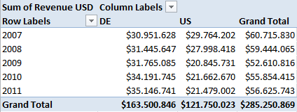

1. **Rotate**

Rotate the view by swapping the axis

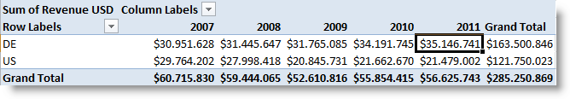

You can observe a different behavior of two countries: whereas Germany shows a continuous increase in revenue, there is a sharp decline in the US in 2009. Try now to identify reasons for this behavior in the data! Do this by slicing the data

1. **Slice**

We analyze the data from Germany first and, therefore, do a slice on country. Switch the Key figure to **Revenue** in local currency.

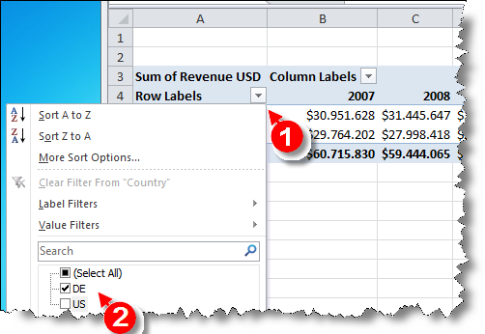

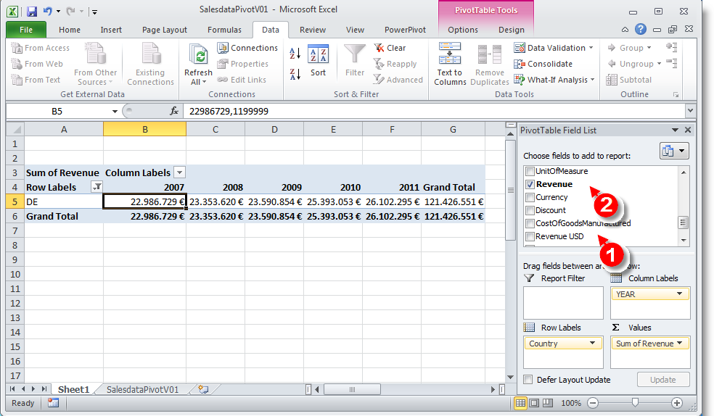

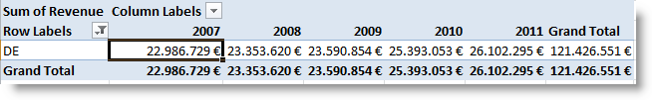

### Drill down to Sales Organization and Customer

Drill down to the sales organization. There is no dependency visible: both sales organizations behave similarly.

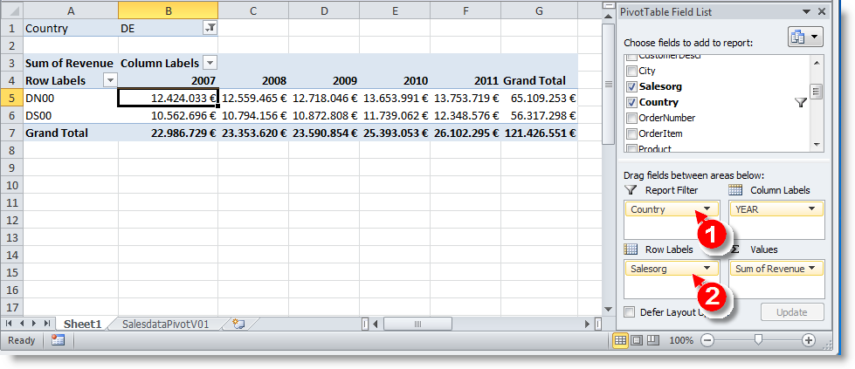

From sales organization, drill down to customer. Everything looks fine!

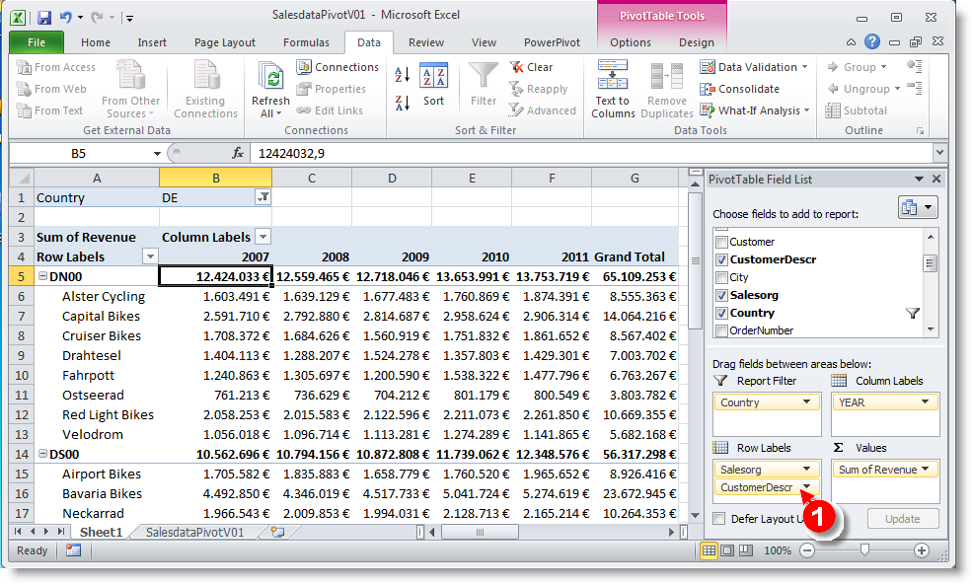

### Rotation

Check the dependency on the product category and product by rotating the cube.

**Make sure that “classic Pivot Table layout” is NOT selected**

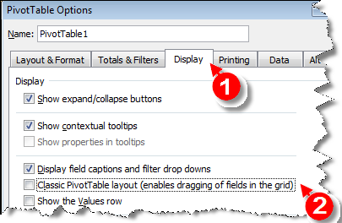

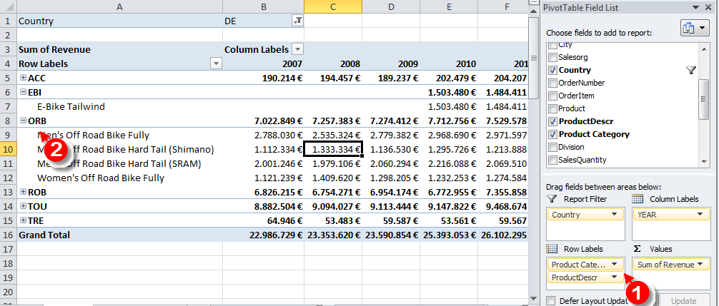

We observe the introduction of a new product in 2010: the new **E-bike Tailwind**. Now analyze the new market in more details!

### Show percentage values

Compare the new E-bike with other bikes. Filter the last two years an all bikes (filter on **Division**!). Instead of showing the revenue in absolute numbers, show values as **% of Column Total**. Sort the data by revenue. We recognize that the new product already contributes more than 5% to the total revenue!

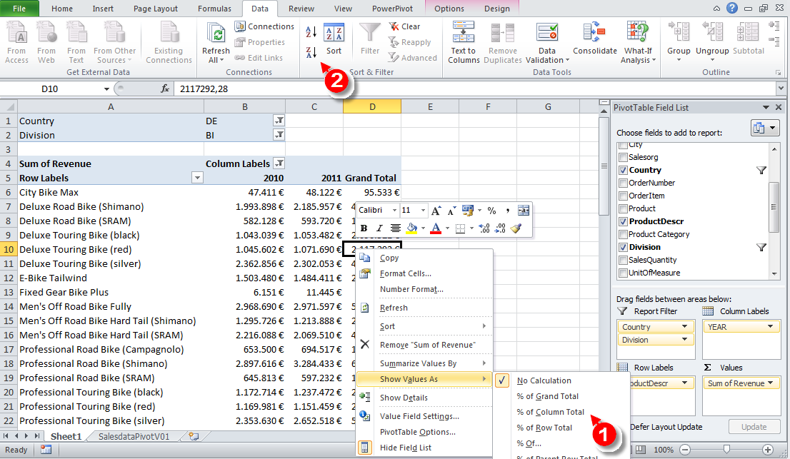

### Drill-through

To finish the analysis of Germany, find out when the new E-bike was sold for the first time. For this have a look at all order items sorted by date.

**Double-click** on the E-Bike 2010 value. A new worksheet is created. On the **Data** tab (1) call **Sort** (2) and use **Add Level** (3) to sort by **MONTH**and **DAY**.

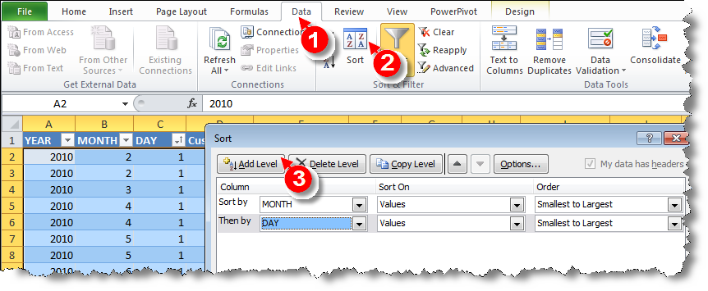

### Analyzing the US Data

In the following, we analyze the situation in the US. Remember that we observed a **sharp revenue decline between 2008 and 2009** and we want to find out reasons for this. Therefore change country to US and remove all other filters. Since revenue is in local currency, change the format to $. In order to obtain Customer and City in two separate columns you have to switch to the **Classic PivotTable layout** (cf.**PivotTable Options**). We observe that a very important customer is lost between 2010 and 2011.

1. **Visualize the data**

We want to explore this in more detail and use a chart to visualize the data.

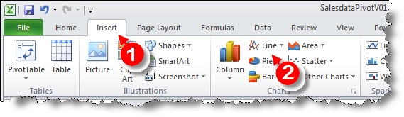

Filter Silicon Valley Bikes and Beantown Bikes Boston (WHY THESE TWO?) and the years 2009 to 2011 (dice operator). Drill down to calendar month and insert another line chart.

We observe that revenue of **Silicon Valley Bikes** is zero from August 2010 on. We have to ask the responsible sales person what was going on here.

1. **Conditional Formatting**

 In order to detect other effects we remove the filter on the calendar year, **exclude**this customer from the subsequent steps.

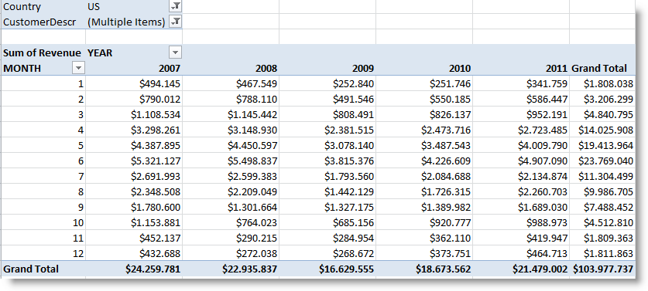

Change presentation of numbers by right-clicking on a data cell and selecting Show values as % Difference from

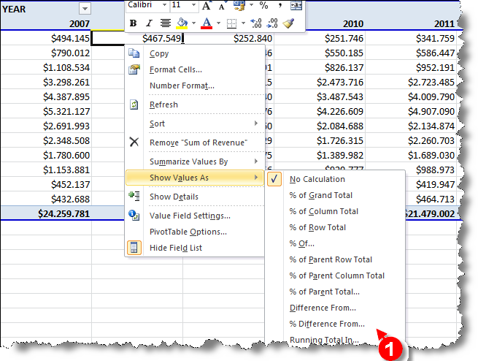

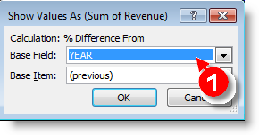

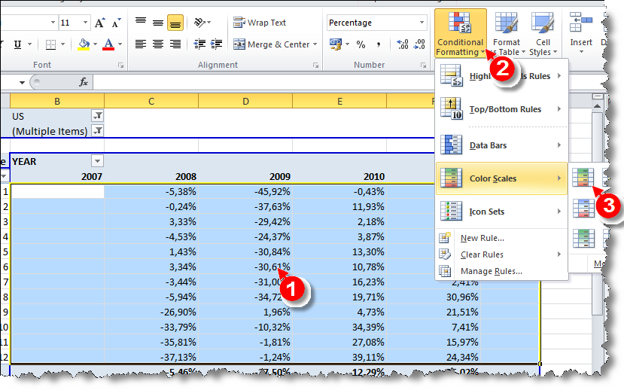

This shows a decline in September 2008 (Lehman crisis) which is partially recovered in the following years.

**CONCLUSION?**