**Technical Assignment 2: Pivot Table**

### Flops

Worldwide, what product sold the **least number of units**?

**FXGR1000 - Fixed Gear Bike Plus** has only sold 71 units worldwide over years 2007 to 2011.

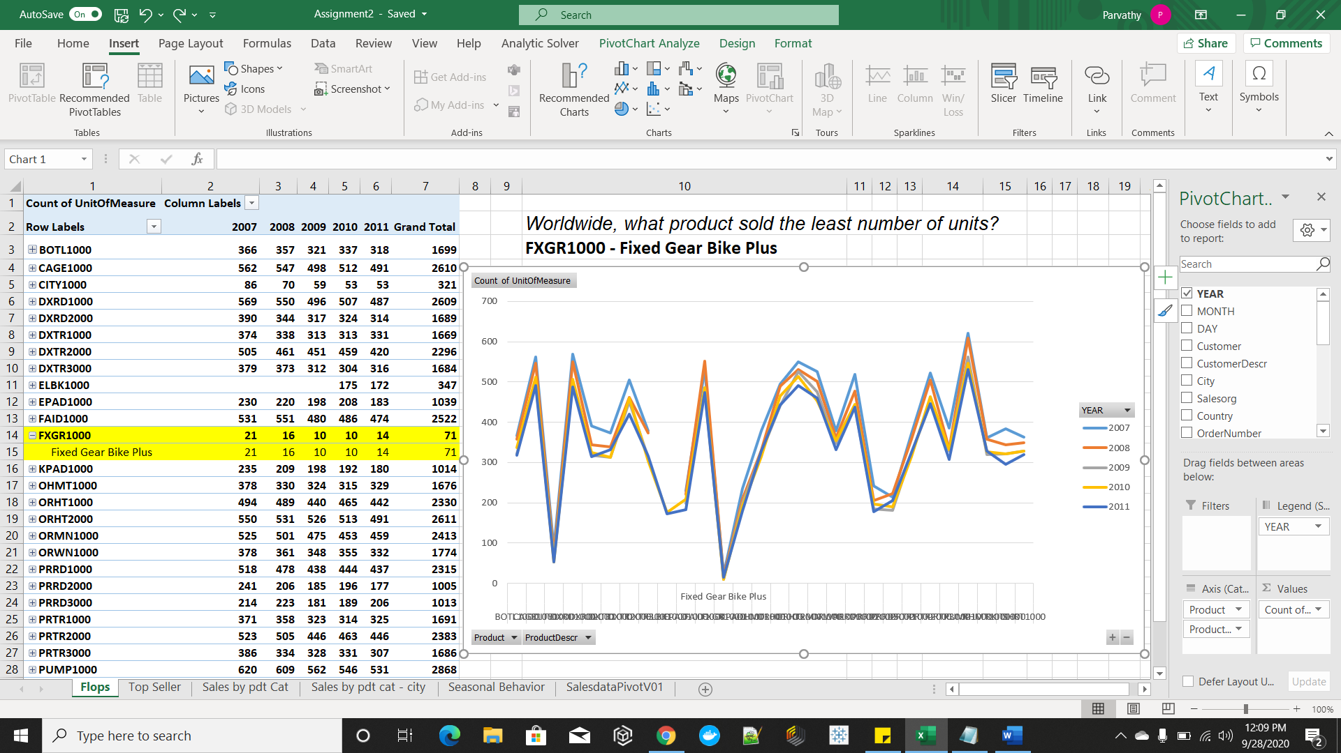

### Top Seller

In U.S., what product category provided the most **revenue** in 2011?

**TOU** is the product category that provided the most revenue in the year 2011.

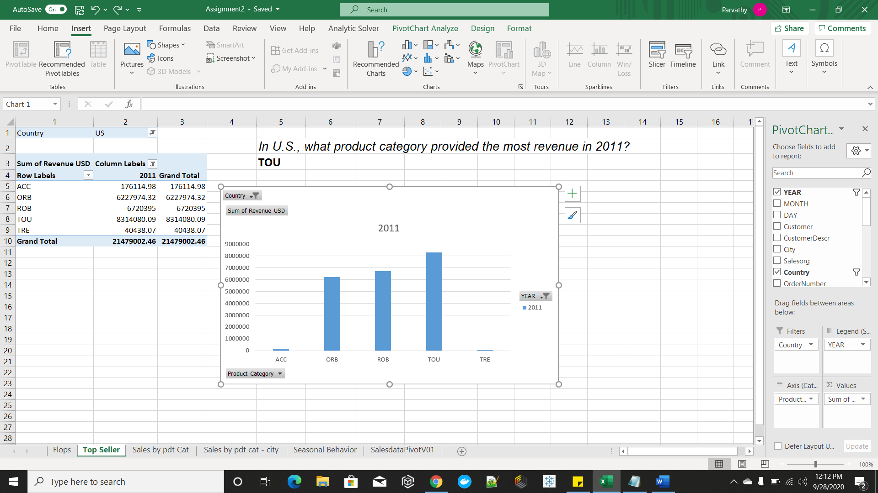

### Sales by Product Category

Worldwide, what percentage did the off-road bikes contribute to the overall bicycle sales **quantity**?

**37.95%** of overall bicycle sales quantity amounts to off-road bikes (ORB) sales quantity.

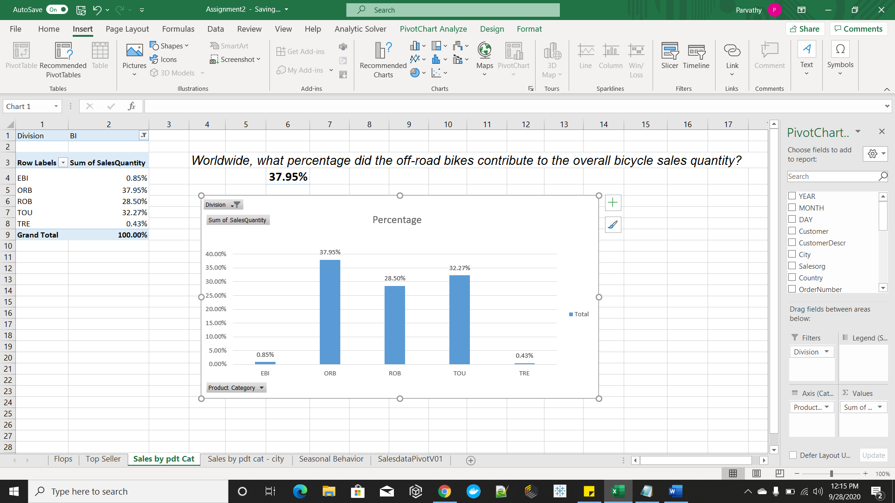

In which **three cities** were this percentage significantly above the average?

**München, Hamburg and Boston.** All cities contribute to 37.95% of ORB. There are 23 cities. Average = 1.65% (37.95/23)

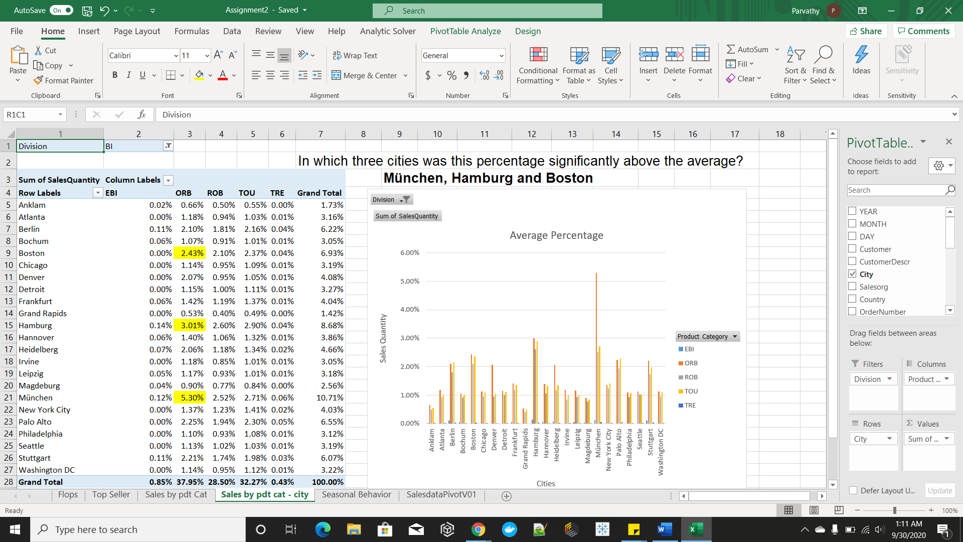

München – 5.30%, Hamburg – 3.01% and Boston 2.43% are the three cities contributing significantly above average of 1.65%.

### Seasonal Behavior

Bicycles and accessories are more likely to be bought in spring and summer as in fall and wintertime. Find **which product is an exception to this rule**. You can use the worldwide data or the U.S. data, the trend is the same.

**First Aid Kit** sales is consistent over all months irrespective of the season. All other product sales vary with season**.**

