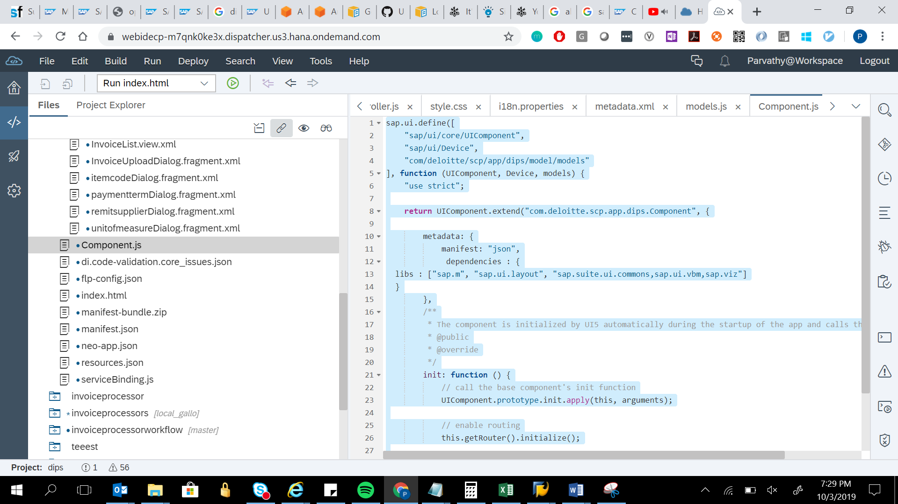

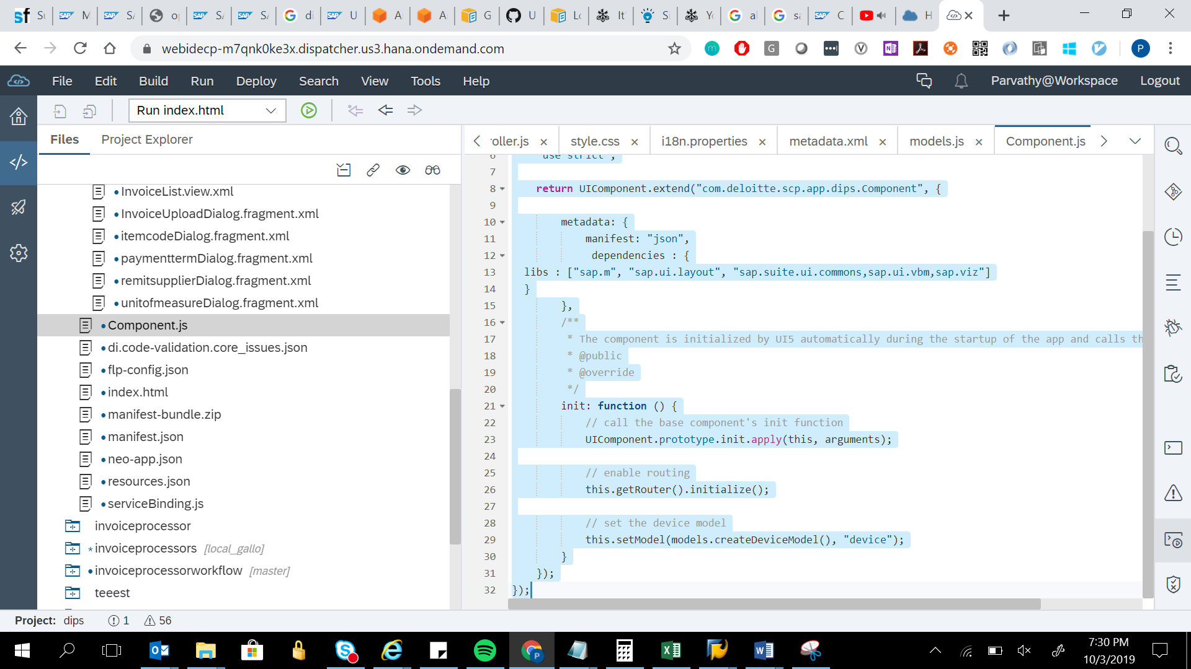

sap.ui.define([

"sap/ui/core/UIComponent",

"sap/ui/Device",

"com/deloitte/scp/app/dips/model/models"

], function (UIComponent, Device, models) {

"use strict";

return UIComponent.extend("com.deloitte.scp.app.dips.Component", {

metadata: {

manifest: "json",

dependencies : {

libs : ["sap.m", "sap.ui.layout", "sap.suite.ui.commons,sap.ui.vbm,sap.viz"]

}

},

/\*\*

\* The component is initialized by UI5 automatically during the startup of the app and calls the init method once.

\* @public

\* @override

\*/

init: function () {

// call the base component's init function

UIComponent.prototype.init.apply(this, arguments);

// enable routing

this.getRouter().initialize();

// set the device model

this.setModel(models.createDeviceModel(), "device");

}

});

});