

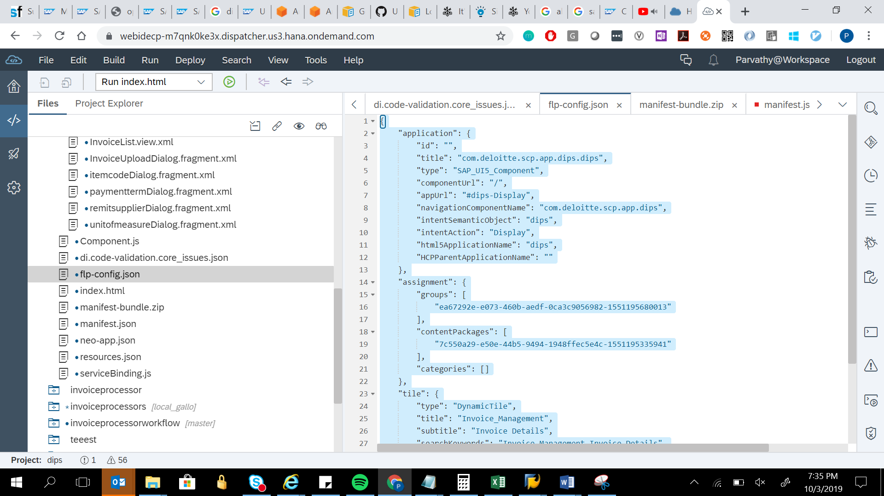

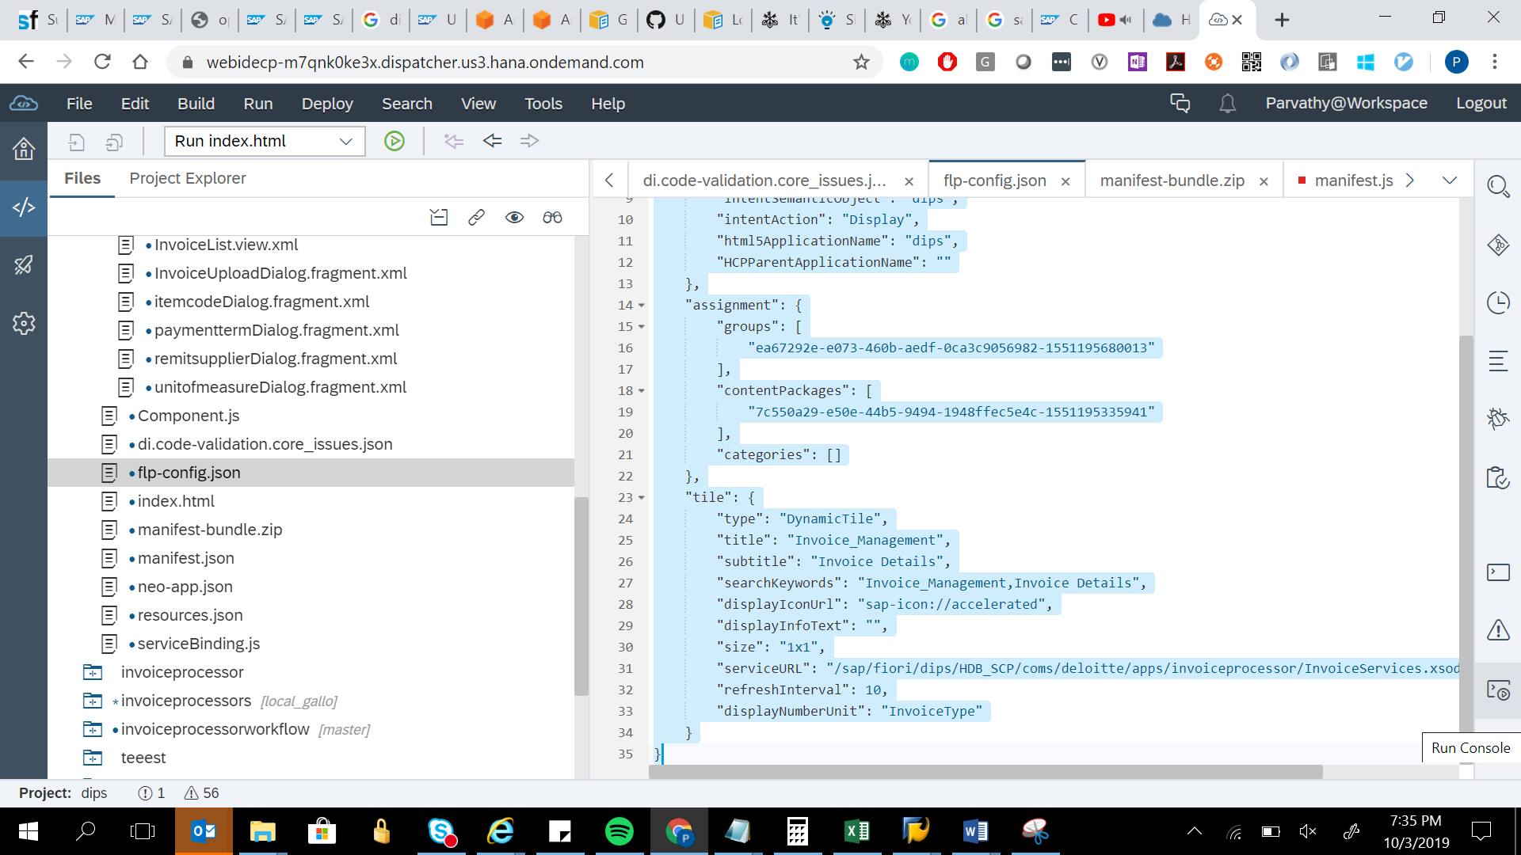

{

"application": {

"id": "",

"title": "com.deloitte.scp.app.dips.dips",

"type": "SAP_UI5_Component",

"componentUrl": "/",

"appUrl": "#dips-Display",

"navigationComponentName": "com.deloitte.scp.app.dips",

"intentSemanticObject": "dips",

"intentAction": "Display",

"html5ApplicationName": "dips",

"HCPParentApplicationName": ""

},

"assignment": {

"groups": [

"ea67292e-e073-460b-aedf-0ca3c9056982-1551195680013"

],

"contentPackages": [

"7c550a29-e50e-44b5-9494-1948ffec5e4c-1551195335941"

],

"categories": []

},

"tile": {

"type": "DynamicTile",

"title": "Invoice_Management",

"subtitle": "Invoice Details",

"searchKeywords": "Invoice_Management,Invoice Details",

"displayIconUrl": "sap-icon://accelerated",

"displayInfoText": "",

"size": "1x1",

"serviceURL": "/sap/fiori/dips/HDB_SCP/coms/deloitte/apps/invoiceprocessor/InvoiceServices.xsodata/Invoice/$count",

"refreshInterval": 10,

"displayNumberUnit": "InvoiceType"

}

}