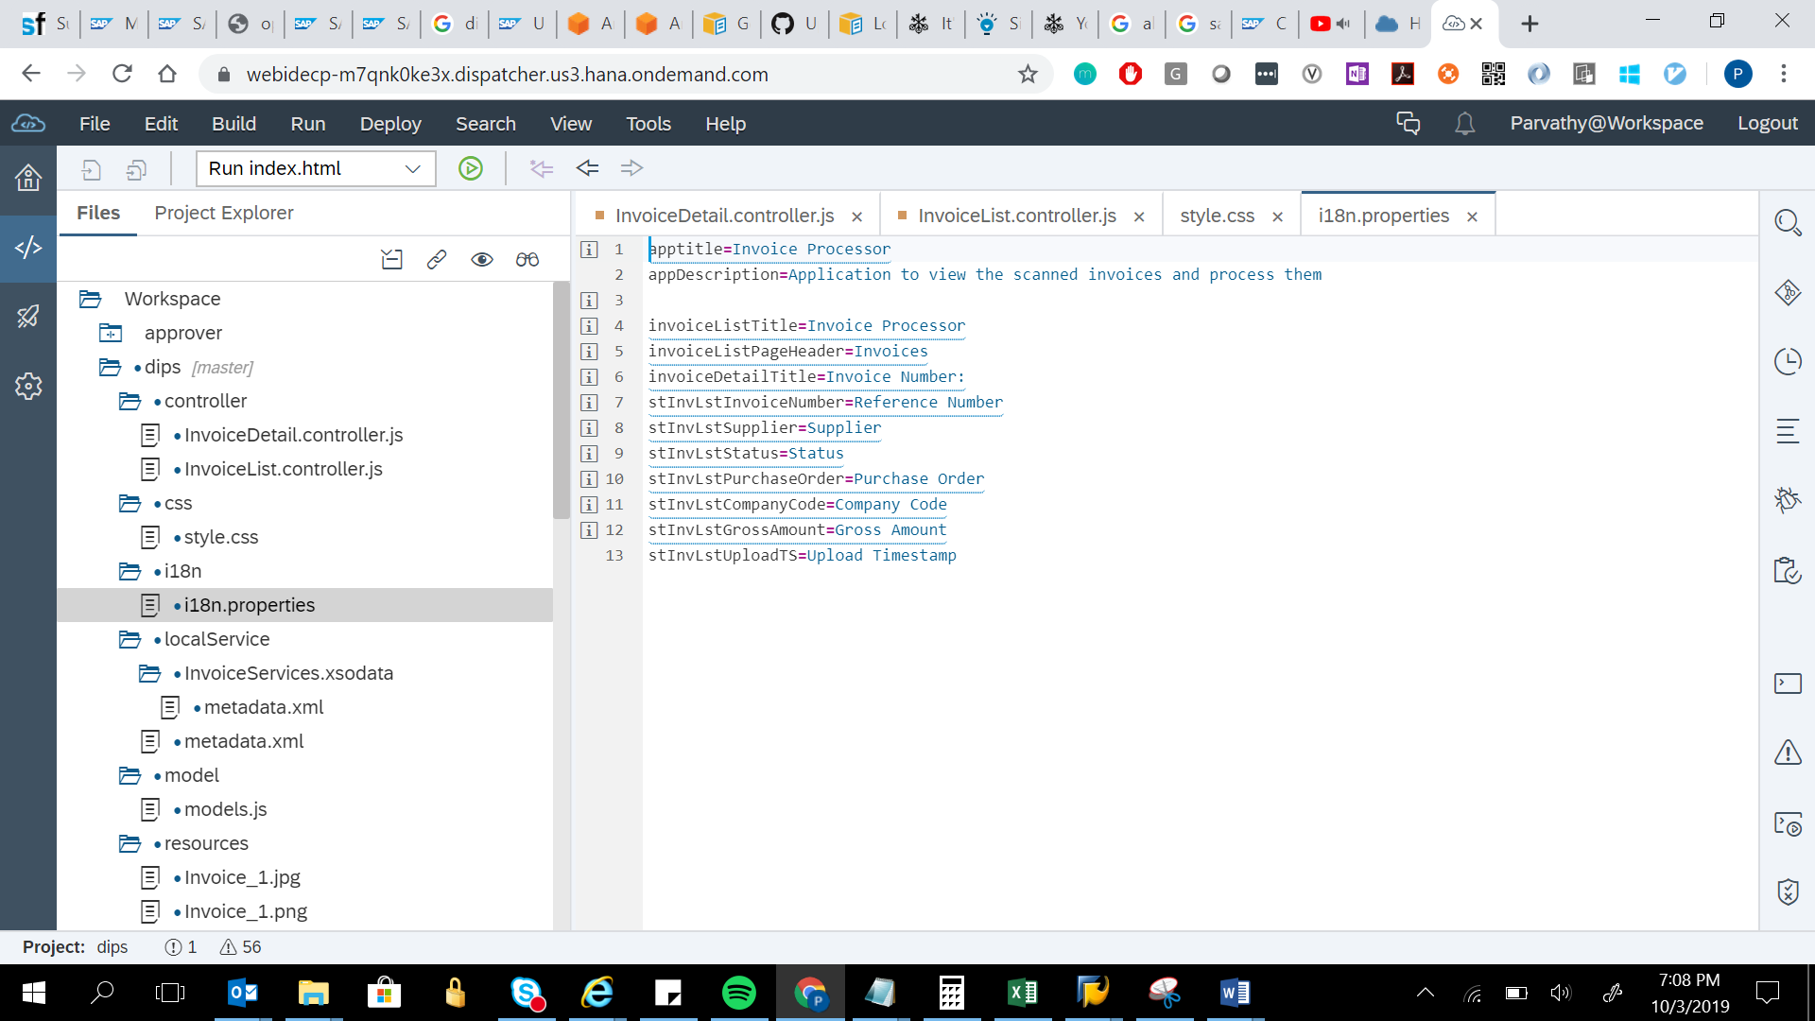

apptitle=Invoice Processor

appDescription=Application to view the scanned invoices and process them

invoiceListTitle=Invoice Processor

invoiceListPageHeader=Invoices

invoiceDetailTitle=Invoice Number:

stInvLstInvoiceNumber=Reference Number

stInvLstSupplier=Supplier

stInvLstStatus=Status

stInvLstPurchaseOrder=Purchase Order

stInvLstCompanyCode=Company Code

stInvLstGrossAmount=Gross Amount

stInvLstUploadTS=Upload Timestamp