

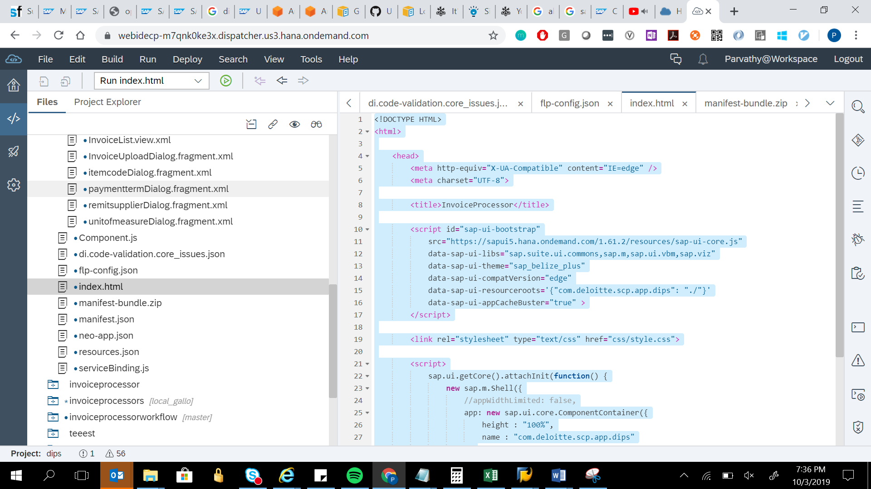

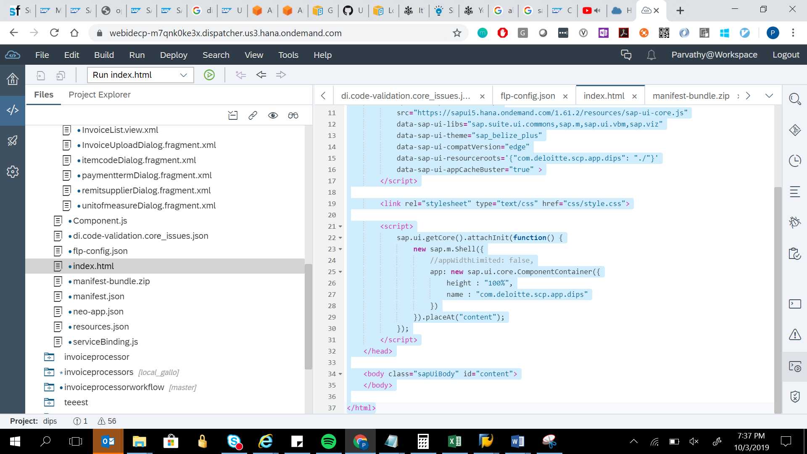

<!DOCTYPE HTML>

<html>

<head>

<meta http-equiv="X-UA-Compatible" content="IE=edge" />

<meta charset="UTF-8">

<title>InvoiceProcessor</title>

<script id="sap-ui-bootstrap"

src="https://sapui5.hana.ondemand.com/1.61.2/resources/sap-ui-core.js"

data-sap-ui-libs="sap.suite.ui.commons,sap.m,sap.ui.vbm,sap.viz"

data-sap-ui-theme="sap_belize_plus"

data-sap-ui-compatVersion="edge"

data-sap-ui-resourceroots='{"com.deloitte.scp.app.dips": "./"}'

data-sap-ui-appCacheBuster="true" >

</script>

<link rel="stylesheet" type="text/css" href="css/style.css">

<script>

sap.ui.getCore().attachInit(function() {

new sap.m.Shell({

//appWidthLimited: false,

app: new sap.ui.core.ComponentContainer({

height : "100%",

name : "com.deloitte.scp.app.dips"

})

}).placeAt("content");

});

</script>

</head>

<body class="sapUiBody" id="content">

</body>

</html>