

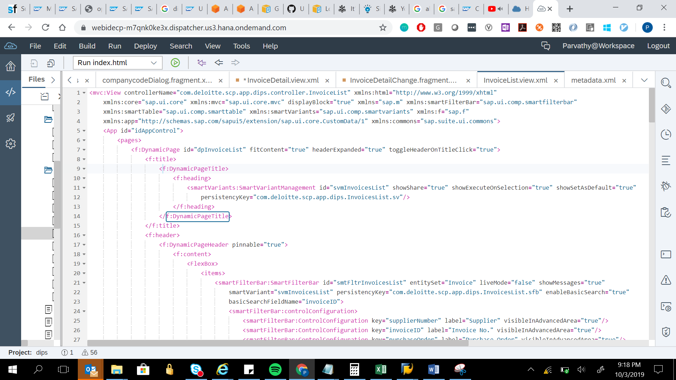

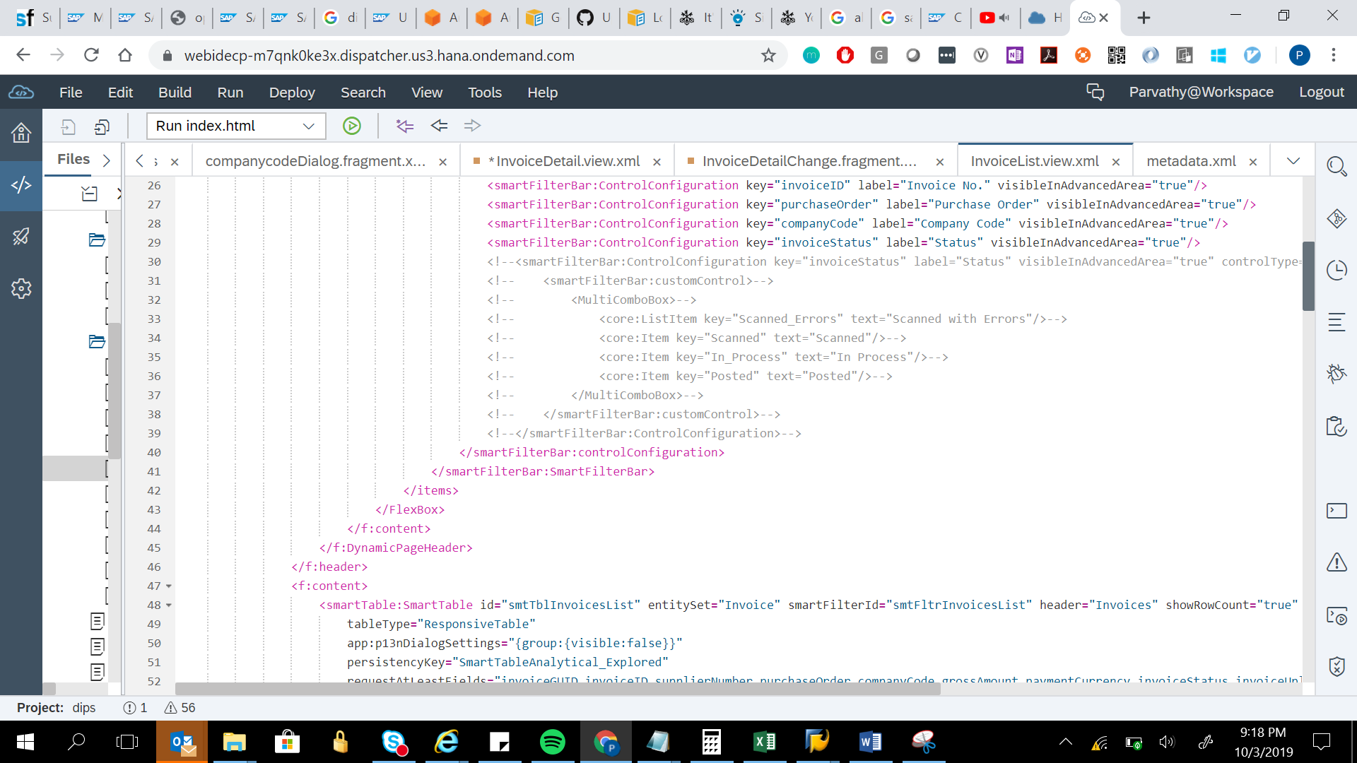

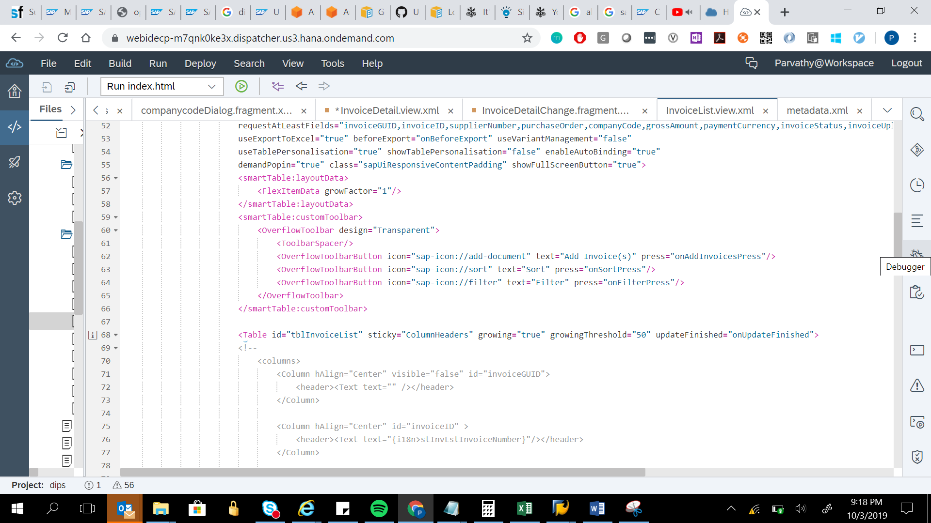

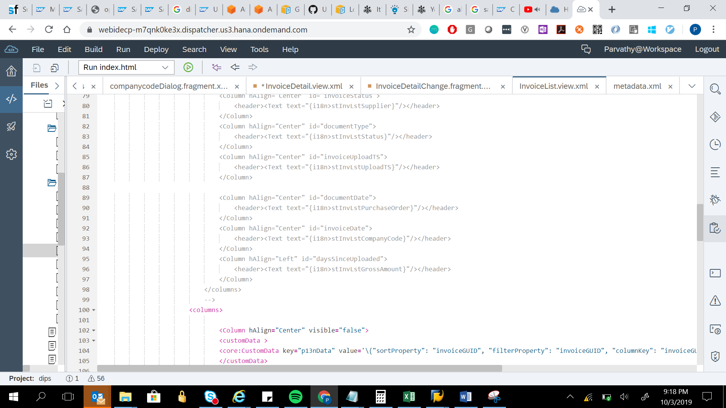

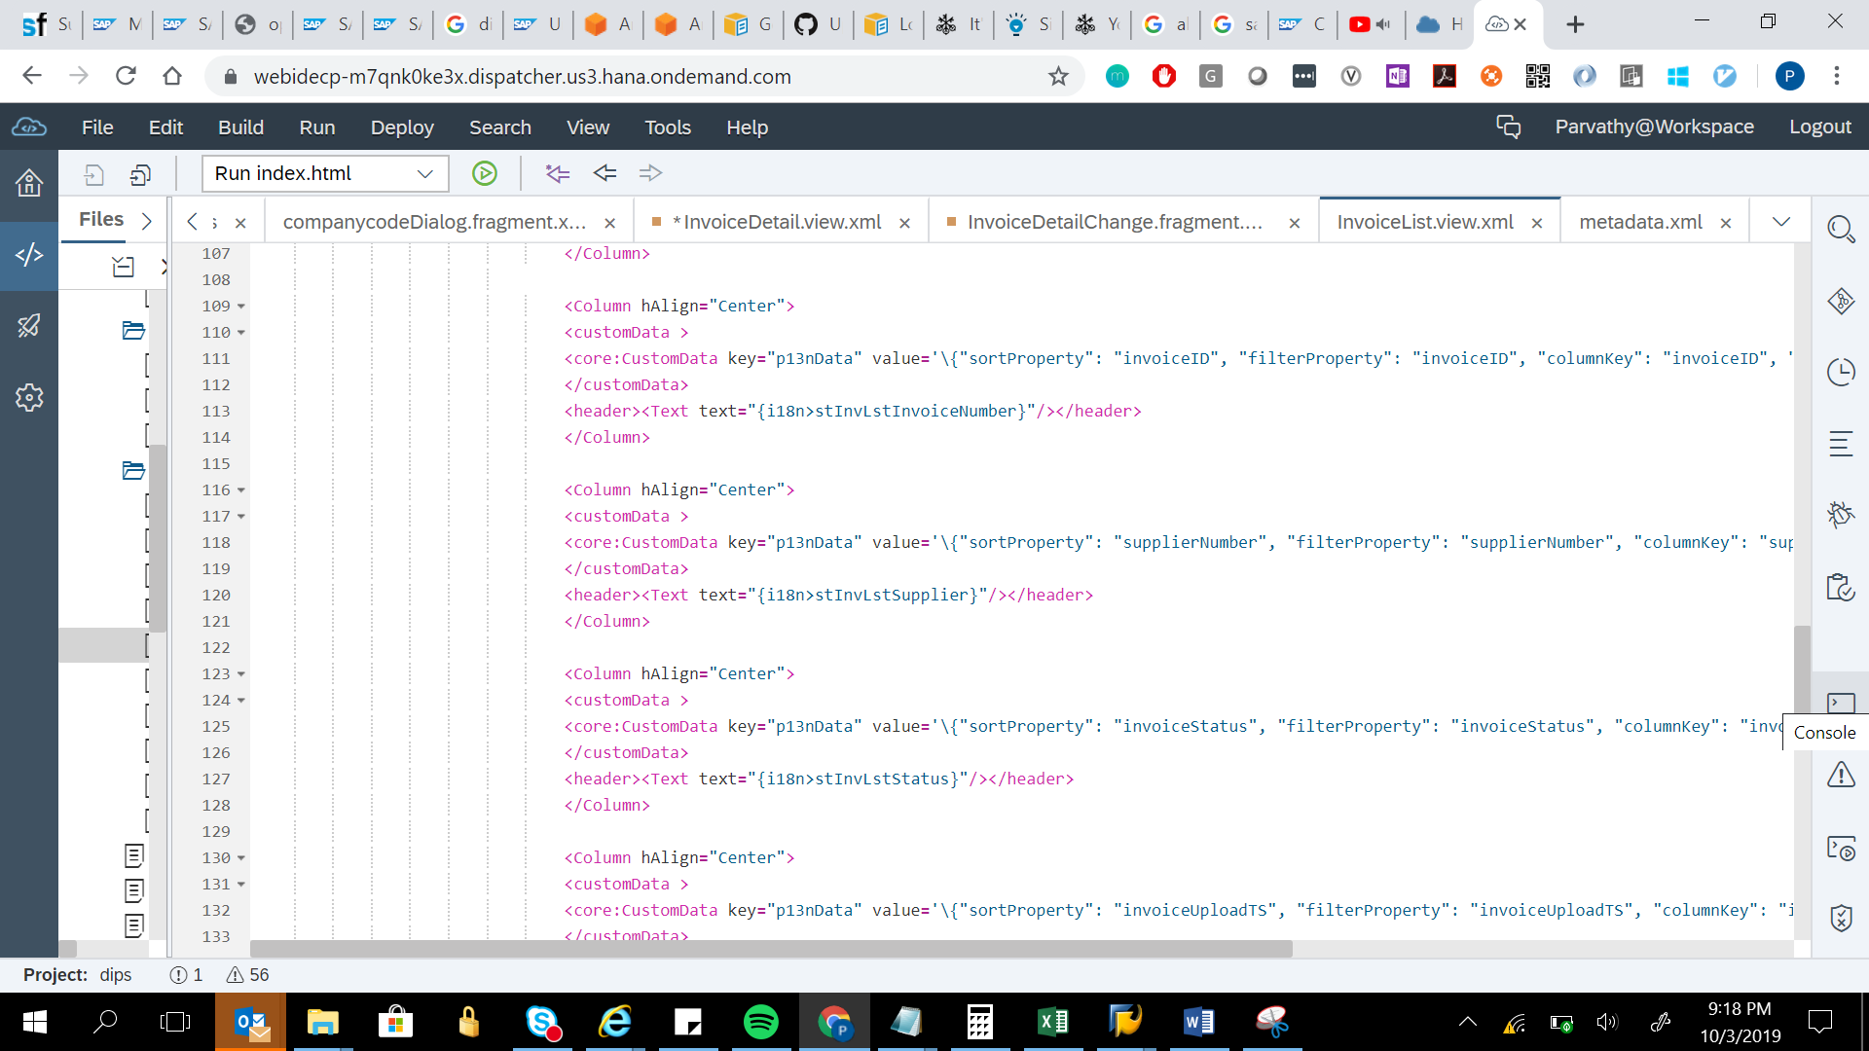

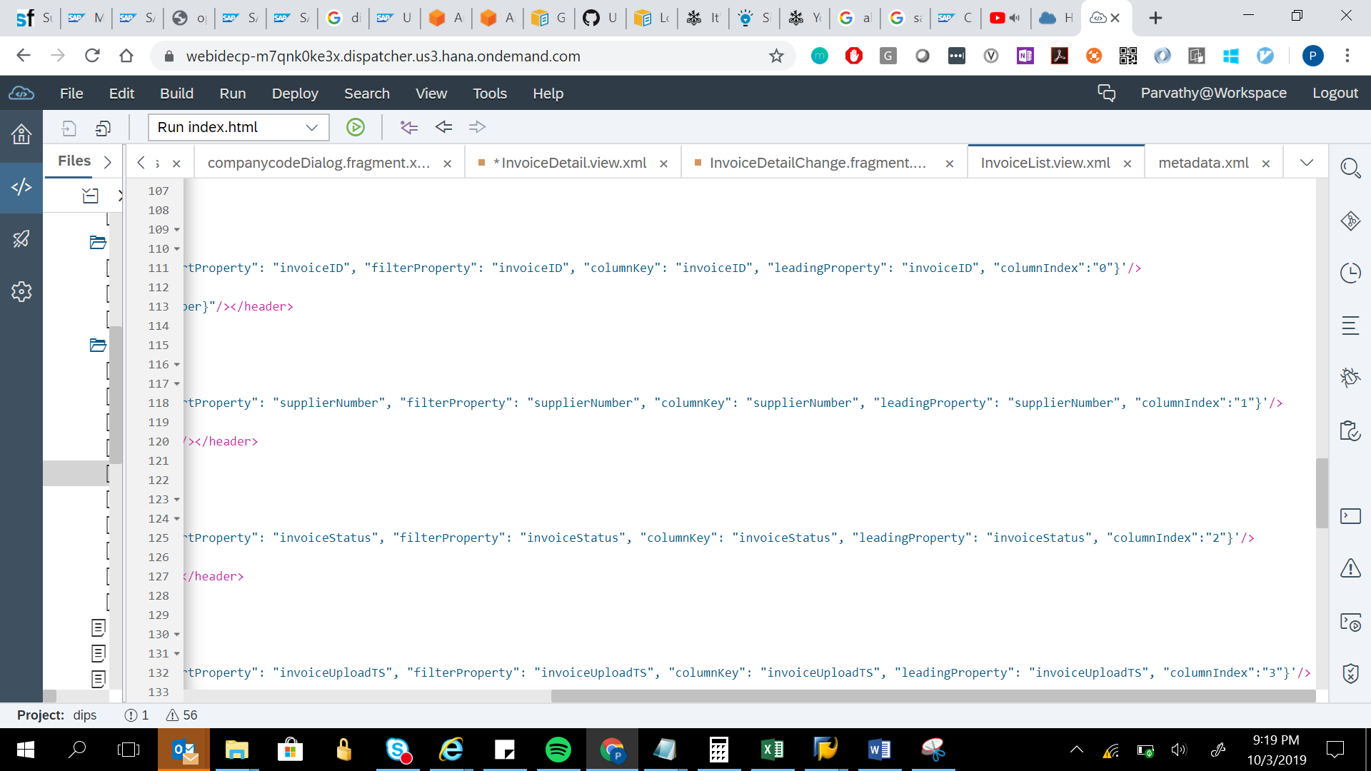

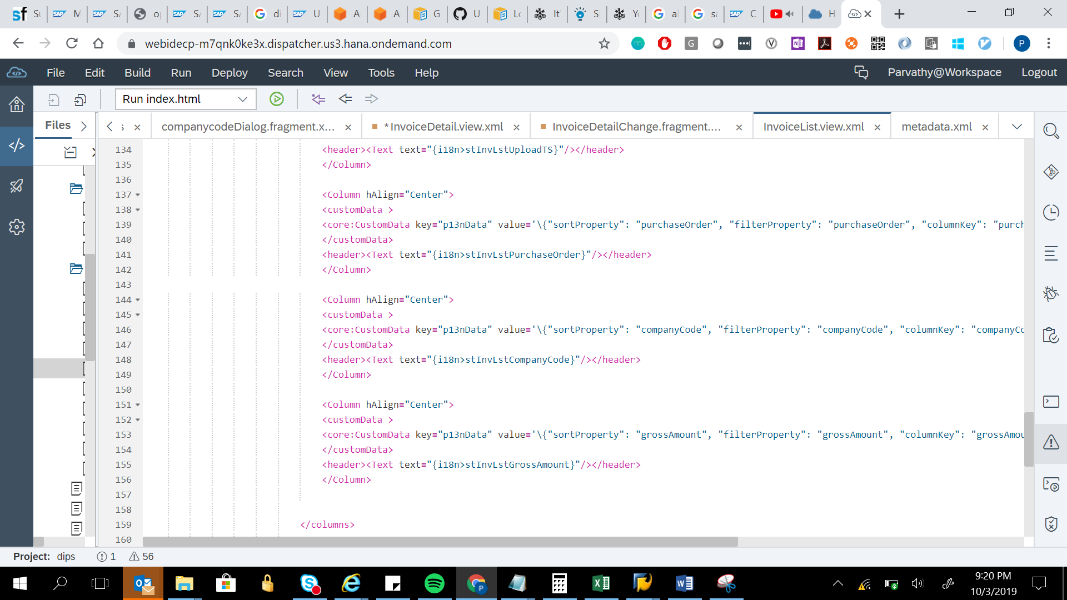

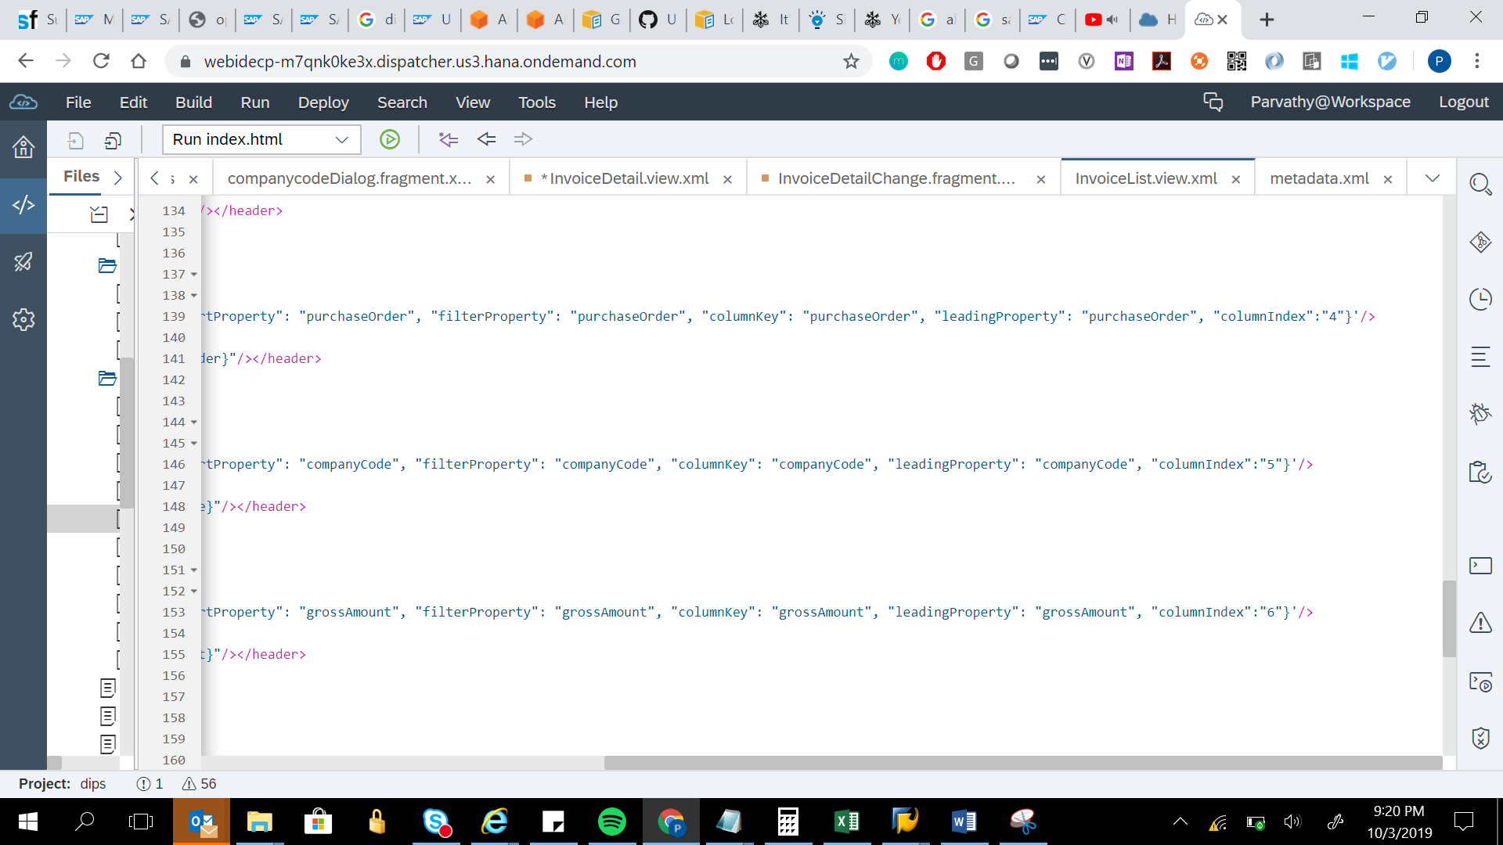

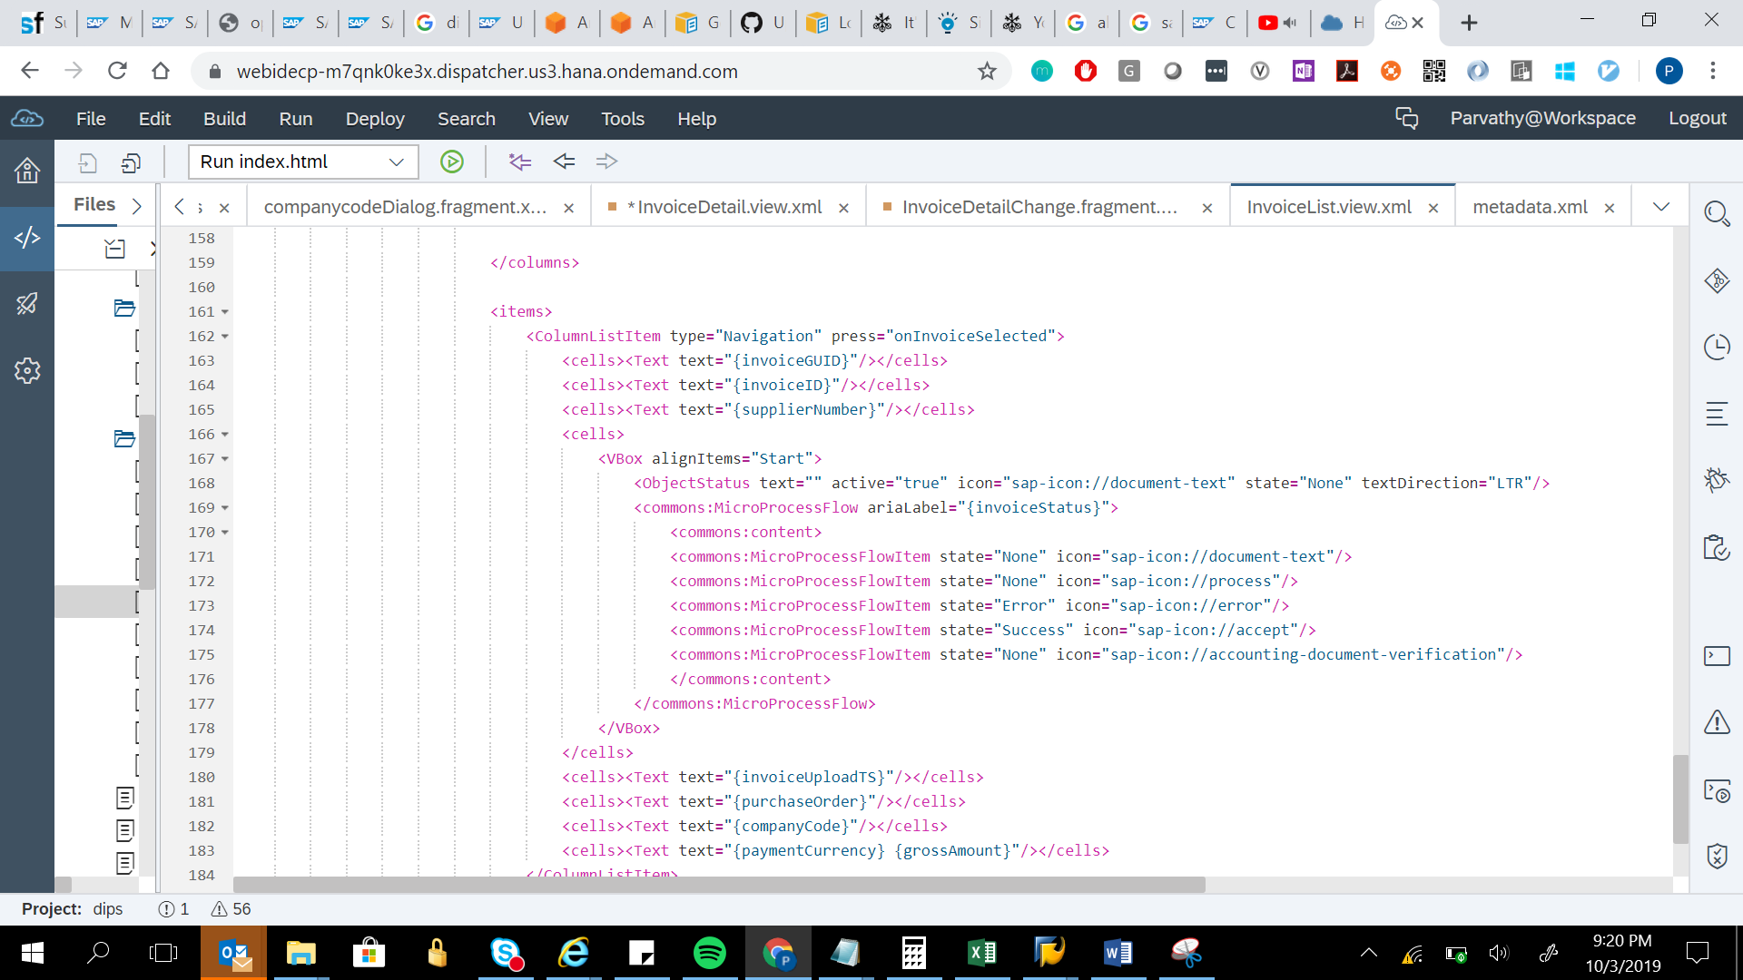

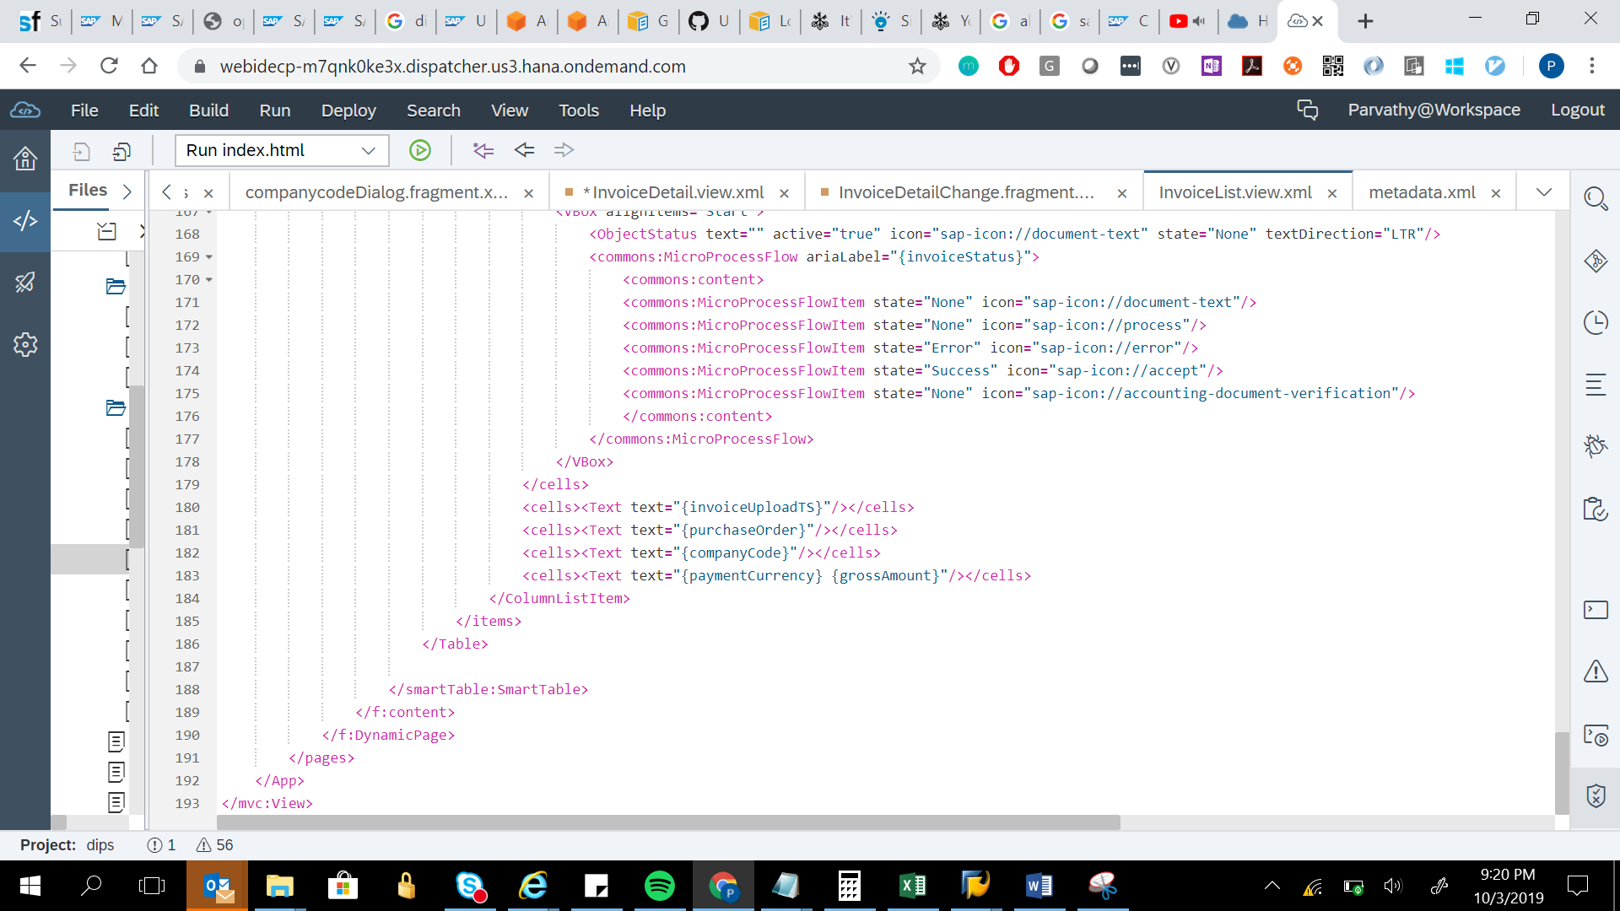

<mvc:View controllerName="com.deloitte.scp.app.dips.controller.InvoiceList" xmlns:html="http://www.w3.org/1999/xhtml"

xmlns:core="sap.ui.core" xmlns:mvc="sap.ui.core.mvc" displayBlock="true" xmlns="sap.m" xmlns:smartFilterBar="sap.ui.comp.smartfilterbar"

xmlns:smartTable="sap.ui.comp.smarttable" xmlns:smartVariants="sap.ui.comp.smartvariants" xmlns:f="sap.f"

xmlns:app="http://schemas.sap.com/sapui5/extension/sap.ui.core.CustomData/1" xmlns:commons="sap.suite.ui.commons">

<App id="idAppControl">

<pages>

<f:DynamicPage id="dpInvoiceList" fitContent="true" headerExpanded="true" toggleHeaderOnTitleClick="true">

<f:title>

<f:DynamicPageTitle>

<f:heading>

<smartVariants:SmartVariantManagement id="svmInvoicesList" showShare="true" showExecuteOnSelection="true" showSetAsDefault="true"

persistencyKey="com.deloitte.scp.app.dips.InvoicesList.sv"/>

</f:heading>

</f:DynamicPageTitle>

</f:title>

<f:header>

<f:DynamicPageHeader pinnable="true">

<f:content>

<FlexBox>

<items>

<smartFilterBar:SmartFilterBar id="smtFltrInvoicesList" entitySet="Invoice" liveMode="false" showMessages="true"

smartVariant="svmInvoicesList" persistencyKey="com.deloitte.scp.app.dips.InvoicesList.sfb" enableBasicSearch="true"

basicSearchFieldName="invoiceID">

<smartFilterBar:controlConfiguration>

<smartFilterBar:ControlConfiguration key="supplierNumber" label="Supplier" visibleInAdvancedArea="true"/>

<smartFilterBar:ControlConfiguration key="invoiceID" label="Invoice No." visibleInAdvancedArea="true"/>

<smartFilterBar:ControlConfiguration key="purchaseOrder" label="Purchase Order" visibleInAdvancedArea="true"/>

<smartFilterBar:ControlConfiguration key="companyCode" label="Company Code" visibleInAdvancedArea="true"/>

<smartFilterBar:ControlConfiguration key="invoiceStatus" label="Status" visibleInAdvancedArea="true"/>

<!--<smartFilterBar:ControlConfiguration key="invoiceStatus" label="Status" visibleInAdvancedArea="true" controlType="dropDownList">-->

<!-- <smartFilterBar:customControl>-->

<!-- <MultiComboBox>-->

<!-- <core:ListItem key="Scanned_Errors" text="Scanned with Errors"/>-->

<!-- <core:Item key="Scanned" text="Scanned"/>-->

<!-- <core:Item key="In_Process" text="In Process"/>-->

<!-- <core:Item key="Posted" text="Posted"/>-->

<!-- </MultiComboBox>-->

<!-- </smartFilterBar:customControl>-->

<!--</smartFilterBar:ControlConfiguration>-->

</smartFilterBar:controlConfiguration>

</smartFilterBar:SmartFilterBar>

</items>

</FlexBox>

</f:content>

</f:DynamicPageHeader>

</f:header>

<f:content>

<smartTable:SmartTable id="smtTblInvoicesList" entitySet="Invoice" smartFilterId="smtFltrInvoicesList" header="Invoices" showRowCount="true"

tableType="ResponsiveTable"

app:p13nDialogSettings="{group:{visible:false}}"

persistencyKey="SmartTableAnalytical_Explored"

requestAtLeastFields="invoiceGUID,invoiceID,supplierNumber,purchaseOrder,companyCode,grossAmount,paymentCurrency,invoiceStatus,invoiceUploadTS"

useExportToExcel="true" beforeExport="onBeforeExport" useVariantManagement="false"

useTablePersonalisation="true" showTablePersonalisation="false" enableAutoBinding="true"

demandPopin="true" class="sapUiResponsiveContentPadding" showFullScreenButton="true">

<smartTable:layoutData>

<FlexItemData growFactor="1"/>

</smartTable:layoutData>

<smartTable:customToolbar>

<OverflowToolbar design="Transparent">

<ToolbarSpacer/>

<OverflowToolbarButton icon="sap-icon://add-document" text="Add Invoice(s)" press="onAddInvoicesPress"/>

<OverflowToolbarButton icon="sap-icon://sort" text="Sort" press="onSortPress"/>

<OverflowToolbarButton icon="sap-icon://filter" text="Filter" press="onFilterPress"/>

</OverflowToolbar>

</smartTable:customToolbar>

<Table id="tblInvoiceList" sticky="ColumnHeaders" growing="true" growingThreshold="50" updateFinished="onUpdateFinished">

<!--

<columns>

<Column hAlign="Center" visible="false" id="invoiceGUID">

<header><Text text="" /></header>

</Column>

<Column hAlign="Center" id="invoiceID" >

<header><Text text="{i18n>stInvLstInvoiceNumber}"/></header>

</Column>

<Column hAlign="Center" id="invoiceStatus">

<header><Text text="{i18n>stInvLstSupplier}"/></header>

</Column>

<Column hAlign="Center" id="documentType">

<header><Text text="{i18n>stInvLstStatus}"/></header>

</Column>

<Column hAlign="Center" id="invoiceUploadTS">

<header><Text text="{i18n>stInvLstUploadTS}"/></header>

</Column>

<Column hAlign="Center" id="documentDate">

<header><Text text="{i18n>stInvLstPurchaseOrder}"/></header>

</Column>

<Column hAlign="Center" id="invoiceDate">

<header><Text text="{i18n>stInvLstCompanyCode}"/></header>

</Column>

<Column hAlign="Left" id="daysSinceUploaded">

<header><Text text="{i18n>stInvLstGrossAmount}"/></header>

</Column>

</columns>

-->

<columns>

<Column hAlign="Center" visible="false">

<customData >

<core:CustomData key="p13nData" value='\{"sortProperty": "invoiceGUID", "filterProperty": "invoiceGUID", "columnKey": "invoiceGUID", "leadingProperty": "invoiceGUID", "columnIndex":""}'/>

</customData>

<header><Text text="{i18n>stInvLstInvoiceNumber}"/></header>

</Column>

<Column hAlign="Center">

<customData >

<core:CustomData key="p13nData" value='\{"sortProperty": "invoiceID", "filterProperty": "invoiceID", "columnKey": "invoiceID", "leadingProperty": "invoiceID", "columnIndex":"0"}'/>

</customData>

<header><Text text="{i18n>stInvLstInvoiceNumber}"/></header>

</Column>

<Column hAlign="Center">

<customData >

<core:CustomData key="p13nData" value='\{"sortProperty": "supplierNumber", "filterProperty": "supplierNumber", "columnKey": "supplierNumber", "leadingProperty": "supplierNumber", "columnIndex":"1"}'/>

</customData>

<header><Text text="{i18n>stInvLstSupplier}"/></header>

</Column>

<Column hAlign="Center">

<customData >

<core:CustomData key="p13nData" value='\{"sortProperty": "invoiceStatus", "filterProperty": "invoiceStatus", "columnKey": "invoiceStatus", "leadingProperty": "invoiceStatus", "columnIndex":"2"}'/>

</customData>

<header><Text text="{i18n>stInvLstStatus}"/></header>

</Column>

<Column hAlign="Center">

<customData >

<core:CustomData key="p13nData" value='\{"sortProperty": "invoiceUploadTS", "filterProperty": "invoiceUploadTS", "columnKey": "invoiceUploadTS", "leadingProperty": "invoiceUploadTS", "columnIndex":"3"}'/>

</customData>

<header><Text text="{i18n>stInvLstUploadTS}"/></header>

</Column>

<Column hAlign="Center">

<customData >

<core:CustomData key="p13nData" value='\{"sortProperty": "purchaseOrder", "filterProperty": "purchaseOrder", "columnKey": "purchaseOrder", "leadingProperty": "purchaseOrder", "columnIndex":"4"}'/>

</customData>

<header><Text text="{i18n>stInvLstPurchaseOrder}"/></header>

</Column>

<Column hAlign="Center">

<customData >

<core:CustomData key="p13nData" value='\{"sortProperty": "companyCode", "filterProperty": "companyCode", "columnKey": "companyCode", "leadingProperty": "companyCode", "columnIndex":"5"}'/>

</customData>

<header><Text text="{i18n>stInvLstCompanyCode}"/></header>

</Column>

<Column hAlign="Center">

<customData >

<core:CustomData key="p13nData" value='\{"sortProperty": "grossAmount", "filterProperty": "grossAmount", "columnKey": "grossAmount", "leadingProperty": "grossAmount", "columnIndex":"6"}'/>

</customData>

<header><Text text="{i18n>stInvLstGrossAmount}"/></header>

</Column>

</columns>

<items>

<ColumnListItem type="Navigation" press="onInvoiceSelected">

<cells><Text text="{invoiceGUID}"/></cells>

<cells><Text text="{invoiceID}"/></cells>

<cells><Text text="{supplierNumber}"/></cells>

<cells>

<VBox alignItems="Start">

<ObjectStatus text="" active="true" icon="sap-icon://document-text" state="None" textDirection="LTR"/>

<commons:MicroProcessFlow ariaLabel="{invoiceStatus}">

<commons:content>

<commons:MicroProcessFlowItem state="None" icon="sap-icon://document-text"/>

<commons:MicroProcessFlowItem state="None" icon="sap-icon://process"/>

<commons:MicroProcessFlowItem state="Error" icon="sap-icon://error"/>

<commons:MicroProcessFlowItem state="Success" icon="sap-icon://accept"/>

<commons:MicroProcessFlowItem state="None" icon="sap-icon://accounting-document-verification"/>

</commons:content>

</commons:MicroProcessFlow>

</VBox>

</cells>

<cells><Text text="{invoiceUploadTS}"/></cells>

<cells><Text text="{purchaseOrder}"/></cells>

<cells><Text text="{companyCode}"/></cells>

<cells><Text text="{paymentCurrency} {grossAmount}"/></cells>

</ColumnListItem>

</items>

</Table>

</smartTable:SmartTable>

</f:content>

</f:DynamicPage>

</pages>

</App>

</mvc:View>