

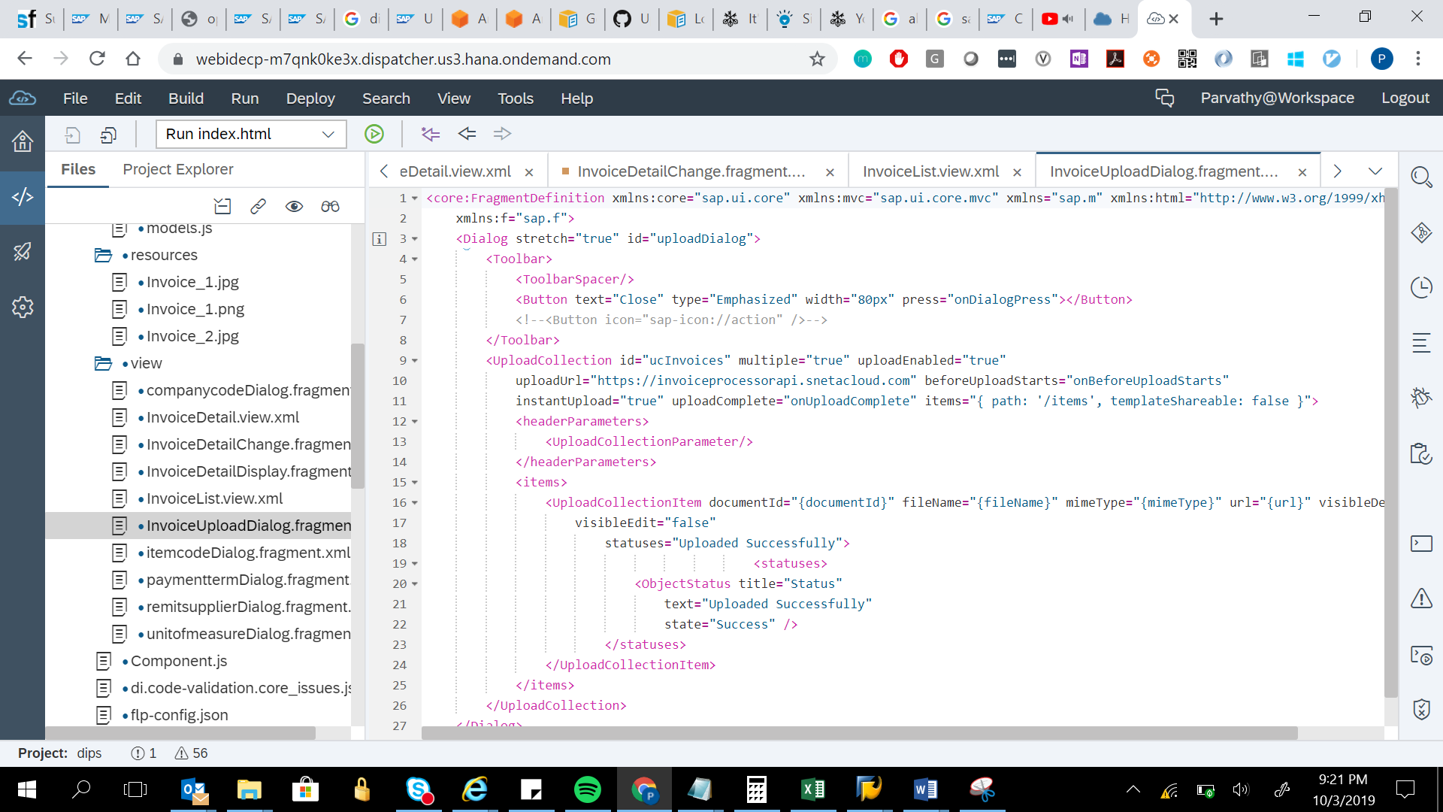

<core:FragmentDefinition xmlns:core="sap.ui.core" xmlns:mvc="sap.ui.core.mvc" xmlns="sap.m" xmlns:html="http://www.w3.org/1999/xhtml"

xmlns:f="sap.f">

<Dialog stretch="true" id="uploadDialog">

<Toolbar>

<ToolbarSpacer/>

<Button text="Close" type="Emphasized" width="80px" press="onDialogPress"></Button>

<!--<Button icon="sap-icon://action" />-->

</Toolbar>

<UploadCollection id="ucInvoices" multiple="true" uploadEnabled="true"

uploadUrl="https://invoiceprocessorapi.snetacloud.com" beforeUploadStarts="onBeforeUploadStarts"

instantUpload="true" uploadComplete="onUploadComplete" items="{ path: '/items', templateShareable: false }">

<headerParameters>

<UploadCollectionParameter/>

</headerParameters>

<items>

<UploadCollectionItem documentId="{documentId}" fileName="{fileName}" mimeType="{mimeType}" url="{url}" visibleDelete="false"

visibleEdit="false"

statuses="Uploaded Successfully">

<statuses>

<ObjectStatus title="Status"

text="Uploaded Successfully"

state="Success" />

</statuses>

</UploadCollectionItem>

</items>

</UploadCollection>

</Dialog>

</core:FragmentDefinition>