

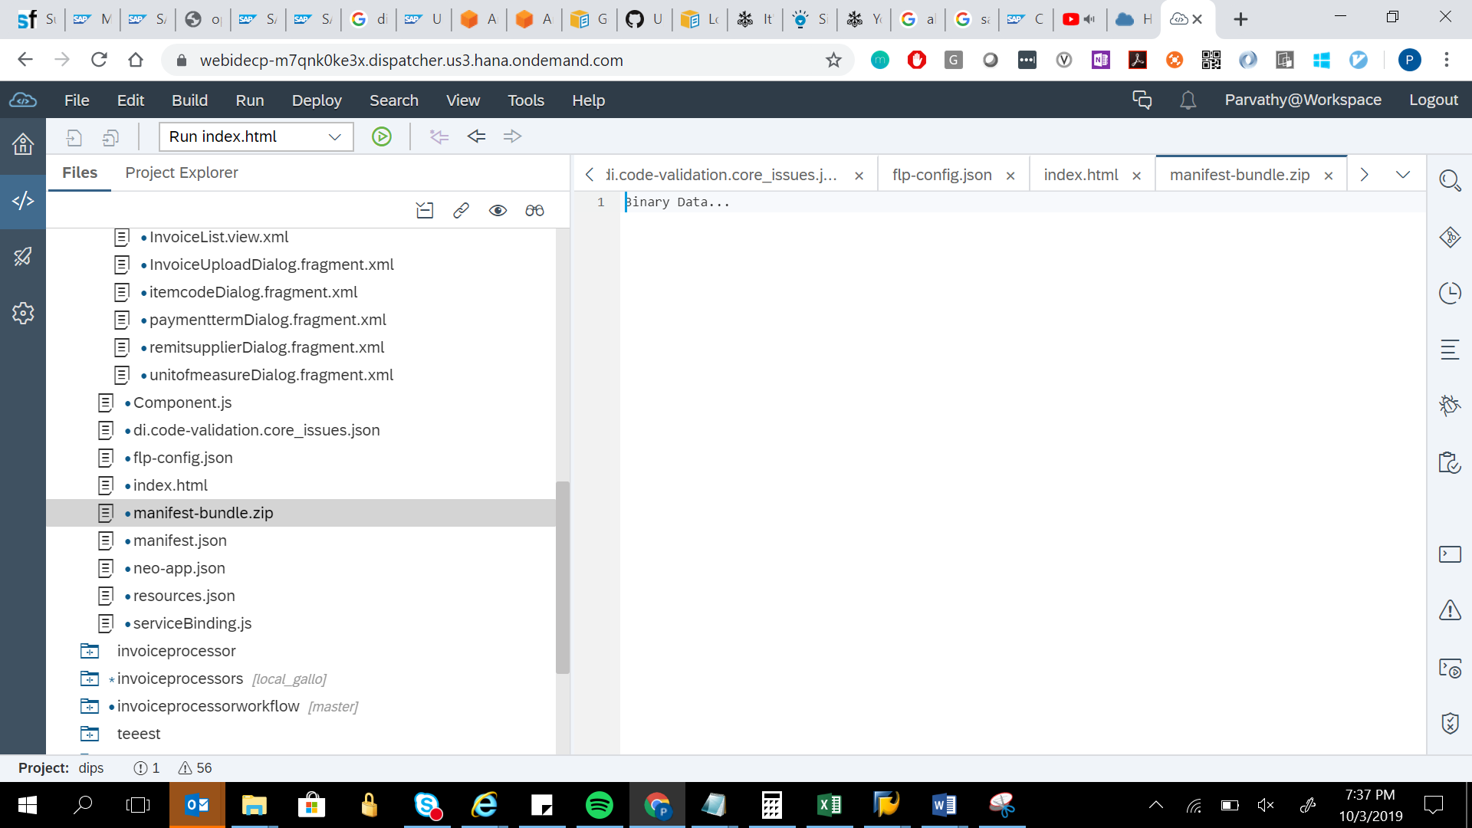



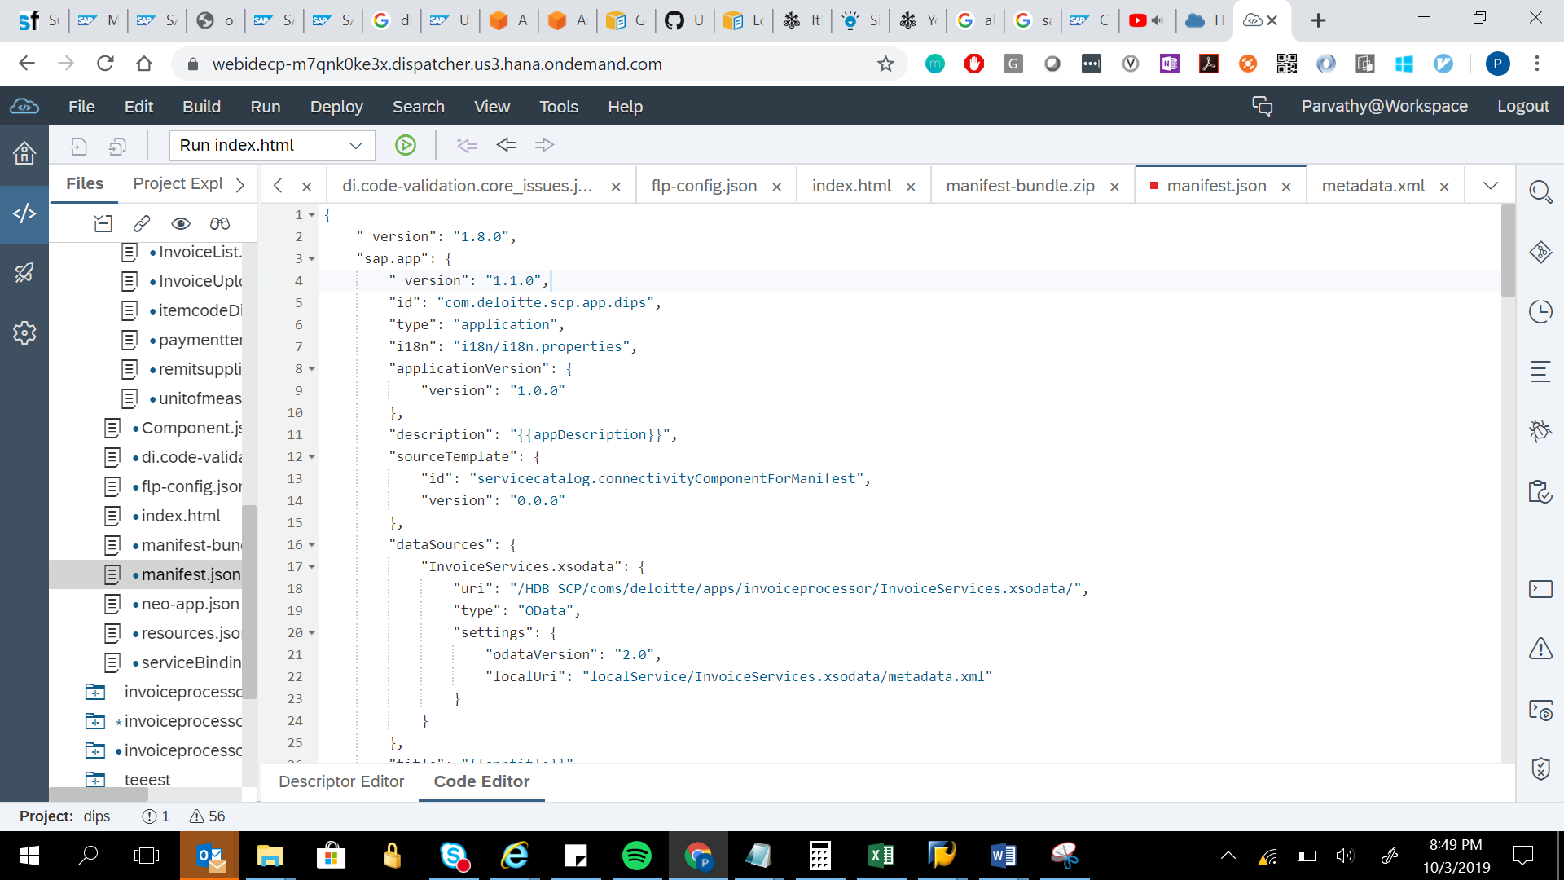

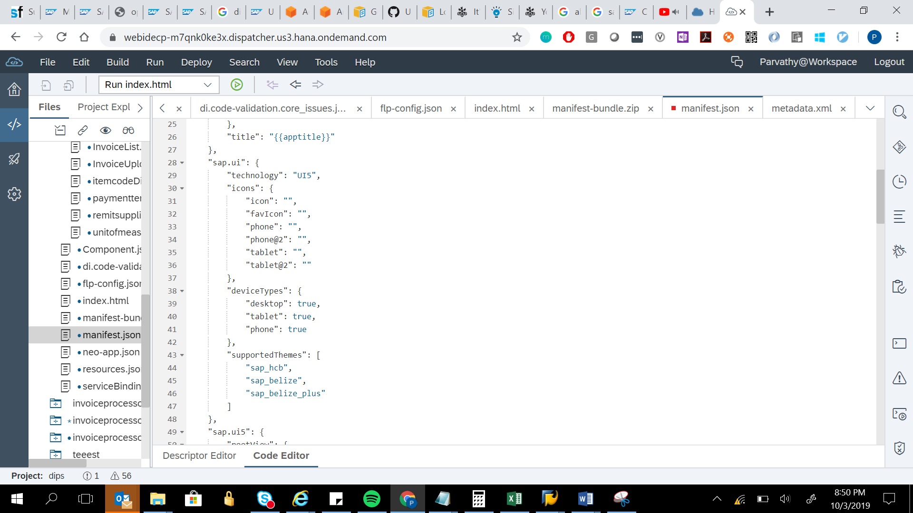

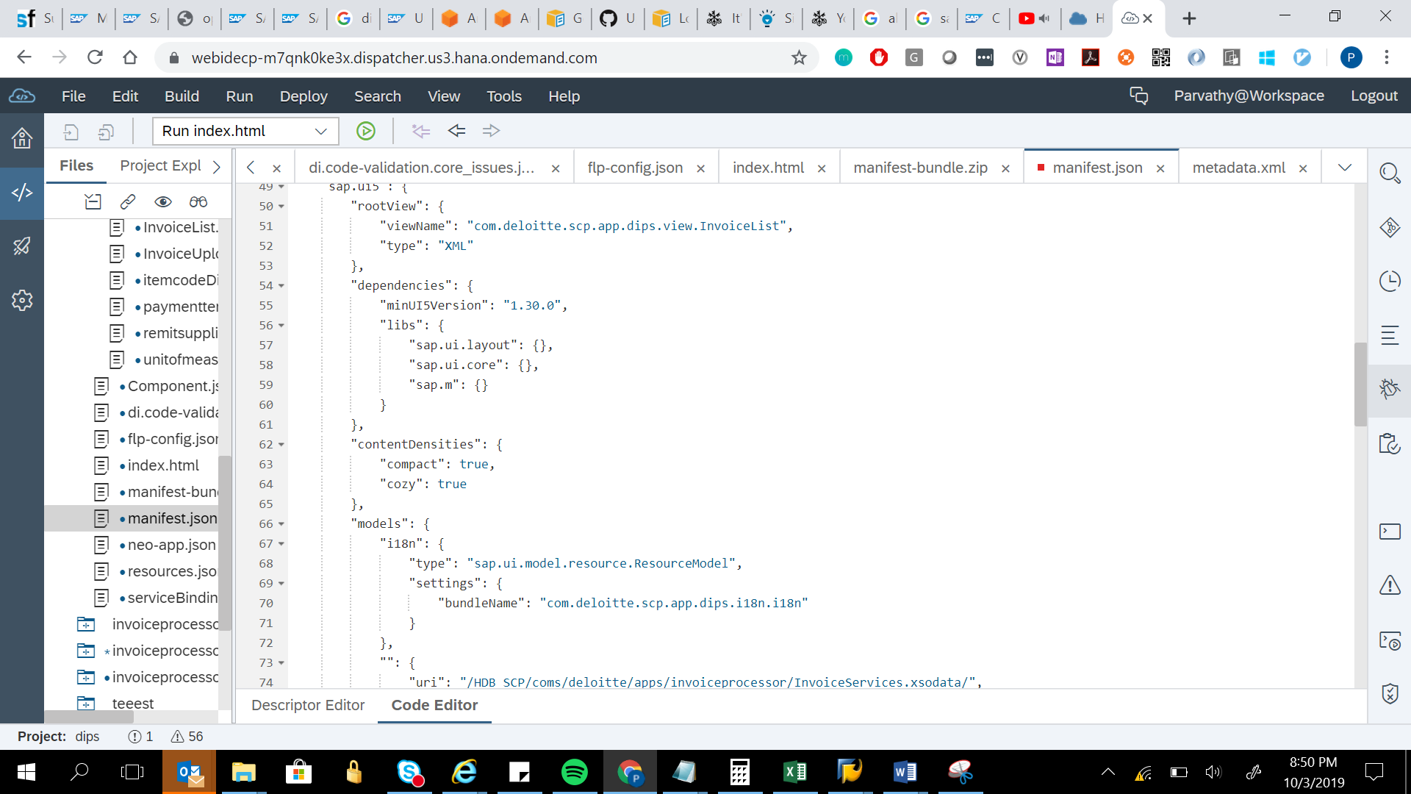

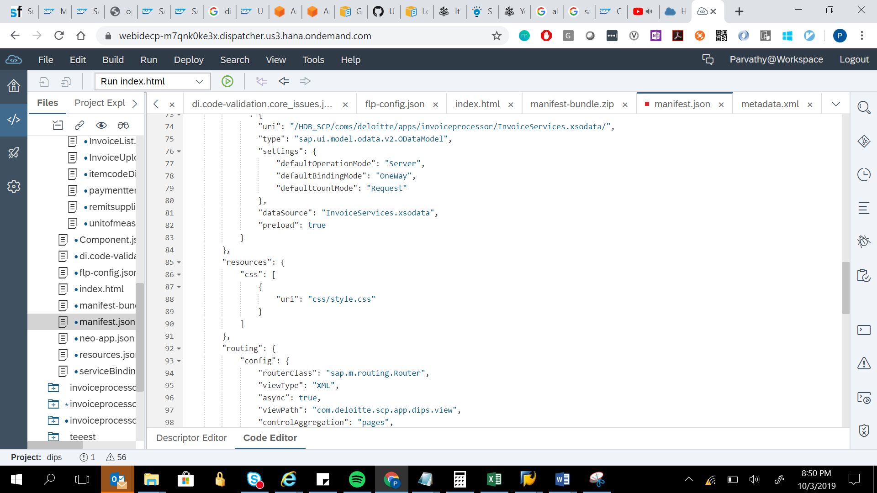

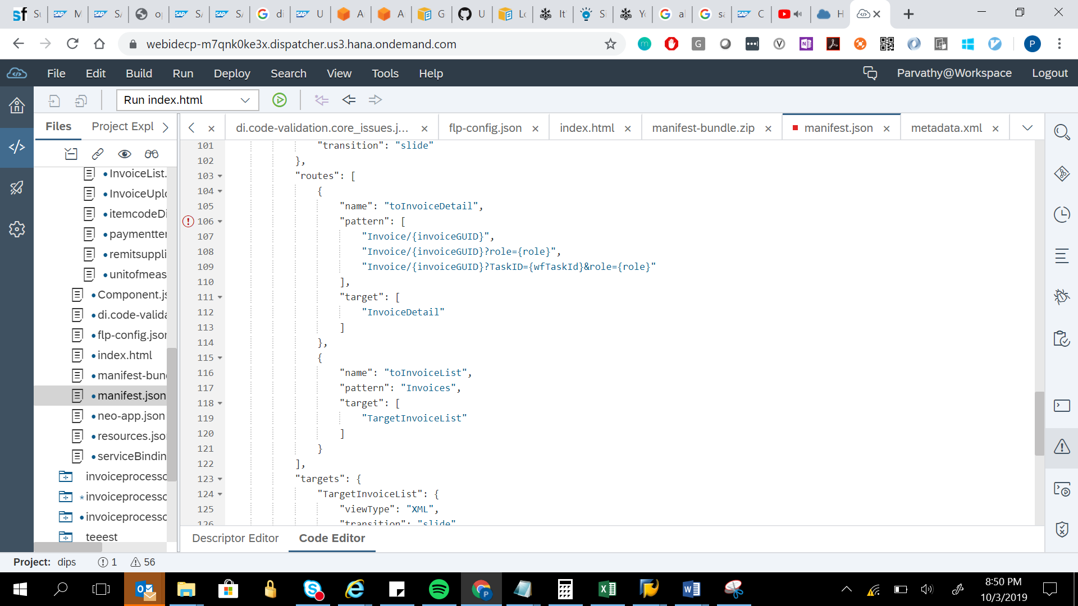

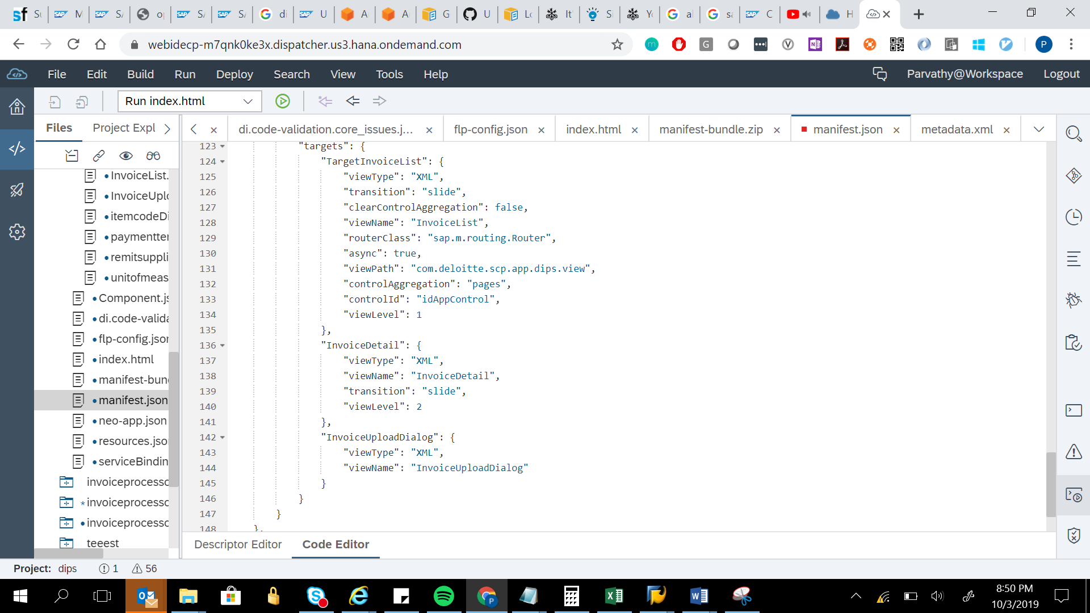

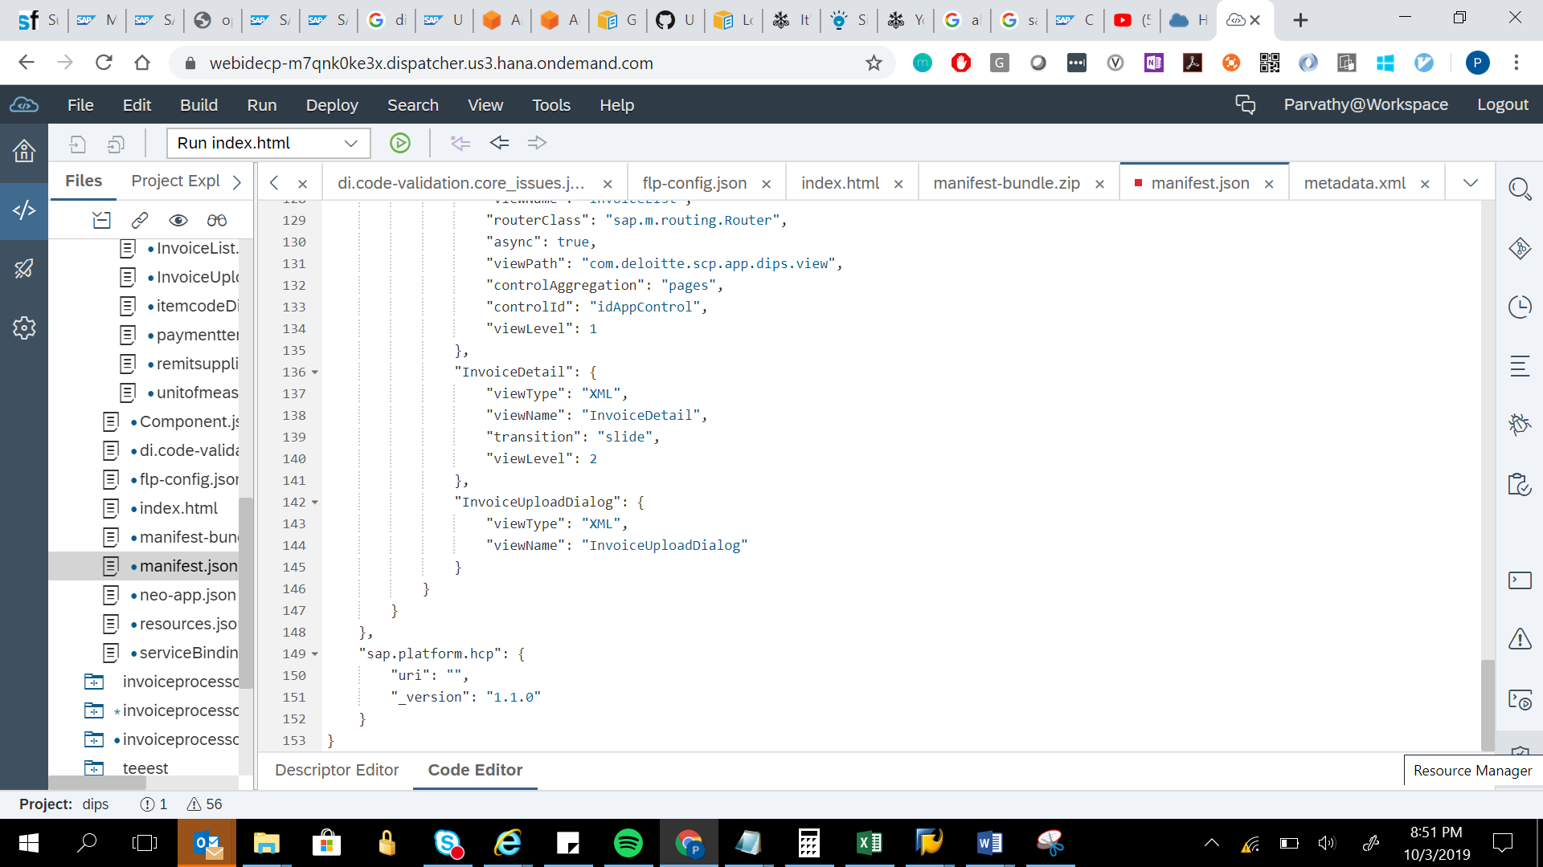

{

"_version": "1.8.0",

"sap.app": {

"_version": "1.1.0",

"id": "com.deloitte.scp.app.dips",

"type": "application",

"i18n": "i18n/i18n.properties",

"applicationVersion": {

"version": "1.0.0"

},

"description": "{{appDescription}}",

"sourceTemplate": {

"id": "servicecatalog.connectivityComponentForManifest",

"version": "0.0.0"

},

"dataSources": {

"InvoiceServices.xsodata": {

"uri": "/HDB_SCP/coms/deloitte/apps/invoiceprocessor/InvoiceServices.xsodata/",

"type": "OData",

"settings": {

"odataVersion": "2.0",

"localUri": "localService/InvoiceServices.xsodata/metadata.xml"

}

}

},

"title": "{{apptitle}}"

},

"sap.ui": {

"technology": "UI5",

"icons": {

"icon": "",

"favIcon": "",

"phone": "",

"phone@2": "",

"tablet": "",

"tablet@2": ""

},

"deviceTypes": {

"desktop": true,

"tablet": true,

"phone": true

},

"supportedThemes": [

"sap_hcb",

"sap_belize",

"sap_belize_plus"

]

},

"sap.ui5": {

"rootView": {

"viewName": "com.deloitte.scp.app.dips.view.InvoiceList",

"type": "XML"

},

"dependencies": {

"minUI5Version": "1.30.0",

"libs": {

"sap.ui.layout": {},

"sap.ui.core": {},

"sap.m": {}

}

},

"contentDensities": {

"compact": true,

"cozy": true

},

"models": {

"i18n": {

"type": "sap.ui.model.resource.ResourceModel",

"settings": {

"bundleName": "com.deloitte.scp.app.dips.i18n.i18n"

}

},

"": {

"uri": "/HDB_SCP/coms/deloitte/apps/invoiceprocessor/InvoiceServices.xsodata/",

"type": "sap.ui.model.odata.v2.ODataModel",

"settings": {

"defaultOperationMode": "Server",

"defaultBindingMode": "OneWay",

"defaultCountMode": "Request"

},

"dataSource": "InvoiceServices.xsodata",

"preload": true

}

},

"resources": {

"css": [

{

"uri": "css/style.css"

}

]

},

"routing": {

"config": {

"routerClass": "sap.m.routing.Router",

"viewType": "XML",

"async": true,

"viewPath": "com.deloitte.scp.app.dips.view",

"controlAggregation": "pages",

"controlId": "idAppControl",

"clearControlAggregation": false,

"transition": "slide"

},

"routes": [

{

"name": "toInvoiceDetail",

"pattern": [

"Invoice/{invoiceGUID}",

"Invoice/{invoiceGUID}?role={role}",

"Invoice/{invoiceGUID}?TaskID={wfTaskId}&role={role}"

],

"target": [

"InvoiceDetail"

]

},

{

"name": "toInvoiceList",

"pattern": "Invoices",

"target": [

"TargetInvoiceList"

]

}

],

"targets": {

"TargetInvoiceList": {

"viewType": "XML",

"transition": "slide",

"clearControlAggregation": false,

"viewName": "InvoiceList",

"routerClass": "sap.m.routing.Router",

"async": true,

"viewPath": "com.deloitte.scp.app.dips.view",

"controlAggregation": "pages",

"controlId": "idAppControl",

"viewLevel": 1

},

"InvoiceDetail": {

"viewType": "XML",

"viewName": "InvoiceDetail",

"transition": "slide",

"viewLevel": 2

},

"InvoiceUploadDialog": {

"viewType": "XML",

"viewName": "InvoiceUploadDialog"

}

}

}

},

"sap.platform.hcp": {

"uri": "",

"_version": "1.1.0"

}

}